
Research and share information on
indigenous cultures
D2.TTG.CL3.18
Trainer Guide

Research and share information on indigenous cultures

D2.TTG.CL3.18

Trainer Guide





Project Base
William Angliss Institute of TAFE
555 La Trobe Street
Melbourne 3000 Victoria
Telephone: | (03) 9606 2111
Facsimile: | (03) 9670 1330
Acknowledgements
Project Director: | Wayne Crosbie
Project Manager | Jim Irwin
Chief Writer: | Alan Hickman
Subject Writer: | Alan Hickman
Editor: | Jim Irwin
DTP/Production: | Daniel Chee, Mai Vu, Cindy Curran

The Association of Southeast Asian Nations (ASEAN) was established on 8 August 1967. The Member States of the Association are Brunei Darussalam, Cambodia, Indonesia, Lao PDR, Malaysia, Myanmar, Philippines, Singapore, Thailand and Viet Nam.
The ASEAN Secretariat is based in Jakarta, Indonesia.
General Information on ASEAN appears online at the ASEAN Website: www.asean.org.
All text is produced by William Angliss Institute of TAFE for the ASEAN Project on “Toolbox Development for Tourism Labour Divisions for Travel Agencies and Tour Operations”.
This publication is supported by the Australian Government’s aid program through the ASEAN- Australia Development Cooperation Program Phase II (AADCP II).
Copyright: Association of Southeast Asian Nations (ASEAN) 2015. All rights reserved.
Disclaimer
Every effort has been made to ensure that this publication is free from errors or omissions. However, you should conduct your own enquiries and seek professional advice before relying on any fact, statement or matter contained in this book. The ASEAN Secretariat and William Angliss Institute of TAFE are not responsible for any injury, loss or damage as a result of material included or omitted from this course. Information in this module is current at the time of publication. Time of publication is indicated in the date stamp at the bottom of each page.
Some images appearing in this resource have been purchased from stock photography suppliers Shutterstock and iStockphoto and other third party copyright owners and as such are non-transferable and non-exclusive. Clip arts, font images and illustrations used are from the Microsoft Office Clip Art and Media Library. Some images have been provided by and are the property of William Angliss Institute.
Additional images have been sourced from Flickr and SXC and are used under Creative Commons licence: http://creativecommons.org/licenses/by/2.0/deed.en
File name: TG_Research_&_share_info_on_indigenous_cultures_150715



Table of contents
Competency Based Training (CBT) and assessment – An introduction for trainers 1
Competency standard 11
Notes and PowerPoint slides 19
Recommended training equipment 187
Instructions for Trainers for using PowerPoint – Presenter View 189
Appendix – ASEAN acronyms 191

© ASEAN 2015
Trainer Guide Research and share information on indigenous cultures

© ASEAN 2015
Trainer Guide
Research and share information on indigenous cultures

Competency Based Training (CBT) and assessment – An introduction for trainers
Competency
Competency refers to the ability to perform particular tasks and duties to the standard of performance expected in the workplace.
Competency requires the application of specified knowledge, skills and attitudes relevant to effective participation, consistently over time and in the workplace environment.
The essential skills and knowledge are either identified separately or combined.
Knowledge identifies what a person needs to know to perform the work in an informed and effective manner.
Skills describe the application of knowledge to situations where understanding is converted into a workplace outcome.
Attitude describes the founding reasons behind the need for certain knowledge or why skills are performed in a specified manner.
Competency covers all aspects of workplace performance and involves:
- Performing individual tasks
- Managing a range of different tasks
- Responding to contingencies or breakdowns
- Dealing with the responsibilities of the workplace
- Working with others.

Unit of competency

Like with any training qualification or program, a range of subject topics are identified that focus on the ability in a certain work area, responsibility or function.
Each manual focuses on a specific unit of competency that applies in the hospitality workplace.
In this manual a unit of competency is identified as a ‘unit’.
Each unit of competency identifies a discrete workplace requirement and includes:
- Knowledge and skills that underpin competency
- Language, literacy and numeracy
- Occupational safety and health requirements.
Each unit of competency must be adhered to in training and assessment to ensure consistency of outcomes.

Element of competency
An element of competency describes the essential outcomes within a unit of competency. The elements of competency are the basic building blocks of the unit of competency.
They describe in terms of outcomes the significant functions and tasks that make up the competency.
In this manual elements of competency are identified as an ‘element’.

Performance criteria

Performance criteria indicate the standard of performance that is required to demonstrate achievement within an element of competency. The standards reflect identified industry skill needs.
Performance criteria will be made up of certain specified skills, knowledge and attitudes.

Learning

For the purpose of this manual learning incorporates two key activities:
- Training
- Assessment.
Both of these activities will be discussed in detail in this introduction.
Today training and assessment can be delivered in a variety of ways. It may be provided to participants:
- On-the-job – in the workplace
- Off-the-job – at an educational institution or dedicated training environment
- As a combination of these two options.
No longer is it necessary for learners to be absent from the workplace for long periods of time in order to obtain recognised and accredited qualifications.

Learning approaches

This manual will identify two avenues to facilitate learning: Competency Based Training (CBT)
This is the strategy of developing a participant’s competency.
Educational institutions utilise a range of training strategies to ensure that participants are able to gain the knowledge and skills required for successful:
- Completion of the training program or qualification
- Implementation in the workplace.
The strategies selected should be chosen based on suitability and the learning styles of participants.

Competency Based Assessment (CBA)

This is the strategy of assessing competency of a participant.
Educational institutions utilise a range of assessment strategies to ensure that participants are assessed in a manner that demonstrates validity, fairness, reliability, flexibility and fairness of assessment processes.

Flexibility in learning

It is important to note that flexibility in training and assessment strategies is required to meet the needs of participants who may have learning difficulties. The strategies used will vary, taking into account the needs of individual participants with learning difficulties.
However they will be applied in a manner which does not discriminate against the participant or the participant body as a whole.
Catering for participant diversity
Participants have diverse backgrounds, needs and interests. When planning training and assessment activities to cater for individual differences, trainers and assessors should:
- Consider individuals’ experiences, learning styles and interests
- Develop questions and activities that are aimed at different levels of ability
- Modify the expectations for some participants
- Provide opportunities for a variety of forms of participation, such as individual, pair and small group activities
- Assess participants based on individual progress and outcomes.
The diversity among participants also provides a good reason for building up a learning community in which participants support each other’s learning.
Participant centred learning
This involves taking into account structuring training and assessment that:
- Builds on strengths – Training environments need to demonstrate the many positive features of local participants (such as the attribution of academic success to effort, and the social nature of achievement motivation) and of their trainers (such as a strong emphasis on subject disciplines and moral responsibility). These strengths and uniqueness of local participants and trainers should be acknowledged and treasured
- Acknowledges prior knowledge and experience – The learning activities should be planned with participants’ prior knowledge and experience in mind
- Understands learning objectives – Each learning activity should have clear learning objectives and participants should be informed of them at the outset. Trainers should also be clear about the purpose of assignments and explain their significance to participants
- Teaches for understanding – The pedagogies chosen should aim at enabling participants to act and think flexibly with what they know
- Teaches for independent learning – Generic skills and reflection should be nurtured through learning activities in appropriate contexts of the curriculum. Participants should be encouraged to take responsibility for their own learning

- Enhances motivation – Learning is most effective when participants are motivated. Various strategies should be used to arouse the interest of participants
- Makes effective use of resources – A variety of teaching resources can be employed as tools for learning
- Maximises engagement – In conducting learning activities, it is important for the minds of participants to be actively engaged
- Aligns assessment with learning and teaching – Feedback and assessment should be an integral part of learning and teaching
- Caters for learner diversity – Trainers should be aware that participants have different characteristics and strengths and try to nurture these rather than impose a standard set of expectations.
Active learning
The goal of nurturing independent learning in participants does not imply that they always have to work in isolation or solely in a classroom. On the contrary, the construction of knowledge in tourism and hospitality studies can often best be carried out in collaboration with others in the field. Sharing experiences, insights and views on issues of common concern, and working together to collect information through conducting investigative studies in the field (active learning) can contribute a lot to their eventual success.
Active learning has an important part to play in fostering a sense of community in the class. First, to operate successfully, a learning community requires an ethos of acceptance and a sense of trust among participants, and between them and their trainers. Trainers can help to foster acceptance and trust through encouragement and personal example, and by allowing participants to take risks as they explore and articulate their views, however immature these may appear to be. Participants also come to realise that their classmates (and their trainers) are partners in learning and solving.
Trainers can also encourage cooperative learning by designing appropriate group learning tasks, which include, for example, collecting background information, conducting small-scale surveys, or producing media presentations on certain issues and themes.
Participants need to be reminded that, while they should work towards successful completion of the field tasks, developing positive peer relationships in the process is an important objective of all group work.

Competency Based Training (CBT)

Principle of Competency Based Training
Competency based training is aimed at developing the knowledge, skills and attitudes of participants, through a variety of training tools.

Training strategies
The aims of this curriculum are to enable participants to:
- Undertake a variety of subject courses that are relevant to industry in the current environment
- Learn current industry skills, information and trends relevant to industry
- Learn through a range of practical and theoretical approaches
- Be able to identify, explore and solve issues in a productive manner

- Be able to become confident, equipped and flexible managers of the future
- Be ‘job ready’ and a valuable employee in the industry upon graduation of any qualification level.
To ensure participants are able to gain the knowledge and skills required to meet competency in each unit of competency in the qualification, a range of training delivery modes are used.

Types of training
In choosing learning and teaching strategies, trainers should take into account the practical, complex and multi-disciplinary nature of the subject area, as well as their participant’s prior knowledge, learning styles and abilities.
Training outcomes can be attained by utilising one or more delivery methods:
Lecture/tutorial
This is a common method of training involving transfer of information from the trainer to the participants. It is an effective approach to introduce new concepts or information to the learners and also to build upon the existing knowledge. The listener is expected to reflect on the subject and seek clarifications on the doubts.
Demonstration
Demonstration is a very effective training method that involves a trainer showing a participant how to perform a task or activity. Through a visual demonstration, trainers may also explain reasoning behind certain actions or provide supplementary information to help facilitate understanding.
Group discussions
Brainstorming in which all the members in a group express their ideas, views and opinions on a given topic. It is a free flow and exchange of knowledge among the participants and the trainer. The discussion is carried out by the group on the basis of their own experience, perceptions and values. This will facilitate acquiring new knowledge. When everybody is expected to participate in the group discussion, even the introverted persons will also get stimulated and try to articulate their feelings.
The ideas that emerge in the discussions should be noted down and presentations are to be made by the groups. Sometimes consensus needs to be arrived at on a given topic.
Group discussions are to be held under the moderation of a leader guided by the trainer. Group discussion technique triggers thinking process, encourages interactions and enhances communication skills.
Role play
This is a common and very effective method of bringing into the classroom real life situations, which may not otherwise be possible. Participants are made to enact a particular role so as to give a real feel of the roles they may be called upon to play. This enables participants to understand the behaviour of others as well as their own emotions and feelings. The instructor must brief the role players on what is expected of them. The role player may either be given a ready-made script, which they can memorize and enact, or they may be required to develop their own scripts around a given situation. This technique is extremely useful in understanding creative selling techniques and human relations. It can be entertaining and energizing and it helps the reserved and less literate to express their feelings.

Simulation games
When trainees need to become aware of something that they have not been conscious of, simulations can be a useful mechanism. Simulation games are a method based on "here and now" experience shared by all the participants. The games focus on the participation of the trainees and their willingness to share their ideas with others. A "near real life" situation is created providing an opportunity to which they apply themselves by adopting certain behaviour. They then experience the impact of their behaviour on the situation. It is carried out to generate responses and reactions based on the real feelings of the participants, which are subsequently analysed by the trainer.
While use of simulation games can result in very effective learning, it needs considerable trainer competence to analyse the situations.
Individual /group exercises
Exercises are often introduced to find out how much the participant has assimilated. This method involves imparting instructions to participants on a particular subject through use of written exercises. In the group exercises, the entire class is divided into small groups, and members are asked to collaborate to arrive at a consensus or solution to a problem.
Case study
This is a training method that enables the trainer and the participant to experience a real life situation. It may be on account of events in the past or situations in the present, in which there may be one or more problems to be solved and decisions to be taken. The basic objective of a case study is to help participants diagnose, analyse and/or solve a particular problem and to make them internalize the critical inputs delivered in the training. Questions are generally given at the end of the case study to direct the participants and to stimulate their thinking towards possible solutions. Studies may be presented in written or verbal form.
Field visit
This involves a carefully planned visit or tour to a place of learning or interest. The idea is to give first-hand knowledge by personal observation of field situations, and to relate theory with practice. The emphasis is on observing, exploring, asking questions and understanding. The trainer should remember to brief the participants about what they should observe and about the customs and norms that need to be respected.
Group presentation
The participants are asked to work in groups and produce the results and findings of their group work to the members of another sub-group. By this method participants get a good picture of each other's views and perceptions on the topic and they are able to compare them with their own point of view. The pooling and sharing of findings enriches the discussion and learning process.
Practice sessions
This method is of paramount importance for skills training. Participants are provided with an opportunity to practice in a controlled situation what they have learnt. It could be real life or through a make-believe situation.

Games
This is a group process and includes those methods that involve usually fun-based activity, aimed at conveying feelings and experiences, which are everyday in nature, and applying them within the game being played. A game has set rules and regulations, and may or may not include a competitive element. After the game is played, it is essential that the participants be debriefed and their lessons and experiences consolidated by the trainer.
Research
Trainers may require learners to undertake research activities, including online research, to gather information or further understanding about a specific subject area.

Competency Based Assessment (CBA)

Principle of Competency Based Assessment
Competency based assessment is aimed at compiling a list of evidence that shows that a person is competent in a particular unit of competency.
Competencies are gained through a multitude of ways including:
- Training and development programs
- Formal education
- Life experience
- Apprenticeships
- On-the-job experience
- Self-help programs.
All of these together contribute to job competence in a person. Ultimately, assessors and participants work together, through the ‘collection of evidence’ in determining overall competence.
This evidence can be collected:
- Using different formats
- Using different people
- Collected over a period of time.
The assessor who is ideally someone with considerable experience in the area being assessed, reviews the evidence and verifies the person as being competent or not.

Flexibility in assessment
Whilst allocated assessment tools have been identified for this subject, all attempts are made to determine competency and suitable alternate assessment tools may be used, according to the requirements of the participant.
The assessment needs to be equitable for all participants, taking into account their cultural and linguistic needs.

Competency must be proven regardless of:
- Language
- Delivery Method
- Assessment Method.

Assessment objectives
The assessment tools used for subjects are designed to determine competency against the ‘elements of competency’ and their associated ‘performance criteria’.
The assessment tools are used to identify sufficient:
- Knowledge, including underpinning knowledge
- Skills
- Attitudes
Assessment tools are activities that trainees are required to undertake to prove participant competency in this subject.
All assessments must be completed satisfactorily for participants to obtain competence in this subject. There are no exceptions to this requirement, however, it is possible that in some cases several assessment items may be combined and assessed together.

Types of assessment
Allocated Assessment Tools
There are a number of assessment tools that are used to determine competency in this subject:
- Work projects
- Written questions
- Oral questions
- Third Party Report
- Observation Checklist.
Instructions on how assessors should conduct these assessment methods are explained in the Assessment Manuals.
Alternative assessment tools
Whilst this subject has identified assessment tools, as indicated above, this does not restrict the assessor from using different assessment methods to measure the competency of a participant.
Evidence is simply proof that the assessor gathers to show participants can actually do what they are required to do.
Whilst there is a distinct requirement for participants to demonstrate competency, there are many and diverse sources of evidence available to the assessor.
Ongoing performance at work, as verified by a supervisor or physical evidence, can count towards assessment. Additionally, the assessor can talk to customers or work colleagues to gather evidence about performance.

A range of assessment methods to assess competency include:
- Practical demonstrations
- Practical demonstrations in simulated work conditions
- Problem solving
- Portfolios of evidence
- Critical incident reports
- Journals
- Oral presentations
- Interviews
- Videos
- Visuals: slides, audio tapes
- Case studies
- Log books
- Projects
- Role plays
- Group projects
- Group discussions
- Examinations.

Recognition of Prior Learning
Recognition of Prior Learning is the process that gives current industry professionals who do not have a formal qualification, the opportunity to benchmark their extensive skills and experience against the standards set out in each unit of competency/subject.
Also known as a Skills Recognition Audit (SRA), this process is a learning and assessment pathway which encompasses:
- Recognition of Current Competencies (RCC)
- Skills auditing
- Gap analysis and training
- Credit transfer.

Assessing competency
As mentioned, assessment is the process of identifying a participant’s current knowledge, skills and attitudes sets against all elements of competency within a unit of competency. Traditionally in education, grades or marks were given to participants, dependent on how many questions the participant successfully answered in an assessment tool.
Competency based assessment does not award grades, but simply identifies if the participant has the knowledge, skills and attitudes to undertake the required task to the specified standard.

10
© ASEAN 2015
Trainer Guide
Therefore, when assessing competency, an assessor has two possible results that can be awarded:
- Pass Competent (PC)
- Not Yet Competent (NYC).
Pass Competent (PC)
If the participant is able to successfully answer or demonstrate what is required, to the expected standards of the performance criteria, they will be deemed as ‘Pass Competent’ (PC).
The assessor will award a ‘Pass Competent’ (PC) if they feel the participant has the necessary knowledge, skills and attitudes in all assessment tasks for a unit.
Not Yet Competent’ (NYC)
If the participant is unable to answer or demonstrate competency to the desired standard, they will be deemed to be ‘Not Yet Competent’ (NYC).
This does not mean the participant will need to complete all the assessment tasks again. The focus will be on the specific assessment tasks that were not performed to the expected standards.
The participant may be required to:
- Undertake further training or instruction
- Undertake the assessment task again until they are deemed to be ‘Pass Competent’.

Competency standard

UNIT TITLE: RESEARCH AND SHARE INFORMATION ON INDIGENOUS CULTURES |  | NOMINAL HOURS: 90
UNIT NUMBER: D2.TTG.CL3.18
UNIT DESCRIPTOR: This unit deals with skills and knowledge required to investigate and communicate information generally available on indigenous cultures, in a culturally appropriate way.
ELEMENTS AND PERFORMANCE CRITERIA | UNIT VARIABLE AND ASSESSMENT GUIDE
Element 1: Research information on indigenous cultures  - Identify sources of information on indigenous cultures  - Research and interpret sources of information  - Demonstrate respect for indigenous people and their  culture(s)  - Determine how information on indigenous cultures should be used  Element 2: Share information on indigenous cultures  - Communicate general knowledge to colleagues  - Use indigenous guides and/or interpreters where possible  - Brief tour groups regarding appropriate behaviour  when interacting with indigenous people  - Communicate general knowledge to tour groups  - Reply to tour group questions on indigenous cultures  - Monitor and respond to culturally inappropriate behaviour | Unit Variables  The Unit Variables provide advice to interpret the scope and context of this unit of competence, allowing for differences between enterprises and workplaces. It relates to the unit as a whole and facilitates holistic assessment.  This unit applies to investigating and communicating information in a culturally appropriate way, within the labour divisions of the hotel and travel industries and may include:  1. Tour Operation  Sources of information may be related to:  - Printed material, including books, magazines, brochures, as well as historic, scientific and anthropologic literature  - The people of different cultures, including elders and key individuals and leaders within various cultures  - Colleagues, including other guides and those with specialised knowledge of different peoples and cultures  - The internet  - The general media  - Formal training courses  - Museum, galleries and cultural centres.

Element 3: Maintain contact with local communities  - Liaise with local communities to identify and respond to changed circumstances  - Modify information provided in accordance with issues raised by the local community | Indigenous cultures relate to local indigenous communities which may include any community that is in the vicinity of a tour group while the tour is being conducted. The community may be domestic or foreign, small or large, nearby or remote. Cultural sites may include, but are not limited to, towns/villages, including individual homes and/or buildings, significant sites, galleries, cultural centres, ceremonies, activities and natural sites.  Research will include:  - Talking and listening to indigenous people, including visiting their communities and interacting with them  - Organising information from personal memory and personal experiences  - Watching, reading and listening to the media, including specific articles and programs on travel and indigenous peoples  - Reading books and other targeted reference sources  - Undertaking internet desktop research  - Visiting museums and cultural centres, including discussions with curators and interactive displays.  Information on indigenous cultures may be related to:  - History of the people, including the time before contact with western or other cultures and societies and after this contact  - Traditional life of the people, including a contrast with their contemporary life which should address the following topics:  - Art, dance and music  - Storytelling, including legends and histories  - Tools and implements  - Foods  - Artefacts  - Symbols and symbolic actions  - Rituals, rites, ceremonies and celebrations

  - Heroes and significant figures and individuals
  - Beliefs, assumptions, values and attitudes
  - Language
  - Religion
  - Education
  - Social institutions and cultural sites
  - The environment.
Demonstrate respect may include:
- Displaying behaviours consistent with cultural sensitivity and awareness, such as observing and respecting nominated protocols when:
  - Conducting research
  - Talking to communities
  - Seeking permission to hold certain cultural information
  - Seeking their permission to share their cultural information.
Culture/s can be described as the socially constructed and learned ways of behaving and believing that identify individual and distinct social groups
Determine how information on indigenous cultures should be used may include:
- Verifying with the indigenous community that researched information has been correctly interpreted
- Checking with the indigenous community that researched information is able to be used and shared with tour groups, including identifying information that is culturally sensitive and is not allowed to be shared with outsiders
- Identifying how and in what context identified information can be shared with tour groups, including meeting with indigenous communities to encourage their participation in the development of appropriate activities and commentaries to share their culture.

Communicate general knowledge to colleagues may include:
- Passing on information gathered
- Explaining aspects of the culture
- Accompanying colleagues to communities, including organising and leading such visitations in conjunction with elders and key people from communities
- Providing demonstrations and activities to assist understanding
- Advising colleagues about what can and what cannot be shared with others
- Introducing colleagues to local communities.
Brief tour groups regarding appropriate behaviour may include:
- Demonstrations of acceptable and unacceptable actions and behaviour
- Providing written or verbal presentations regarding culturally sensitive behaviour
- Explaining potential consequences of failing to observe appropriate behaviour.
Communicate general knowledge may include:
- visiting communities to experience the culture, including interaction with people and items, where appropriate
- Providing written or other graphic representations of the culture, including sample items, appropriate/approved film/video and drawings
- Provide commentaries, including historical and contextual matters
- Applying the interpretive approach to the provision of explanations.
Reply to tour group questions may include:
- Maintaining truthfulness, including a total ban on fabrication of answers
- Respecting requests from communities regarding information that cannot be shared
- Referring customers to information sources for their later research
- Deferring questions where the correct response is not known.

Respond to culturally inappropriate behaviour may include:
- Reinforcing previously presented information on culturally sensitive and acceptable behaviour
- Demonstrating culturally sensitive and acceptable behaviour as part of the tour guiding process
- Asking tour group members to modify unacceptable behaviour while on tour and/or when interacting with a community
- Terminating an activity or visitation where there is unacceptable tour group behaviour
- Liaise with local communities may include:
- Keeping in regular contact with the local community to encourage communication
- Being available to meet with the local communities when requested
- Following-up on issues that may have arisen during previous tours, such as unacceptable and/or disrespectful behaviour in order to demonstrate respect for indigenous people and their culture.
Modify information provided may involve:
- Demonstrating a willingness to vary information provided and commentaries to suit local community needs
- Altering scheduled itineraries and activities on the basis of feedback received from the local community
- Being receptive to suggestions for change, including suggestions to reduce or extend existing arrangements.
Assessment Guide
The following skills and knowledge must be assessed as part of this unit:
- Enterprise policies and procedures in regard to dealing with indigenous communities
- Ability to undertake culturally-based research
- Principles of interpretive guiding
- General knowledge about indigenous communities and their culture

- Ability to communicate on indigenous communities including cultural general knowledge, respectfully
- Ability to communicate and negotiate with indigenous communities
- Sensitivity to cultural issues of unique cultures
- Ability to communicate with colleagues and customers.
Linkages To Other Units
- Develop and update tourism industry knowledge
- Work as a tour guide
- Coordinate and operate a day-tour (or short excursions)
- Manage and facilitate an extended tour experience
- Plan, develop and evaluate interpretive activities
- Prepare and present tour commentaries
- Develop interpretive content for eco-tourism activities
- Conduct interpretive activities in the field
- Develop and coordinate appropriate cultural tourism activity.
Critical Aspects of Assessment
Evidence of the following is essential:
- Understanding of host enterprise policies and procedures for dealing with indigenous communities
- Demonstrated ability to research general information on nominated aspects of culture for a nominated indigenous community and produce hard copy information and a scripted commentary suitable for presentation to a tour group
- Demonstrated ability to share identified general information with colleagues and customers on a tour
- Demonstrated ability to maintain contact with a nominated community in order to identify and to respond effectively to cultural tour-related issues raised by that community.

Context of Assessment
Assessment must ensure:
- Actual workplace application of research and general information sharing activities in conjunction with an actual indigenous community.
Resource Implications
Training and assessment must include research of an actual indigenous community and sharing of general information with customers on an actual tour.
Assessment Methods
The following methods may be used to assess competency for this unit:
- Observation of practical candidate performance
- Portfolio of research material, material developed for distribution to customers and colleagues and script(s) for commentaries
- Role plays
- Oral and written questions
- Third party reports completed by a supervisor
- Project and assignment work.
Key Competencies in this Unit
Level 1 = competence to undertake tasks effectively Level 2 = competence to manage tasks
Level 3 = competence to use concepts for evaluating

18
© ASEAN 2015
Trainer Guide

 | Key Competencies | Level | Examples
 | Collecting, organising and analysing information | 3 | Researching and developing general knowledge about the culture of a community
 | Communicating ideas and information | 3 | Communicating and negotiating with a community to determine general that can be shared with tour groups
 | Planning and organising activities | 2 | Organising arrangements with communities to use a local interpreter and guide to share general cultural information with tour groups
 | Working with others and in teams | 3 | Developing and maintaining rapport with communities
 | Using mathematical ideas and techniques | -
 | Solving problems | 3 | Dealing with inappropriate and unacceptable tour group behaviour
 | Using technology | 1 | Using the internet for research

Notes and PowerPoint slides

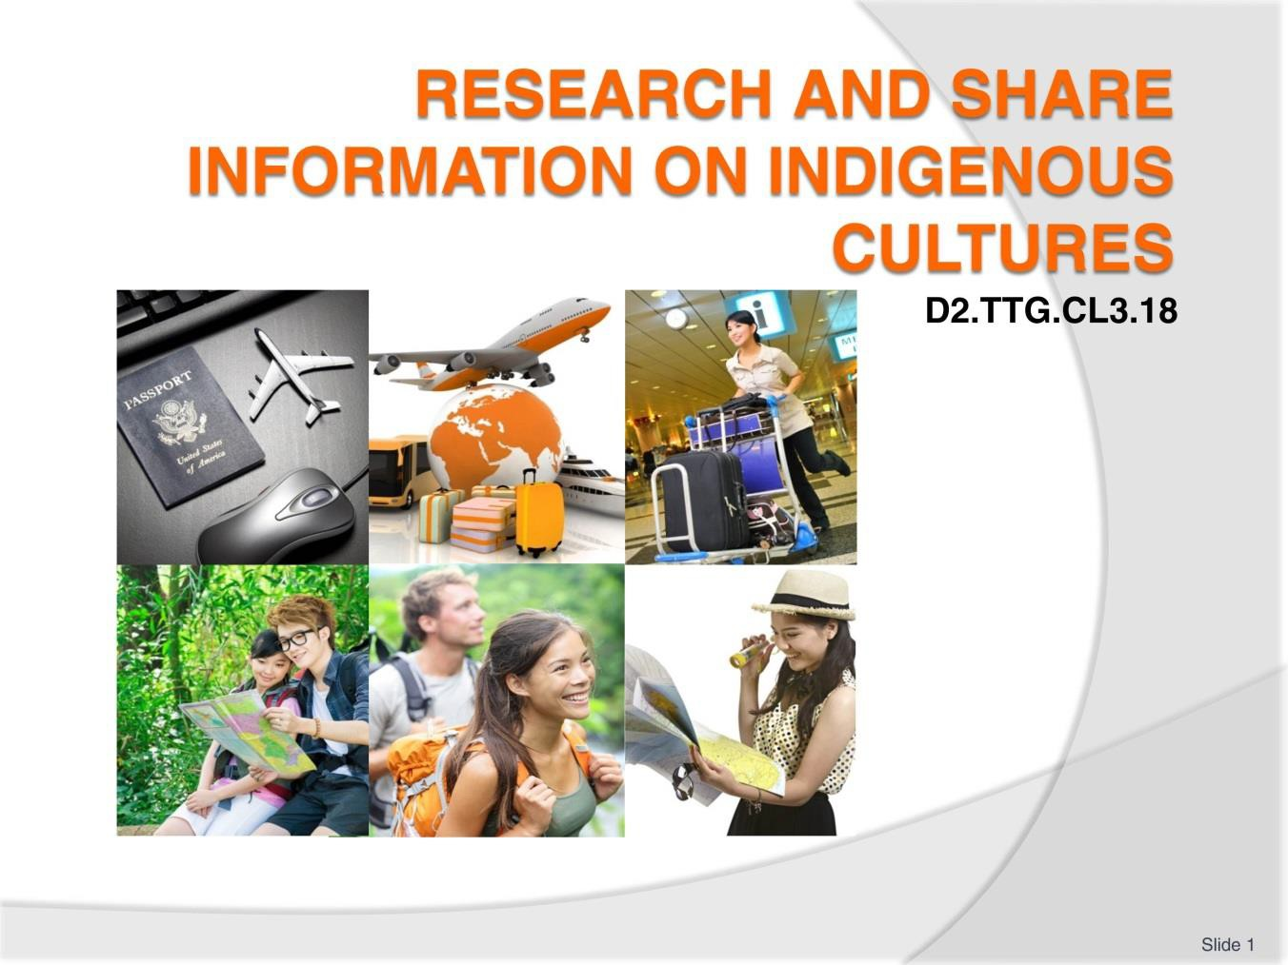
Slide
Slide No
Trainer Notes
1.
Trainer welcomes students to class.

Slide
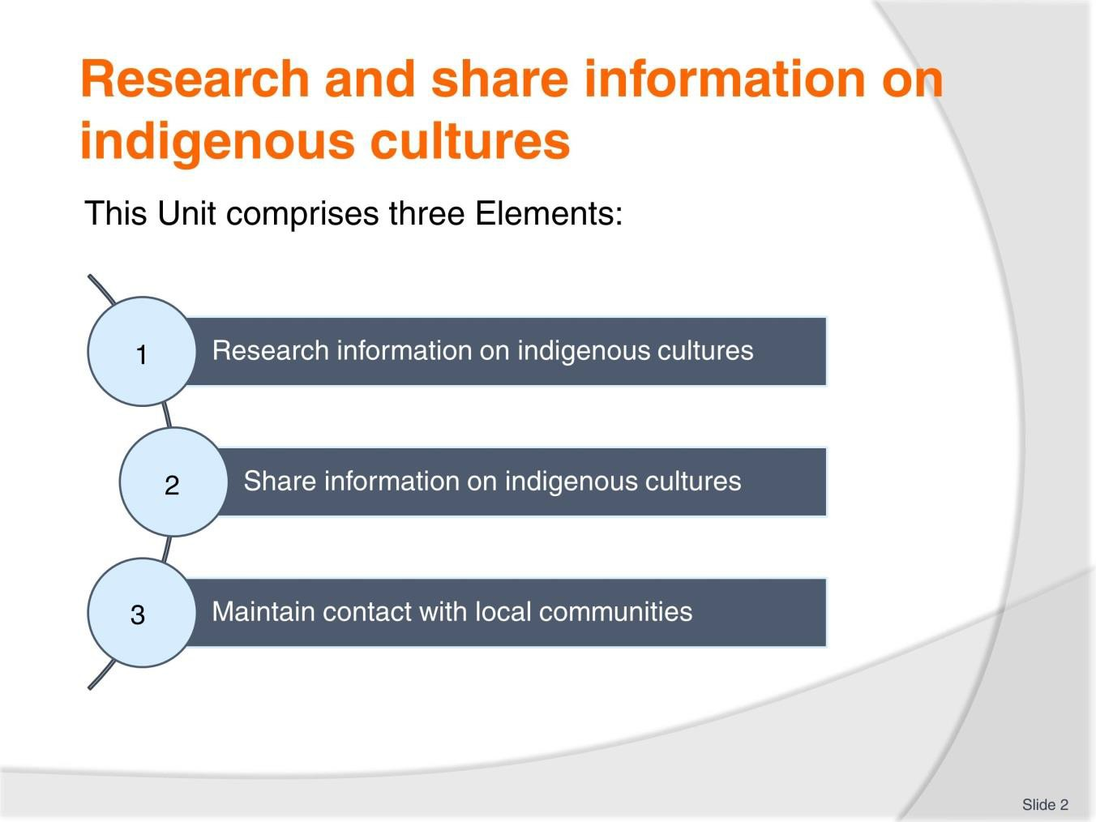
Slide No | Trainer Notes
2. | Trainer advises trainees this Unit comprises three Elements, as listed on the slide explaining:  - Each Element comprises a number of Performance Criteria which will be identified throughout the class and explained in detail  - Trainees can obtain more detail from their Trainee Manual  - At times the course presents advice and information about various protocols but where their workplace requirements differ to what is presented, the workplace practices and standards, as well as policies and procedures must be observed.

Slide
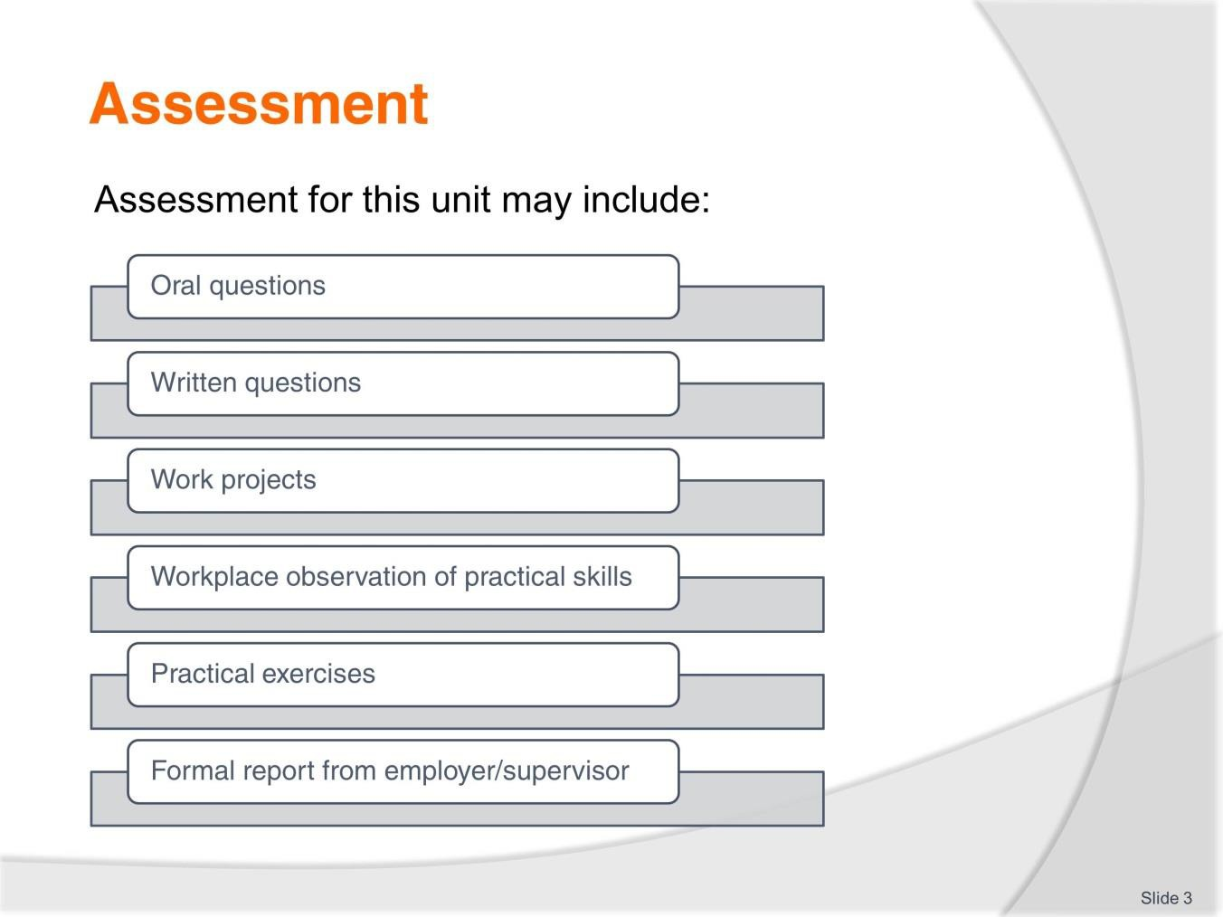
Slide No | Trainer Notes
3. | Trainer advises trainees that assessment for this Unit may take several forms, all of which are aimed at verifying they have achieved competency for the Unit as required.  Trainer indicates to trainees the methods of assessment that will be applied to them for this Unit.

Slide
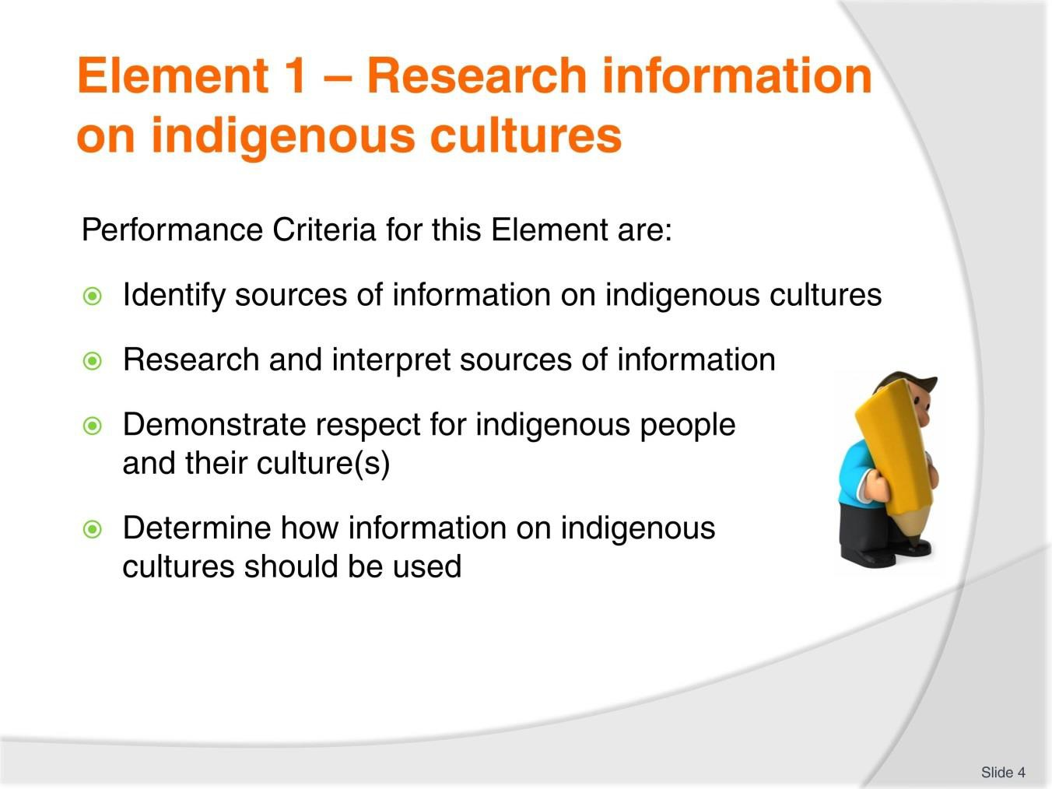
Slide No | Trainer Notes
4. | Trainer identifies for trainees the Performance Criteria for this Element, as listed on the slide.  Class Activity – General Discussion  Trainer leads a general class discussion by asking questions such as:  - What is ‘indigenous culture’?  - Why is it important to be able to provide it to tour groups?  - What issues need to be taken into account when researching information on indigenous cultures?  - What sources might be used to capture/gain information required?

Slide
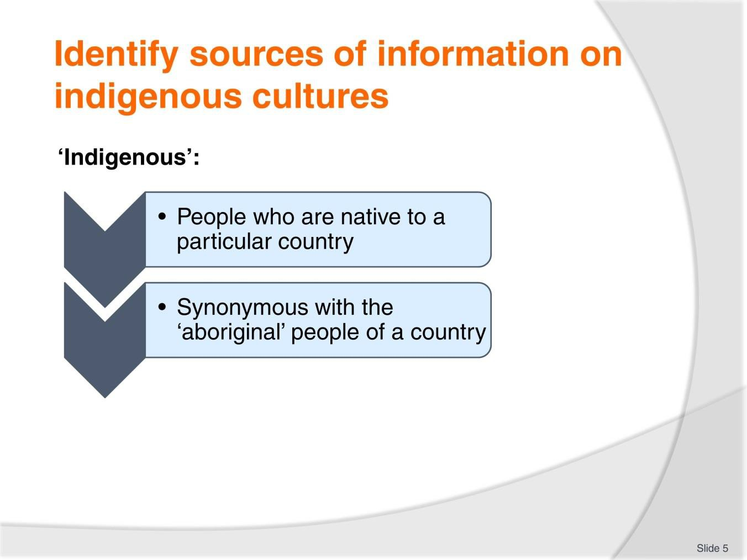
Slide No | Trainer Notes
5. | Trainer begins by introducing some basic terminology observing:  - Different business/operators may have their own interpretations of these terms – so it is important to determine definitions as they apply and as they are used in individual organisations  - There is always a need to determine the countries, cultures and communities a Tour Operator wants to investigate – because all research needs to have a specific target.  Indigenous  - There is sometimes confusion about exactly what the term ‘indigenous’ means  - In reality it has a very straight-forward definition  - It simply means people who are native to a particular country  - The term is synonymous with the ‘aboriginal’ people of a country.  Classroom Activity – Internet Research  Trainer facilitates research into and discuss about (sites such as):  http://www.iwgia.org/iwgia_files_publications_files/0511_ASEAN_BRIEFING_PAPER_e b.pdf - ASEAN’S Indigenous peoples.

Slide
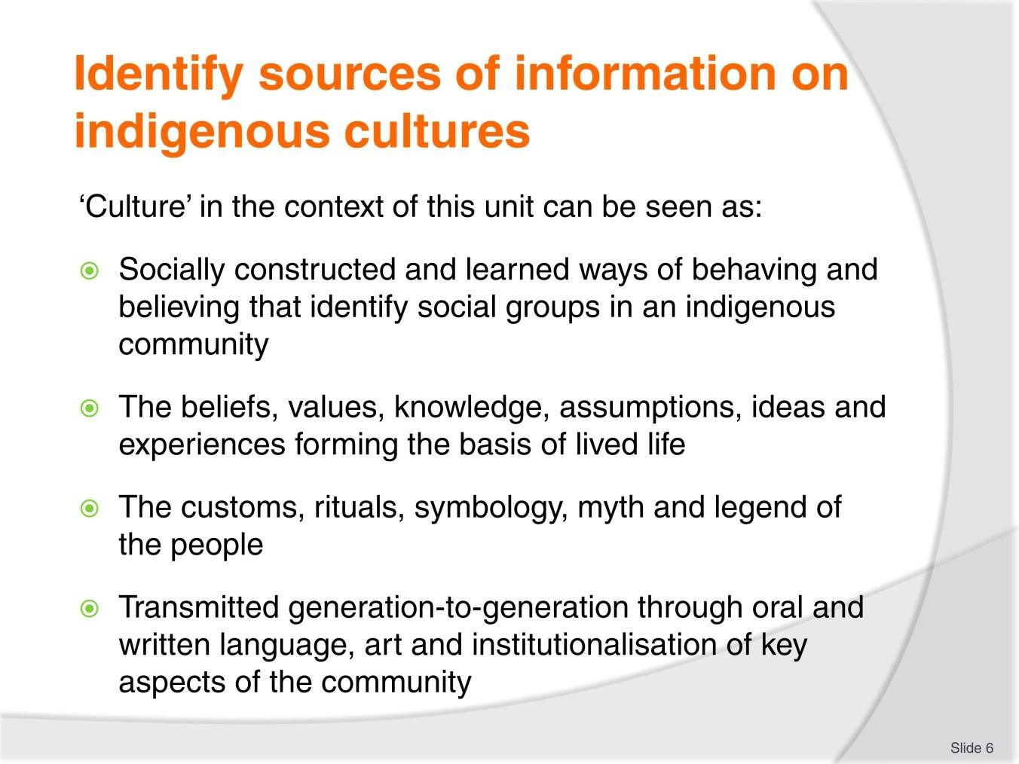
Slide No | Trainer Notes
6. | Trainer continues presenting basic unit-related definitions/terminology:  Culture/s  In the context of this unit culture/s can be seen as:  - The socially constructed and learned ways of behaving and believing that identify individual and distinct social groups such as an indigenous community  - The beliefs, values, knowledge, assumptions, experiences and ideas which form the basis of the way a community thinks, lives and acts  - The suite of customs, rituals, symbology, myth and legend of the people in the community  - Being transmitted/passed on to other generations through a combination of oral communication and writing (language), art (such as music, song, story-telling, painting and dance) and the institutionalisation of key aspects of the community (as this relates [for example] to social activity, economics, politics, agriculture and farming, industrialisation, laws and justice, security, health, the environment, education and religion).  Classroom Activity – Internet Research  Trainer facilitates research into and discuss about (sites such as):  http://www.austlii.edu.au/au/journals/ILB/2013/1.pdf - The ASEAN Human Rights Declaration and Indigenous Rights

Slide
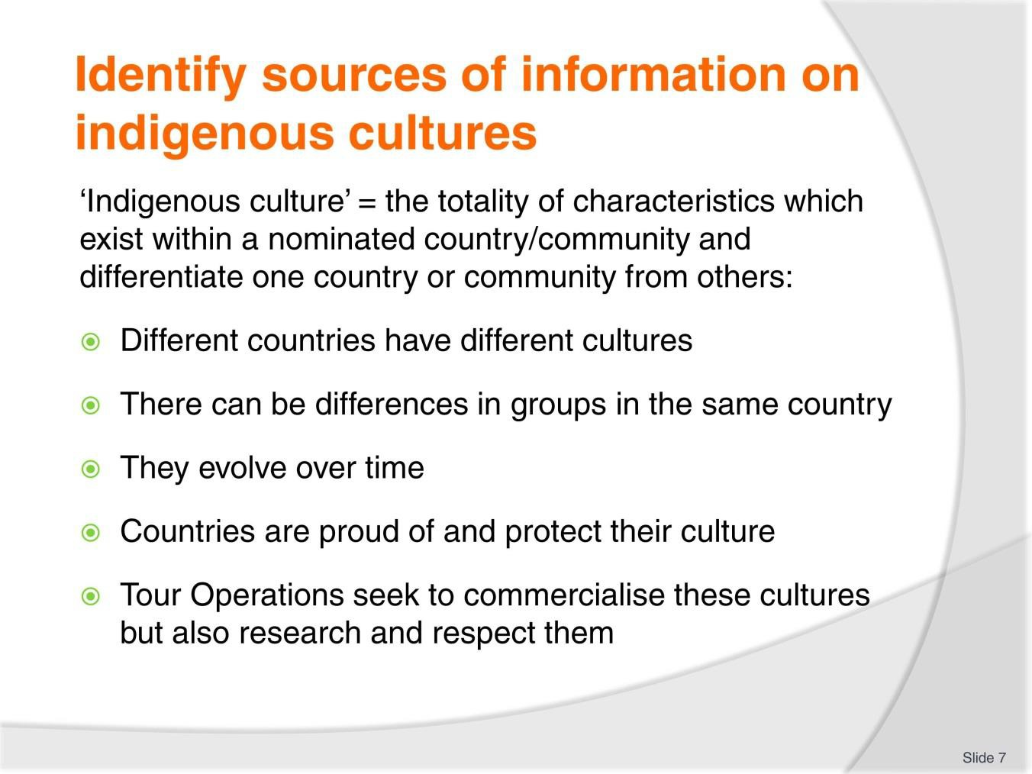
Slide No | Trainer Notes
7. | Trainer continues presenting basic unit-related definitions/terminology:  Indigenous culture  - Indigenous culture is the term used to describe the totality of characteristics which exist within a nominated country or community and differentiate one country or community from others.  In practice:  - There is commonly variations between the cultures of different countries – despite there often being several points of similarity  - Different cultures can exist within different communities/groups within the same nation/country  - Cultures of countries and communities evolve over time as they change to accommodate internal events and external pressures  - Countries and communities are proud and protective of their culture – regardless of how different they may be to the cultures of other countries and communities  - Enterprises (such as Tour Operators) are increasingly aware of:  - The commercial value of different indigenous cultures  - The need to research and share information on indigenous cultures in a respectful and sensitive manner.

Classroom Activity – Internet Research
Trainer facilitates research into and discuss about (sites such as):
http://www.iwgia.org/iwgia_files_publications_files/0657_indigenous_peoples_and_corp orate_accountability_in_the_ASEAN_compressed.pdf - Indigenous people’s and corporate accountability in the ASEAN: a report of the Asia Indigenous Peoples Pact.

Slide
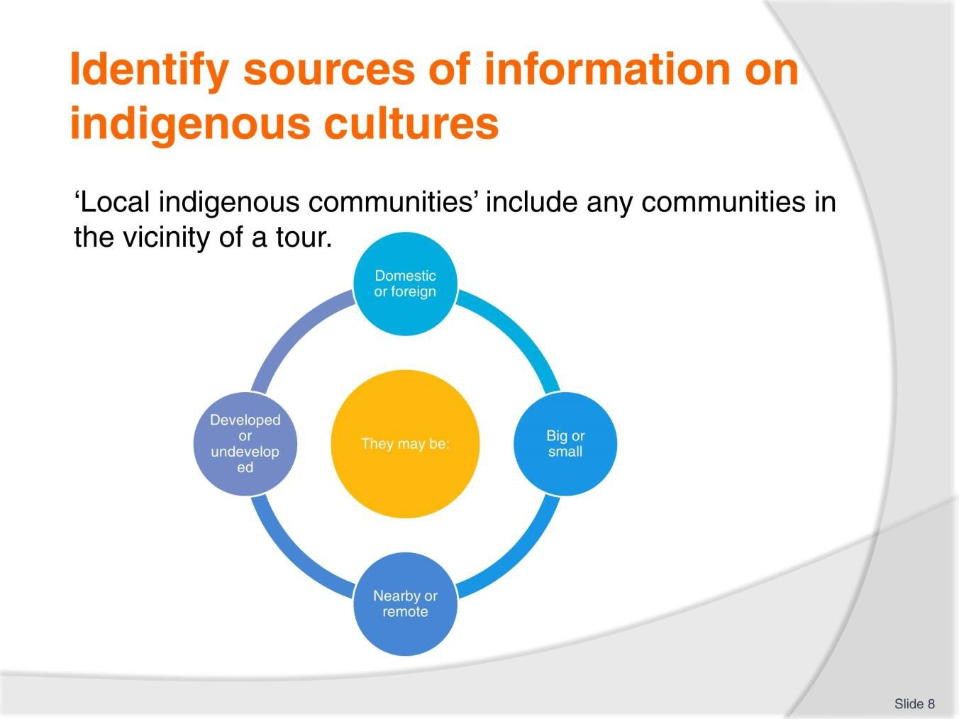
Slide No | Trainer Notes
8. | Trainer continues presenting basic unit-related definitions/terminology:  Local indigenous communities  Local indigenous communities may include any community that is in the vicinity of a tour group while the tour is being conducted.  The community may be:  - Domestic or foreign  - Small or large  - Nearby or remote  - Developed or undeveloped.  Classroom Activity – Internet Research  Trainer facilitates research into and discuss about (sites such as):  http://rio20.net/en/propuestas/statement-of-indigenous-peoples-and-ethnic-minorities- of-asean/ - Statement of Indigenous Peoples and Ethnic Minorities of ASEAN.

Slide
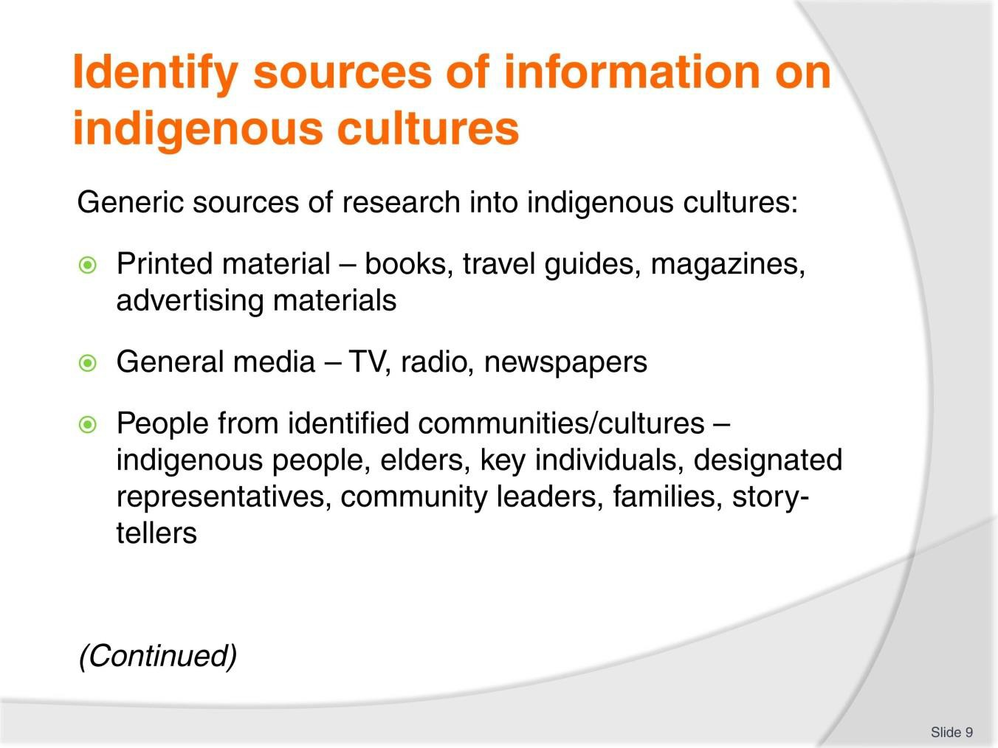
Slide No | Trainer Notes
9. | Trainer discusses possible sources of information for research on indigenous cultures identifying them as generically being:  - Printed material – such as:  - Books – which will include:  - Travel guides for the country in question  - Literature/texts on nominated countries and communities  - Magazines  - Advertising brochures and promotional materials  - The general media – domestic and as available in target destinations/communities (see later slides)  - Relevant people from identified communities – such as:  - The people of different cultures  - Elders  - Key individuals from within the community with specialist knowledge/expertise  - Community leaders within various cultures  - Families  - Story-tellers

Classroom Activity (1) – Samples
Trainer distributes and discusses a variety of printed material which may be a source of information on indigenous cultures.
Classroom Activity (2) – Guest Speaker/s
Trainer arranges for people as identified on the slide to attend and:
- Describe the role they can play in helping with research into indigenous cultures
- Provide sample information relating to cultures/communities to which they belong/whom they represent.

Slide
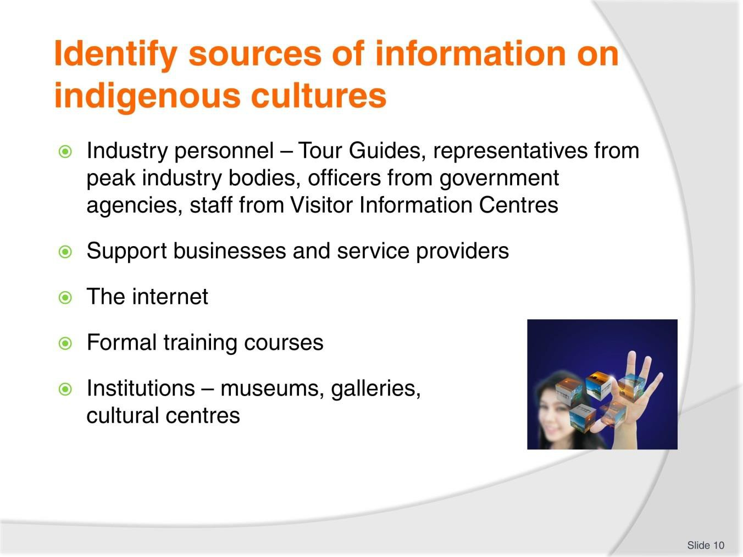
Slide No | Trainer Notes
10. | Trainer continues identifying generic sources of information on indigenous cultures:  - Industry personnel – such as:  - Other Tour Guides with specialised knowledge of different peoples and cultures  - Representatives from peak industry bodies – who often have a database of relevant information or who can provide the names of people who can be valuable sources  - Officers from the government bodies who have responsibility for Tourism, Culture, Trade or other related/associated matters  - Staff working in Visitor Information Centres of target countries/communities (where these exist) – as these venues are excellent sources of a wide range of information all available in the one location  - Support businesses and service providers – such as:  - Carriers – operating to and from the destination  - Accommodation providers – within the country/community  - The internet – which is an excellent multi-purpose tool (see later slides):  - Formal training courses – which can be useful for a range of reasons (see later slides)  - Institutions – such as:  - Museums, Galleries, Cultural centres.

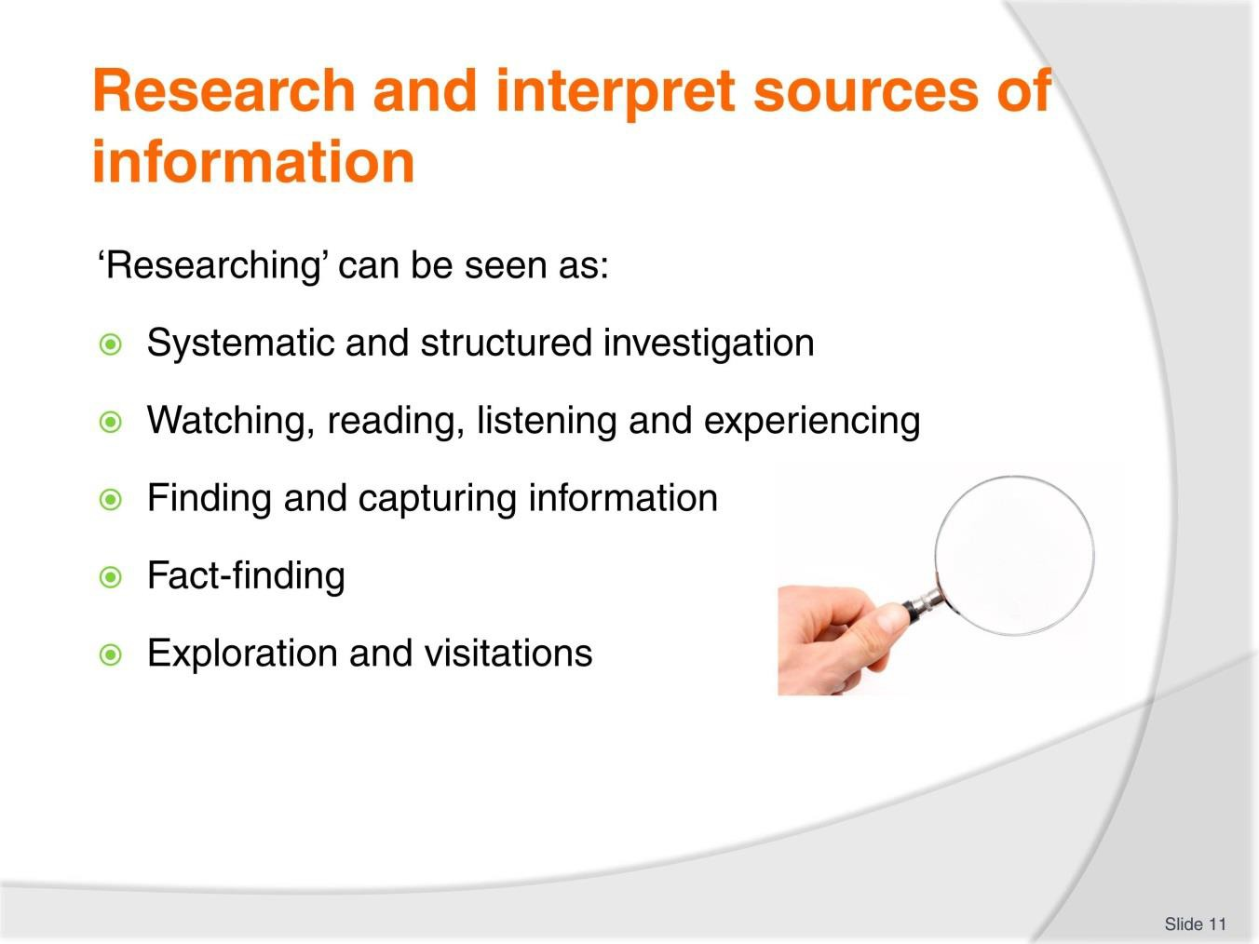
Slide
Slide No
Trainer Notes
11.
Trainer states in this context ‘researching’ can be seen as:
- Systematic and structured investigation
- Watching, reading, listening and experiencing
- Finding and capturing information
- Fact-finding
- Exploration and visitations.

Slide
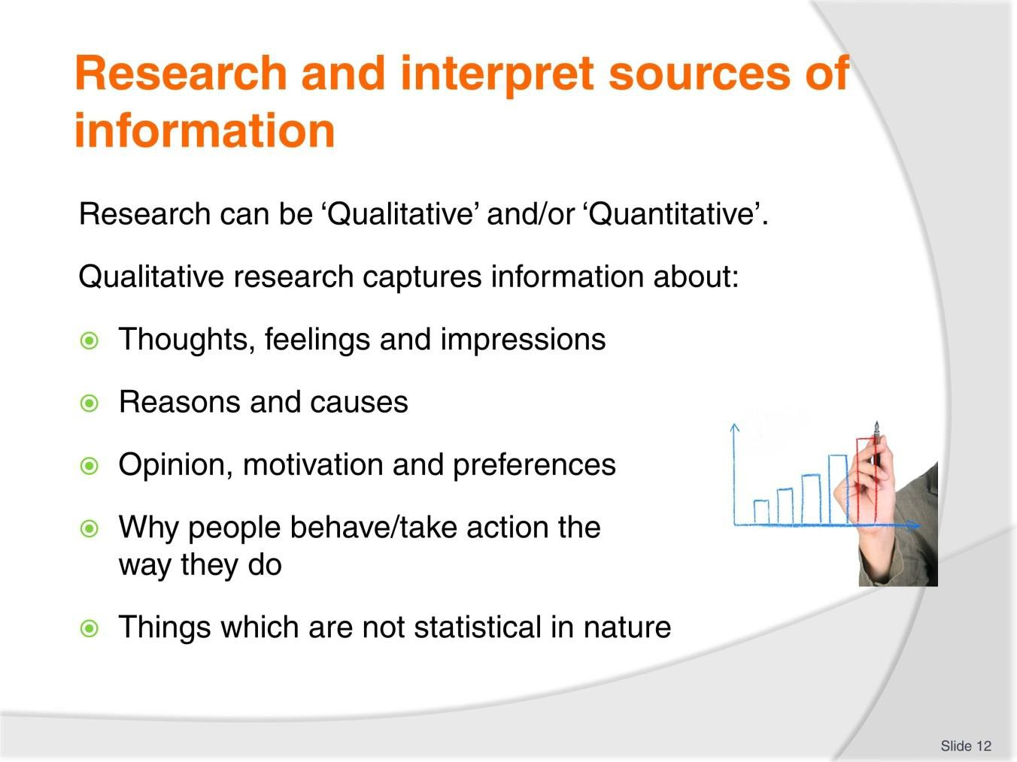
Slide No | Trainer Notes
12. | Trainer introduces ‘Qualitative research’ observing it is about capturing information relating to:  - Thoughts, feelings and impressions  - Reasons and causes  - Opinion, motivation and preferences  - Why people behave/take action the way they do  - Things which are not statistical in nature.

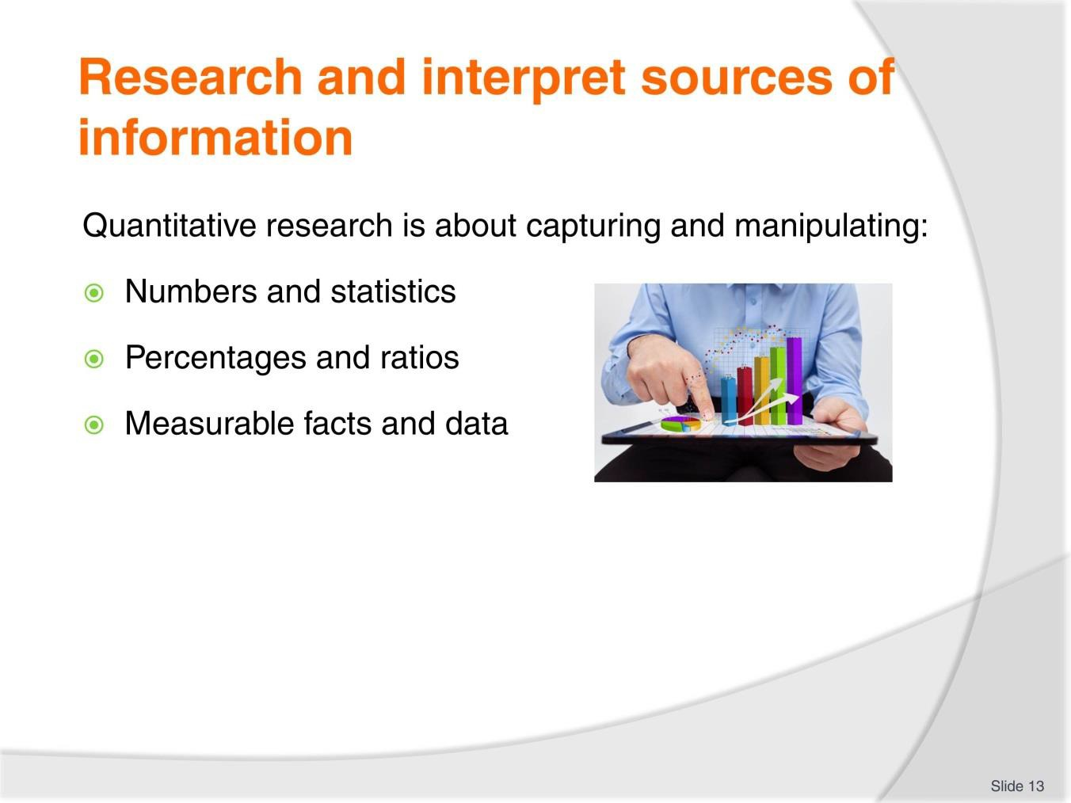
Slide
Slide No
Trainer Notes
13.
Trainer explains Quantitative research is about capturing and manipulating:
- Numbers and statistics
- Percentages and ratios
- Measurable facts and data.

Slide
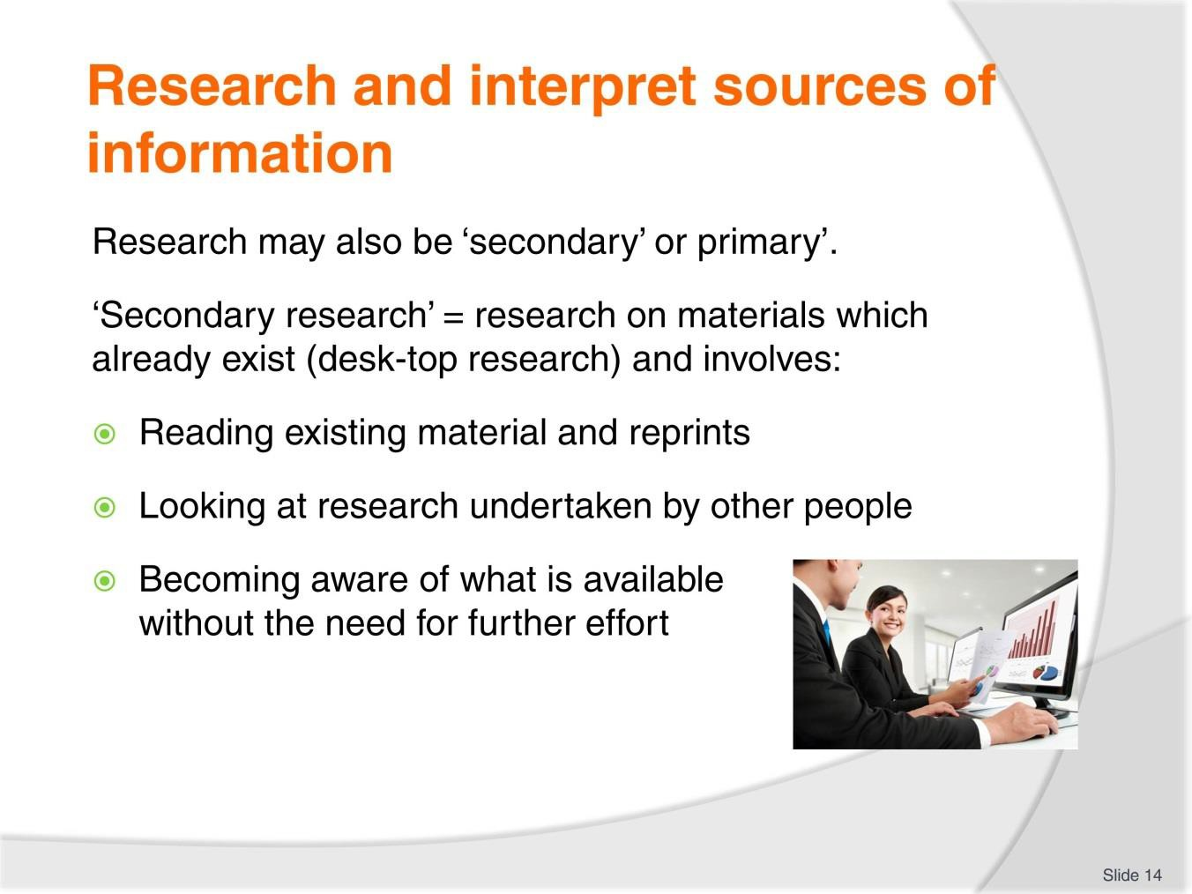
Slide No | Trainer Notes
14. | Trainer further explains research may be ‘secondary’ and/or ‘primary’.  Secondary research  Secondary research is research conducted using materials which already exist. It is essentially desk-top research involving:  - Reading existing material and reprints  - Looking at research undertaken by other people  - Becoming aware of what is available without the need for further effort.

Slide
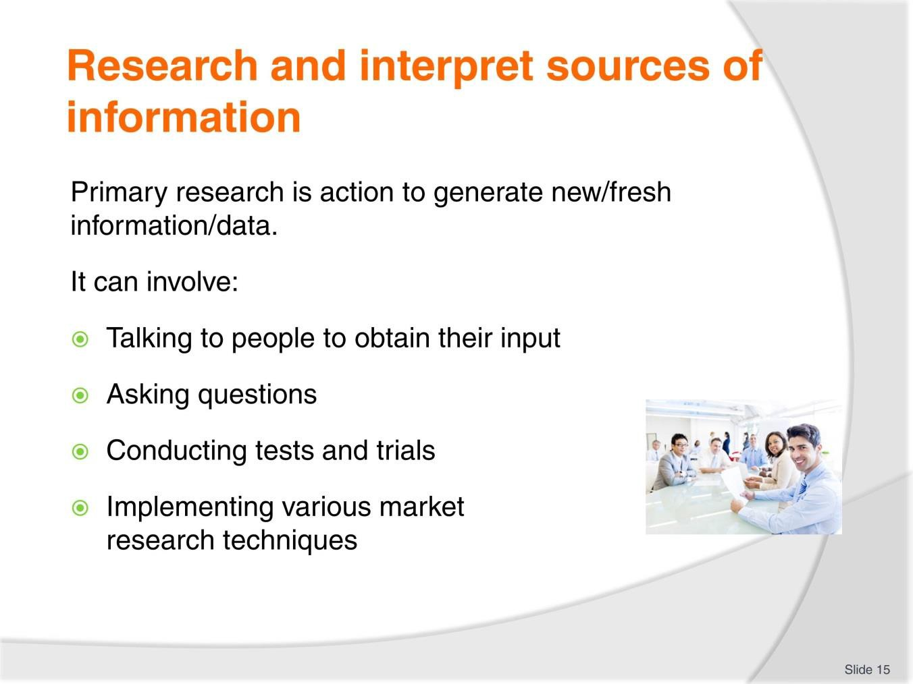
Slide No | Trainer Notes
15. | Trainer discusses primary research  Primary research  Primary research involves taking action to generate fresh/new research findings and information that has never been collected previously.  It can involve:  - Talking to people to obtain their input  - Asking questions  - Conducting tests and trials  - Implementing various market research techniques.

Slide
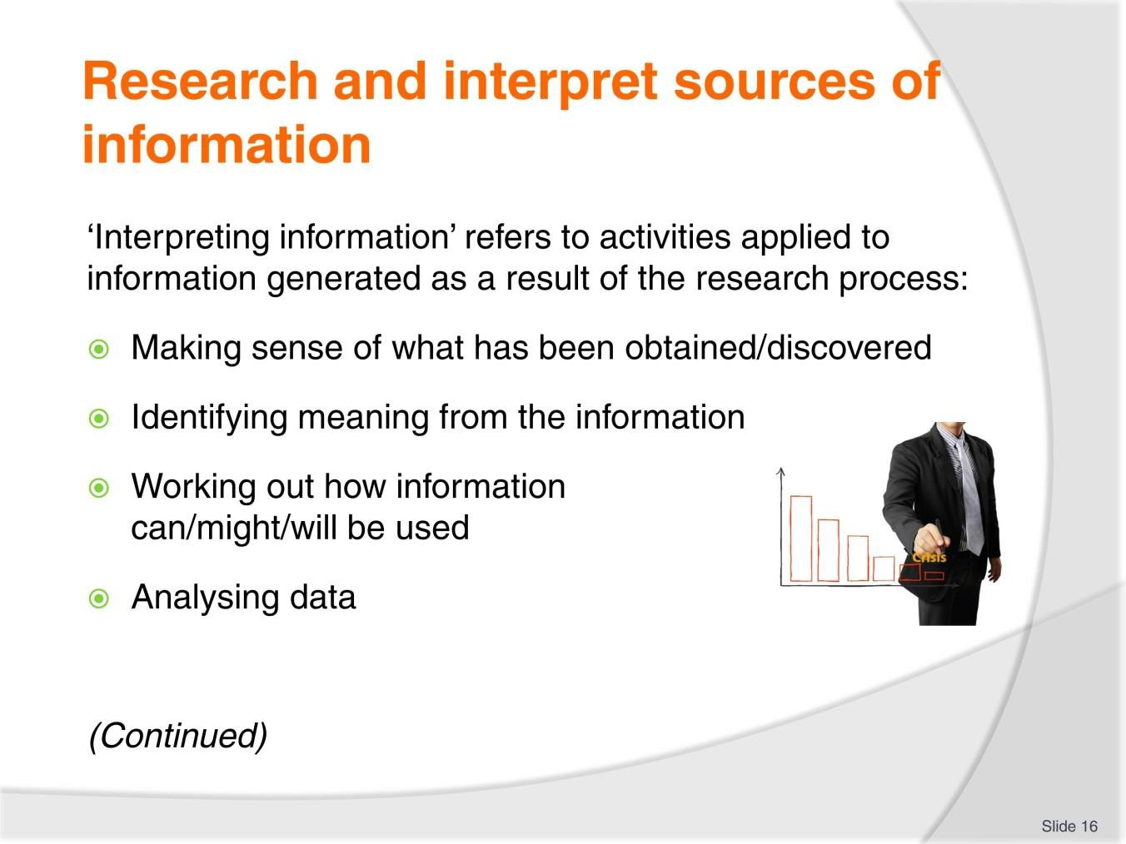
Slide No | Trainer Notes
16. | Trainer observes for the purposes of this unit ‘interpreting’ refers to activities applied to the material, data and information generated from the research process – such as:  - Making sense of what has been obtained/discovered  - Identifying meaning from the information  - Working out how information can/might/will be used  - Analysing data.

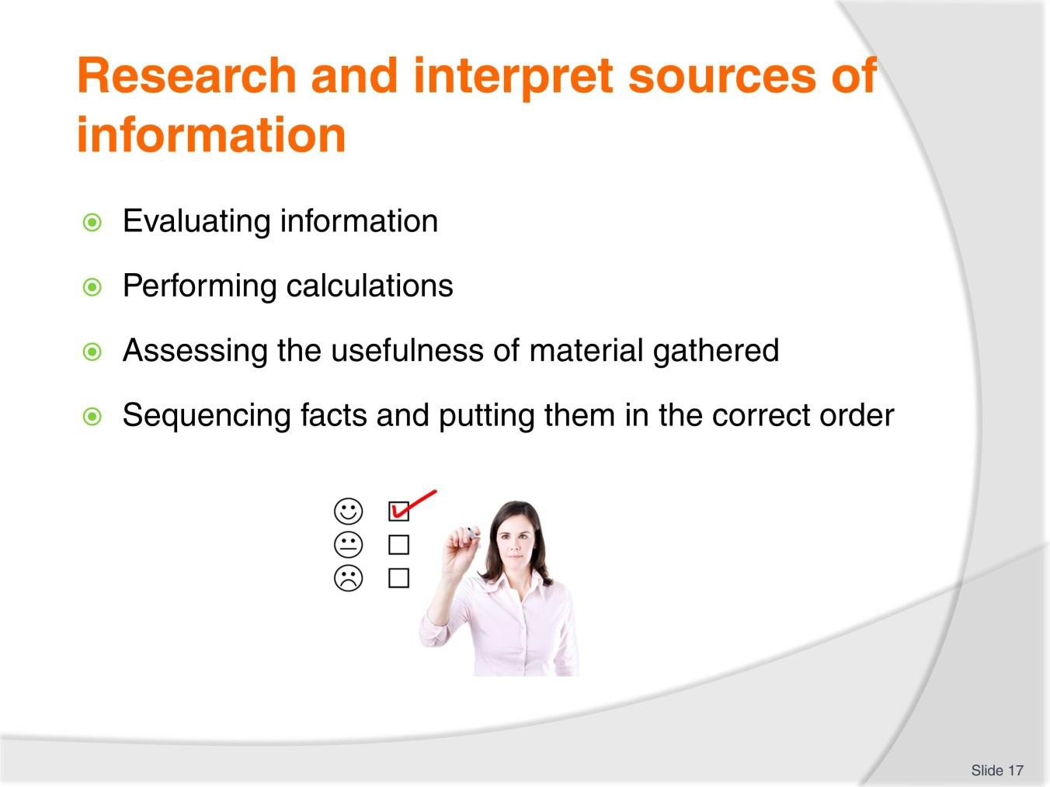
Slide
Slide No
Trainer Notes
17.
Trainer continues defining ’interpreting information stating it relates to:
- Evaluating information
- Performing calculations
- Assessing the usefulness of material gathered
- Sequencing facts and putting them in the correct order.

Slide
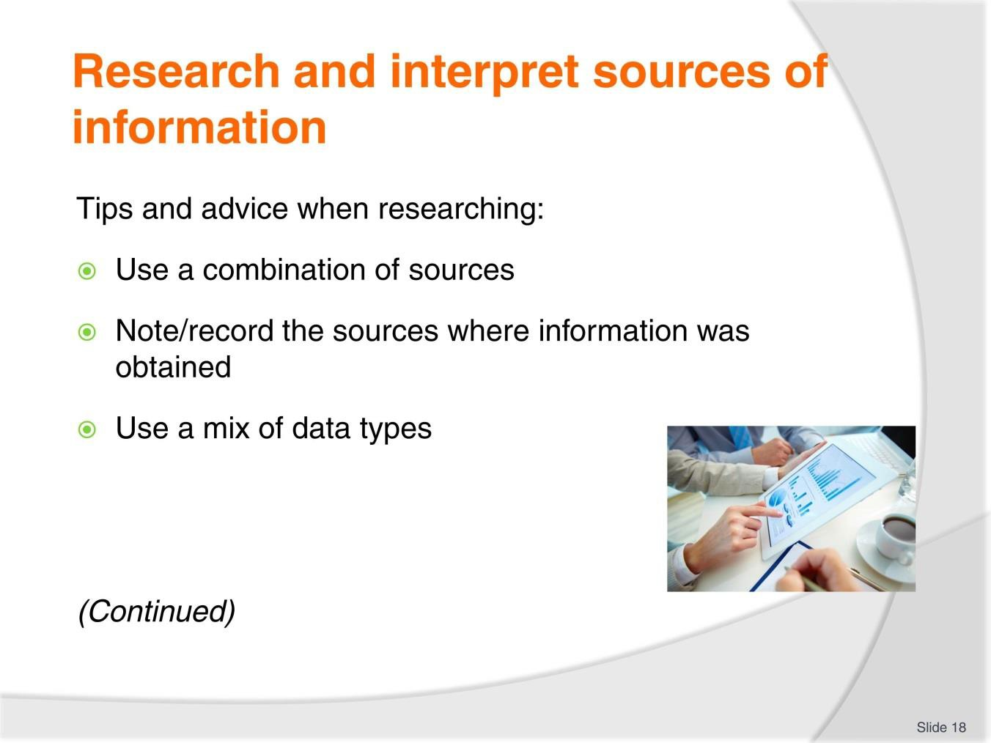
Slide No | Trainer Notes
18. | Trainer gives tips and advice when research observing the following have emerged as useful points to observe when researching:  - It is always best to use a combination of sources to generate research data when researching any aspect of indigenous culture – as opposed to relying on just one source  - Always note/record the sources used to capture information – in order the source may be:  - Cited/quoted if required  - Re-visited as and when necessary to check facts and figures, and/or obtain further information  - Use a mix of research data types – in terms of:  - Qualitative and quantitative research  - Primary and secondary research options.

Slide
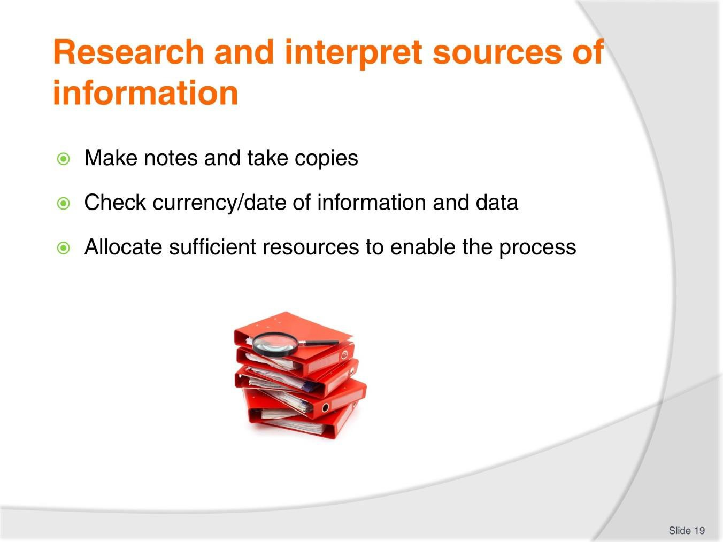
Slide No | Trainer Notes
19. | Trainer continues giving tips and advice on researching:  - Make notes, obtain copies or capture images when researching – so they can form the basis of the materials which will be generated:  - Never rely solely on memory  - Check the currency of the materials used as the basis for research – it is not essential for all materials to be ‘the latest’ but it is imperative researchers understand the time/year those materials were generated in order to:  - Give context to the information  - Indicate whether more current materials might exist  - Determine whether the information sourced can/should be used  - The research process can be a complex activity and it needs to be properly resourced – this means there is a need to:  - Allocate sufficient time to the research – research needs to begin well in advance of the need to use/share the material generated by the process  - Allocate sufficient funds – for meetings, travel, purchase of source materials. preparation of materials to be shared with tour group members  - Allocate sufficient staff to undertake all the research and associated activities – such as meetings, reading, preparation of draft materials for sharing, reviewing and revising draft materials.

Slide
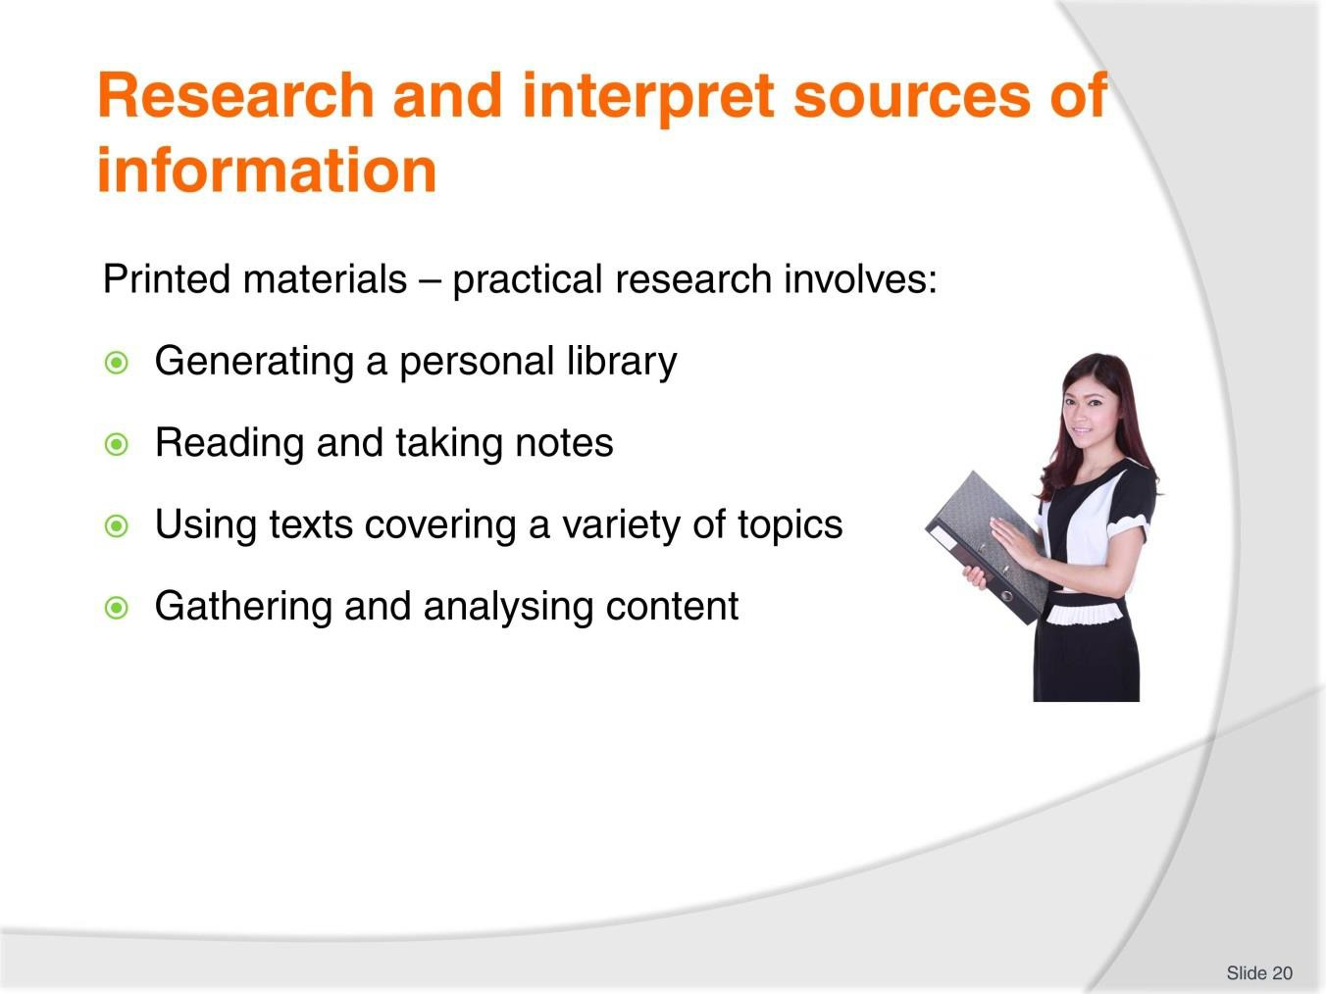
Slide No | Trainer Notes
20. | Trainer discusses using identified sources on indigenous cultures:  Printed material  Practical research requires:  - Generating a personal library of reference material – which:  - Grows over time; Is available to all those who need it; Should be managed/classified to facilitate access to information which may be needed from time-to-tome  - Obtaining, reading and taking notes from a range of travel guides for the identified indigenous cultures:  - Popular travel guides are those by Fodor’s, Lonely Planet and Frommer’s but others also exist  - Obtaining, reading and taking notes from a range of literature/texts – on generic topics such as:  - History; Science; Anthropology; Geography

- Obtaining, reading and taking notes from a range of magazines – which may include;
  - Articles from general-purpose/circulation publications
  - Travel and tourism-specific magazines
- Gathering and analysing the material contained in advertising brochures and promotional materials – generated by other operators and commercial enterprises.
Classroom Activity (1) – Handouts
Trainer distributes and discusses examples of brand name ‘Travel Guide’ books (such as Fodor’s, Lonely Planet and Frommer’s).
Classroom Activity (2) – Exercise
Trainer provides students with printed material and gives them a research task to perform using those resources/sources.

Slide
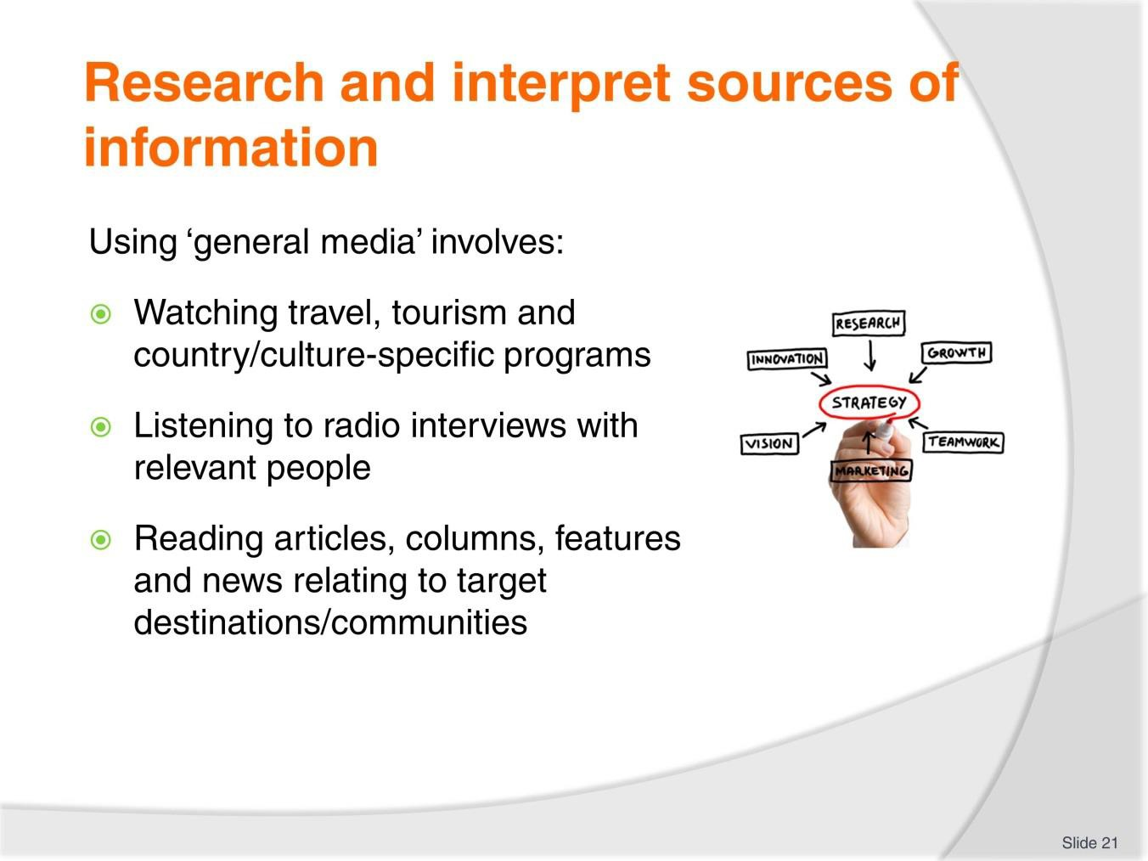
Slide No | Trainer Notes
21. | Trainer continues to discuss using identified sources on indigenous cultures:  The general media  Research involving the general media can involve:  - Watching television programmes and documentaries relating to:  - Travel and tourism  - Target countries and cultures  - Certain aspects of interest relating to identified communities  - Listening to radio interviews – which feature:  - Indigenous peoples  - Community leaders  - Tour Operators and Tour Guides  - Tourists who have been to target destinations  - Reading culture- and indigenous community-related articles contained in the Travel and Tourism section (or features) of newspapers – these may be:  - Regular columns by reporters and travellers who have visited target destinations

- Special (or ‘feature’) reports which occur from time-to-time on a range of different countries
- Articles by industry bodies and/or government authorities on certain aspects of countries, communities or cultures.
Classroom Activity – Exercise
Trainer provides students with media-based resources/source materials and gives them a research task to perform using those resources/sources.

Slide
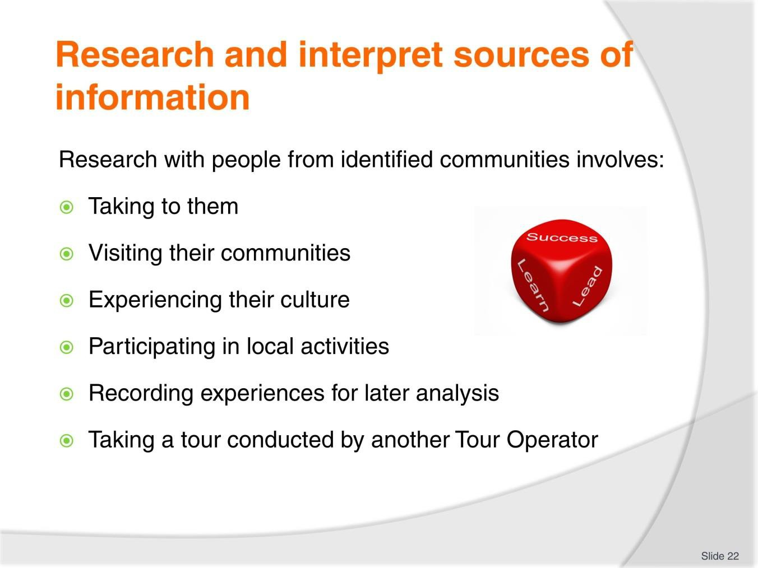
Slide No | Trainer Notes
22. | Trainer continues to discuss using identified sources on indigenous cultures:  People from identified communities  Research activities involving people from identified communities may involve:  - Meeting with them  - Taking to them  - Visiting their communities  - Experiencing their culture  - Participating in local activities  - Recording personal experiences for later analysis/interpretation  - Taking a tour to a target destination as a tourist on a tour conducted by another Tour Operator.  Classroom Activity – Guest Speaker/s  Trainer arranges for people as identified on the slide to attend and:  - Describe the role they can play in helping with research into indigenous cultures  - Provide sample information relating to cultures/communities to which they belong/whom they represent.

Slide
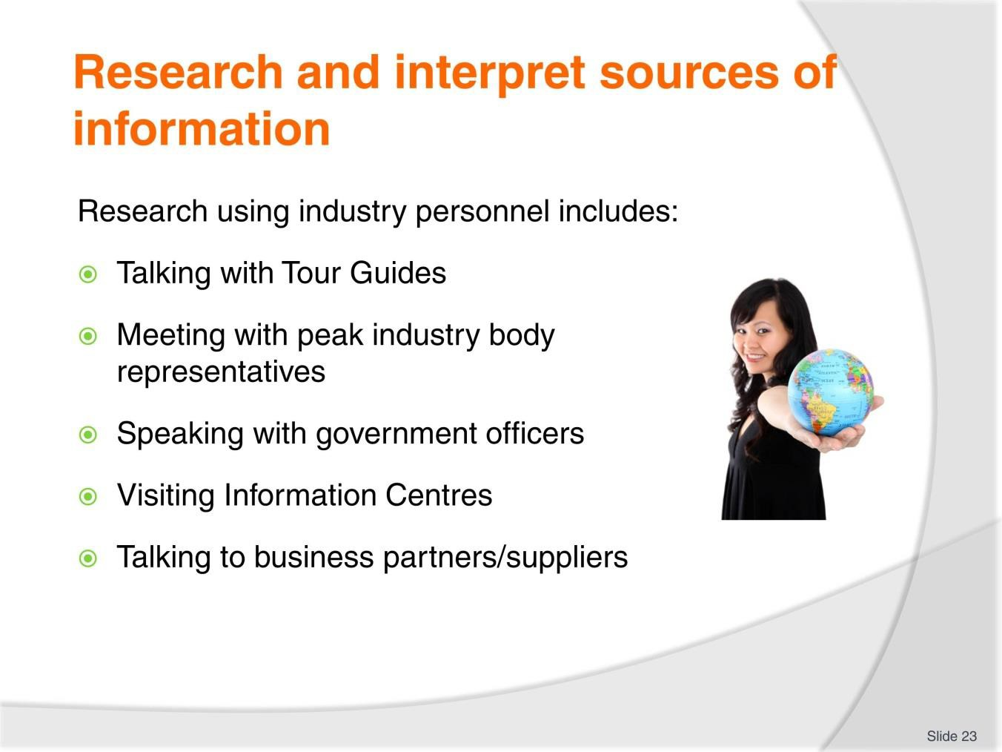
Slide No | Trainer Notes
23. | Trainer continues to discuss using identified sources on indigenous cultures:  Industry personnel  Research activities involving industry personnel can entail:  - Talking with Tour Guides – particularly those who have experience/specialised knowledge of different peoples and cultures  - Meeting with representatives from peak industry bodies – to capture information and ‘contact persons/points’  - Speaking with officers from government agencies/authorities – with responsibility for Tourism, Culture, Trade or other related/associated matters and are often able to provide:  - Valuable statistical information  - Details of any plans and proposals relating to the target destination  - Details of schemes/incentives to encourage and support tourism activities in/to target destinations.  - Visiting Visitor Information centres of target countries/communities (where these exist) – in order to:  - Talk to Information Officers  - Obtain hard copy, take-away promotional materials produced by local Tour Operators

- Obtain documentation available from other Tour Operators relating to operational matters – such as sample itineraries, fees and charges, tour schedules, terms and conditions
- Visiting and or talking to support businesses and service providers – to:
  - Gain an idea of products/services available to support/enable tours/activities in the destinations
  - Gauge cost/prices of materials being sold
  - Determine attitude of third party providers towards tourism initiatives into their area
  - Learn about and from their previous experience with Tour Operators and what they have done right and/or wrong in relation to the country/community.
Classroom Activity – Guest Speaker/s
Trainer arranges for people as identified on the slide to attend and:
- Describe the role they can play in helping with research into indigenous cultures
- Provide sample information relating to cultures/communities to which they belong/whom they represent.

Slide
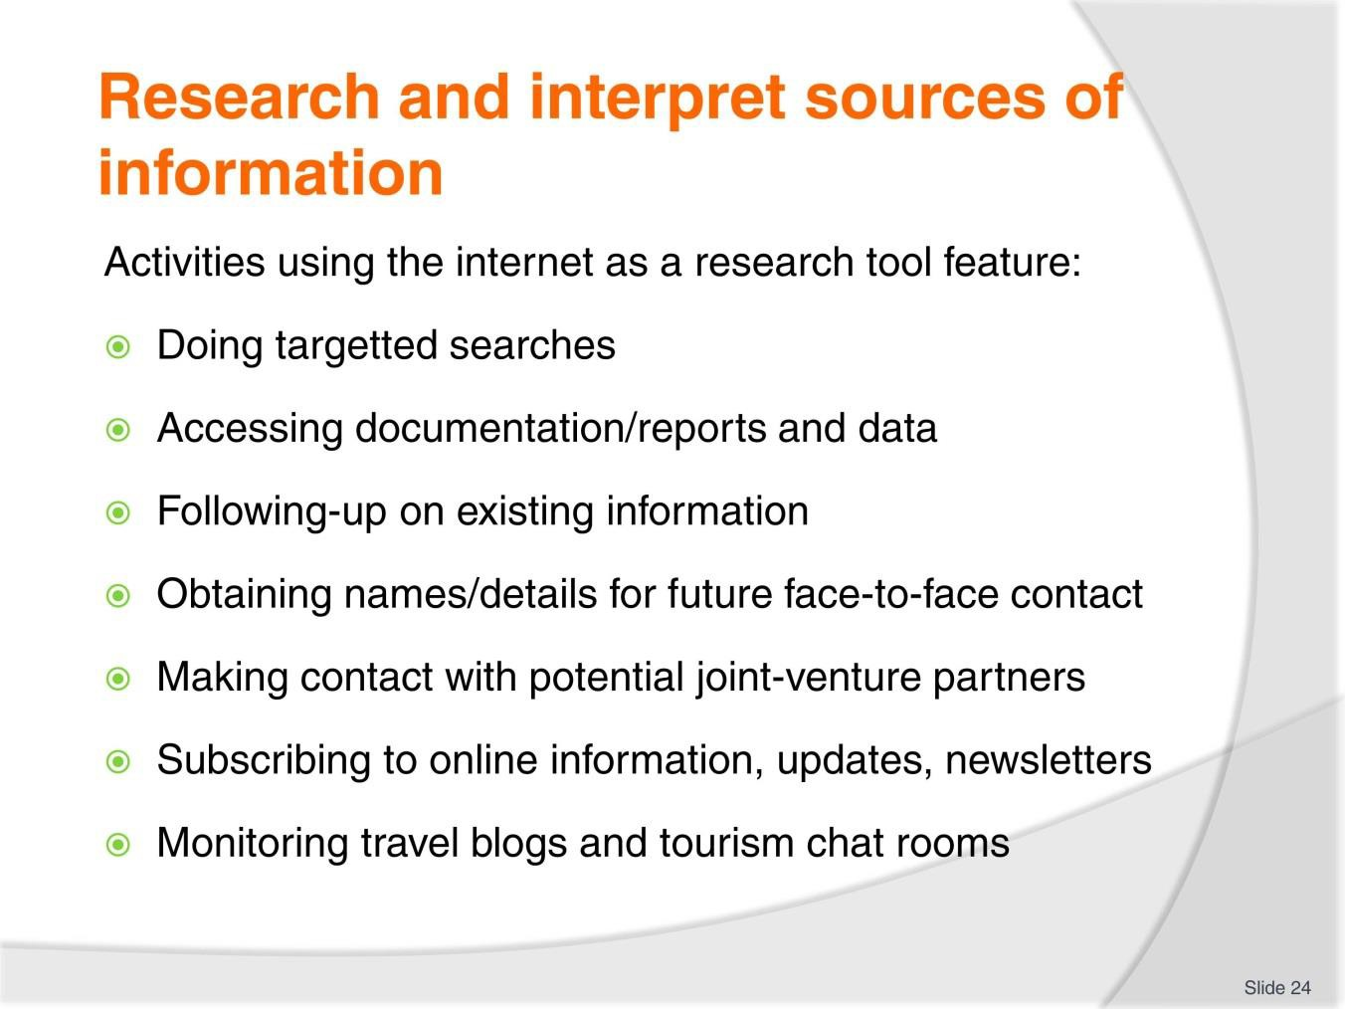
Slide No | Trainer Notes
24. | Trainer continues to discuss using identified sources on indigenous cultures:  The internet  Using the internet as part of the desk-top research component of the process can involve:  - Undertaking targeted searches – on destinations, required aspects (as identified as being the focus for planned tours, activities and inclusions)  - Accessing publicly listed/released reports and documentation – as prepared by (for example) government agencies and industry bodies  - Following-up and gaining additional material on knowledge already obtained from other sources  - Obtaining names of people, places and businesses for subsequent personal/face- to-face contact  - Making contact with potential joint-venture partners  - Subscribing to relevant online newsletters and email alerts  - Monitoring relevant travel and tourism blogs and discussion forums/chat rooms.  Classroom Activity – Exercise  Trainer provides students with a research objective/task and provides access to the internet to enable them to research this topic.

Slide
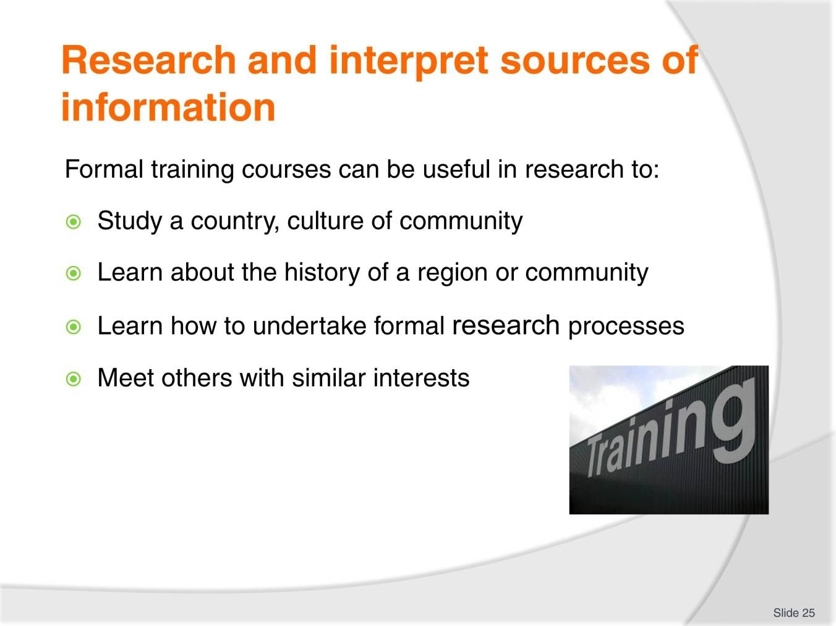
Slide No | Trainer Notes
25. | Trainer continues to discuss using identified sources on indigenous cultures:  Formal training courses  Formal training courses can be useful to:  - Study a country, culture of community  - Learn about the history of a region or community  - Learn how to undertake formal research processes  - Meet others with similar interests.  Classroom Activity – Guest Speaker/s  Trainer arranges for representative from local training institution to attend and:  - Discuss courses available to assist with research  - Describe study options  - Explain costs  - Provide pamphlets.

Slide
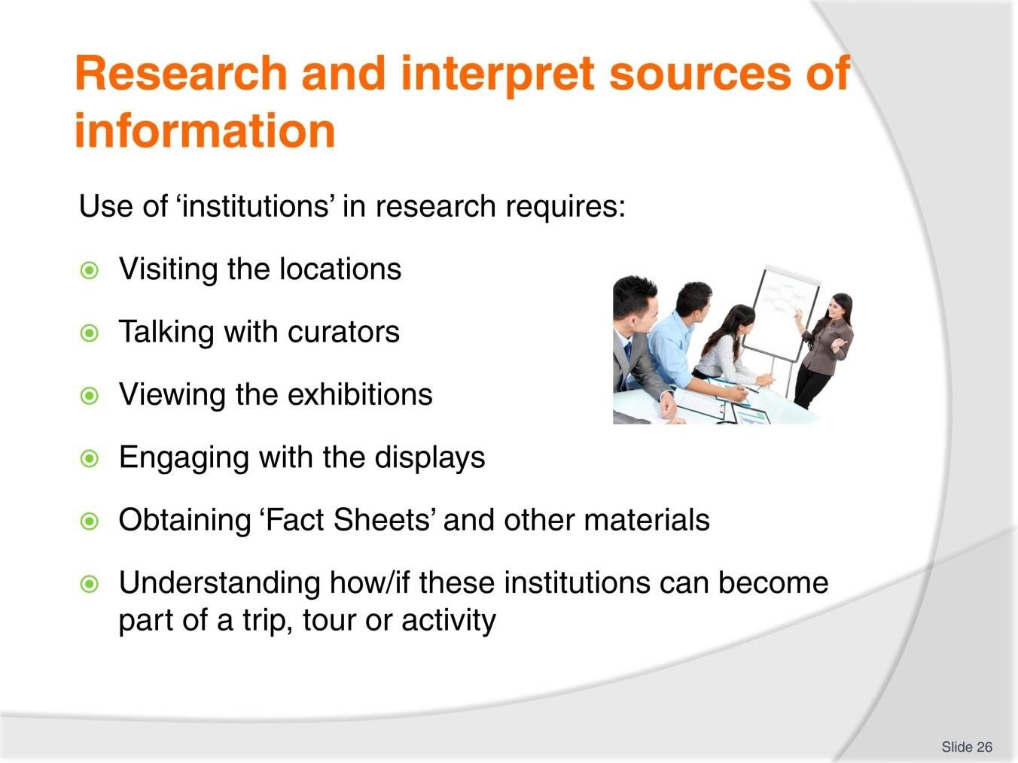
Slide No | Trainer Notes
26. | Trainer continues to discuss using identified sources on indigenous cultures:  Institutions  Using institutions as part of the research process generally requires:  - Visiting the locations  - Talking with curators  - Viewing the exhibitions  - Engaging with the displays  - Obtaining ‘Fact Sheets’ and other materials distributed to visitors  - Understanding how/if these institutions can become part of a trip, tour or activity.  Classroom Activity (1) – Guest Speaker/s  Trainer arranges for representatives from local ‘institutions’ to attend and:  - Describe their capacity to support relevant research  - Explain how their institution might be part of a local tour/activity  - Provide sample Facts Sheets.

Classroom Activity (2) – Excursion
Trainer arranges for students to visit a local ‘institution’ and:
- View facilities
- Talk to curators
- Identify their role in supporting relevant research
- Obtain information sheets and similar.

Slide
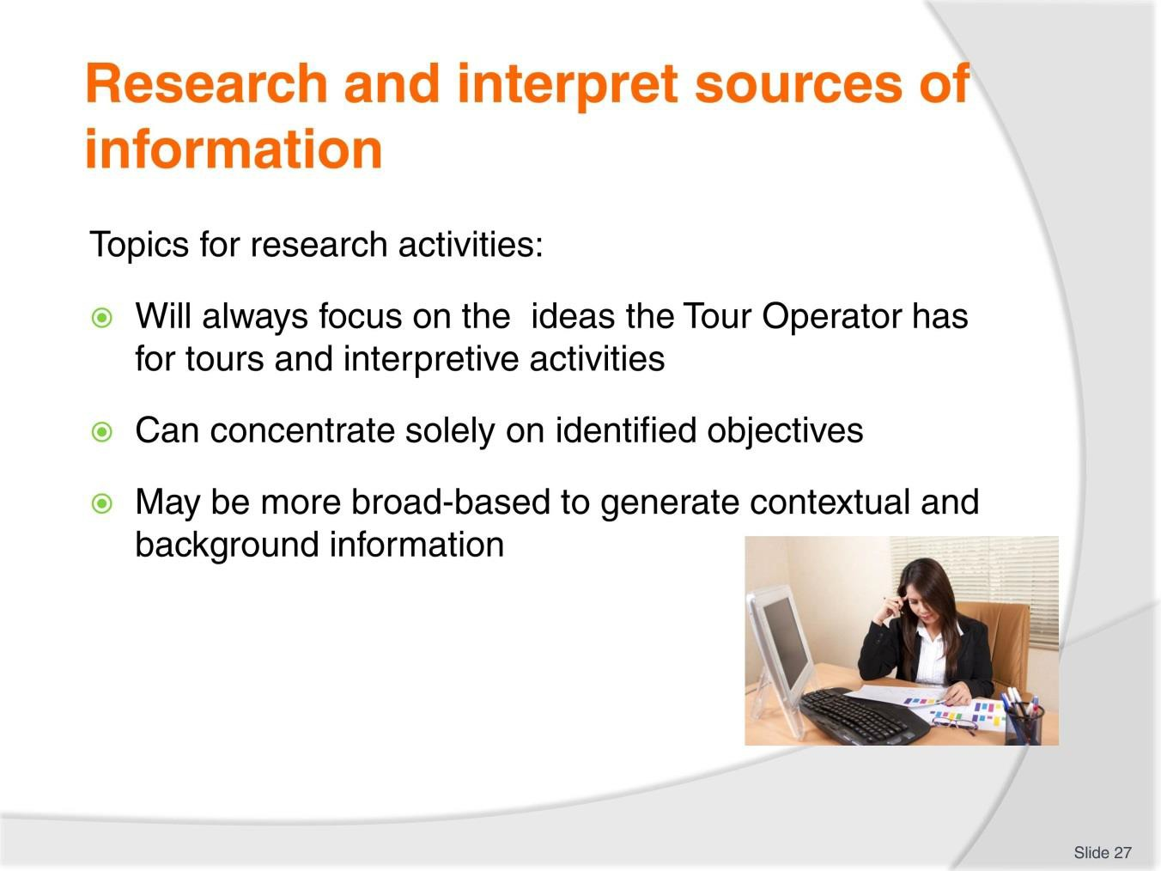
Slide No | Trainer Notes
27. | Trainer introduces range of topics which might be the focus of research explaining:  - The research being conducted will always focus on the ideas a Tour Operator has regarding proposed tours and activities  - In many cases, this will be the sole focus of the research and interpretation processes.

Slide
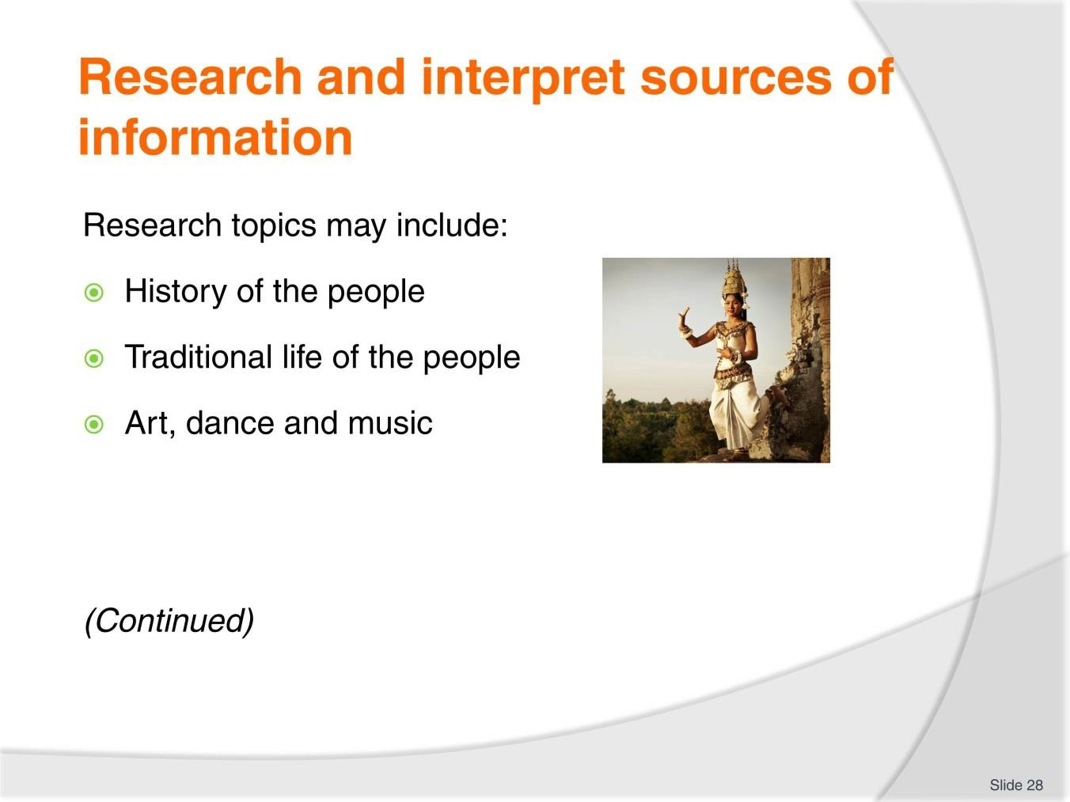
Slide No | Trainer Notes
28. | Trainer presents possible research topics:  - History of the people – which can be divided into different sections as appropriate to the country and the plans of the Tour Operator. Two commonly used divisions are:  - Time before contact with western or other cultures and societies  - Time after the above contact  - The traditional life of the people – including reference to:  - Customs, tools and practices  - The family unit  - Community life  - The unique nature of the culture/community  - Contrast with their contemporary life  - Art, dance and music – which can address:  - The different types of art practices by the people including materials and instruments used  - Examples of work produced  - Reasons why art, dance and music was produced  - Role of same in community life.

Classroom Activity – Individual/Small Group Exercise
Trainer or students select a country/culture/community and conducts research on this target destination using the topics listed on the slide.

Slide
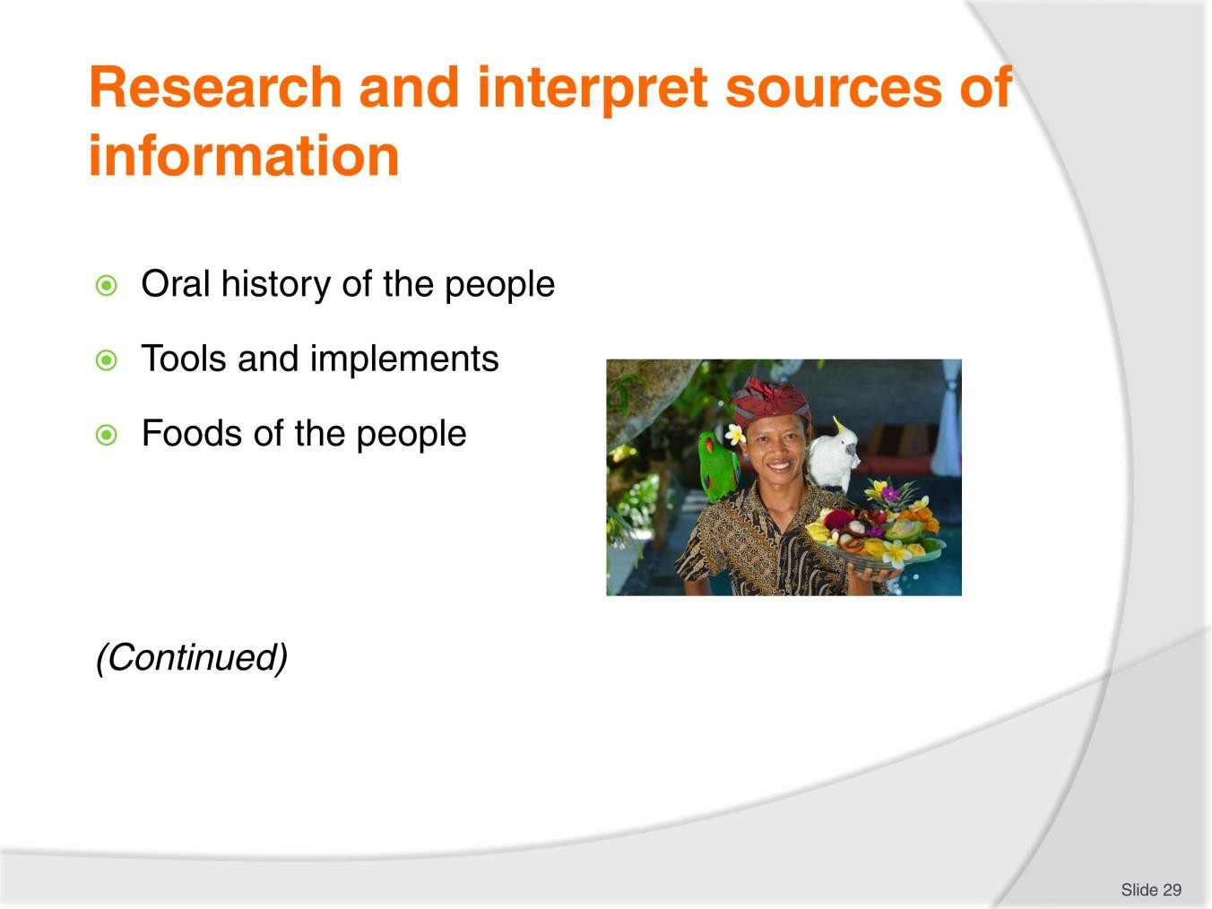
Slide No | Trainer Notes
29. | Trainer continues to present possible research topics:  - Oral history of the people – in terms of process and content with reference to:  - Story telling  - Legends  - Myths  - Tools and implements – used for:  - Day-to-day living  - Farming and agriculture  - Warfare  - Foods of the people – including coverage of:  - Items and ingredients  - Cooking processes and practices/dishes prepared  - Beverages.

Classroom Activity (1) – Individual/Small Group Exercise
Trainer or students select a country/culture/community and conducts research on this target destination using the topics listed on the slide.
Note:
- This Activity may flow from the previous one or be separate to it
- This Activity may be part of the Work Project requirements for the unit.
Classroom Activity (2) – Internet Research
Trainer facilitates research into and discuss about (sites such as): http://en.wikipedia.org/wiki/Primary_research - Primary research. http://en.wikipedia.org/wiki/Secondary_research - Secondary research.
https://explorable.com/quantitative-and-qualitative-research - Quantitative and qualitative research.

Slide
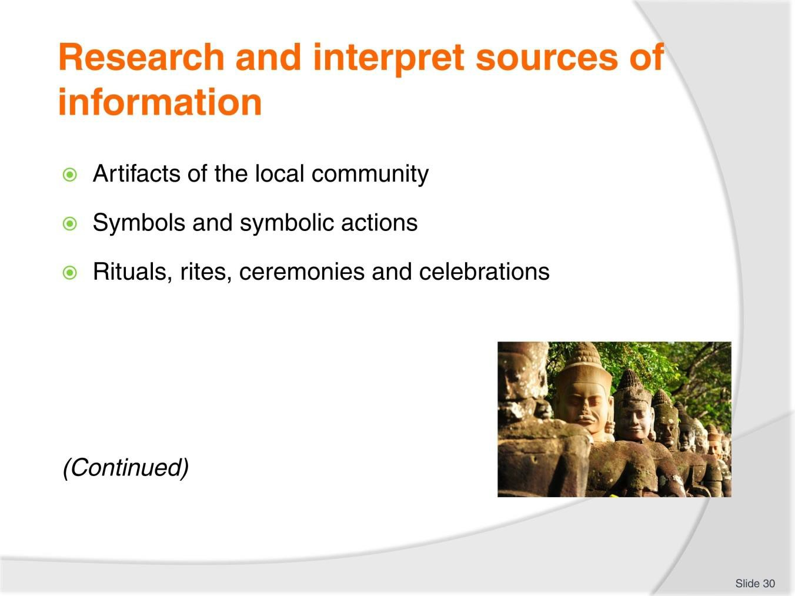
Slide No | Trainer Notes
30. | Trainer continues to present possible research topics:  - Artefacts of the local community – these can be:  - Items made by the people that have cultural significance  - Things produced locally which are of local uniqueness  - Items of historical significance  - Symbols and symbolic actions of the people – with reference to:  - Why the symbols exist and why the symbolic actions are taken  - What they are  - When and where they are used  - Rituals, rites, ceremonies and celebrations – to determine:  - Reasons they exist and are observed  - Names and dates – or times they are observed  - Activities inherent in each.

Classroom Activity (1) – Individual/Small Group Exercise
Trainer or students select a country/culture/community and conducts research on this target destination using the topics listed on the slide.
Note:
- This Activity may flow from the previous one or be separate to it
- This Activity may be part of the Work Project requirements for the unit.
Classroom Activity (2) – Internet Research
Trainer facilitates research into and discuss about (sites such as): http://www.lonelyplanet.com/ - Lonely Planet. http://www.frommers.com/ - Frommer’s.

Slide
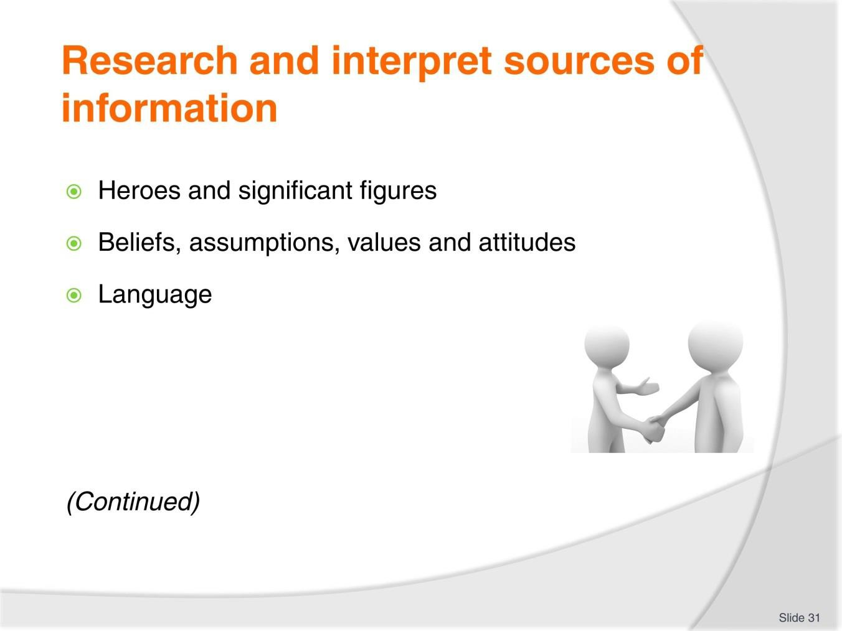
Slide No | Trainer Notes
31. | Trainer continues to present possible research topics:  - Heroes and significant figures and individuals – to identify:  - Who they are  - Why they are significant and what they did  - Their role in the community  - Beliefs, assumptions, values and attitudes – with reference to:  - What these are  - Why they are held  - Their impact on the life of the people  - Language – to ascertain:  - The evolution of the language  - Basic terms, words and phrases  - Verbal and non-verbal components.

Classroom Activity (1) – Individual/Small Group Exercise
Trainer or students select a country/culture/community and conducts research on this target destination using the topics listed on the slide.
Note:
- This Activity may flow from the previous one or be separate to it
- This Activity may be part of the Work Project requirements for the unit.
Classroom Activity (2) – Internet Research
Trainer facilitates research into and discuss about (sites such as): http://www.fodors.com/guidebooks/ - Fodor’s guidebooks. http://en.wikipedia.org/wiki/List_of_travel_magazines - List of travel magazines.

Slide
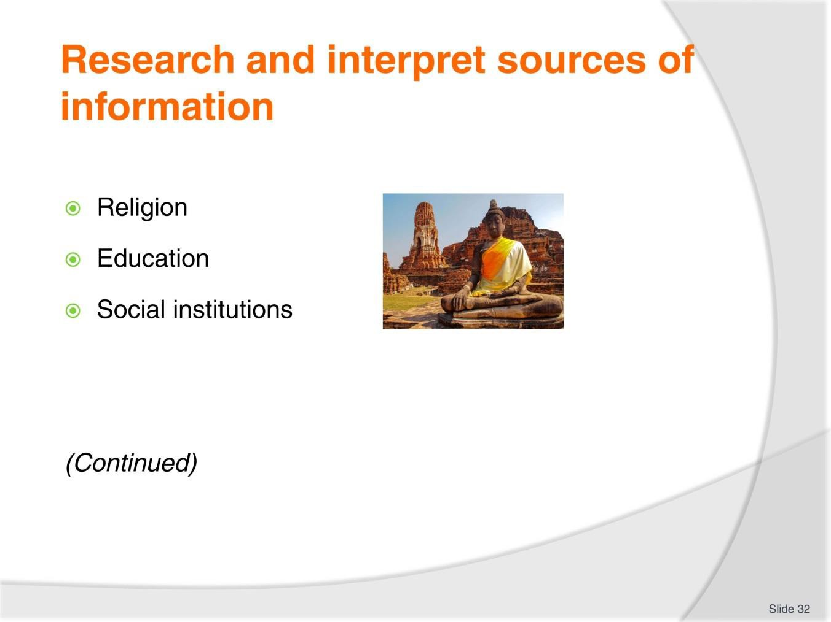
Slide No | Trainer Notes
32. | Trainer continues to present possible research topics:  - Religion – to identify:  - Beliefs and religious organisation  - Religious practices  - Education – and details such as:  - What content is deemed relevant  - How knowledge is communicated/transferred  - Significant institutions and achievements  - Social institutions which exist within communities (such as governments, health and welfare systems, educational systems, business structures, judicial systems) – to determine:  - What they are  - What they are called  - How they function.

Classroom Activity (1) – Individual/Small Group Exercise
Trainer or students select a country/culture/community and conducts research on this target destination using the topics listed on the slide.
Note:
- This Activity may flow from the previous one or be separate to it
- This Activity may be part of the Work Project requirements for the unit.
Classroom Activity (2) – Internet Research
Trainer facilitates research into and discuss about (sites such as):
http://www.studylecturenotes.com/basics-of-sociology/what-are-the-basic-elements-of- religion - What are the basic elements of religion?
http://www.academia.edu/5237947/ASEAN_Tourism_Policy_and_Planning - Regional tourism policy and planning ASEAN.

Slide
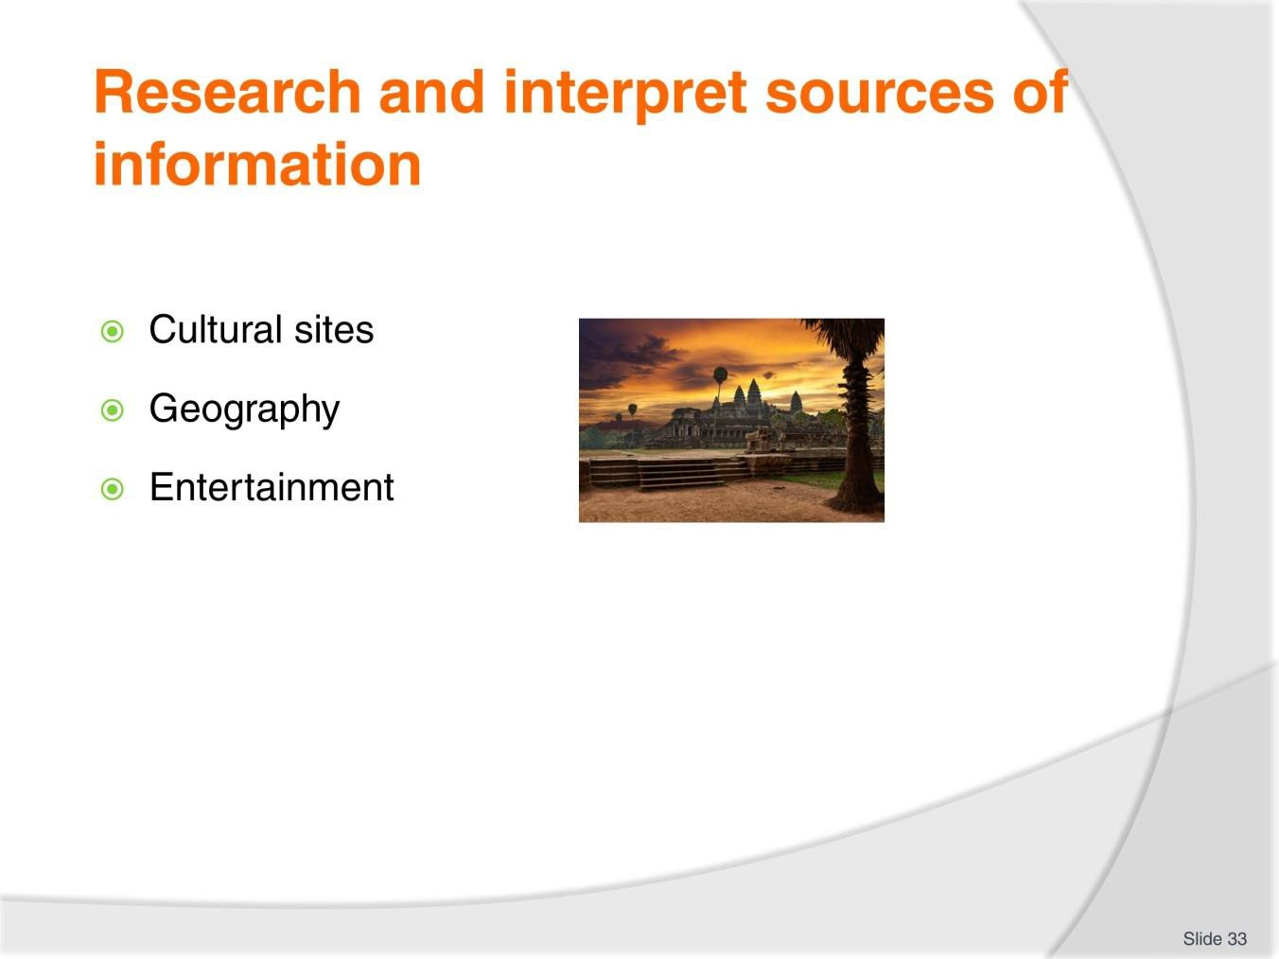
Slide No | Trainer Notes
33. | Trainer continues to present possible research topics:  - Cultural sites – to identify:  - What they are and where they are located  - Their names  - What they are used for and why they are important  - Geography – in terms of:  - Layout of the country  - Natural features  - Statistical information  - Environmental issues  - Entertainment – regarding (for example):  - Domestic leisure activities  - Games played by children and adults  - Sports.

Classroom Activity (1) – Individual/Small Group Exercise
Trainer or students select a country/culture/community and conducts research on this target destination using the topics listed on the slide.
Note:
- This Activity may flow from the previous one or be separate to it
- This Activity may be part of the Work Project requirements for the unit.
Classroom Activity (2) – Internet Research
Trainer facilitates research into and discuss about (sites such as):
http://www.asean.org/communities/asean-economic-community/item/plan-of-action-on- asean-cooperation-in-tourism - Plan of action on ASEAN cooperation in tourism.
http://www.scribd.com/doc/111871570/ASEAN-Tourism-Strategic-Plan-2011- 2015#scribd – ASEAN Tourism strategic plan 2011 – 2015.

Slide
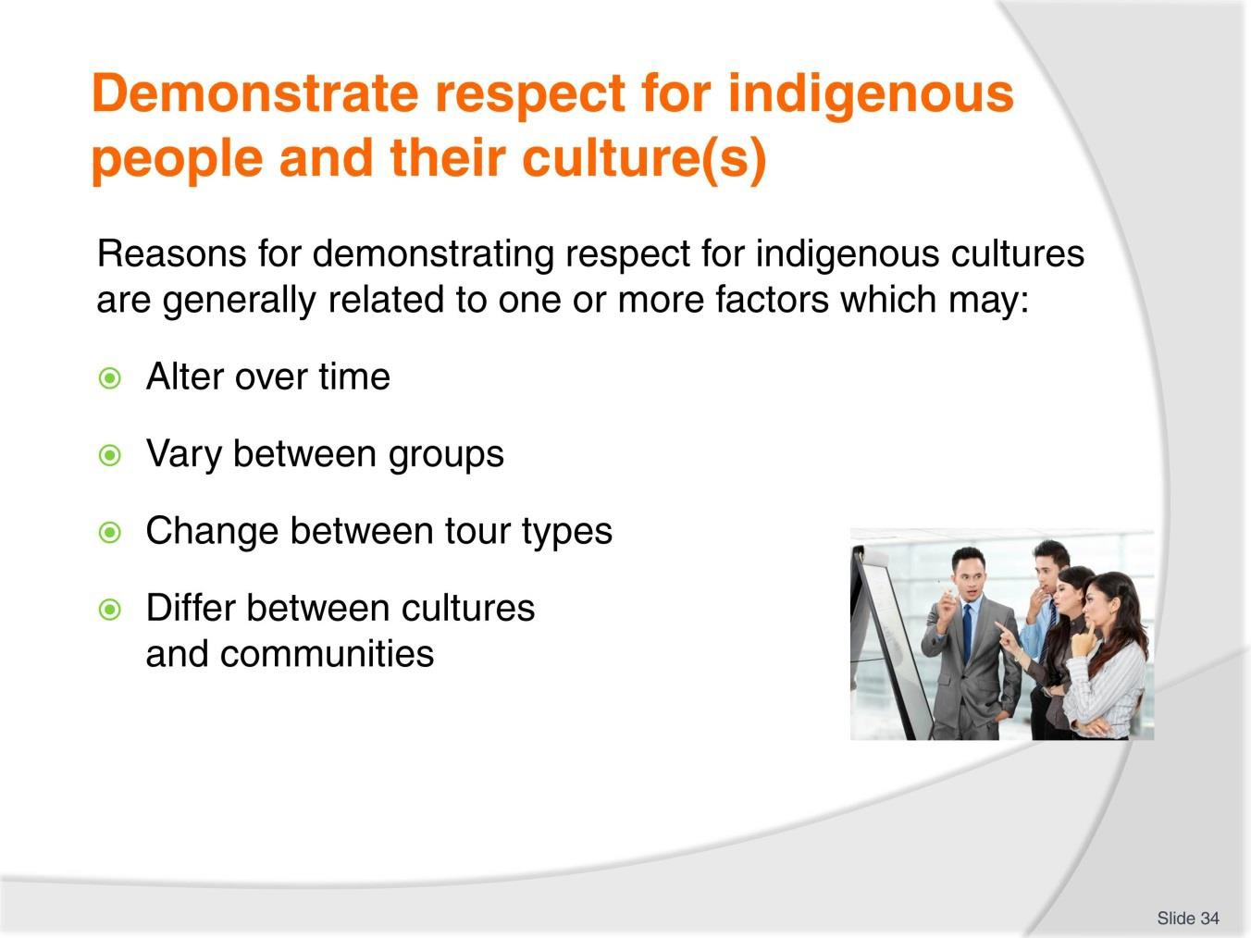
Slide No | Trainer Notes
34. | Trainer explains reasons for demonstrating respect for indigenous cultures are generally related to one or more factors highlighting these factors are not ‘constant’ and may:  - Alter over time  - Vary between different tour group  - Change between specialised custom/private tours  - Differ between different communities and cultures.

Slide
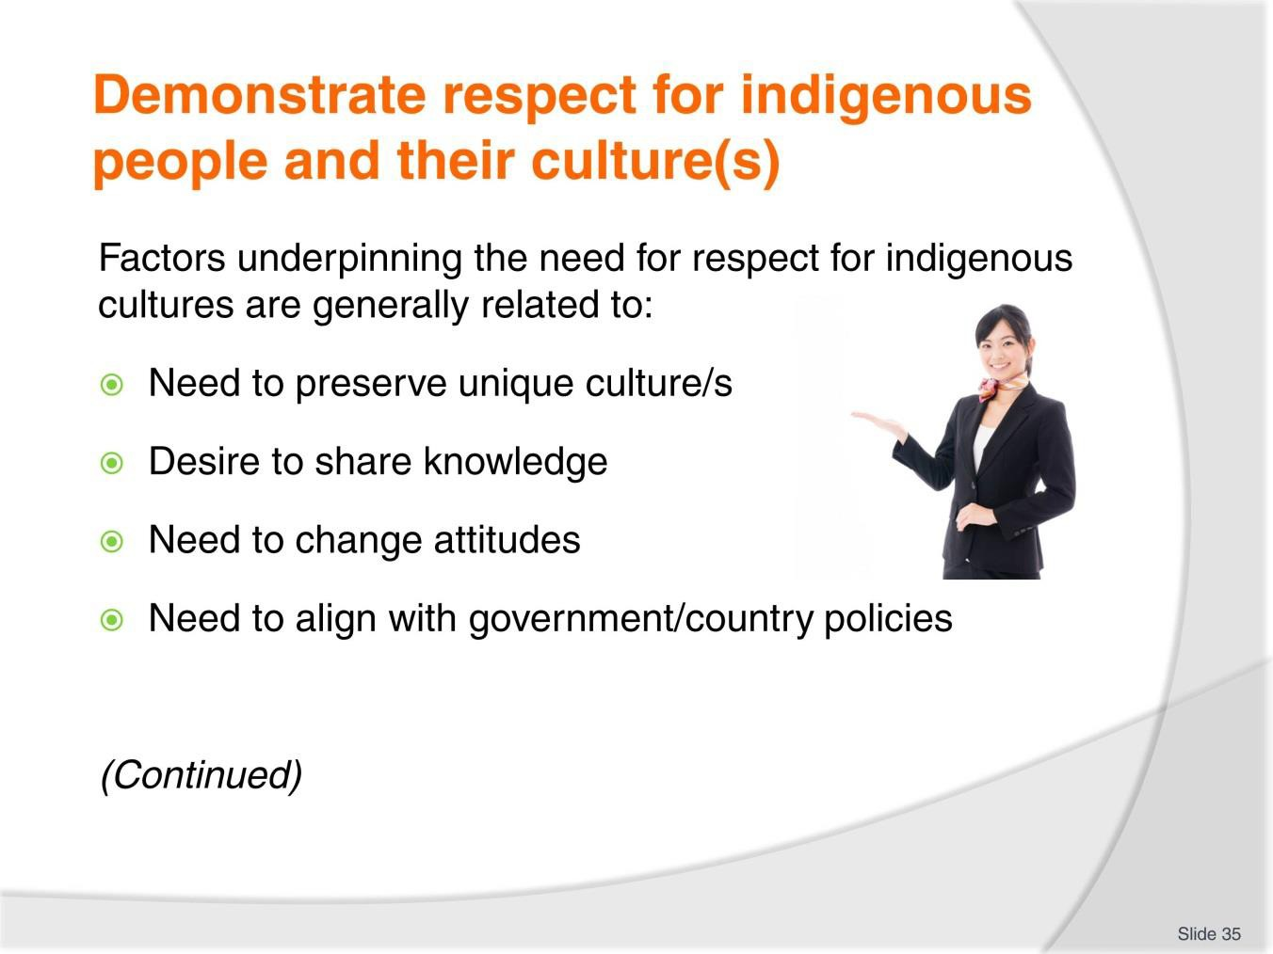
Slide No | Trainer Notes
35. | Trainer presents factors underpinning the need for respect for indigenous cultures are generally related to:  - The need to preserve unique cultures – so that what they have and what they represent is not lost to mankind through being absorbed into other cultures and/or over-taken by other priorities:  - This aim is often set against a need to save an entire culture/way of life from fading into the mists of time by avoiding what often seems to be the very slow but nonetheless relentless disappearance of a whole culture/society  - A desire to share knowledge – so more/other people learn about a rare/unique culture/community, what they are, how they function and how they live:  - This desire is often related to the preservation of a culture but it differs in that the primary aim is to make more people aware of what actually exists  - Some argue that by doing this it actually raises the potential for the indigenous culture to be exploited or destroyed if ‘too many’ people become aware of it and what it may have to offer  - A need change the attitudes of visitors – this can be borne out of a desire to:  - Present a culture in a different way  - Offer a rarely seen aspect of the culture/community to outside eyes  - Explain why a people do what they do based on the facts and actual context/reality of their lives

- Realisation by society in general, a country/Government of a range of issues including:
  - Valuing individuals and different cultures and communities for who they are and the individual way they live their lives
  - Recognising the contribution people/communities have made to other cultures and/or the wider world
  - Acknowledging the right of different people to live in different ways.

Slide
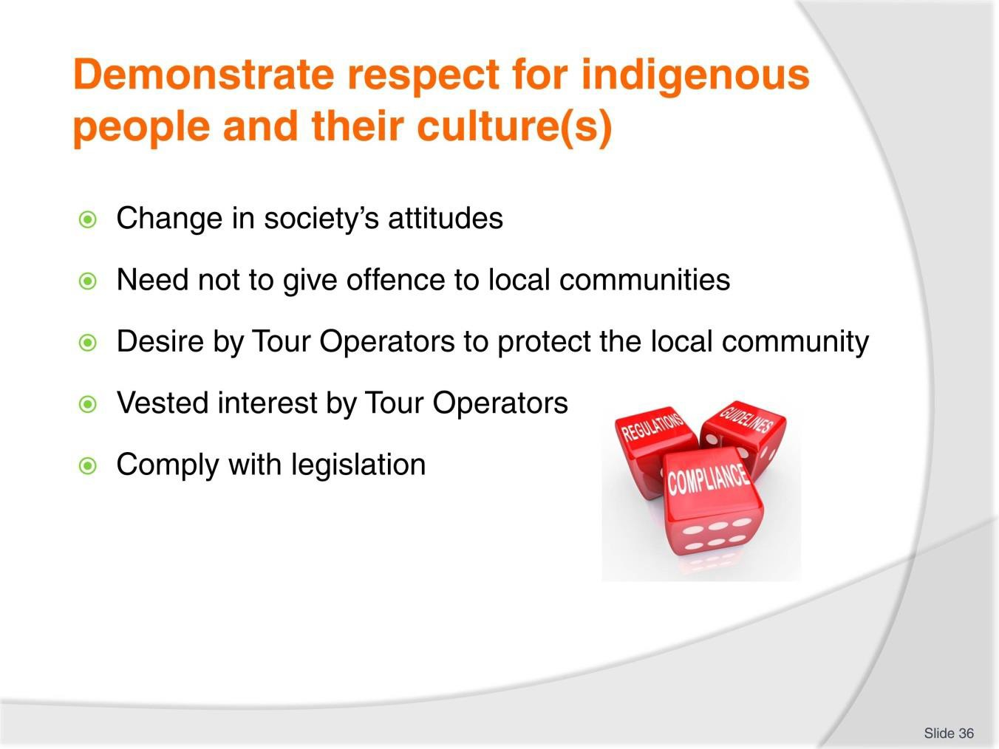
Slide No | Trainer Notes
36. | Trainer continues to present factors underpinning the need for respect for indigenous cultures are generally related to:  - Acceptance on the part of society in relation changing attitudes – such that what was ignored or treated with suspicion or indifference years ago is now a valid and legitimate way of life or orientation:  - This often relates to the concept today’s world/society can learn something from a previous world or society  - A need on the part of the Tour Operator (and associated Government agencies/tourism bodies) to ensure no offence is given by tour group when they visit indigenous communities/cultures – in relation to things such as:  - How visitors speak and dress in their presence  - The way in which tour group interact with them  - Actions taken by individuals when in indigenous communities  - A desire of the part of tours/Tour Operators to protect the ‘normal’ way of life of indigenous cultures – from:  - Unintended consequences of interacting with other peoples/cultures  - The encroachment of other civilisations  - Unwanted intrusions across a range of fronts such as political, economic, moral, religious

- A vested interest on the part of a Tour Operator in creating a more positive relationship/rapport with the communities which will be more conducive to:
  - Future deals/negotiations involving tours and visitations to their communities
  - More lucrative financial arrangements between the parties
  - Better working relationships between everyone
- An obligation to comply with legislation – which is imposed by law to protect the various rights of certain cultures, communities and people such as their:
  - Human rights; Civil rights; Constitutional rights; Civil liberties.

Slide
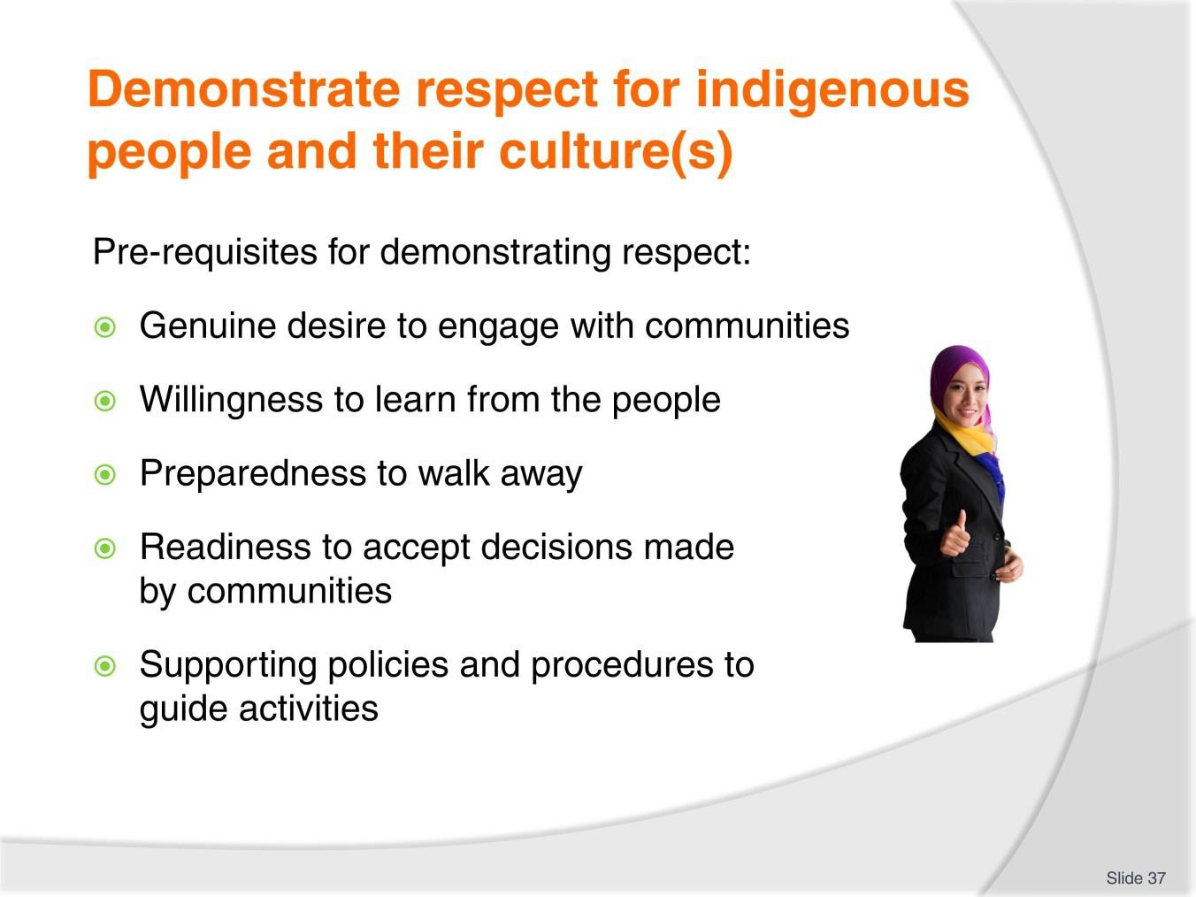
Slide No | Trainer Notes
37. | Trainer identifies in order to actually demonstrate respect for indigenous people and their culture/s it is vital to begin with:  - A genuine desire to engage with the communities  - A willingness to learn from the people  - Preparedness to:  - Walk away from a community if they are not interested/do not want to be involved with the Tour Operator  - Accept decisions made by the people in the community  - A working framework (Tour Operator policies and procedures) which underpin respectful treatment of/engagement with indigenous people and their culture/s.  Classroom Activity – Handouts  Trainer distributes and discusses examples of local Tour Operator policies and procedures which have been developed to guide research into and interactions with indigenous cultures/communities.

Slide
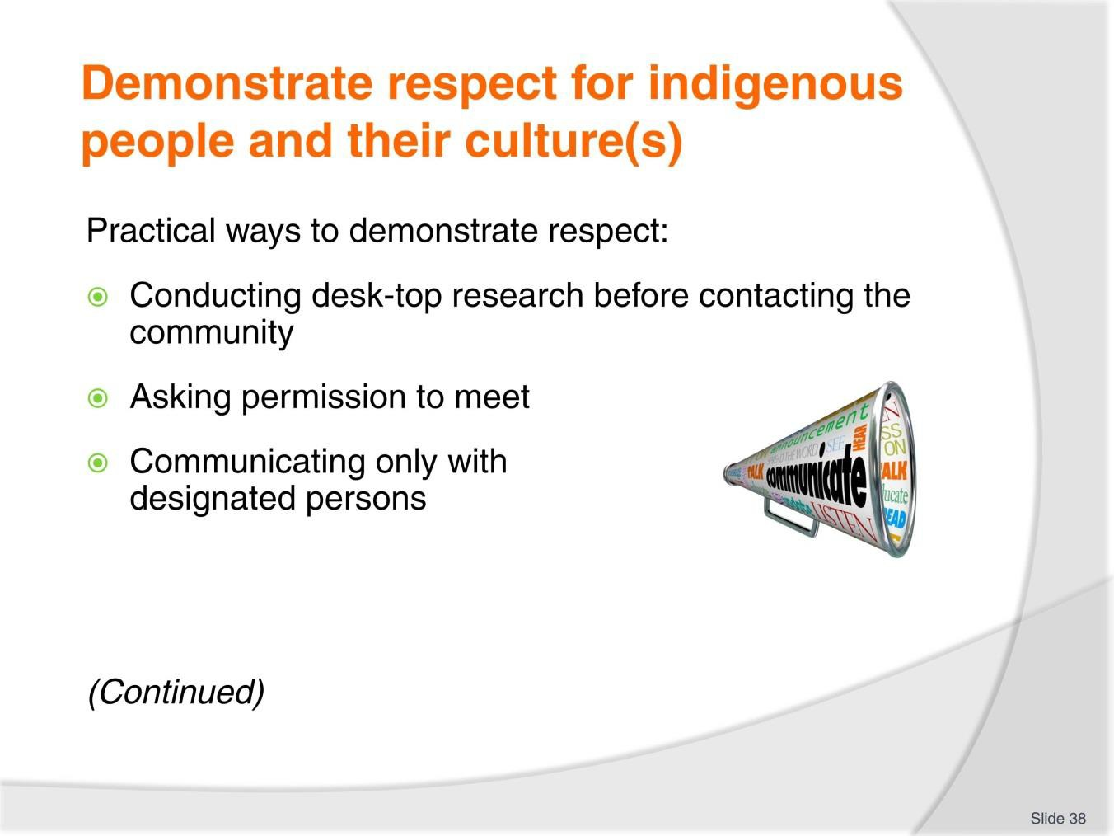
Slide No | Trainer Notes
38. | Trainer presents practical actions to demonstrate respect for indigenous people and their culture/s when researching information may include:  - Doing desk-top or other research (speaking to recognised experts; undertaking web-based research; reading relevant texts) about the community before making initial direct contact with the community – to:  - Gain a basic understanding of the community/people  - Learn about particular community cultural preferences and/or taboos  - ‘Asking’ permission to meet – as opposed to:  - Demanding a meeting or information  - Starting the local research process without prior contact, introductions, explanations and (where necessary) offers of payment  - Only communicating with designated persons – as identified as a result of:  - The desk-top research  - Advice received directly from the community.

Slide
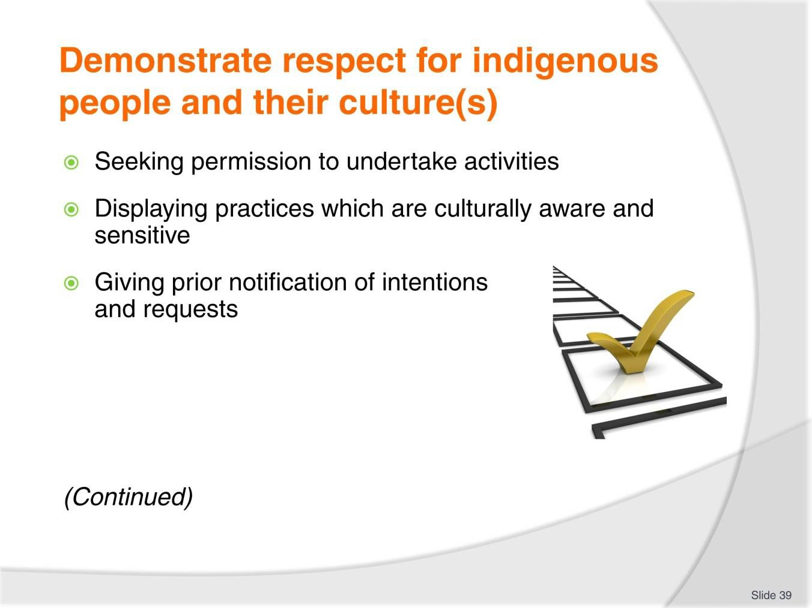
Slide No | Trainer Notes
39. | Trainer continues presenting practical action to demonstrate respect:  - Seeking approval/permission to undertake certain activities which historically have raised issued with indigenous communities – such as:  - Taking photographs/video or any form of recording  - Entering buildings/houses and ‘sacred’ sites  - Speaking to women or children  - Touching/handling or removing items  - Displaying visible behaviours and practices consistent with cultural sensitivity and awareness – which will vary between individual cultures but may require/relate to:  - Dressing appropriately  - Avoiding eye contact  - Controlling volume when speaking  - Avoiding use of certain words, terms or phrases  - Avoiding body language and gestures which are locally offensive or otherwise unacceptable

- Giving prior notification of intentions and requests – as opposed to making such requests ‘on-the-spot’. These might relate to specific research activities such as:
  - Talking to nominated individuals or groups
  - Obtaining nominated information
  - Observing activities within the community
  - Making recordings for use in promotional and other materials.

Slide
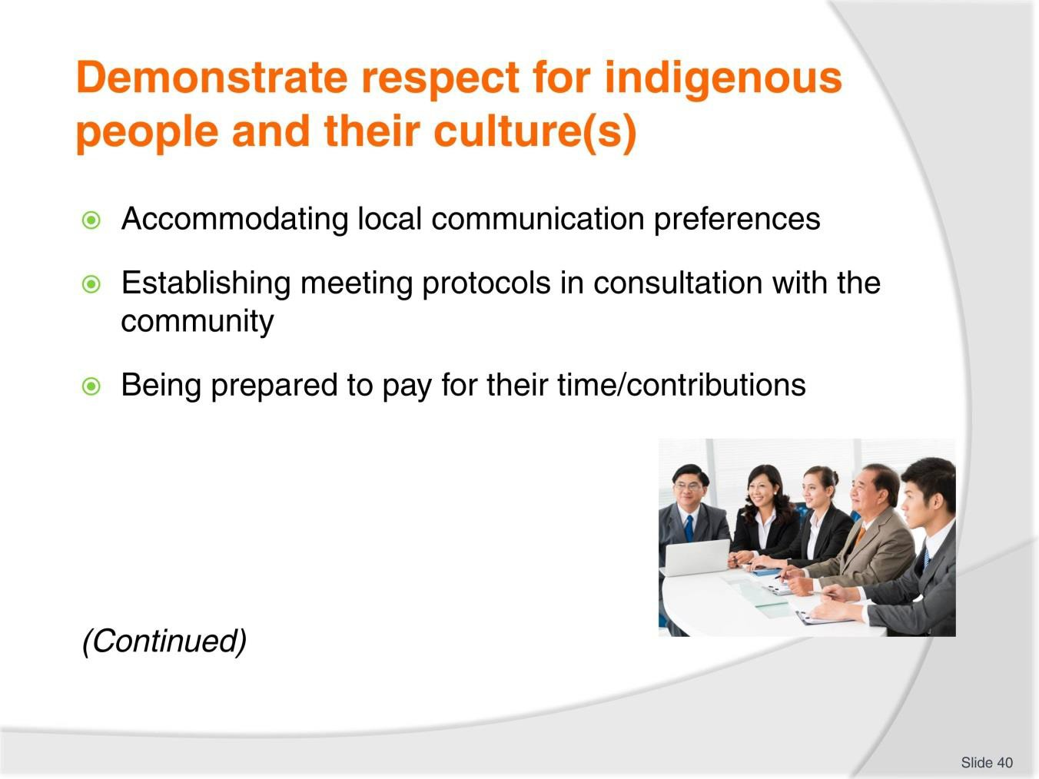
Slide No | Trainer Notes
40. | Trainer continues presenting practical action to demonstrate respect:  - Accommodating local preferences for critical communication factors – such as:  - Location for meetings and information sessions/exchanges  - Timing of these meetings  - Method/s of communication to be used  - Speaking with the community to establish meeting and/or communication protocols  – to enable meetings/sessions to occur efficiently, effectively and respectfully, such as:  - Determining local contacts/representatives as elected, nominated or approved by the community  - Identifying meetings procedures – in terms of a range of possible factors such as:  - Level of formality  - Seating arrangements  - Those who can/cannot attend meetings  - Being prepared to pay for the time and contribution of individuals and/or the local community – for input regarding (for example):  - Attending meetings

- Providing information
- Undertaking research on behalf of the Tour Operator
- Reviewing, editing and approving draft materials prepared by the Tour Operator.

Slide
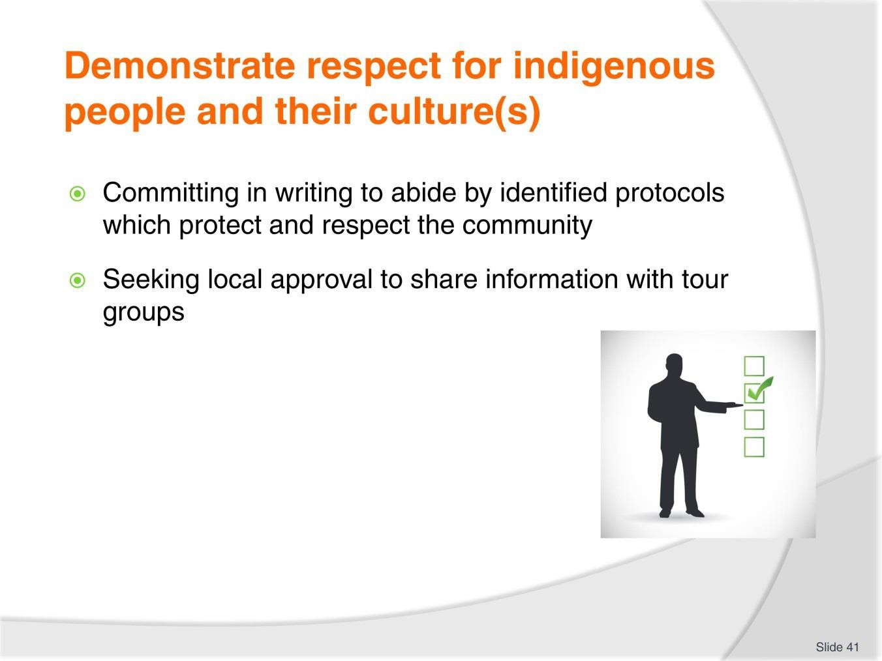
Slide No | Trainer Notes
41. | Trainer continues presenting practical action to demonstrate respect:  - Stating clearly and being prepared to commit to writing the intention of the Tour Operator to abide by identified protocols – such as:  - Never revealing information deemed by the indigenous community to be secret  - Observing procedures as contained in a nominated Code of Conduct/Practice for working with indigenous communities  - Always presenting materials/information to be used by the Tour Operator to the community for their approval before it is used  - Seeking consent for the Tour Operator to hold certain cultural information – as distinct from assuming the Tour Operator has a right to do this  - Seeking local community permission to share their cultural information – and obtaining agreements regarding:  - How this may and may not occur  - The duration of the permission granted  - Payment for same  - Protocols for obtaining approval to use material that is required.

Classroom Activity – Guest Speaker
Trainer arranges for experienced Tour Guide to attend and:
- Discuss the process of engaging with local communities/indigenous people
- Describe tips and advice for researching indigenous people
- Explain sample Codes of Conduct/Practice which apply to interacting with indigenous communities.

Slide
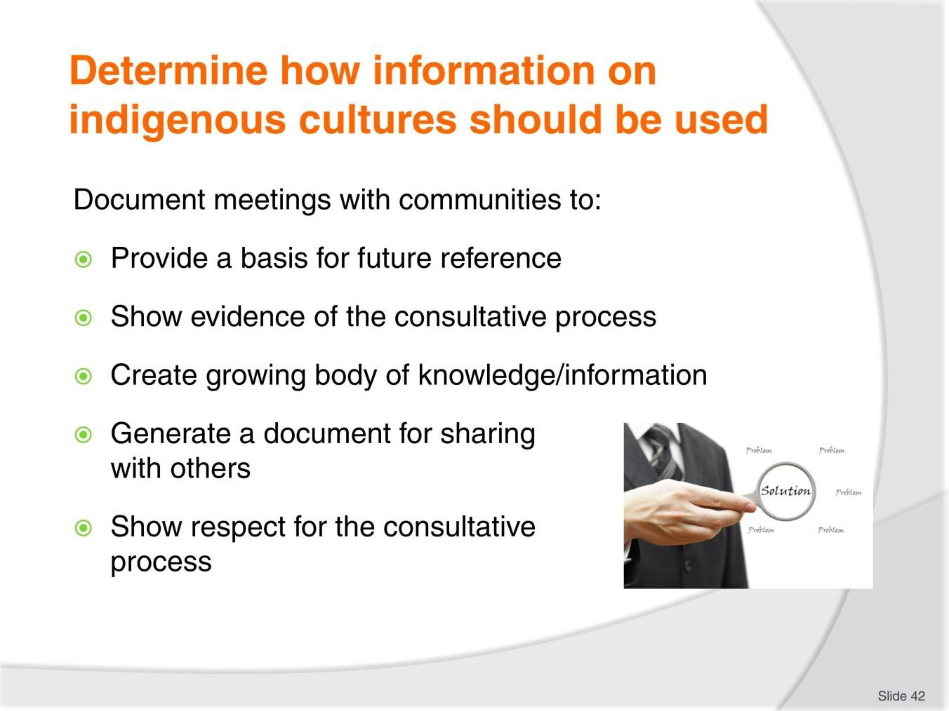
Slide No | Trainer Notes
42. | Trainer stresses it should be standard practice to document meetings and talks with local communities and indigenous people – in order to:  - Provide a basis for future reference – so materials produced reflect the wishes expressed by the people during the talks, visits and meetings  - Show evidence of the consultation process – in order to help maintain the reputation of the Tour Operator as being sensitive to local communities and indigenous people  - Create a growing body of knowledge – about the communities and cultures  - Generate a document which can be shared with stakeholders – to:  - Provide a record of what was discussed  - List stated agreements and arrangements made at meetings  - Provide a basis for future discussion/follow-up  - Show respect for the consultation process – in that recording the meetings demonstrates proof of the value of the talks and shows a serious orientation to matters discussed.

Slide
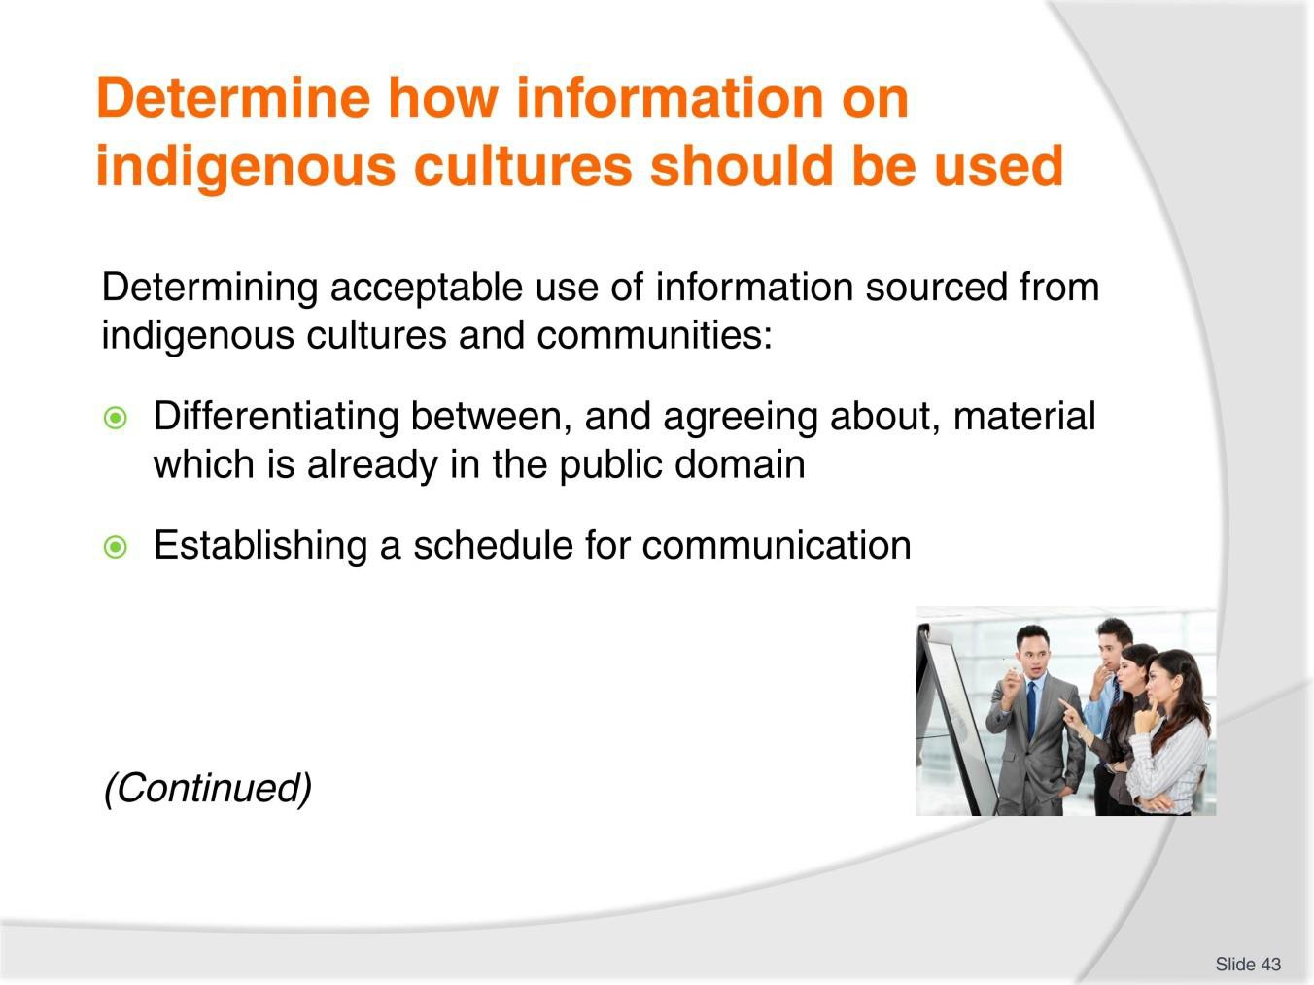
Slide No | Trainer Notes
43. | Trainer identifies standard practices for determining acceptable use of information sourced from indigenous cultures and communities:  - Differentiating between, and agreeing about, material which is already in the public domain – and already/readily available to others. This can be done by:  - Verbally discussing the material  - Showing copies/evidence of existing material:  - Material already available to the public comes with far fewer restrictions attached to its use providing there is agreement and acceptance about the content and its veracity  - Establishing a schedule for communication in this regard – which needs to accommodate the needs, wants and preferences of the local people as these relate to:  - Dates and times  - Meeting places  - Those who can or must be present  - Meeting protocols – seating arrangement, presence of recording devices, refreshments  - Whether people require payment for attendance.

Classroom Activity – Internet Research
Trainer facilitates research into and discuss about (sites such as): http://green.hotelscombined.com/Rtg-Benefits-of-Tourism.php - Benefits of tourism.

Slide
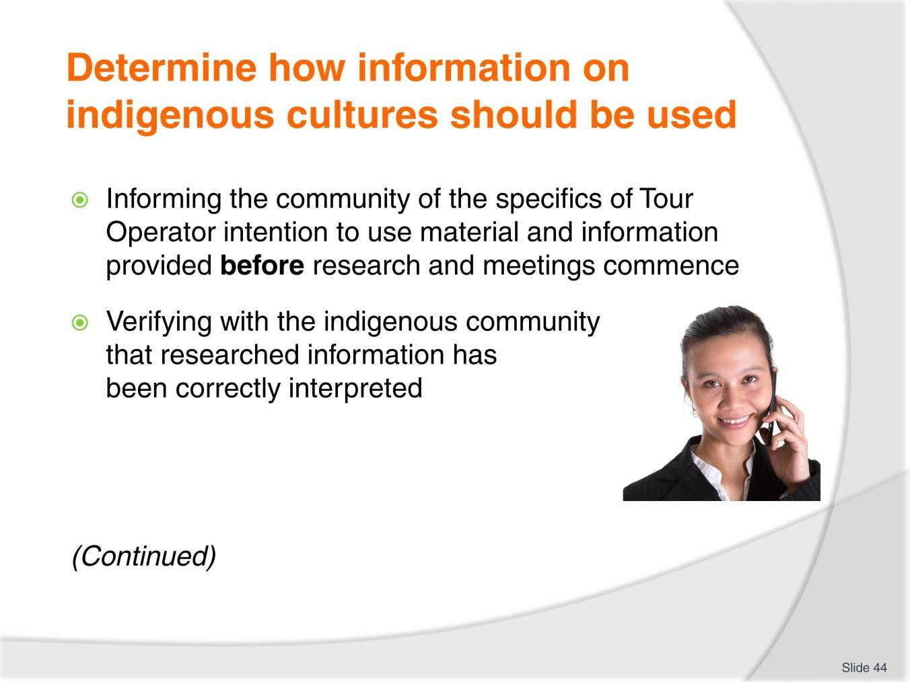
Slide No | Trainer Notes
44. | Trainer continues to identify standard practices for determining acceptable use of information sourced from indigenous cultures and communities:  - Informing the community of the specifics of Tour Operator intention to use material and information provided before research and meetings commence – so the people are:  - Genuinely aware of the reasons for the talks  - Fully understand why the information is being sought:  - This can help them decide:  - What they want to disclose  - What they want to keep secret  - If they require payment for their input/contributions  - Verifying with the indigenous community that researched information has been correctly interpreted – and:  - Allowing the community the right to review materials produced – so they remain engaged with the process of participating in the development and release of material and so they can:  - Approve and/or amend the proposed items  - Reject the way certain information is presented

- Giving the community the right to veto material – so they know they:
  - Are respected as an integral part of the process
  - Retain final control over the information released/provided.
Classroom Activity – Internet Research
Trainer facilitates research into and discuss about (sites such as):
http://sanctuaries.noaa.gov/management/pdfs/Day5_H2_BenefitsThreats.pdf - Some benefits for local communities; some threats for local communities.

Slide
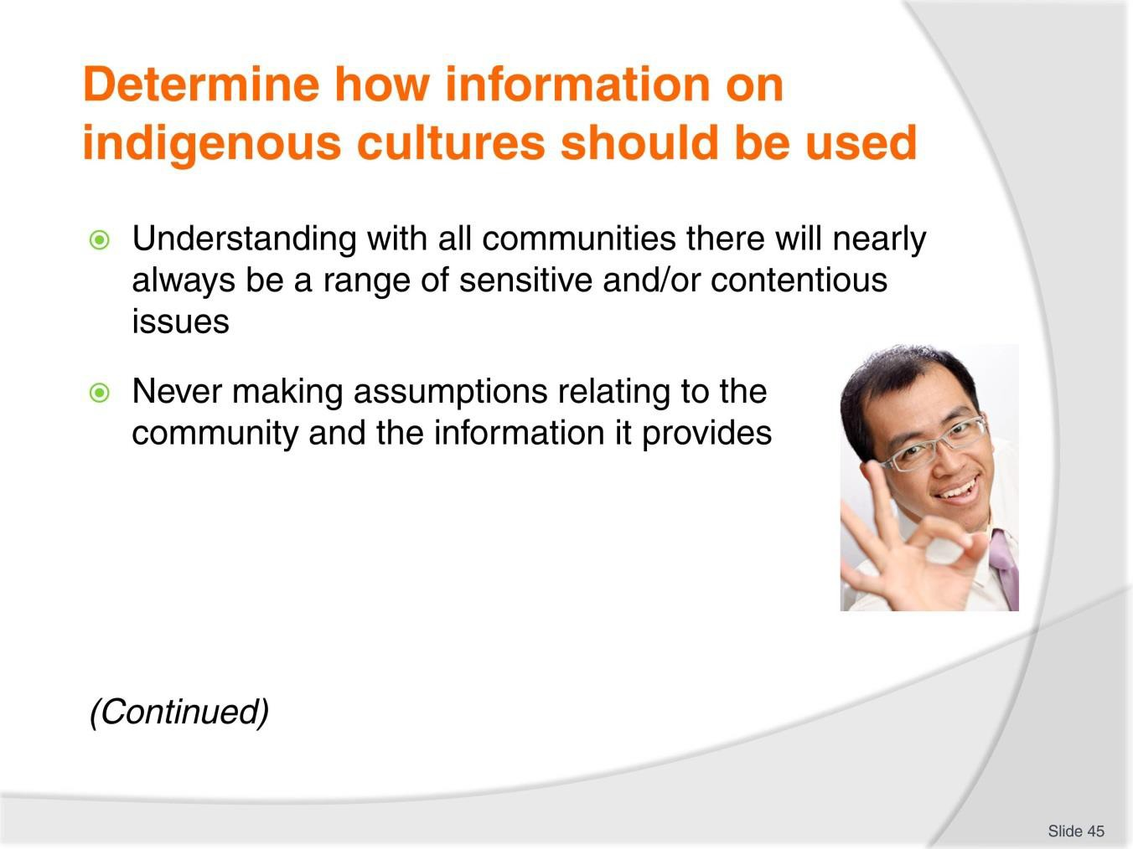
Slide No | Trainer Notes
45. | Trainer continues to identify standard practices for determining acceptable use of information sourced from indigenous cultures and communities:  - Understanding with all communities there will nearly always be a range of sensitive and/or contentious issues – such as:  - Things the community does not agree about  - Matters the people have difficulty explaining  - Culturally-sensitive matters (times, events, practices or customs) which the community:  - Does not want to talk about at all  - Wants handled/treated in a certain way  - Access to certain people, places and/or practices  - Never making assumptions relating to the community and the information it provides – for example it is never acceptable/respectful to:  - Assume the community knows about the Tour Operator and what it does  - Assume the people know what Tour Operators do and the tourism industry is  - Assume all materials and information provided can be used for tour- related/tourism purposes.

Classroom Activity – Internet Research
Trainer facilitates research into and discuss about (sites such as):
http://www.onecaribbean.org/content/files/GoodPracticestourismawareness%282%29.p df – Competing with the best: Good practices in tourism awareness programs.

Slide
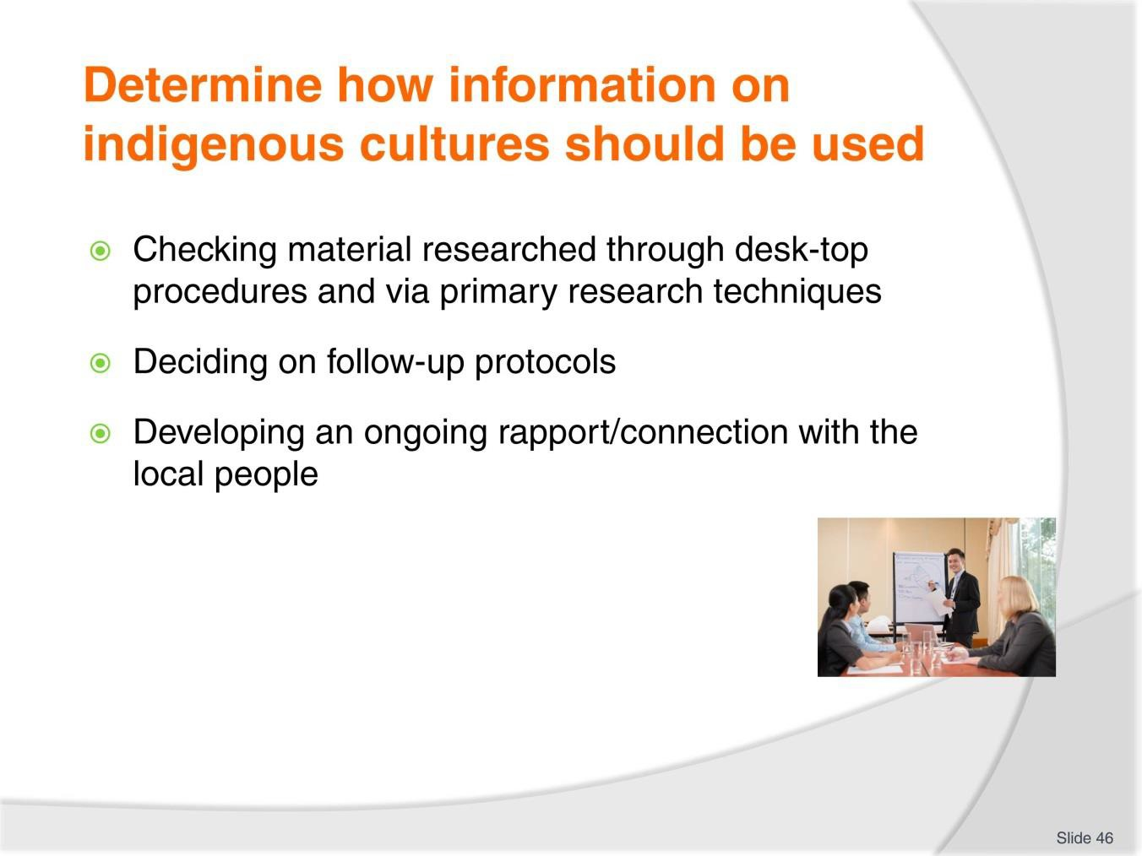
Slide No | Trainer Notes
46. | Trainer continues to identify standard practices for determining acceptable use of information sourced from indigenous cultures and communities:  - Checking with the indigenous community about material which has been researched through desk-top procedures and via primary research techniques – to determine:  - Truth and accuracy of the content  - Whether or not the information is able to be used and shared with tour groups  - Preferences/limitations which might apply to the dissemination or sharing of certain pieces of information – for example, there may be:  - Bans on sharing with women  - Restrictions on access to areas/sites  - Times/seasons when material cannot be shared  - Bans on using names of certain people or places  - Refusal to provide items for use as samples/models for showing to tour groups  - Prohibition on certain interpretive activities which have been proposed

- Deciding on follow-up protocols – as these might apply to:
  - Monitoring activities to record and track the impact of activities designed and implemented as a result of the information provided/agreed to
  - Reporting procedures for communicating and discussing the data produced as a result of agreed monitoring protocols
  - Review and revision practices – for considering materials which have been produced and are subject to evaluation
- Developing an ongoing rapport/connection with the local people – to:
  - Continue meeting with indigenous communities
  - Establish a ‘reference group’ to deal with the Tour Operator
  - Encourage their participation in the development of appropriate activities and commentaries to share their culture
  - Identify commercial opportunities available to them – if required/applicable.
Classroom Activity – Internet Research
Trainer facilitates research into and discuss about (sites such as):
http://social.eyeforpharma.com/column/untapped-potential-asean-key-growth-factors - The untapped potential of ASEAN: the key growth factors.
http://www.reportlinker.com/d0104205547/Tourism-Industry-in-Asia.html?pos=5 – Tourism industry in Asia.

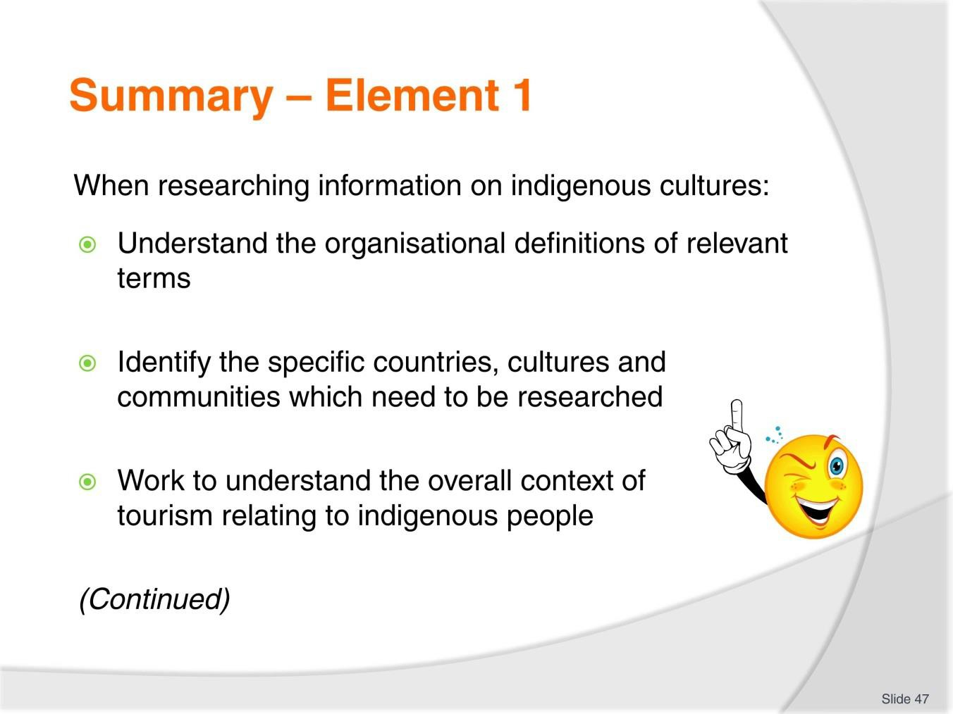
Slide
Slide No
Trainer Notes
47.
Trainer provides a recap of the Element asking questions to check trainee understanding and responding to questions from trainees, as required.

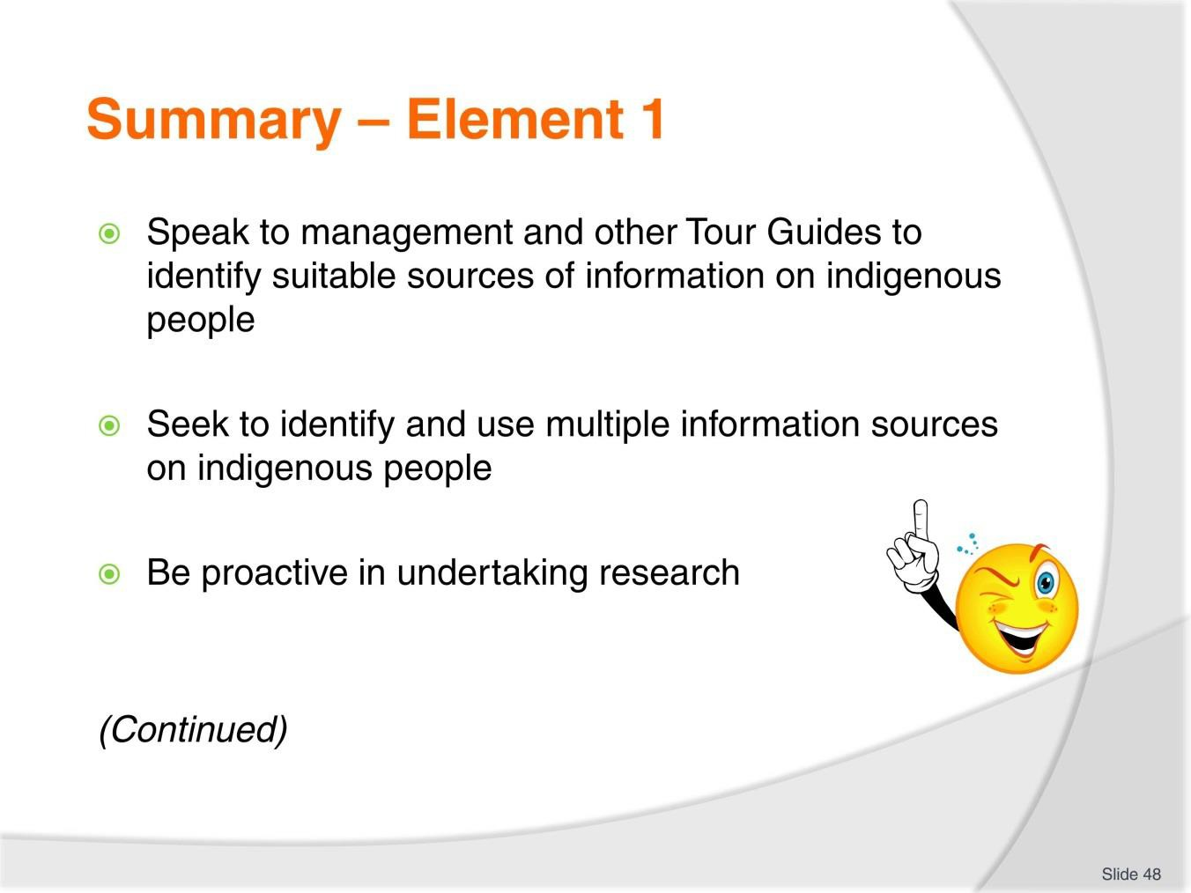
Slide
Slide No
Trainer Notes
48.
Trainer provides a recap of the Element asking questions to check trainee understanding and responding to questions from trainees, as required.

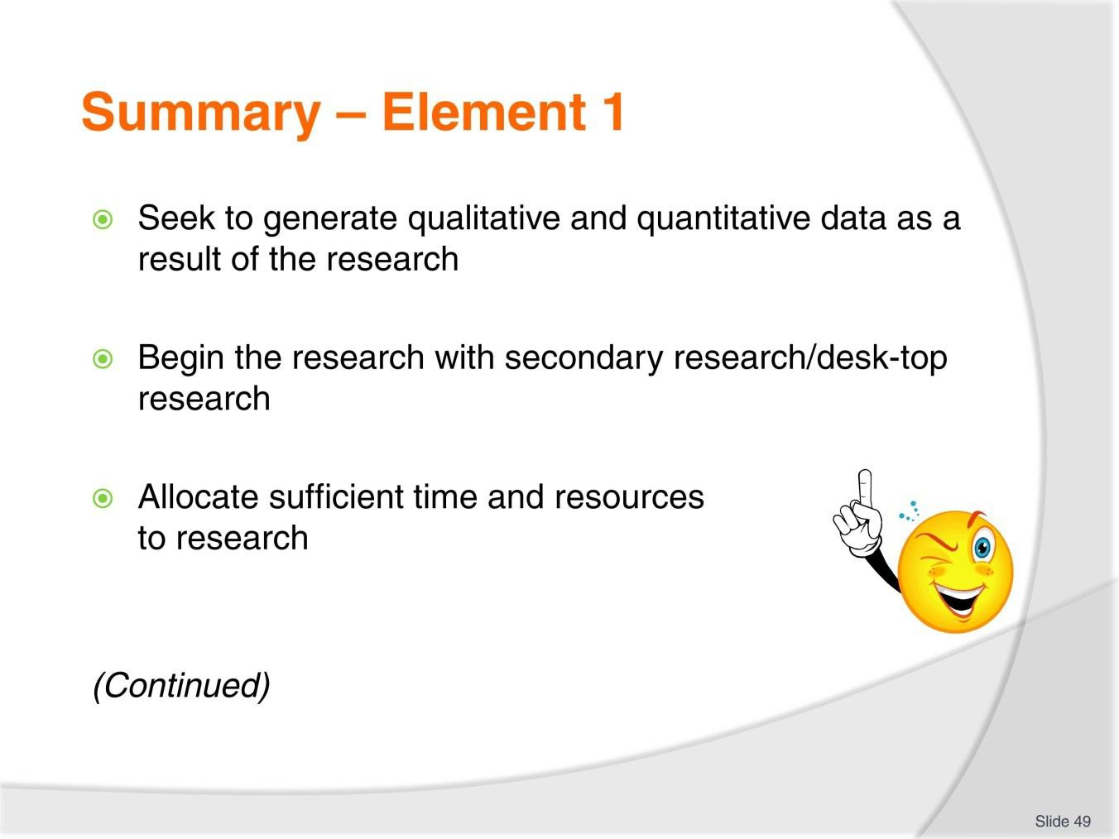
Slide
Slide No
Trainer Notes
49.
Trainer provides a recap of the Element asking questions to check trainee understanding and responding to questions from trainees, as required.

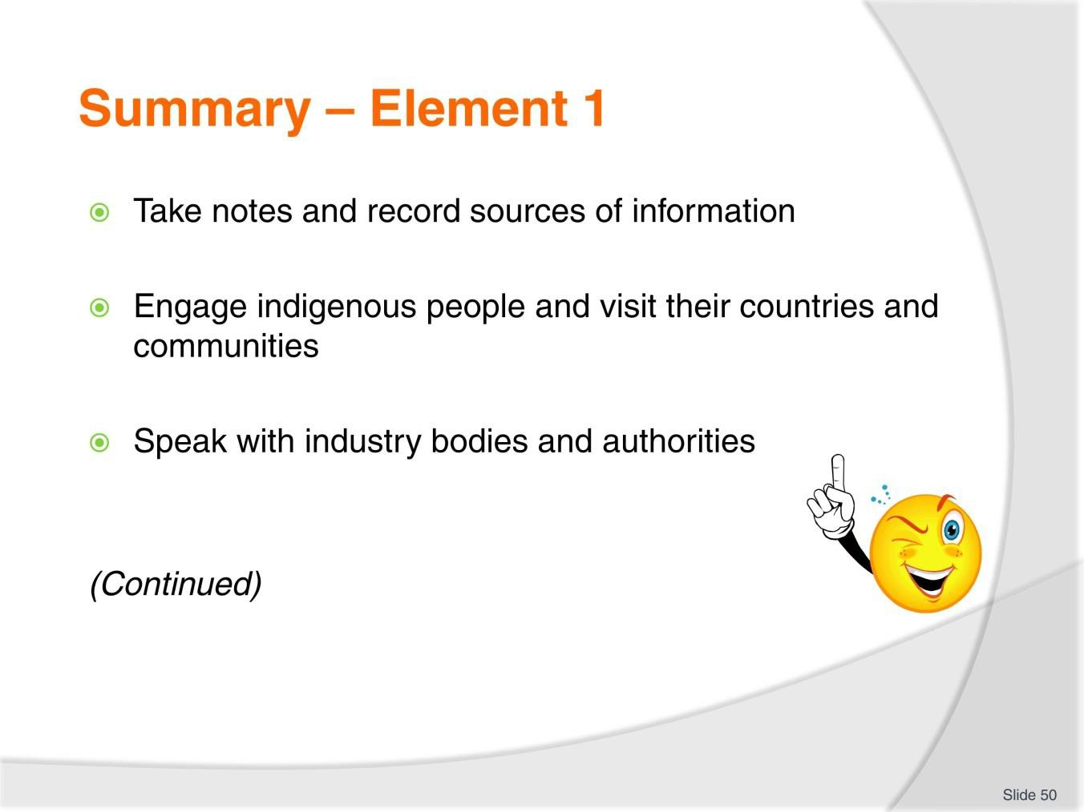
Slide
Slide No
Trainer Notes
50.
Trainer provides a recap of the Element asking questions to check trainee understanding and responding to questions from trainees, as required.

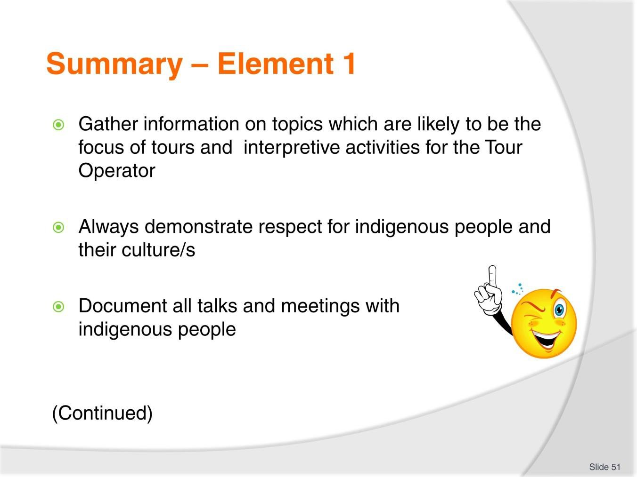
Slide
Slide No
Trainer Notes
51.
Trainer provides a recap of the Element asking questions to check trainee understanding and responding to questions from trainees, as required.

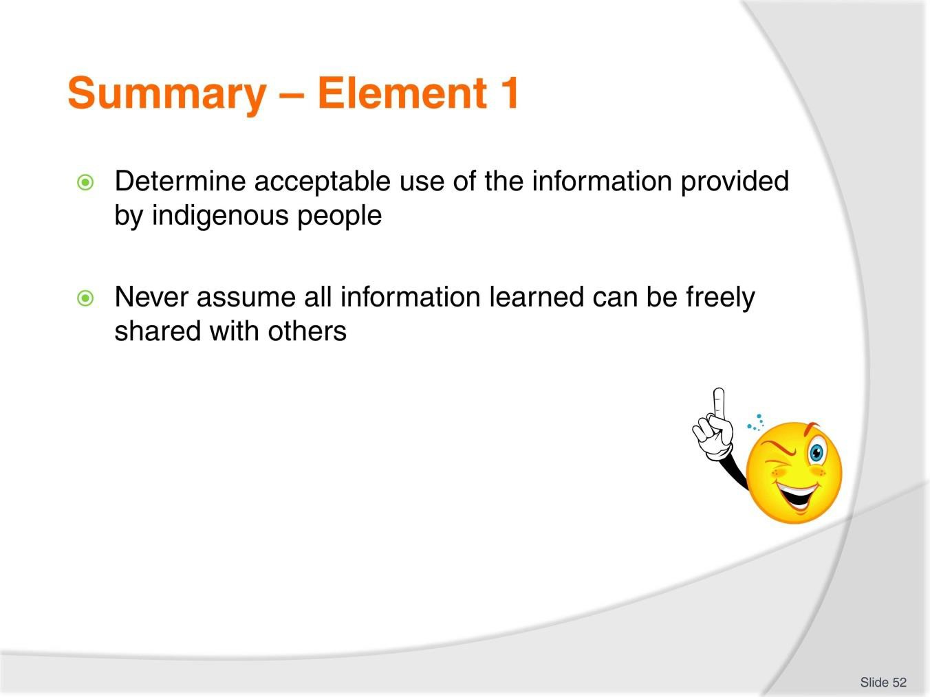
Slide
Slide No
Trainer Notes
52.
Trainer provides a recap of the Element asking questions to check trainee understanding and responding to questions from trainees, as required.

Slide
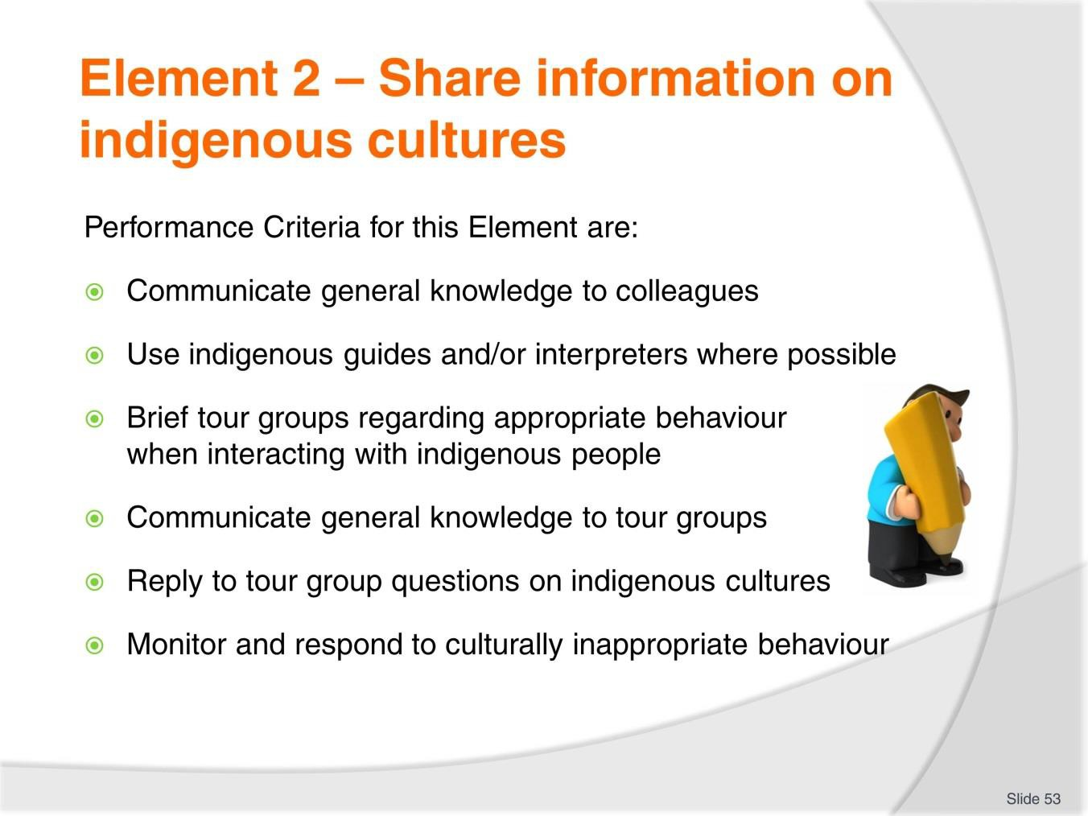
Slide No | Trainer Notes
53. | Trainer identifies for trainees the Performance Criteria for this Element, as listed on the slide.  Class Activity – General Discussion  Trainer leads a general class discussion by asking questions such as:  - Why is there a need to share information on indigenous cultures?  - Who might it need to be shared with?  - When and how might it be shared?

Slide
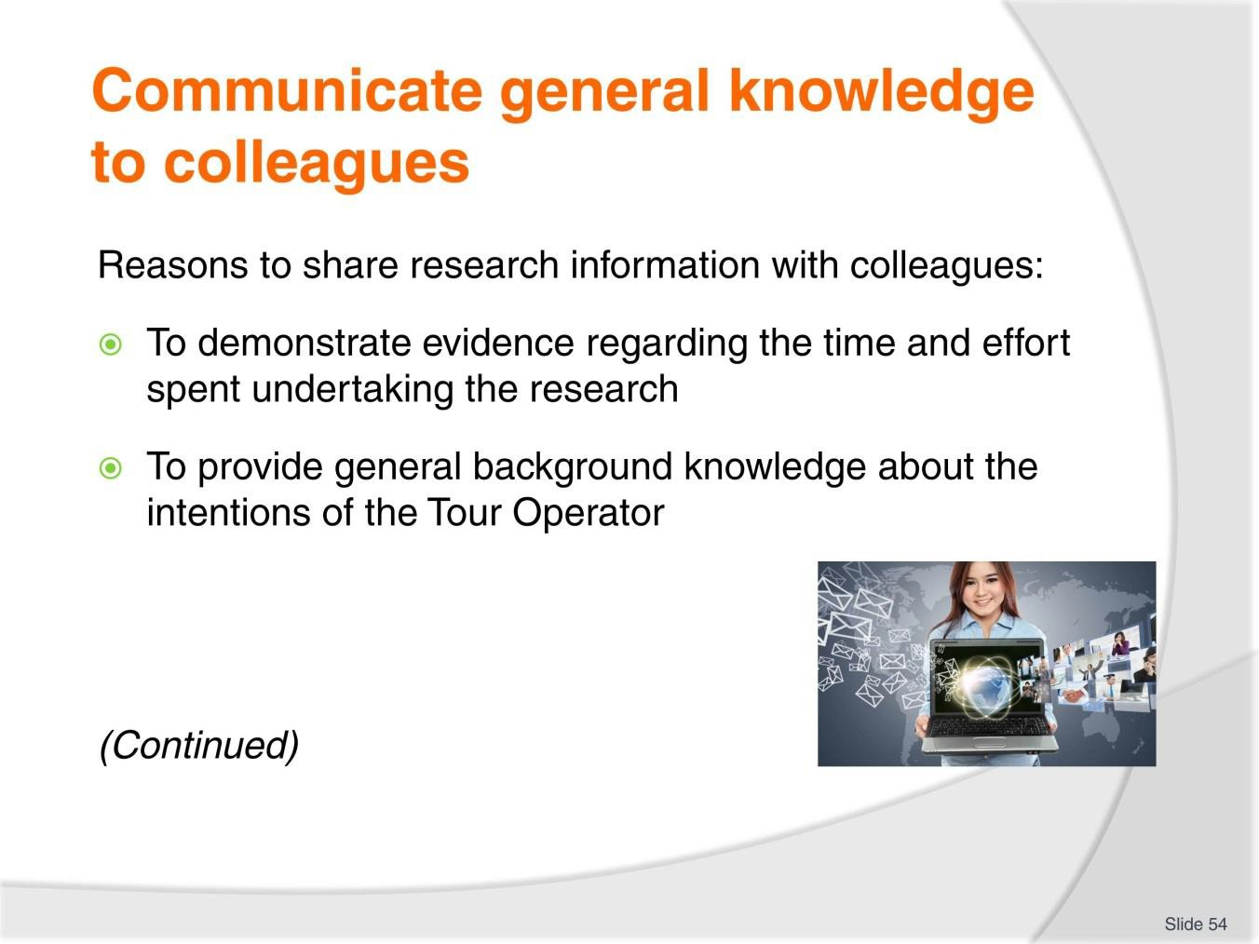
Slide No | Trainer Notes
54. | Trainer presents reasons to share with colleagues the information learned/gained from research for the following reasons:  - To demonstrate evidence regarding the time and effort spent undertaking the research – so that:  - Others can see what was achieved  - Proof is visible to show resources was well spent  - Give others a better appreciate of the scope of the research – as they often have little idea about what is involved in comprehensive research of this nature  - To provide general background knowledge about the intentions of the Tour Operator – these information sessions traditionally also feature:  - Future general/strategic plans of the company  - Changes proposed for new/different target markets and/or re-positioning of the business in the marketplace  - Specific plans as they relate to the development of the market in relation to the individual indigenous culture/people being discussed – n terms of (for example) coverage and details regarding anticipated:  - Types of tours and interpretive activities being proposed – including overview of inclusions, duration, cost/selling price  - Itineraries

- Tour schedules
- Predicted traffic and sales volume.
Classroom Activity – Guest Speaker
Trainer arranges for Tour Operator to attend and:
- Discuss need for information sharing regarding new indigenous communities/cultures to be visited
- Explain techniques to share information
- Identify those who are involved in the process
- Provide sample documentations/materials/resources used in the process.

Slide
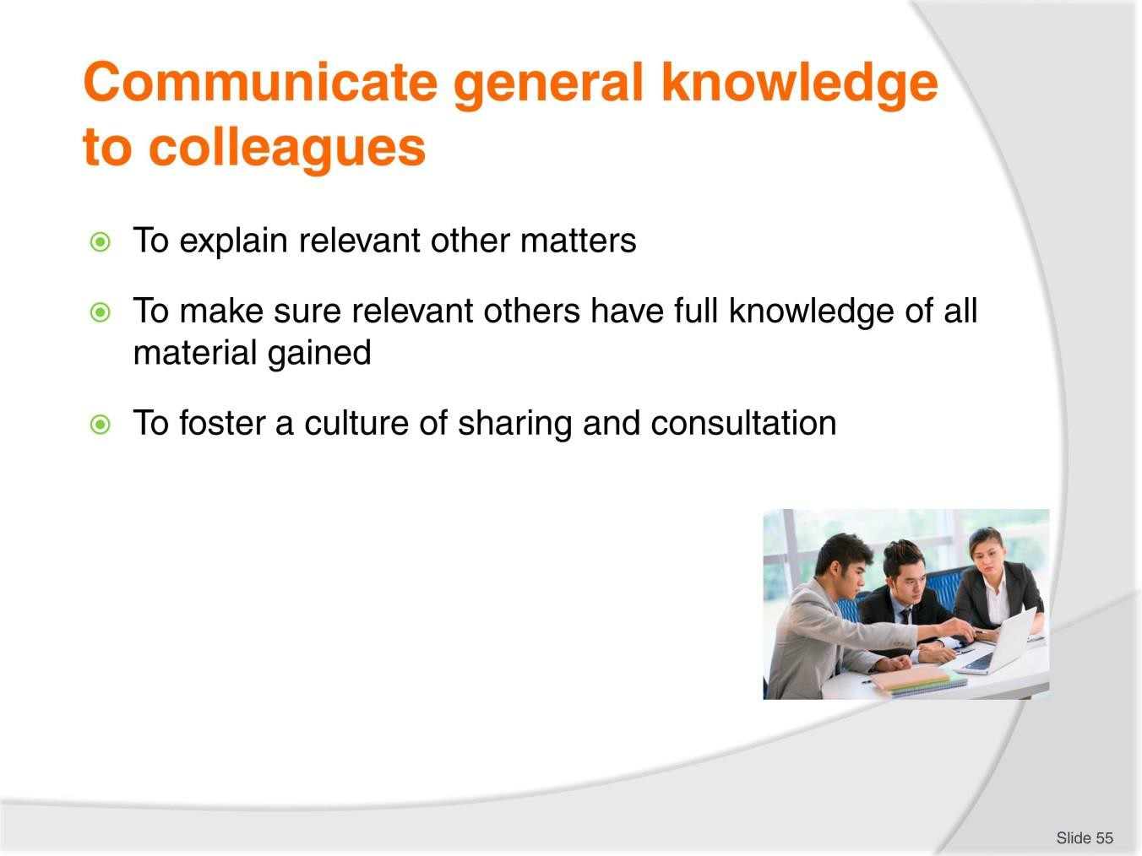
Slide No | Trainer Notes
55. | Trainer continues to present reasons to share information with colleagues:  - To explain relevant other matters – as they may relate to:  - Action already being taken by other Tour Operators  - Proposed actions of competitors  - Plans and schemes proposed or available through industry bodies and/or government agencies to support/promote tourism in the target destination/s  - To make sure relevant others have full knowledge of all material gained – so these people can use the knowledge to:  - Conduct further research  - Develop tours and activities  - Create and produce promotional material  - Begin selling activities  - Generate handouts and scripts for commentaries  - To foster a culture of sharing and consultation:  - Between staff  - Within the organisation  - Among joint-venture partners.

Slide
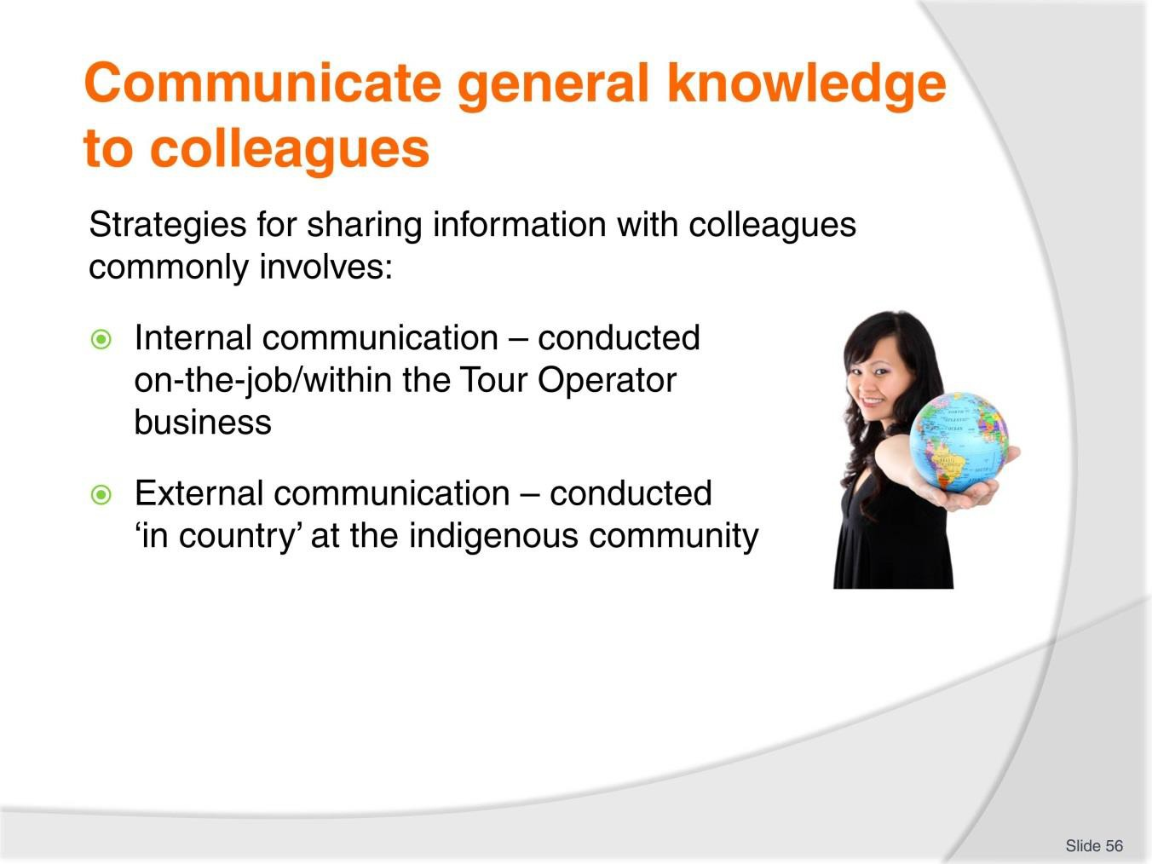
Slide No | Trainer Notes
56. | Trainer discusses strategies for sharing information noting:  - The process commonly take two forms:  - Internal (on-the-job) communication  - External (‘in country’) communication.  - Some strategies listed below can be used in both/either form – for example, meeting with and talking to community members/representatives could take place ‘in the office’ or in their community.

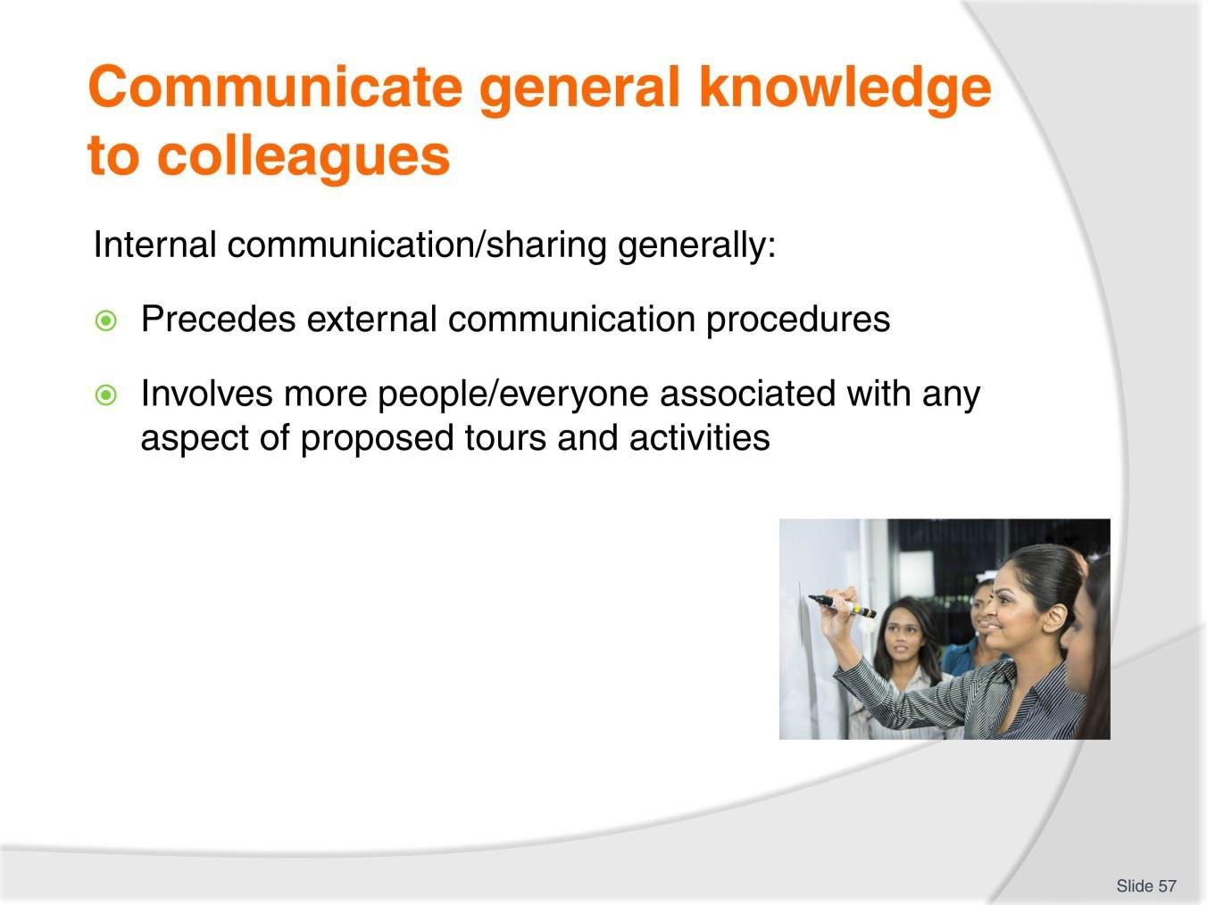
Slide
Slide No
Trainer Notes
57.
Trainer discusses internal communication highlighting this sharing of information generally:
- Precedes external communication
- Involves everyone involved with promotion, sales, guiding and operational matters.

Slide
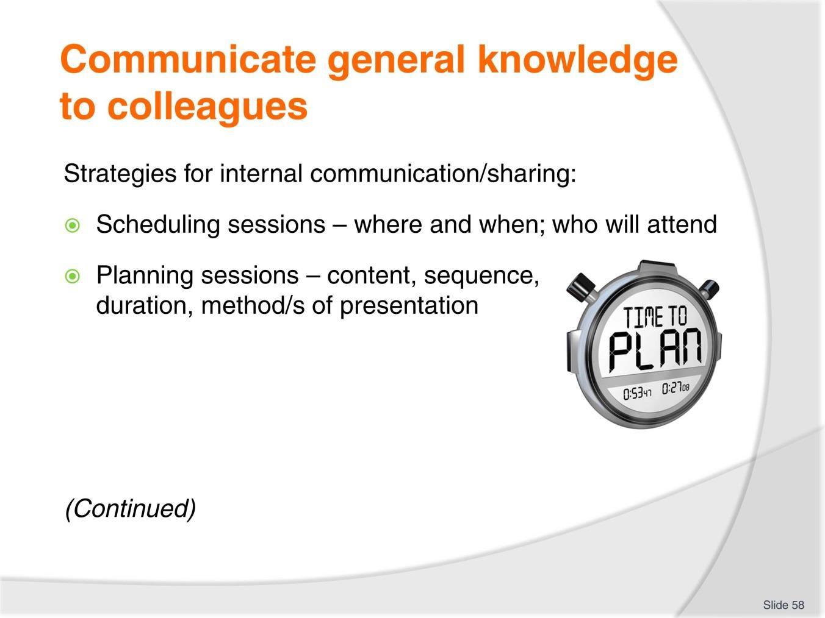
Slide No | Trainer Notes
58. | Trainer presents strategies for internal sharing/communication:  - Scheduling communication sessions – which entails:  - Determining suitable dates and times for the sessions  - Arranging support resources for the presentation – such as catering and technologies required to use (for example) PowerPoint presentations, video playback and to play sound recordings  - Sending invitations to those who should attend  - Arranging for back-filling of staff who need to attend information sessions  - Monitoring attendance at the sessions  - Conducting extra sessions as/if required and following-up with those who were unable to attend  - Planning the session – in terms of:  - What to say/present – this is the content of the presentation/details of the information which will be provided  - Sequence of presentation – the order in which material will be delivered  - Duration and timing issues – regarding:  - Starting and finishing time

- Time for each portion of the session
- Allowance for a Q&A session
- Form of presentation – with common options being:
  - Verbal presentations; Handouts; Slides, overheads and PowerPoint shows; Video and audio recordings
  - Guest speakers.
Classroom Activity – Individual Exercise
Trainer asks students to identify a community/culture they want to share information about and then undertake supervised preparation of a presentation session which will have a final outcome of them actually presenting the session to the rest of the class – Trainer to assist as required.

Slide
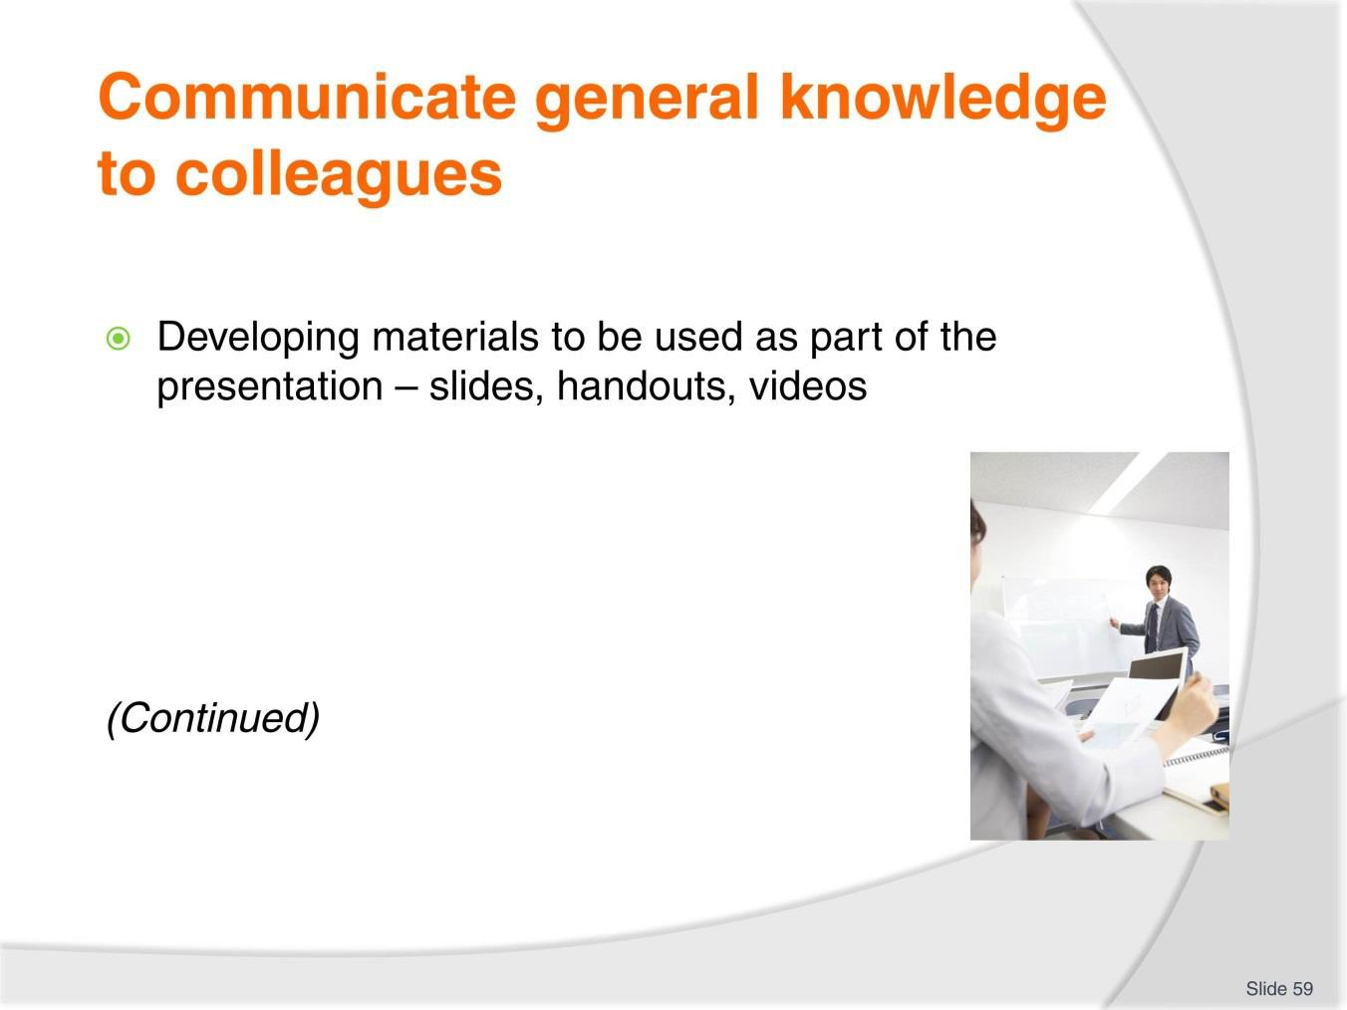
Slide No | Trainer Notes
59. | Trainer continues to present strategies for internal sharing/communication:  - Developing the range of materials to be used during the session – which must always address:  - The needs of the presenter – to use during/as part of the presentation  - Materials to be distributed to those who attend. In practice these materials may need to include:  - Slides, Overhead projection sheets/transparencies, PowerPoint slides, Handouts (such as: Statistics, Photographs, Fact/Information sheets, Contact names and numbers, Copies of reports, Examples of promotional material/s from other Tour Operators relating to the community being targeted)  - Video and audio recordings.  Classroom Activity – Individual Exercise  Trainer asks students to produce necessary materials and resources to support/enable their presentation of the internal information session they are preparing – Trainer to assist as required.

Slide
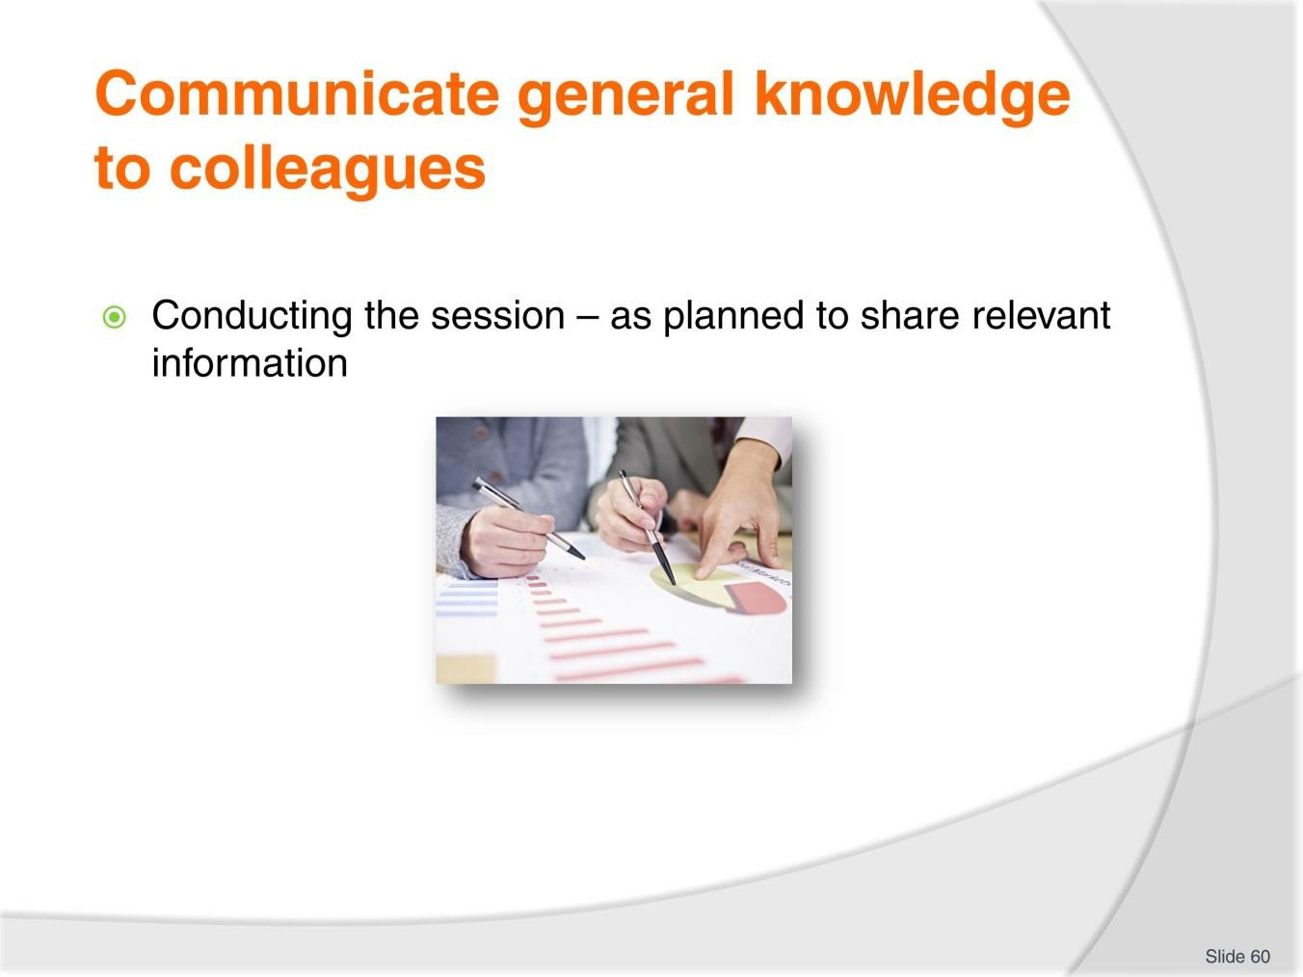
Slide No | Trainer Notes
60. | Trainer continues to present strategies for internal sharing/communication:  - Conducting the session – which will traditionally include:  - Welcoming the colleagues and thanking them for attending  - Explaining reason for the session  - Following the plan for the session – which may involve:  - Passing on general, background information on the culture/community  - Communicating specific information gathered on the topics of interest to the Tour Operator  - Explaining aspects of culture/community/country relevant to Tour Operator plans, proposals and intentions  - Providing demonstrations to assist understanding  - Describing proposed interpretive activities  - Listing sites and destinations for visitation  - Noting tours and activities already being conducted into the destination by other Tour Operators  - Identifying incentives (from other operators, government agencies) to support engagement with community

- Explaining what (if anything) the community requires in exchange for their cooperation
- Advising colleagues about what can and what cannot be shared with others
– and indicating other restrictions which have already been identified at this stage of discussions/negotiations.
Classroom Activity – Individual Exercise
Trainer asks students to deliver the information sharing presentation they have been preparing as part of the last two Classroom Activities – Trainer to provide constructive comment and feedback.

Slide
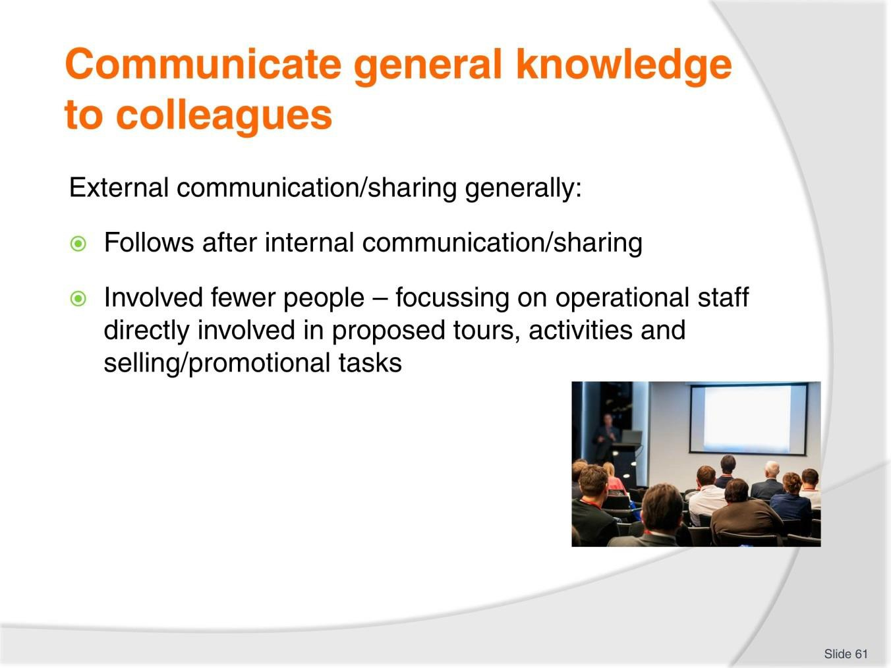
Slide No | Trainer Notes
61. | Trainer presents the external component of sharing information observing it generally:  - Follows initial external communication  - Involves fewer people than the internal notification – this means this aspect of communication may be limited to:  - Tour Guides who will be leading tours into the destination  - Staff who will be involved in conducting on-site interpretive activities  - Key sales and advertising staff.

Slide
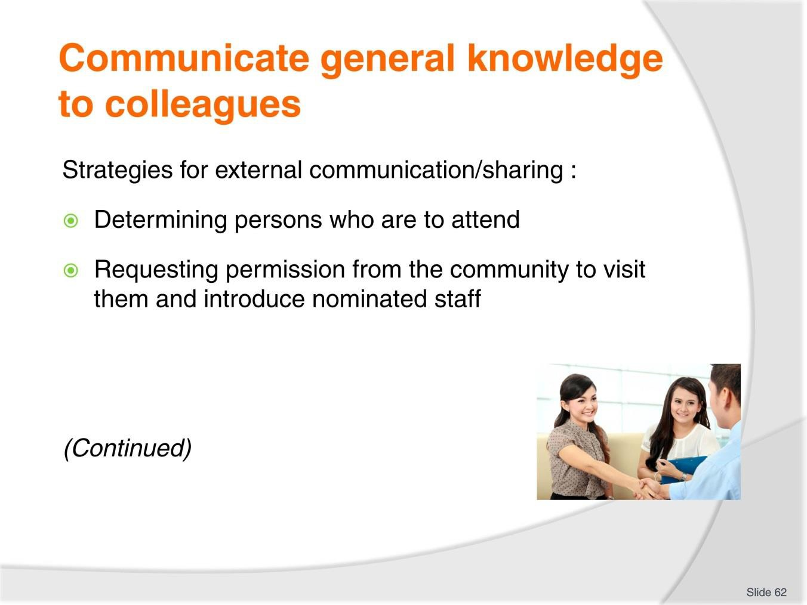
Slide No | Trainer Notes
62. | Trainer presents strategies for external sharing/communication:  - Determining persons who are to attend – commonly selecting from:  - Staff within the Tour Operator business (as identified immediately above)  - Personnel from joint-venture partners  - Media outlets  - Government (tourism-related) agencies  - Requesting permission from the community to visit them and introduce nominated staff – this is an essential element which must be undertaken in order to:  - Demonstrate respect  - Form the basis for all future contact/s with the community  - Further develop the relationship which has already been started  - Prove the community is acknowledged, recognised and valued – and not taken for granted  - Advise community of what the visit seeks to achieve and what personnel want to do, see and who they wish to talk to.

Slide
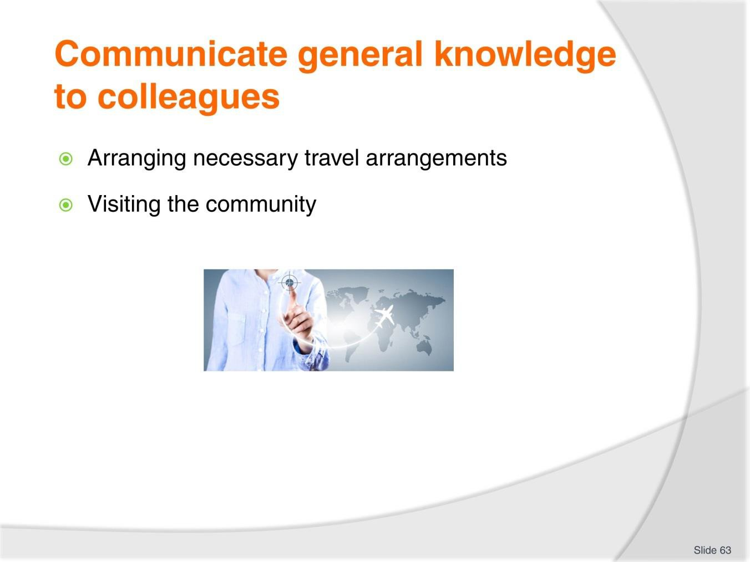
Slide No | Trainer Notes
63. | Trainer continues to present strategies for external sharing/communication:  - Arranging necessary travel arrangements – which might necessitate:  - Organising tickets and/or transport  - Determining accommodation  - Identifying dates and times  - Confirming arrangements with target destination/community  - Visiting the community – which will require:  - Observing local/previously identified protocols  - introducing colleagues to local communities and designated people (elders, community leaders)  - Engaging in talks and meetings with local people  - Touring the area/community  - Viewing sites and activities  - Describing proposed tours and activities within their actual context/location  - Capturing additional information, photographs and ‘missing’ data  - Identifying new tour-related opportunities  - Conducting model tours and interpretive activities

- Discussing potential impact of tours/activities on the community identifying options for mitigating same
- Repeating/confirming Tour Operator intention of working collaboratively with the community
- Thanking the community.

Slide
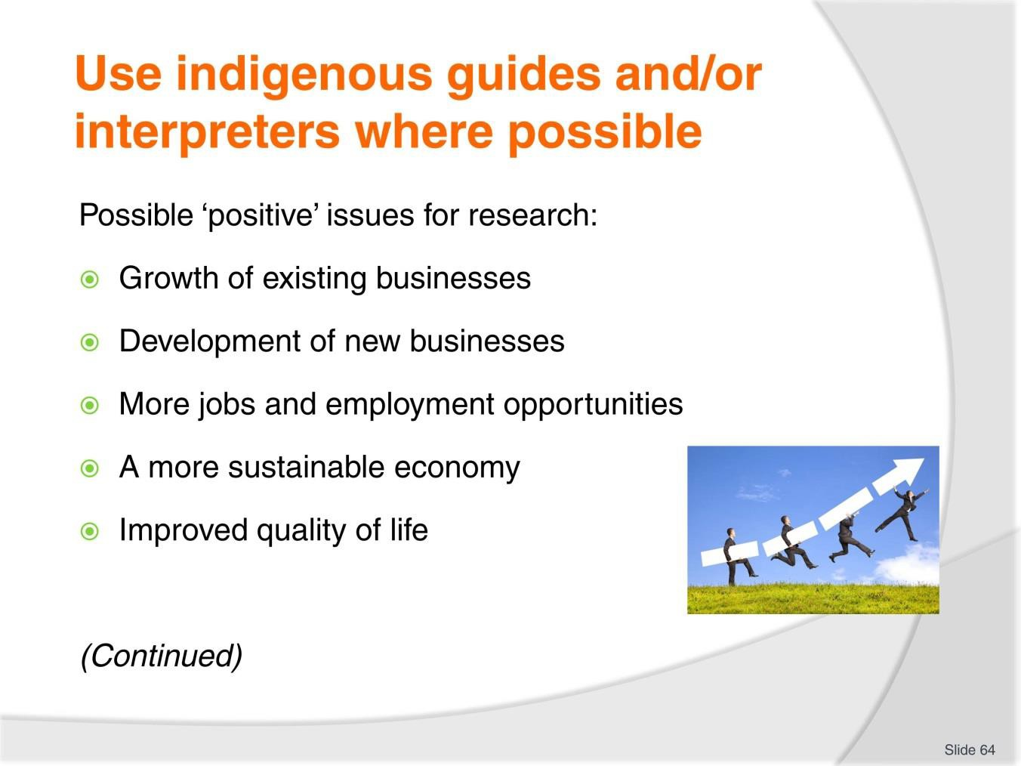
Slide No | Trainer Notes
64. | Trainer presents and discusses possible positive issues often associated with tourism in indigenous communities:  - Growth of existing businesses  - Development of new businesses  - More jobs and employment opportunities  - A more sustainable economy  - Improved quality of life for people/families flowing from employment, economic growth and stability.  Classroom Activity – Internet Research  Trainer facilitates research into and discuss about (sites such as): http://green.hotelscombined.com/Rtg-Benefits-of-Tourism.php - Benefits of tourism.  http://sanctuaries.noaa.gov/management/pdfs/Day5_H2_BenefitsThreats.pdf - Some benefits for local communities; some threats for local communities.

Slide
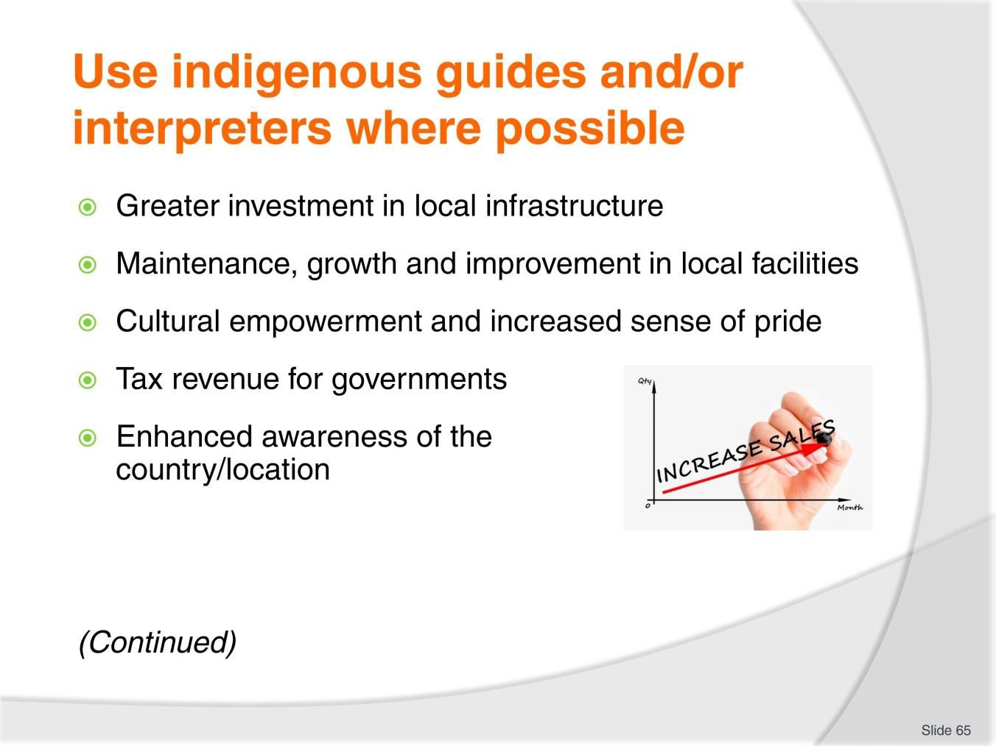
Slide No | Trainer Notes
65. | Trainer continues presenting and discussing possible positive issues:  - Greater investment in local infrastructure and public transport systems from governments  - Maintenance, growth and improvement in local facilities  - Cultural empowerment and increased sense of pride as locals become ambassadors for tourism in their region  - Tax revenue for governments  - Enhanced public/international awareness of the country/location.  Classroom Activity – Internet Research  Trainer facilitates research into and discuss about (sites such as):  http://www.tourisme.gouv.qc.ca/activites/symposium-developpement- durable/presentations/17-C-15h20-2-Richard-Butler.pdf - Benefits to communities of sustainable tourism.

Slide
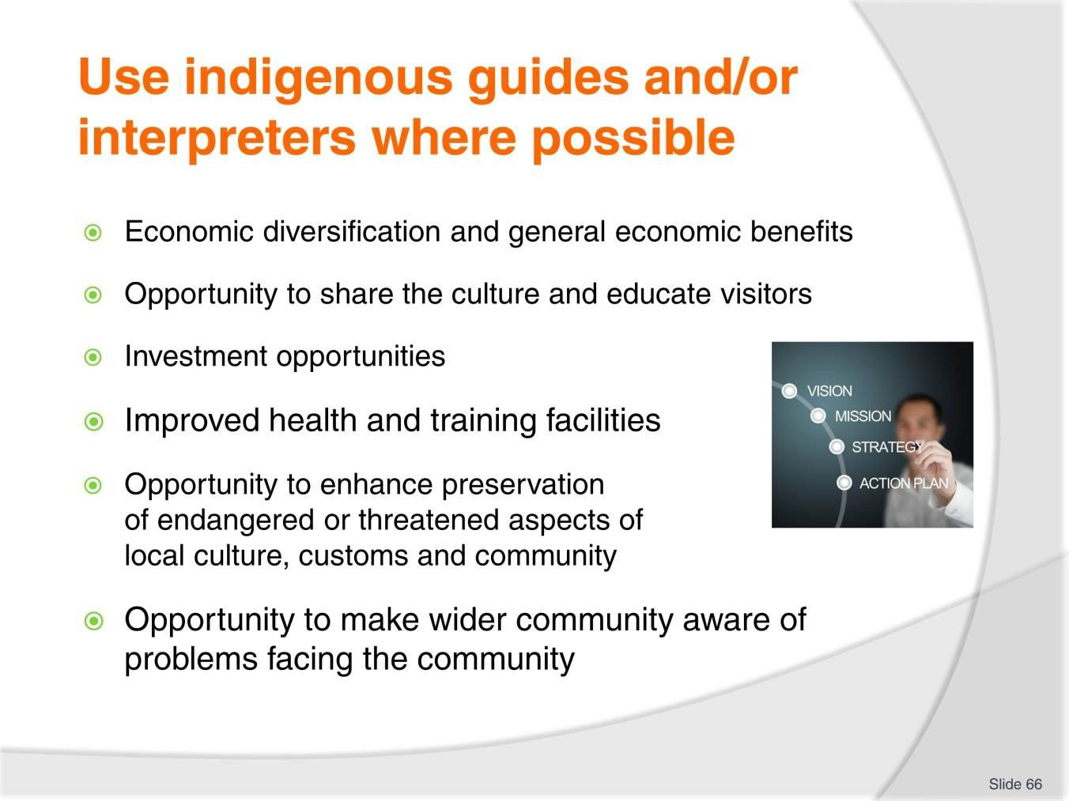
Slide No | Trainer Notes
66. | Trainer continues presenting and discussing possible positive issues:  - Economic diversification and general economic benefits to the local community  - Opportunity to share the culture and educate visitors  - Investment opportunities from the private sector in relation to businesses, real estate, and infrastructure  - Improved health and training facilities  - Opportunity to enhance preservation of endangered or threatened aspects of the local culture, customs and community  - Opportunity to make the wider community aware of the problems facing the community.  Classroom Activity – Internet Research  Trainer facilitates research into and discuss about (sites such as):  http://www.academia.edu/5237947/ASEAN_Tourism_Policy_and_Planning - ASEAN tourism planning and policy.

Slide
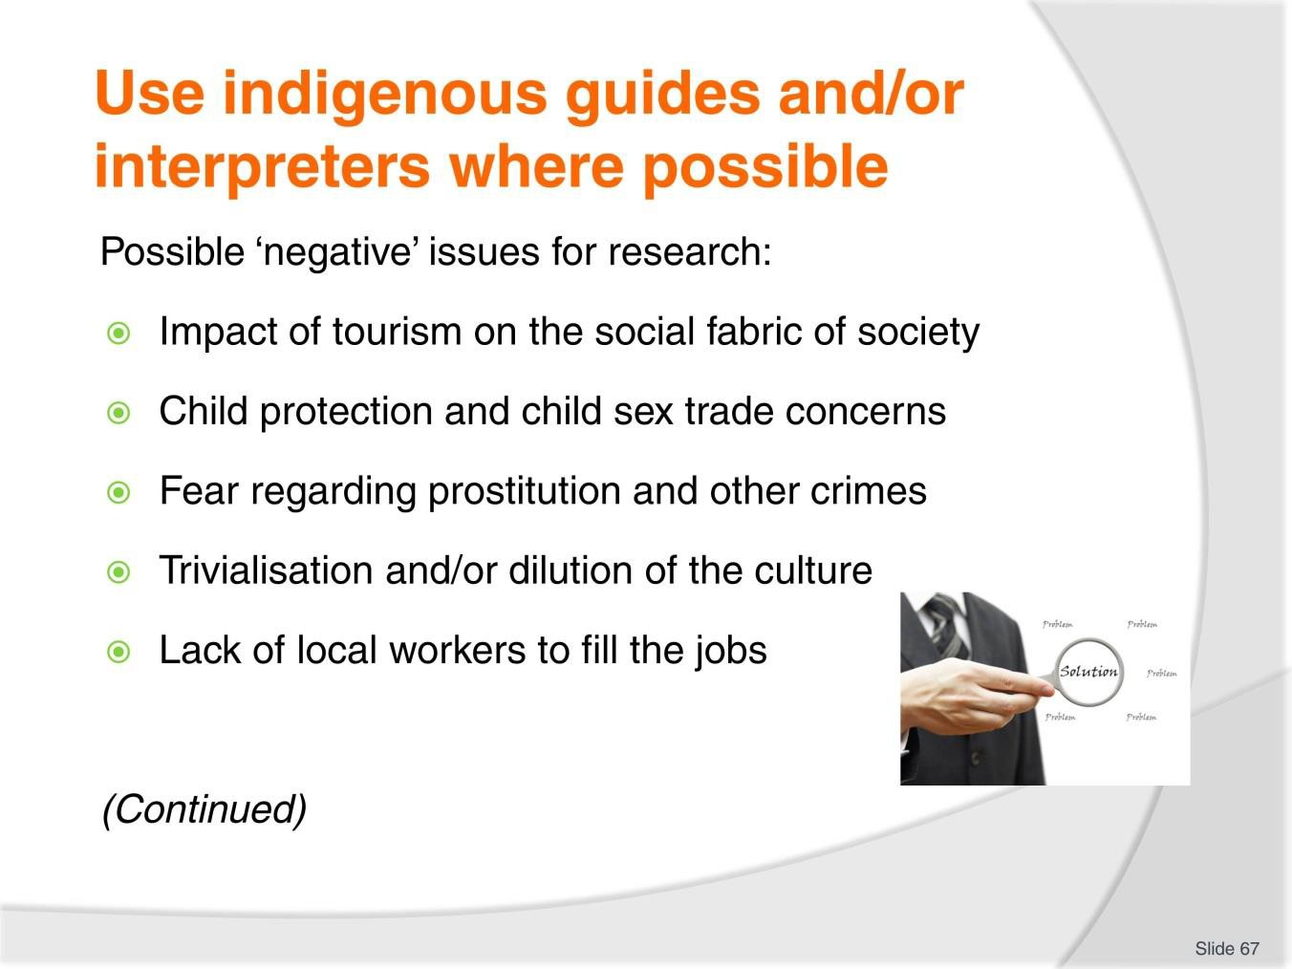
Slide No | Trainer Notes
67. | Trainer presents and discusses possible negative issues often associated with tourism in indigenous communities:  - Impact of tourism on the social fabric of society  - Child protection and child sex trade concerns  - A fear regarding prostitution and other crimes  - Trivialisation and/or dilution of the culture  - Lack of local workers to fill the jobs which are generated.  Classroom Activity – Internet Research  Trainer facilitates research into and discuss about (sites such as):  http://www3.weforum.org/docs/WEF_TTCR_ASEAN_ExecutiveSummary_2012.pdf - The ASEAN Travel and Tourism Competitiveness Report 2012.

Slide
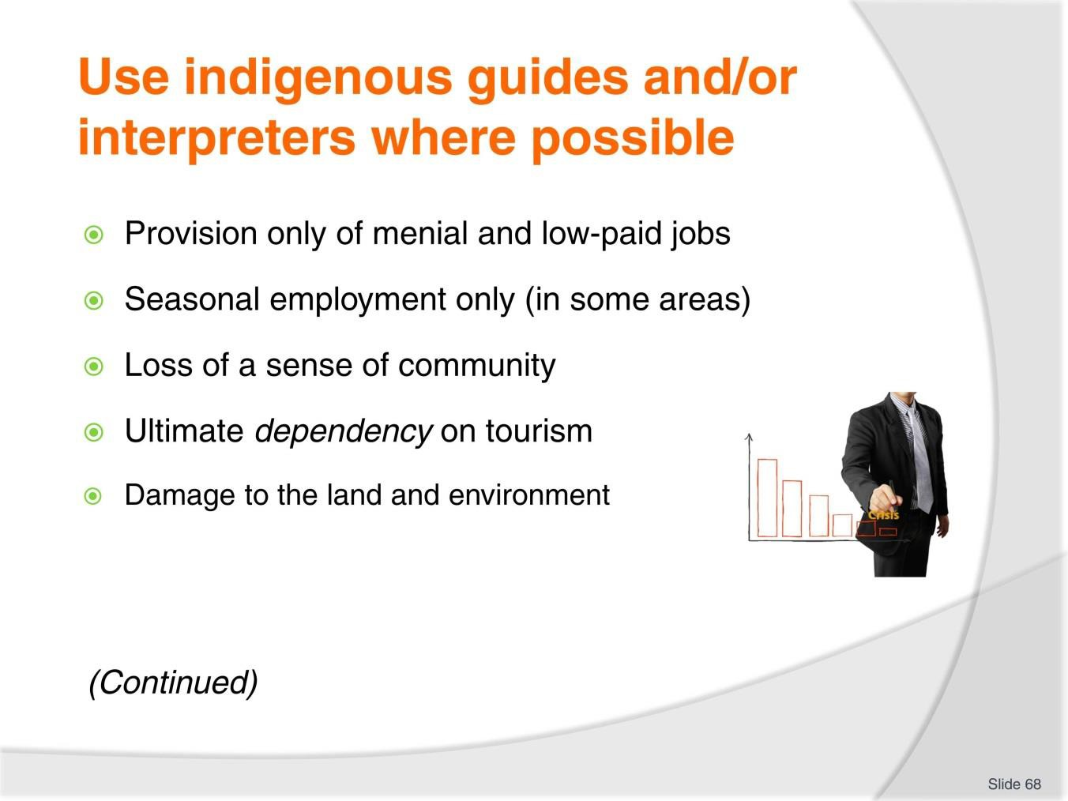
Slide No | Trainer Notes
68. | Trainer continues presenting and discussing possible negative issues:  - Provision only of menial and low-paid jobs  - Seasonal employment only (in some areas)  - Loss of a sense of community within the area  - Ultimate dependency on tourism and consequent need to accommodate whatever is required regardless of the consequences  - Damage to the land and environment including additional pollution.

Slide
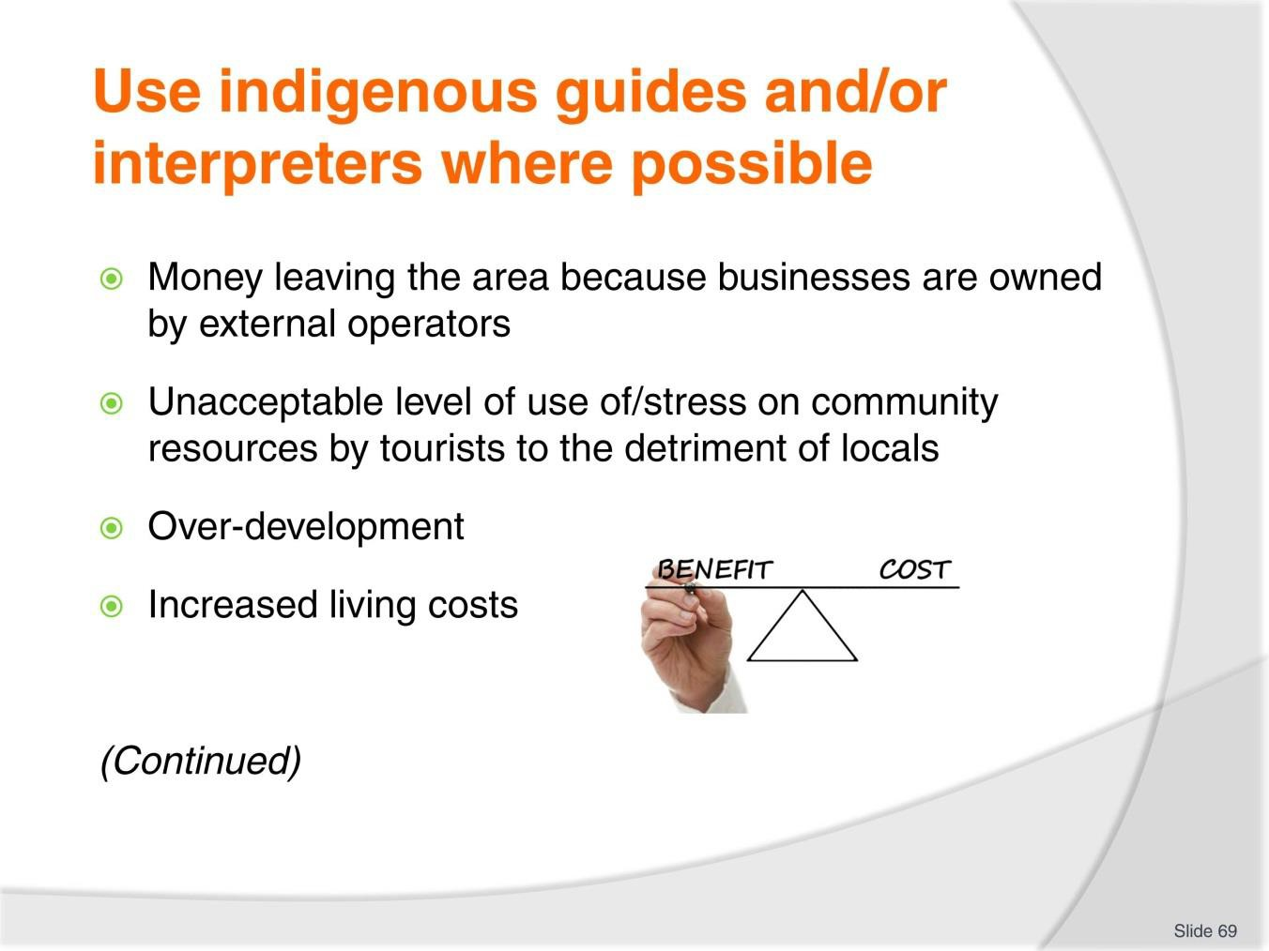
Slide No | Trainer Notes
69. | Trainer continues presenting and discussing possible negative issues:  - Money leaving the area because businesses are owned by external operators  - Unacceptable level of use of/stress on community resources by tourists to the detriment of the local community – over-crowding and (traffic) congestion  - Over-development resulting in decreased amenity of the area  - Increased living costs.

Slide
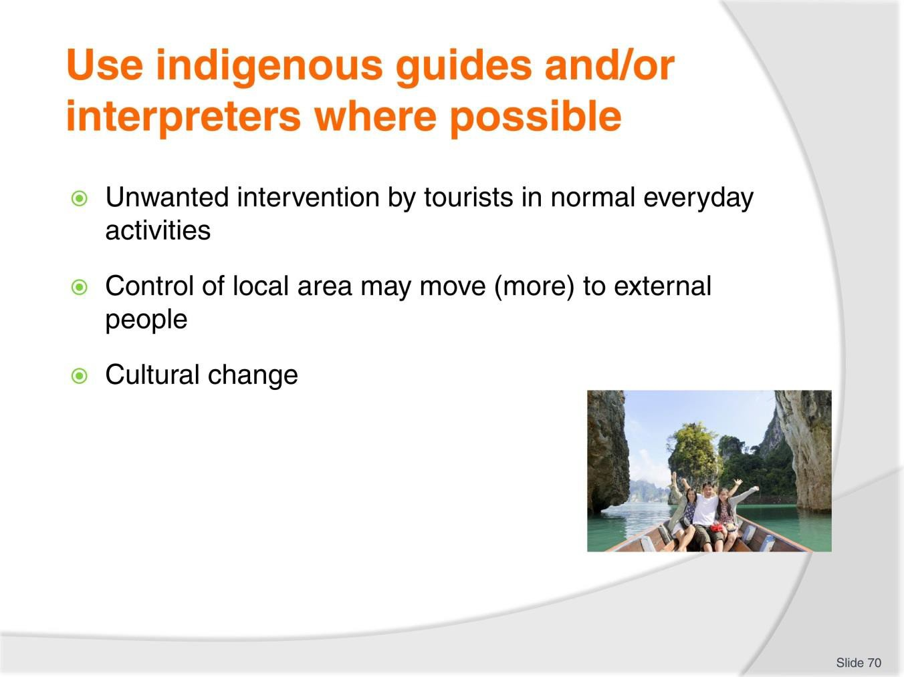
Slide No | Trainer Notes
70. | Trainer continues presenting and discussing possible negative issues:  - Unwanted intervention by tourists in normal everyday activities  - Control of the local area may move (more) to external people, businesses or authorities  - Cultural change – as tourism negatively impacts/influences the lives of the locals.  Classroom Activity – Internet Research  Trainer facilitates research into and discuss about (sites such as):  http://www.tourismkm-asean.org/wp- content/pdf/impact_of_fta/unwto_report_on_asean_tourism_integration.pdf - ASEAN integration and its impact on tourism.

Slide
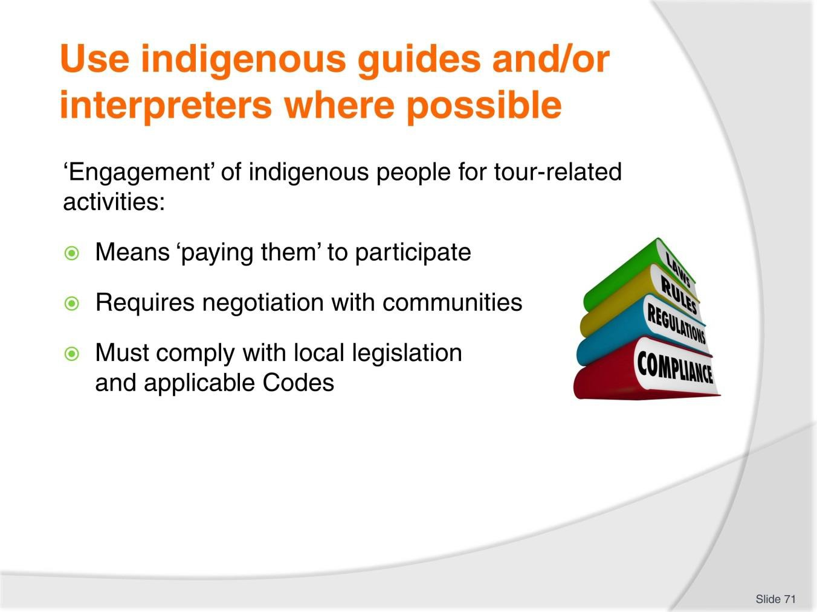
Slide No | Trainer Notes
71. | Trainer discusses ‘engagement’ of indigenous people for tour-related activities observing:  - This means ‘paying them to deliver part of the prepared tour program’.  - The details of payment needs to:  - Be negotiated with them – as opposed to being imposed on  - Comply with applicable laws and Codes of Practice – regarding employment and involvement of indigenous people/workers.

Slide
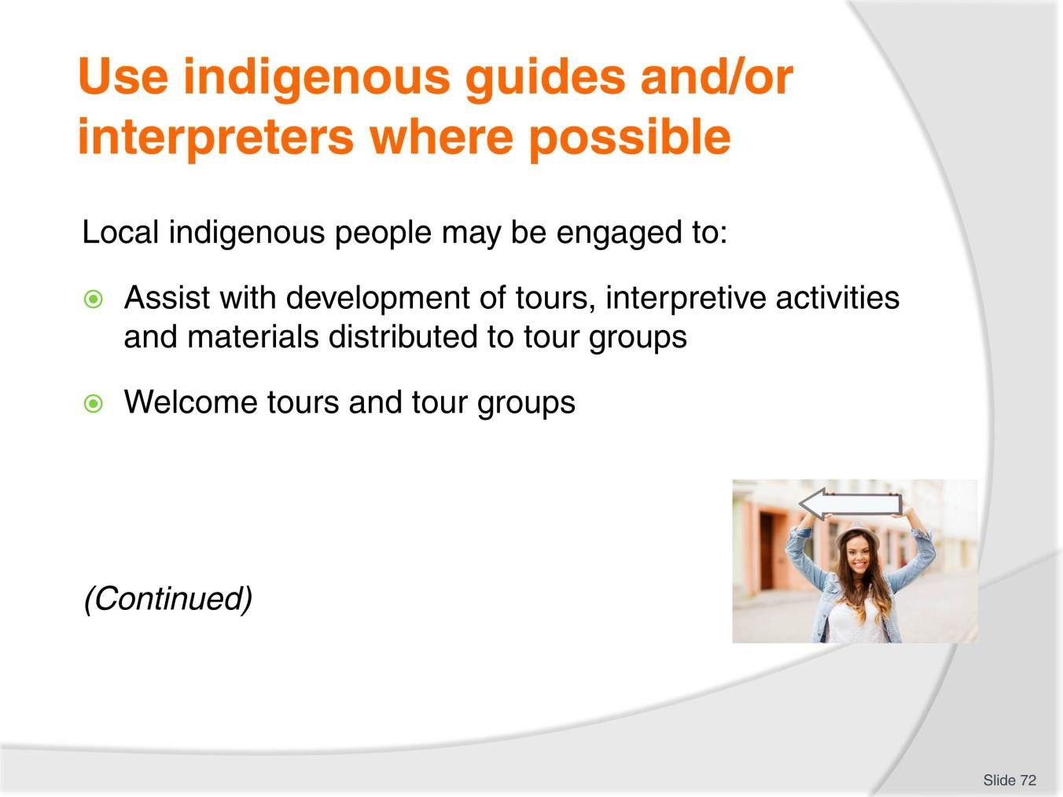
Slide No | Trainer Notes
72. | Trainer notes local indigenous people may be engaged in a wide variety of roles – these include:  - Assisting in the development of suitable, interesting and acceptable tours and interpretive activities – as part of the development process, in terms of:  - Identifying whether or not proposals by the Tour Operator are acceptable or not to the local community  - Suggesting more or alternate ideas for tours and activities  - Describing seasonal influences on weather, access, availability of areas, resources, flora and fauna  - Providing required information and resources  - Contributing vital insight and detail to enhance materials such as promotional materials, scripted commentaries, handouts for tour group members, plans for tours and interpretive activities  - Helping obtain local permission/s to conduct tours, have access to required areas, meet with locals, present activities and provide support services  - Welcoming tourists and tour groups – which may involve:  - Traditional greeting or welcome ceremony  - Making presentations of local items and/or food on arrival.

Slide
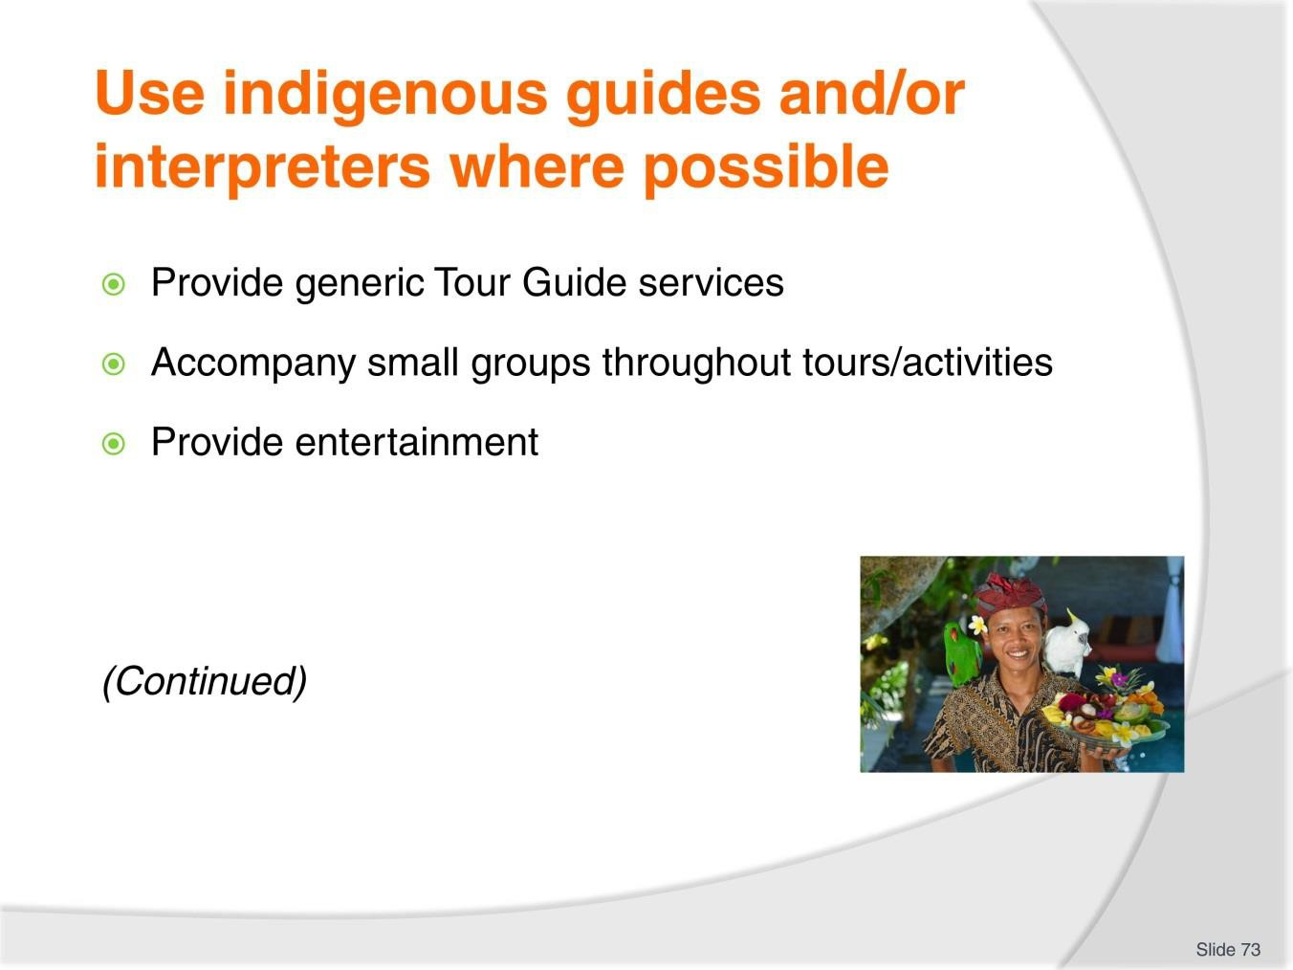
Slide No | Trainer Notes
73. | Trainer continues to identify roles which may be undertaken by local indigenous people:  - Providing generic Tour Guide services – where they:  - Take over the tour after tour groups have arrived and been welcomed  - Conduct only designated sections/aspects of tours  - Supply local knowledge and input to supplement the scripted commentary given by the usual Tour Guide  - Introduce the group to local people  - Facilitate access to areas and resources  - Accompany small groups throughout the tour (which is led by the usual Tour Guide)  - Presenting interpretive activities – such as:  - Story-telling  - Doing demonstrations  - Performing song and dance  - Conducting explorations and exercises  - Leading de-briefing sessions after activities have been completed

- Providing entertainment – in terms of:
  - Singing, music and dancing
  - Presentations of local art and culture
  - Explanation and description of local customs, rites and ceremonies.

Slide
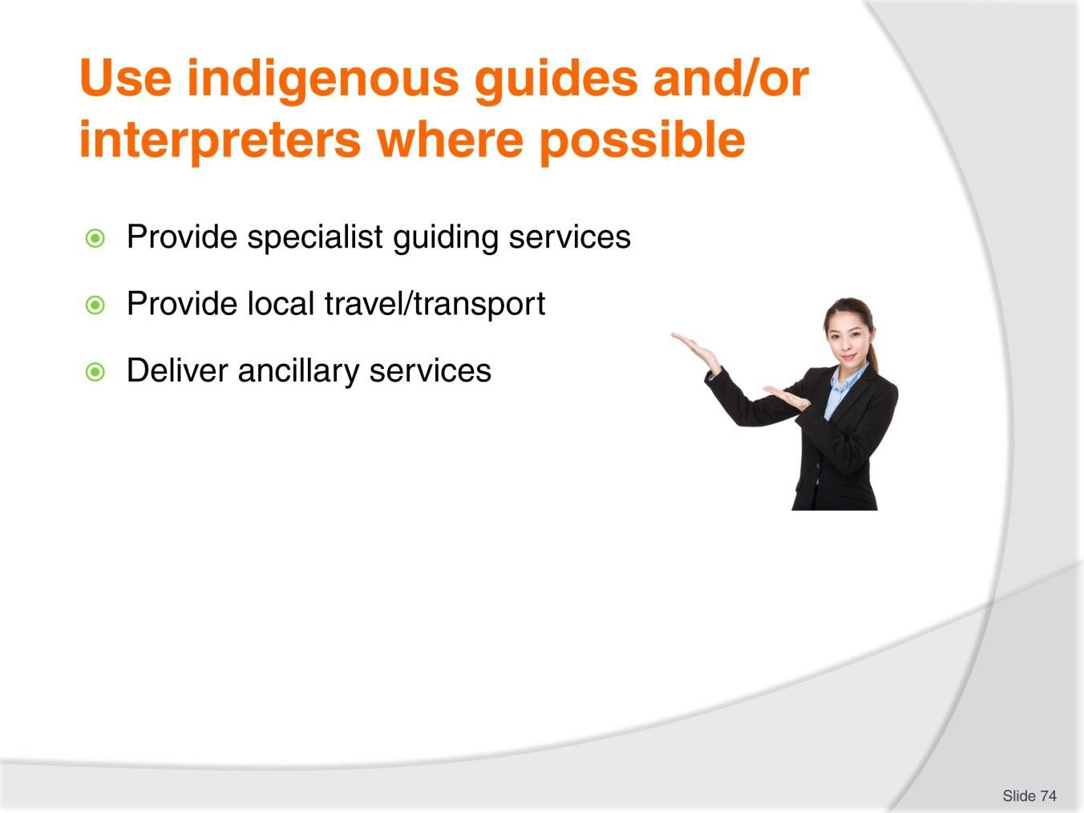
Slide No | Trainer Notes
74. | Trainer continues to identify roles which may be undertaken by local indigenous people:  - Providing specialist Tour Guiding services – as appropriate to distinct/individual tours such as those which have a focus on one or more of the following:  - Observing wildlife; Cooking; Observing religious and other celebrations and rites; Participating in local activities – such as sports, games, tests and trials, dance, hunting; Learning language; Participating in family life; Trekking and safaris; Overnight camping  - Providing local travel/transport services – such as:  - Driving of local tour vehicles in indigenous lands  - Operating water craft on rivers and other waters  - Flying helicopters or ‘planes  - Delivering ancillary services – which may include:  - Providing safety and security services; Interpreting and translating; Providing liaison between the tour party/group and the local community; Loading and unloading services; Carrying supplies and equipment; Distributing materials  - Cleaning; Catering.

Classroom Activity – Excursion
Trainer arranges for students to participate as tourists on a tour (with interpretive activities) to an indigenous community so they may:
- Observe Tour Guide in action
- Get a feel for the information provided – to indicate nature and depth of research required
- Experience the way information is shared by Tour Guide/Operator/staff with tour group members
- Speak with Tour Guide
- Obtain sample handout materials/information sheets.

Slide
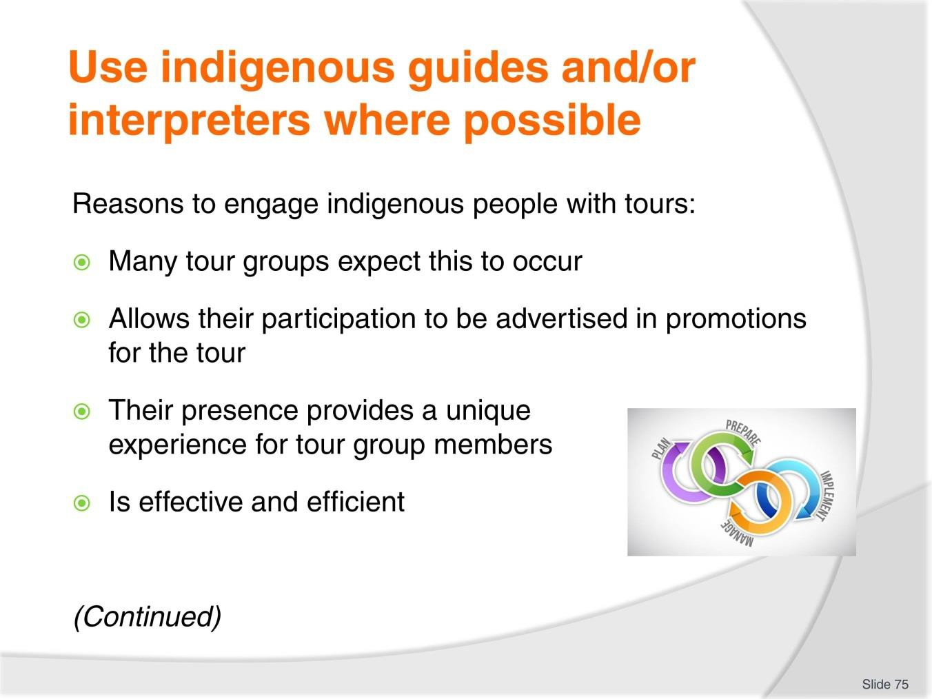
Slide No | Trainer Notes
75. | Trainer identifies the primary reasons for engaging indigenous people with tour-related activities are:  - Many tour groups expect this to occur – they expect to meet and interact with local indigenous people so their involvement helps meet expectations and raise the levels of customer satisfaction with the tour experience  - The involvement of local people allows their participation to be advertised in promotions for the tour – thereby raising interest and making the tour more attractive to potential purchasers of tickets  - Their presence on-tour and in activities provides a unique experience for tour group members – in terms of a range of factors such as:  - Visual impact on tourists – they provide immediate local ‘colour and movement’  - The sound of their voices  - Their smell  - Ability to interact at one-on-one level with an indigenous person – as opposed to observing them ‘at a distance’  - Their willingness to be photographed/video’s by tour groups

- The use of local guides and interpreters has traditionally been shown to be more effective – in terms of:
  - Reducing adverse impact of tours on the local community
  - Lessening the potential for damage to the local environment
  - Lowering threat levels which may be posed by local communities and/or conditions.

Slide
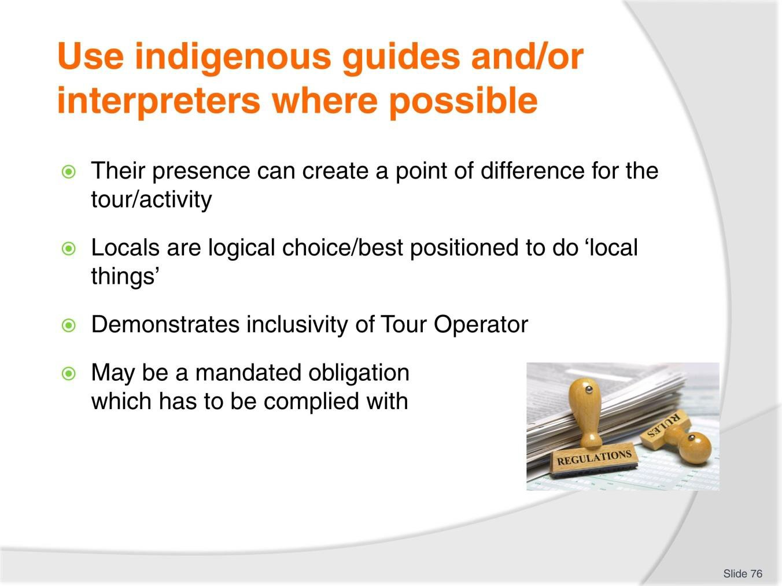
Slide No | Trainer Notes
76. | Trainer continues to identify reasons to engage indigenous people on tours:  - Their participation in tours may create a point of difference for the purposes of sales and marketing – where competition does not feature engagement with locals  - Local people are obviously best able to perform a number of common and necessary tour-related tasks – such as:  - Explain local conditions and customs  - Lead the way to areas where required sighting can be made and nominated experiences can be had  - Describe the local landscape, flora, fauna, weather, environmental conditions and similar aspects relevant to the tour and in response to questions asked by the tour group  - Monitor the actions of tour groups in relation to behaviour likely to give local offence or cause other problems  - Discuss the indigenous family and social structures  - Speak the language  - Demonstrate local skills  - Mediate disputes/problems between locals and tour groups

- Genuine engagement with the local community by the Tour Operator demonstrates a positive orientation to people – by:
  - Showing respect for their knowledge
  - Acknowledging the potential they have to contribute
  - Positioning themselves to receive immediate feedback from the community regarding the impact of tours and activities on the community – so changes can be made to arrangements where/if required
  - Assisting the growth of the local community by making a financial contribution to the area/people
- It may be a mandated requirement – as prescribed by:
  - In-country legislation
  - An applicable Code of Conduct to which the Tour Operator subscribes or by which they are bound
  - Internal agreements which have been developed by the community to govern contact and interaction with Tour Operators
  - The terms and conditions attaching to funding/incentives offered by governments to encourage and assist development of tourist activity in nominated countries/communities.

Slide
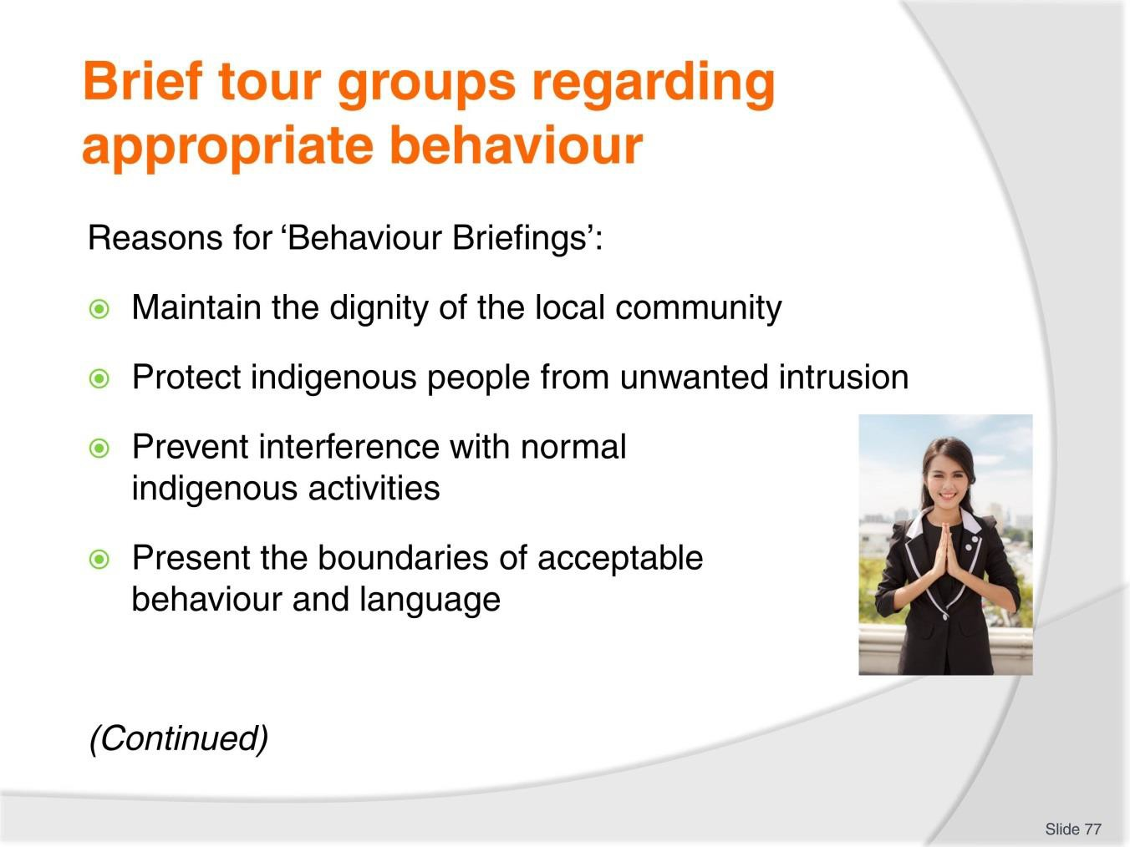
Slide No | Trainer Notes
77. | Trainer identifies reasons for these briefings to be given to tour groups:  - Maintain the dignity of the local community – through:  - Taking actions which respect their values and beliefs  - Refraining from actions which cause offence  - Protect indigenous people from unwanted intrusion – in terms of:  - Being observed by others  - Being engaged in discussions and interactions with tourists  - Prevent interference with normal indigenous activities – such as:  - Family activities  - Traditional day-to-day life  - Religious celebrations and rites  - Present the boundaries of acceptable behaviour and language – and unacceptable behaviour and language (see ‘Content of the briefing’ on later slides).  Classroom Activity – Individual Exercise  Trainer asks students to develop a ‘Behaviour Briefing’ for use with tours in relation to communities they have already researched m- this briefing to be delivered to the class as the next Classroom Activity.

Slide
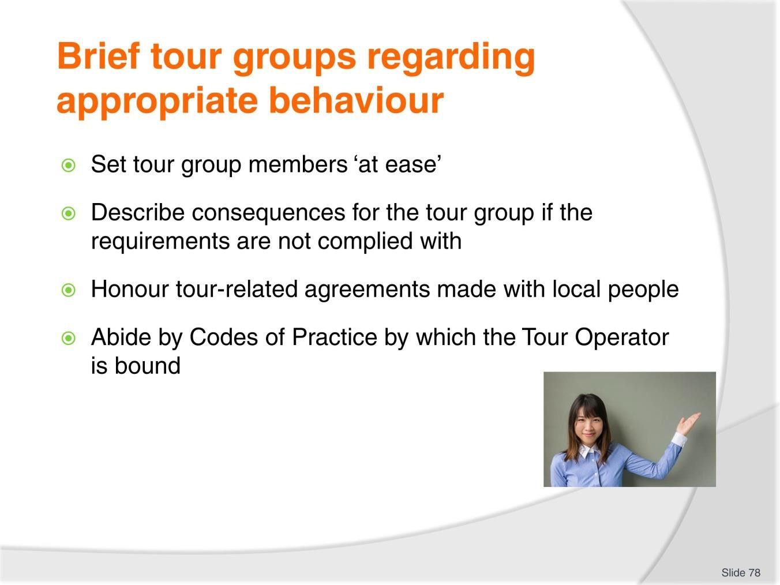
Slide No | Trainer Notes
78. | Trainer continues to identify reasons for these briefings to be given to tour groups:  - Set tour group members ‘at ease’ – by advising them in advance of what they can and cannot do and say:  - Many tour group members appreciate the setting of such ‘boundaries’ as they are often nervous about causing unintended offence to others  - Describe consequences for the tour group if the requirements are not complied with  – see later slides  - Honour tour-related agreements made with local people – in terms of:  - Actually presenting the briefing to every group for every tour, excursion or activity  - Content of the briefing identified by the local community as being essential to their individual need  - Abide by Codes of Practice by which the Tour Operator is bound – or to which they subscribe which requires such a briefing to precede all such tours and activities.  Classroom Activity – Role Play  Trainer asks students to play the role of a Tour Guide conducting a Behaviour Briefing to a tour group.

Slide
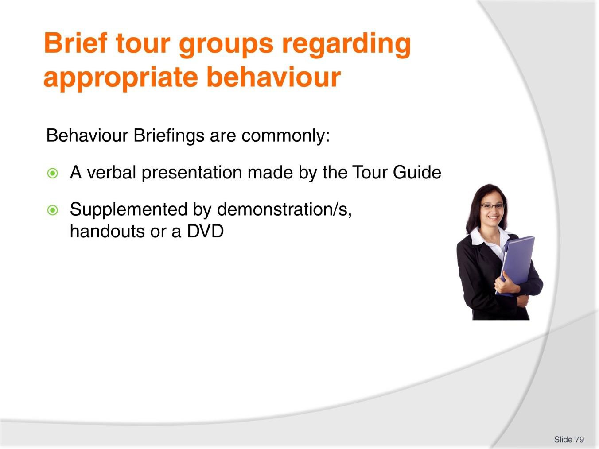
Slide No | Trainer Notes
79. | Trainer notes the Behaviour Briefing may be delivered in several ways stating it is commonly:  - A verbal presentation made by the Tour Guide  - Supplemented by demonstrations, hard copy handouts/information sheets and/or a short video/DVD.  Classroom Activity – Handouts/Examples  Trainer presents materials used to deliver Behaviour Briefings as appropriate to what has been sourced from local Tour Operators – for example:  - Distributing and discussing handouts and/or scripts for same  - Screening and discussing DVD/video.

Slide
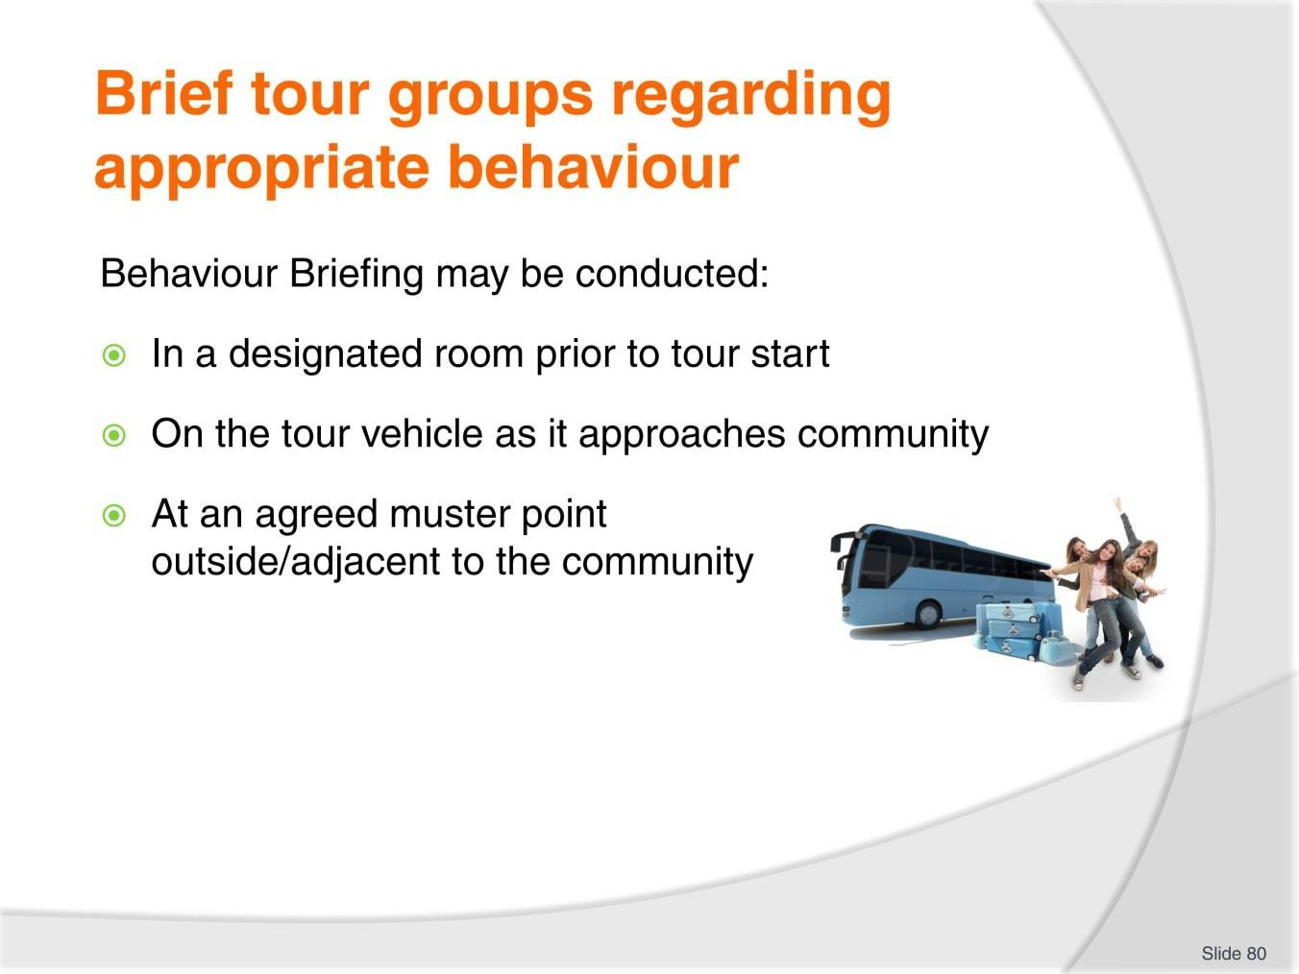
Slide No | Trainer Notes
80. | Trainer informs the briefing is commonly presented:  - In a room or other designated location at the offices of the Tour Operator before the tour/activity commences as part of the wider ‘Tour Briefing’ which commonly precedes all tours, activities and excursions  - On the tour vehicle as it approaches the destination or as it is parked in the agreed parting area for the tour, excursion or activity  - At an agreed muster point for the tour/activity which is inside or near the entry to the indigenous community.

Slide
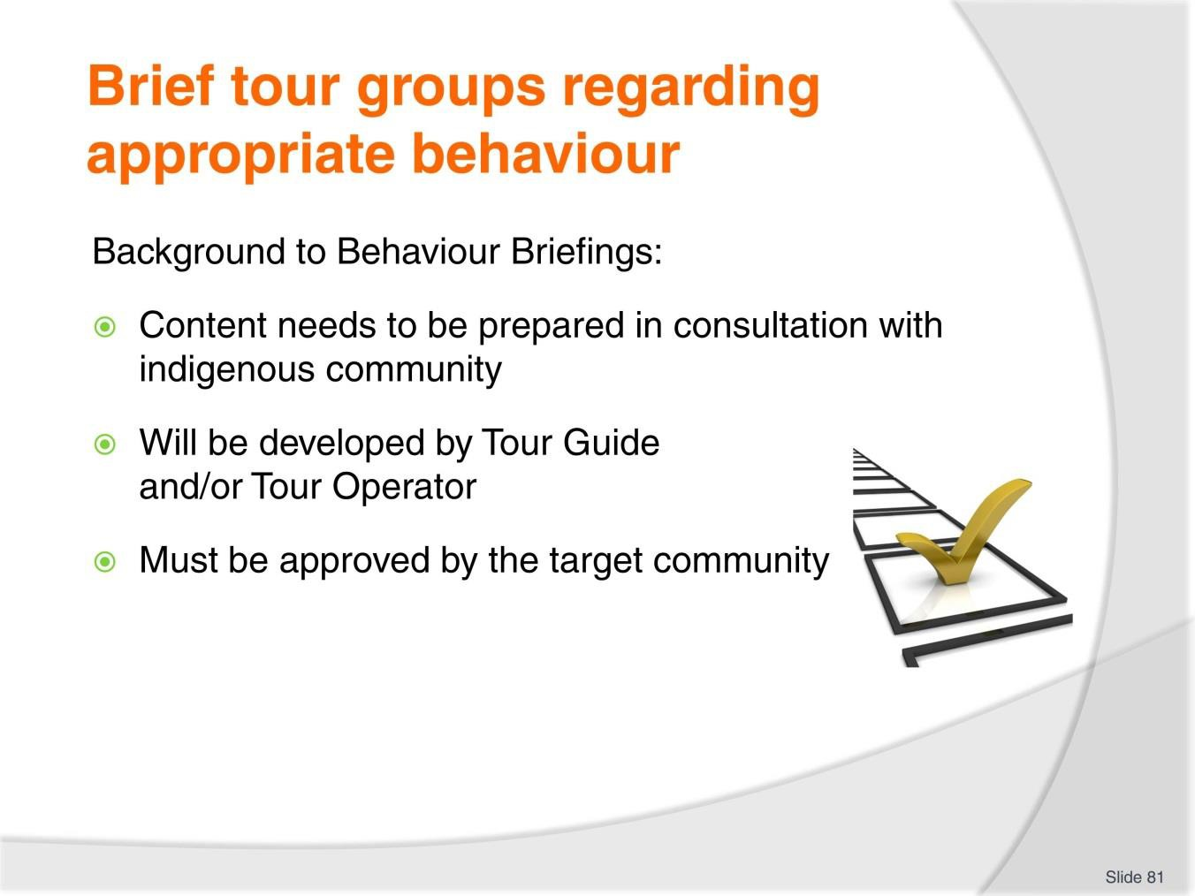
Slide No | Trainer Notes
81. | Trainer discusses content of the Behaviour Briefing  Background  - The content of the briefing will need to be prepared in consultation with the indigenous community in order to address their individual concerns and issues, and may need to be:  - Developed by the individual Tour Guide conducting the Tour, excursion of activity – as part of their preparation activities  - Developed by the Tour Operator – and be provided as part of the standard ‘Tour Brief’ to the Tour Guide/staff  - Have to gain ‘final approval from the local community – prior to its implementation.

Slide
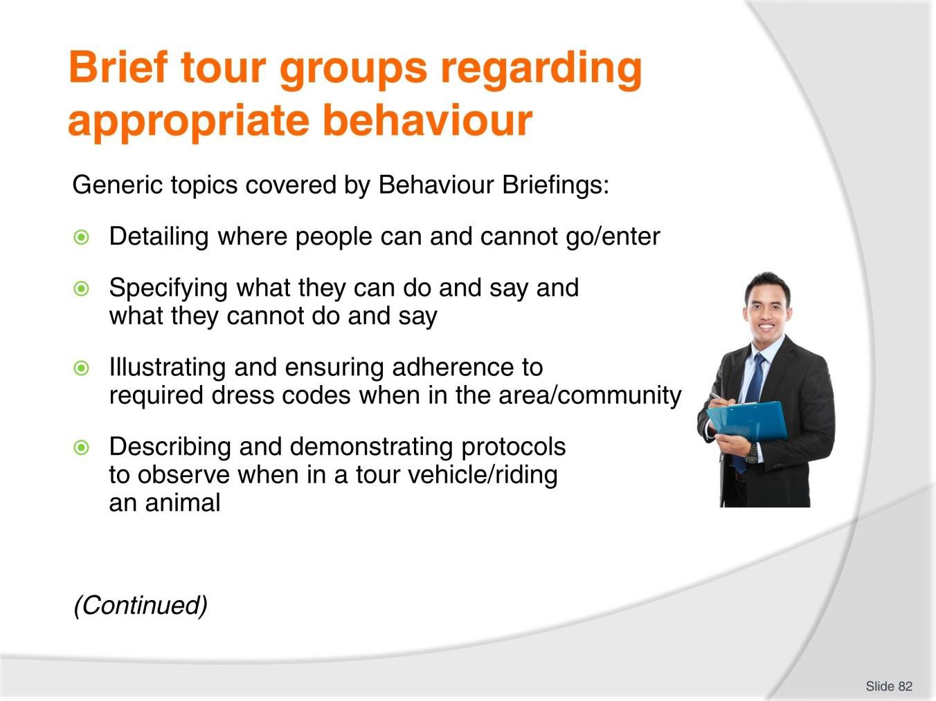
Slide No | Trainer Notes
82. | Trainer continues to discuss content of the Behaviour Briefing  Generic topics  Issues commonly covered by these briefings include:  - Detailing where people can and cannot go/enter  - Specifying what they can do and say and what they cannot do and say  - Illustrating and ensuring adherence to required dress codes when in the area/community  - Describing and demonstrating protocols to observe when in a tour vehicle/riding an animal.  Classroom Activity – Internet Research  Trainer facilitates research into and discuss about (sites such as):  http://www.aippnet.org/index.php/human-rights/763-statement-of-indigenous-peoples-a- ethnic-minorities-ipaem-of-asean - Statement of indigenous peoples and ethnic minorities (IP&EM) of ASEAN.

Slide
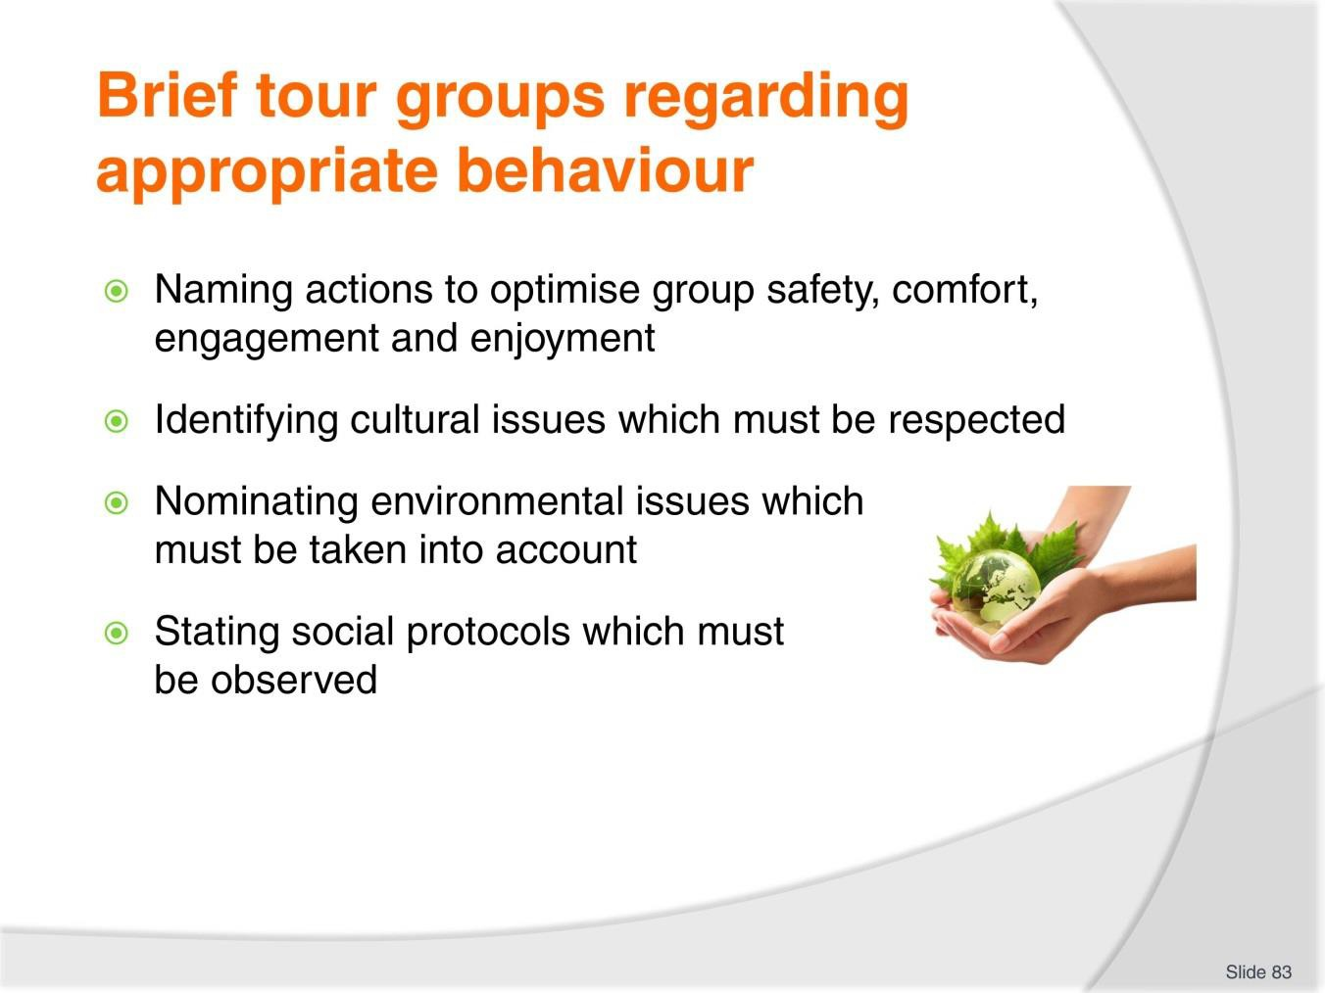
Slide No | Trainer Notes
83. | Trainer continues to discuss generic content of the Behaviour Briefing:  - Naming actions to optimise group safety, comfort, engagement and enjoyment  - Identifying cultural issues which must be respected  - Nominating environmental issues which must be taken into account  - Stating social protocols which must be observed.  Classroom Activity – Internet Research  Trainer facilitates research into and discuss about (sites such as):  http://www.aippnet.org/pdf/ASEAN,%20CC,%20REDD+%20AND%20IPs_FINAL.pdf – ASEAN, Climate Change, REDD+and indigenous peoples.

Slide
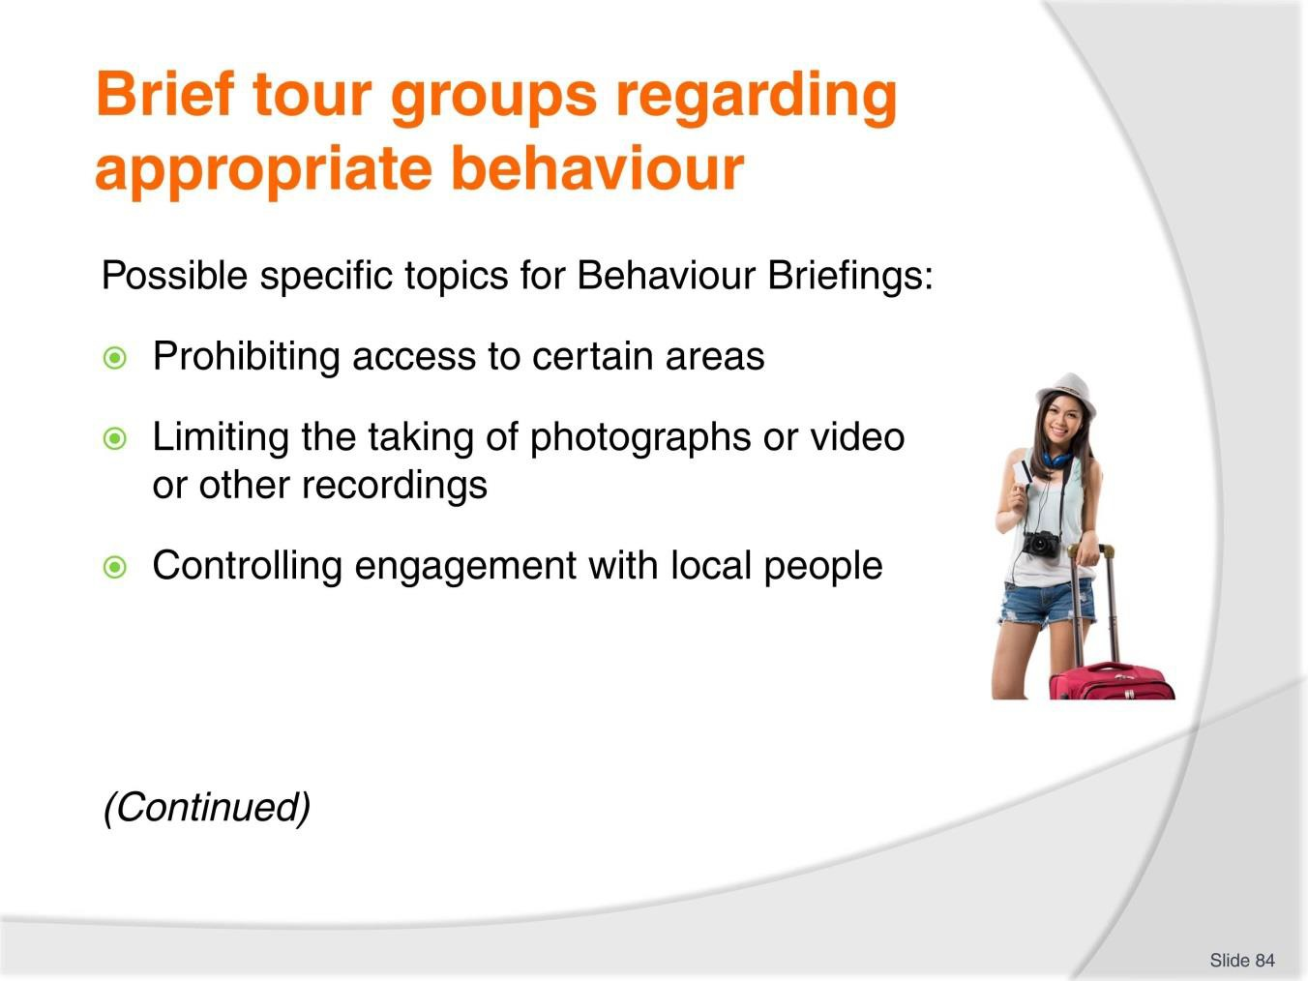
Slide No | Trainer Notes
84. | Trainer identified possible specific topics which may need to be covered by Behaviour Briefings:  - Prohibiting access to certain areas – such as:  - Not entering nominated buildings and/or grounds  - Staying a certain distance from designated sites  - Never going into private homes/dwellings  - Avoiding contact with obvious family areas  - Not wandering off designated tracks/walking paths  - Limiting the taking of photographs or video or other recordings – in relation to (for example):  - Prohibiting images of indigenous people – or females, or children in the community  - Banning recording images of designated sacred sites  - Requiring permission before recording images  - Asking if locals need payment to be photographed/recorded

- Controlling engagement with local people – in terms of:
  - Banning discussion with the general population – and limiting verbal exchanges only to local/indigenous Tour Guides and/or designated community people identified as being part of the tour group/staff
  - Not allowing offering of cash or gifts
  - Avoiding staring
  - Prohibiting eye contact.
Classroom Activity – Guest Speaker
Trainer arranges for an experienced Guest Speaker to attend and:
- Demonstrate delivery of a Behaviour Briefing
- Supply sample script for the Behaviour Briefing.

Slide
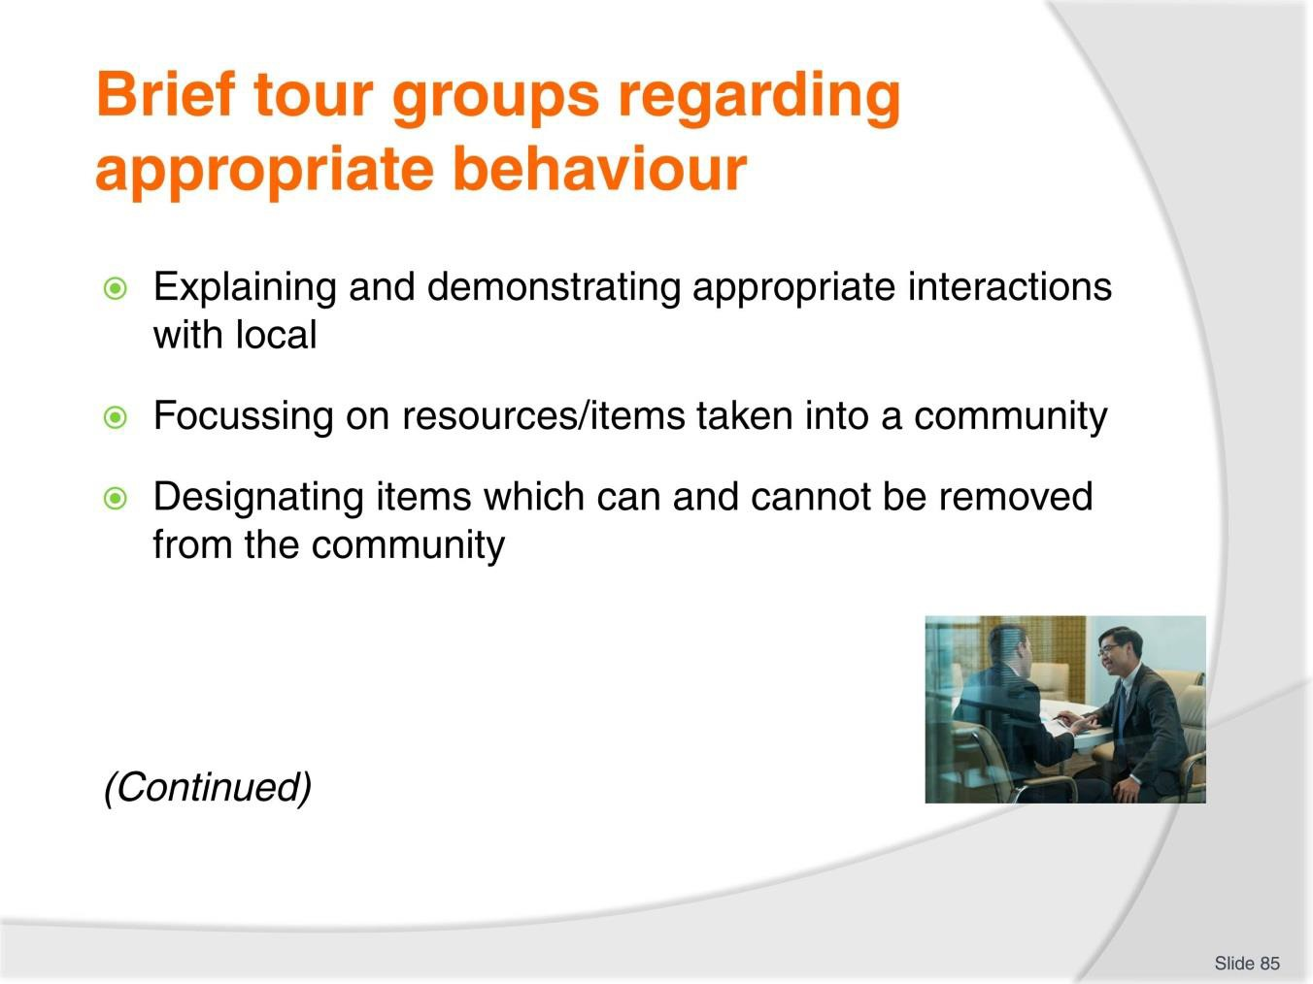
Slide No | Trainer Notes
85. | Trainer continues to identify possible specific topics which may need to be covered by Behaviour Briefings:  - Explaining and demonstrating appropriate interactions with local – which may address:  - Initial contact/greeting – saying ‘Hello’  - Appropriate body language – and actions to avoid  - Topics which can be discussed and which should be avoided  - General conversation tips and words/phrases – such as saying ‘Please’ and ‘Thank you’  - Focussing on resources/items taken into a community – with reference to (for example):  - Insisting all resources/items taken into a community are taken out – and no rubbish is left behind as a result of the tour, excursion or activity  - Banning carriage of certain products into a community – such as disposable nappies, plastic bags, fast food, bottles  - Designating items which can and cannot be removed from the community – which may address:  - Banning removal of food, flora and fauna from the area  - Stressing only merchandise purchased from the locals can be removed.

Slide
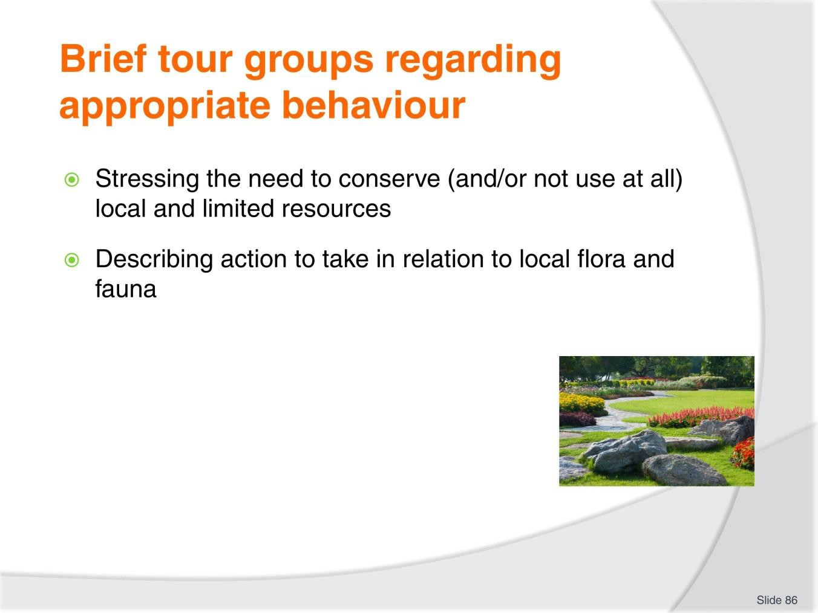
Slide No | Trainer Notes
86. | Trainer continues to identify possible specific topics which may need to be covered by Behaviour Briefings:  - Stressing the need to conserve (and/or not use at all) local and limited resources – which may be:  - Water/drinking water  - Wood  - Foodstuffs  - Describing action to take in relation to local flora and fauna – such as:  - Not scaring animals  - Not touching, patting or feeding local stock  - Not picking flowers.  Classroom Activity – Role Play  Trainer asks students to play the role of a Tour Guide conducting a Behaviour Briefing to a tour group.

Slide
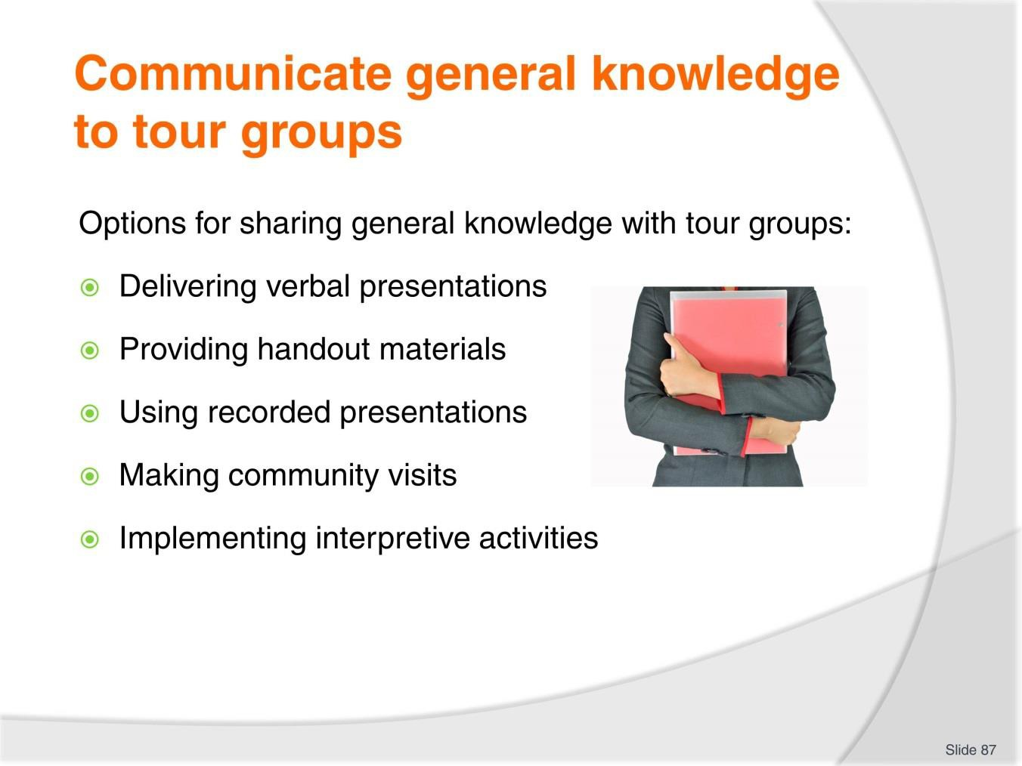
Slide No | Trainer Notes
87. | Trainer identifies options for sharing general information:  - Delivering verbal presentations – in terms of:  - Formal, structured presentations  - Casual, supplementary contributions  - Providing handout materials  - Using recorded presentations  - Making community visits  - Implementing interpretive activities.

Slide
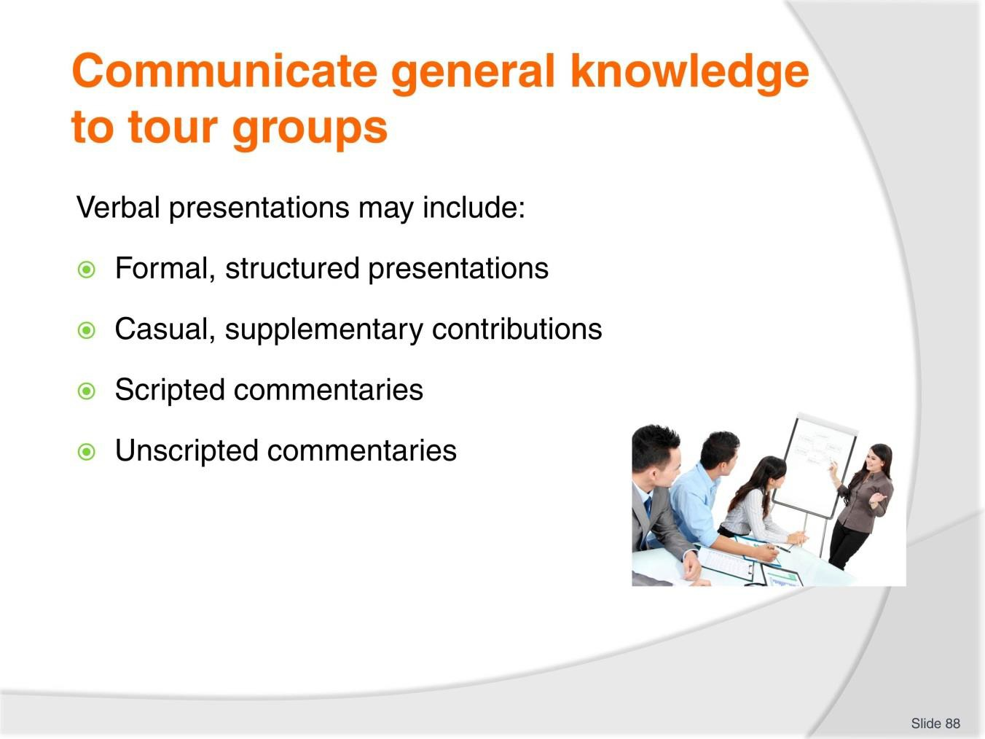
Slide No | Trainer Notes
88. | Trainer discusses verbal presentations offering they may include:  - Formal, structured presentations – which:  - Are provided to all tour group members for every tour, excursion or activity  - Will be time-limited – in that they need to be completed in a set time  - Have been developed before-hand and may have been approved by the destination communities  - Are targeted to the individual community that is the focus of an up-coming tour/activity  - Address topics relevant to the type and aim/objectives of the tour  - Ensure ‘required topics’ as identified by the indigenous people are delivered and explained to the tour groups  - May be supplemented by use of a PowerPoint, slide or overhead projection presentation  - Could include distribution of handout materials and recorded information – see later slides  - May feature demonstrations – to illustrate certain points deemed important/central to the tour/activity

- Casual, supplementary contributions – these are comments made by the Tour Guide and other tour staff:
  - In response to special requests raised by tour group members when on-tour
  - When answering on-tour questions asked by members of the tour group
  - While conversing with individuals or small groups while on-tour
- Scripted commentaries – these:
  - The pre-prepared/written scripts used when providing a tour commentary when on-tour
  - Differ to reflect the individual requirements of each tour type
  - Provide consistent general information to every tour group on every tour
  - Are sequenced to match sights and activities featured on the tour
  - Are based on significant research and input from relevant stakeholders including the indigenous community
  - Will be approved by the local community to ensure it is factual and truly reflective of their culture
- Unscripted commentaries – these are different to ‘Casual, supplementary contributions’ as described above in that they:
  - Add information about topics and issues as they arise on tour which are ‘over and above’ the content covered by the scripted commentary
  - Address ‘one-off’ instances observed by the group while on-tour
  - Factor in seasonal and unique events.
Classroom Activity – Handout
Trainer distributes and discusses sample scripted commentary.

Slide
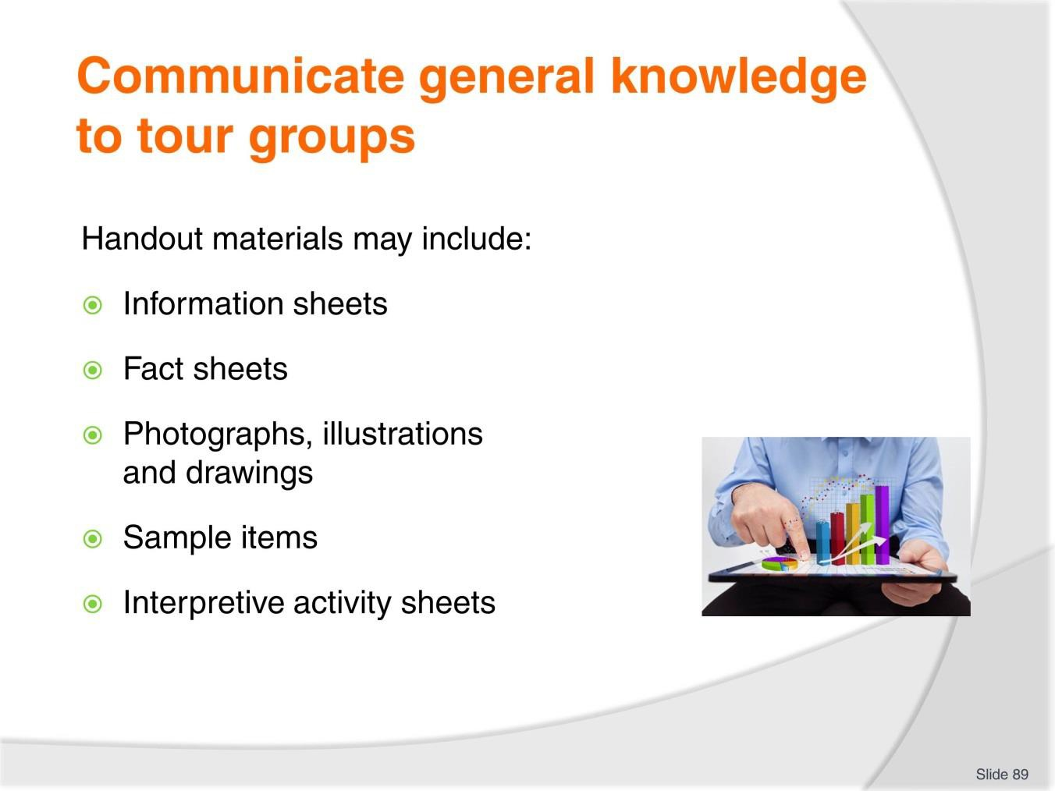
Slide No | Trainer Notes
89. | Trainer discusses handout materials which can include:  - Information sheets – giving basic information about the destination such as coverage of topics including:  - History; Geographical features; Flora and fauna; Customs and beliefs; Social and family structures  - Rites and religions  - Fact sheets – which may be produced to supplement and extend information on topics which provide a focus for individual tour types. These sheets – which will vary depending on the nature/type/title of the tour being conducted into the indigenous community – give ‘extra’ detail and insight on the individual headings/topics covered by the Information sheets  - Photographs, illustrations and drawings – relating to people, their community, their art, animals and a wide range of potential other topics:  - Once again the focus of these should reflect the nature, type or title of the tour as well as any known interests or special requests made by tour group members

- Sample items – this may involve:
  - Showing of indigenous artifacts
  - Tasting of local food and beverages
  - Distribution of examples of local work and art
- Interpretive activity sheets – these can:
  - Provide targeted information relevant only to specific interpretive activities to be conducted
  - Give relevant background information to assist with understanding the context for each interpretive activity
  - Include observation (or ‘scoring’) sheets – for tour group members to record their findings, feelings, experiences and similar.
Classroom Activity – Handouts
Trainer distributes and discusses items as identified on the slide.

Slide
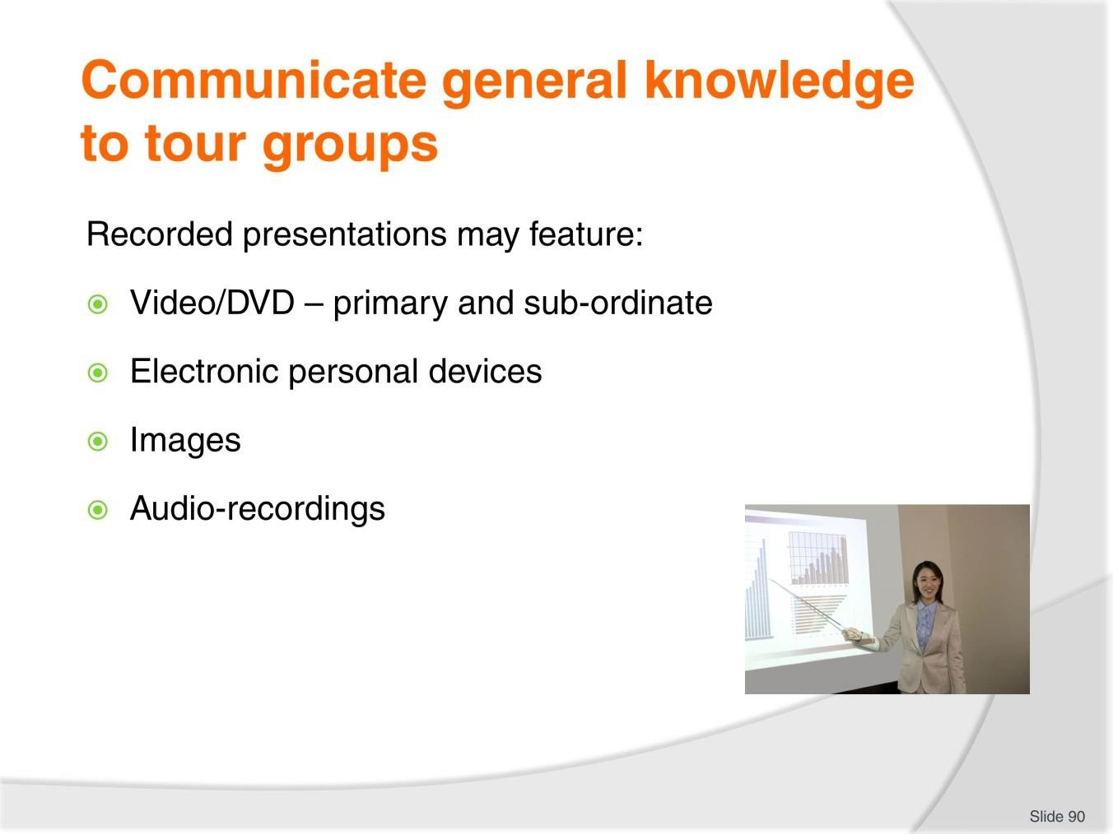
Slide No | Trainer Notes
90. | Trainer observes general information may also be shared using:  - A video/DVD which provides general information about the overall indigenous community and people – this video/DVD would be shown to all tour groups  - A range of sub-ordinate videos/DVDs – which provide information targeted to narrower elements/topics which will be addressed by certain tour types  - Electronic personal devices – provided to individual tour group members to enable them to conduct their own ‘self briefings’  - A range of ‘images’ – which may be shared/communicated using:  - Booklets and brochures  - Individual photographs  - PowerPoint presentations  - Audio recording – of language, singing, animals, natural events.  Classroom Activity – Demonstration  Trainer demonstrates use of the resources identified on the slide for sharing general knowledge about indigenous communities.

Slide
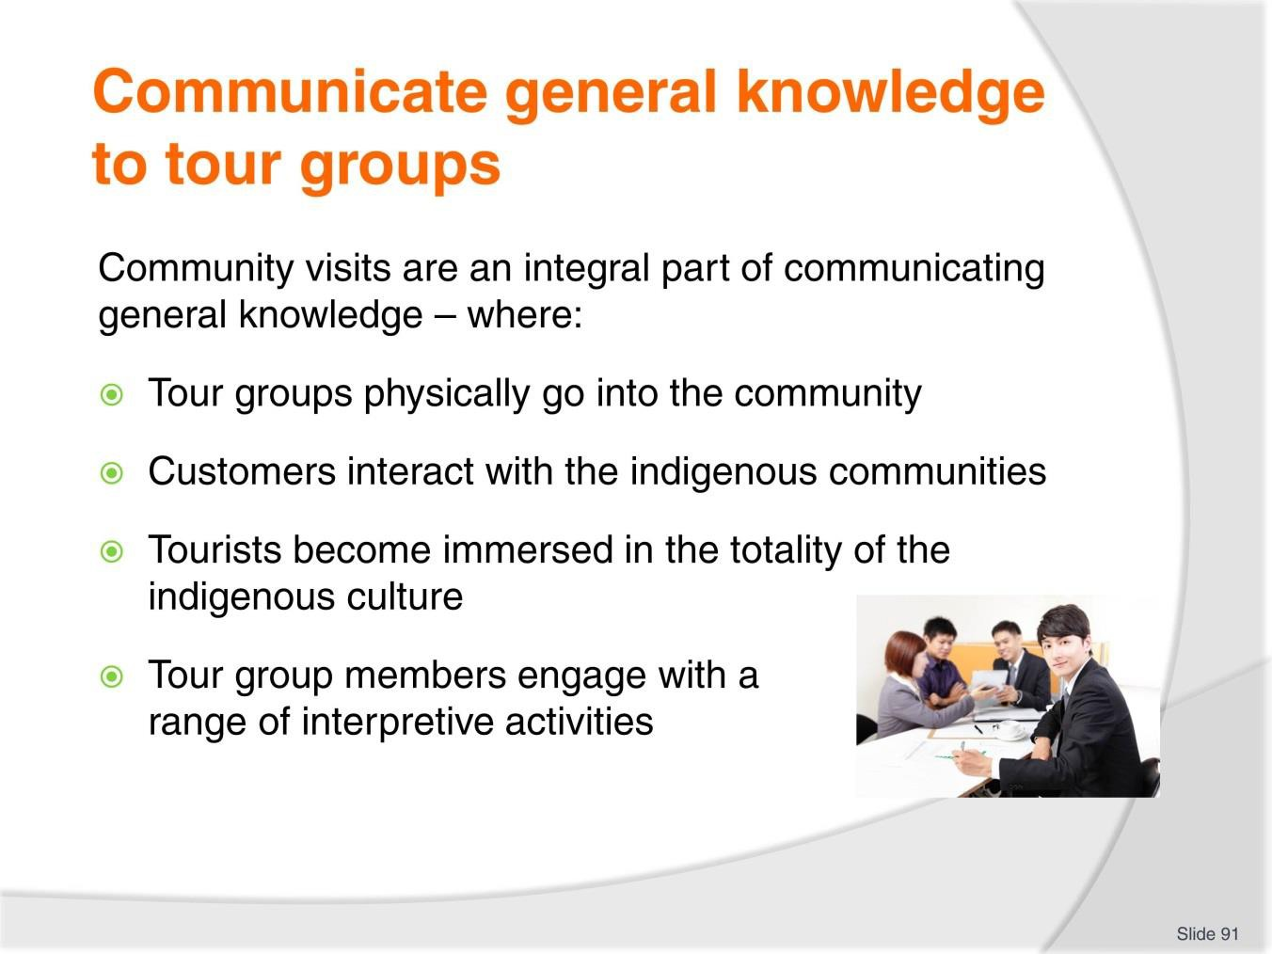
Slide No | Trainer Notes
91. | Trainer indicates general information sharing always includes community visits where:  - Tour groups physically go into the community – to observe the people and the environment and engage with the land/community  - Customers interact with the indigenous communities – in-keeping with pre- arranged/allowed limits  - Tourists become immersed in the totality of the indigenous culture – and what it has to offer  - Tour group members engage with a range of interpretive activities – pre-prepared by the Tour Operator and approved and supported by the local community.

Slide
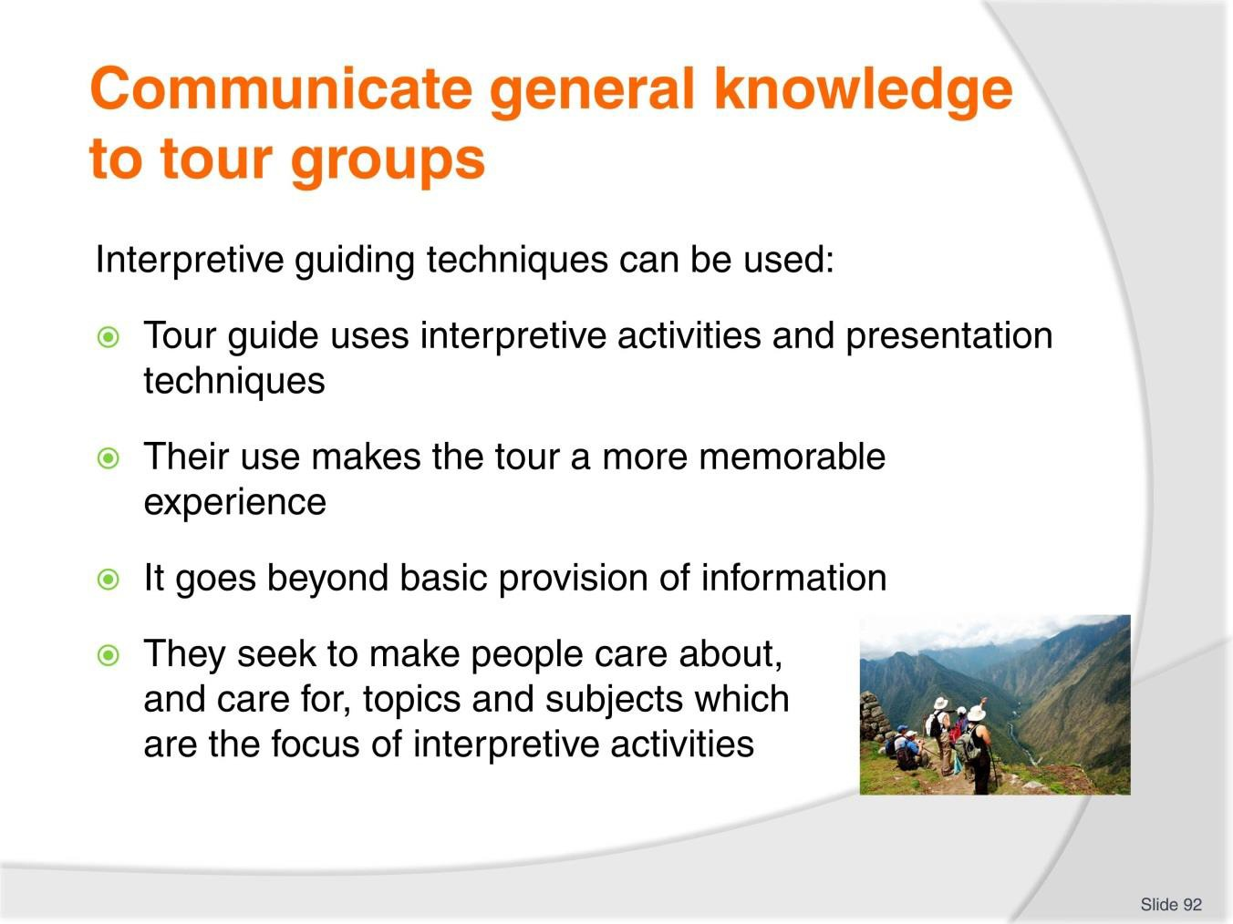
Slide No | Trainer Notes
92. | Trainer highlights interpretive guiding techniques can also be used to share general information inasmuch that:  - They can be seen as the use of interpretive activities and presentation techniques by a Tour Guide when leading/presenting a tour  - Their use makes a tour for participants a much more memorable experience.  - It goes beyond the basic provision of information which is seen by many as their sole objective when conducting a tour  - Their implementation refers to the use of interpretive activities and techniques to interpret the topics/areas which are the focus of the tour or encountered along the way.  - They seek to make people care about, and care for, topics and subjects which are the focus of interpretive activities.

Slide
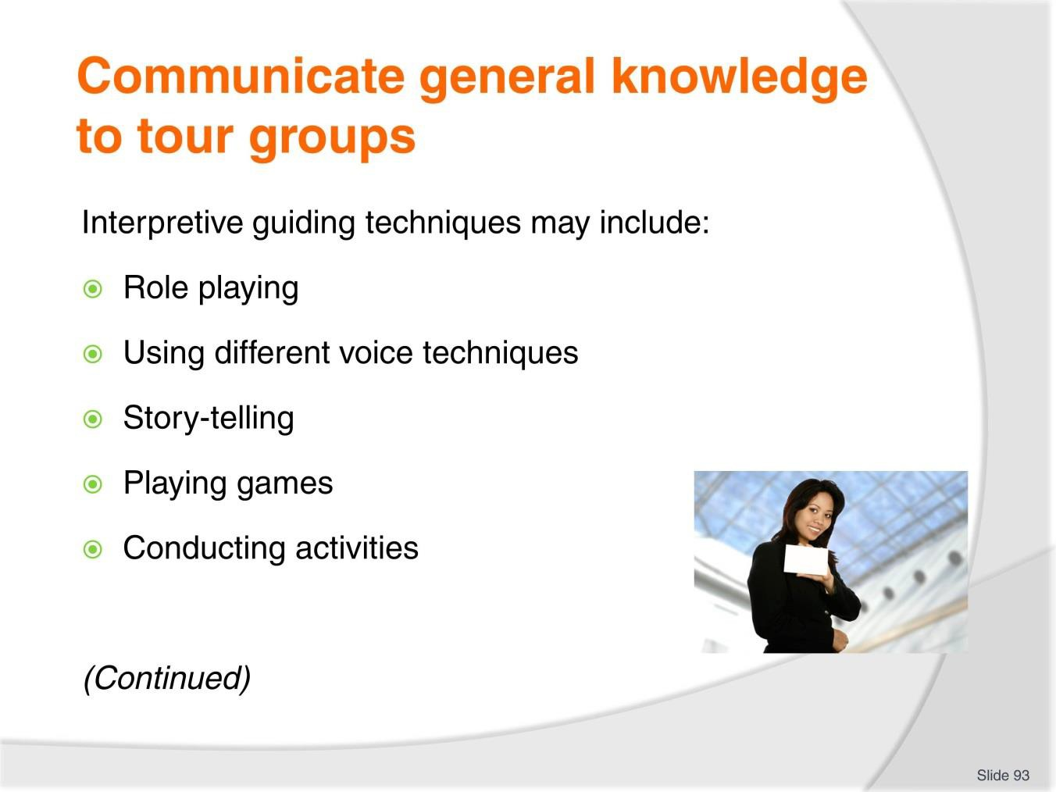
Slide No | Trainer Notes
93. | Trainer identifies interpretive guiding techniques which may be used for sharing general knowledge:  - Role playing  - Using different voice techniques  - Story-telling  - Playing of games  - Conducting activities.  Classroom Activity – Demonstration and Practice  Trainer uses the interpretive guiding techniques identified on the slide to present general information to a simulated tour group and provides an opportunity for students to do the same.

Slide
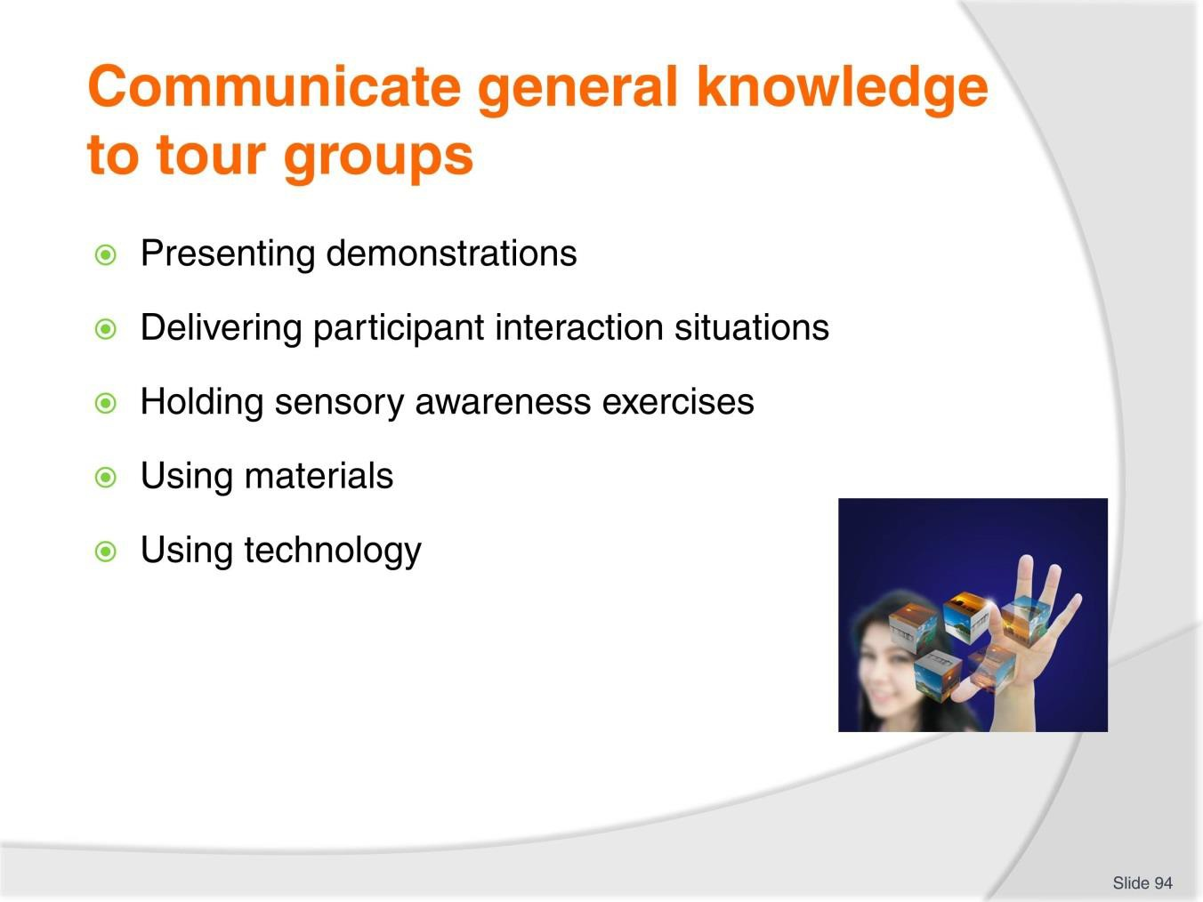
Slide No | Trainer Notes
94. | Trainer continues to identify interpretive guiding techniques which may be used for sharing general knowledge:  - Presenting demonstrations  - Delivering participant interaction situations  - Holding sensory awareness exercises  - Using materials to enhance illustration and experiences  - Utilising technology to assist with delivery.  Classroom Activity – Demonstration and Practice  Trainer uses the interpretive guiding techniques identified on the slide to present general information to a simulated tour group and provides an opportunity for students to do the same.

Slide
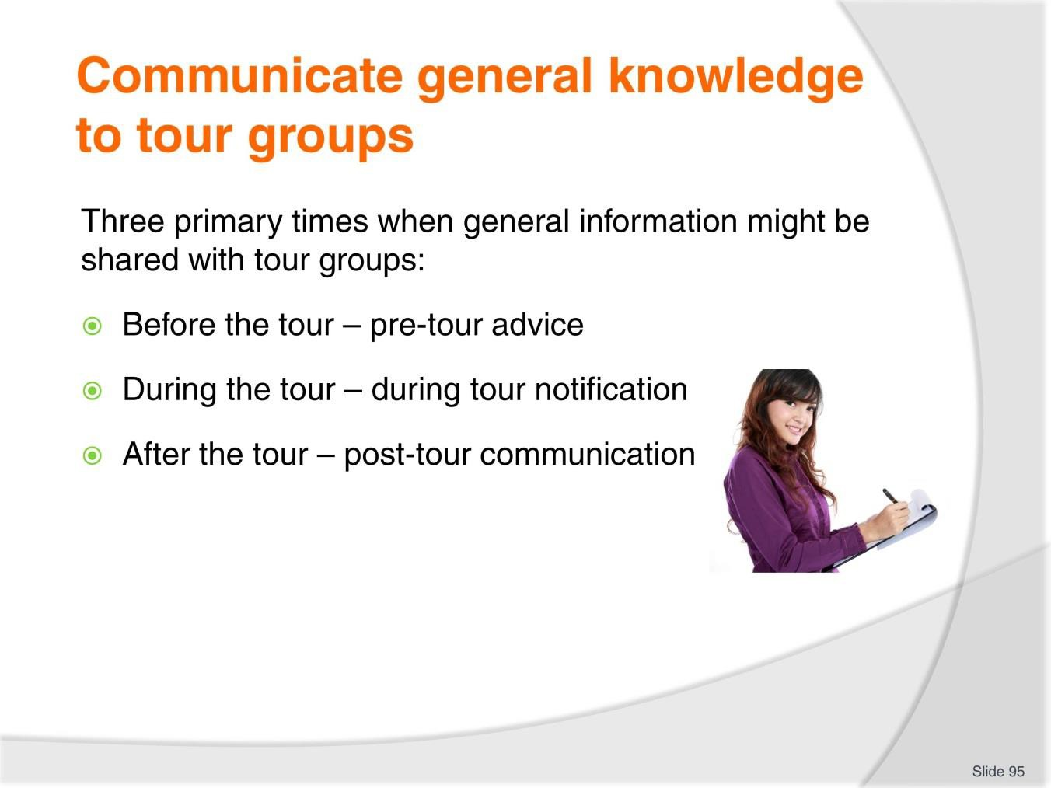
Slide No | Trainer Notes
95. | Trainer advises there are several standard times when general knowledge about an indigenous culture might be shared with tour groups. These times can generally be divided into three discrete sections:  - Pre-tour advice  - During-tour notification  - Post-tour communication.

Slide
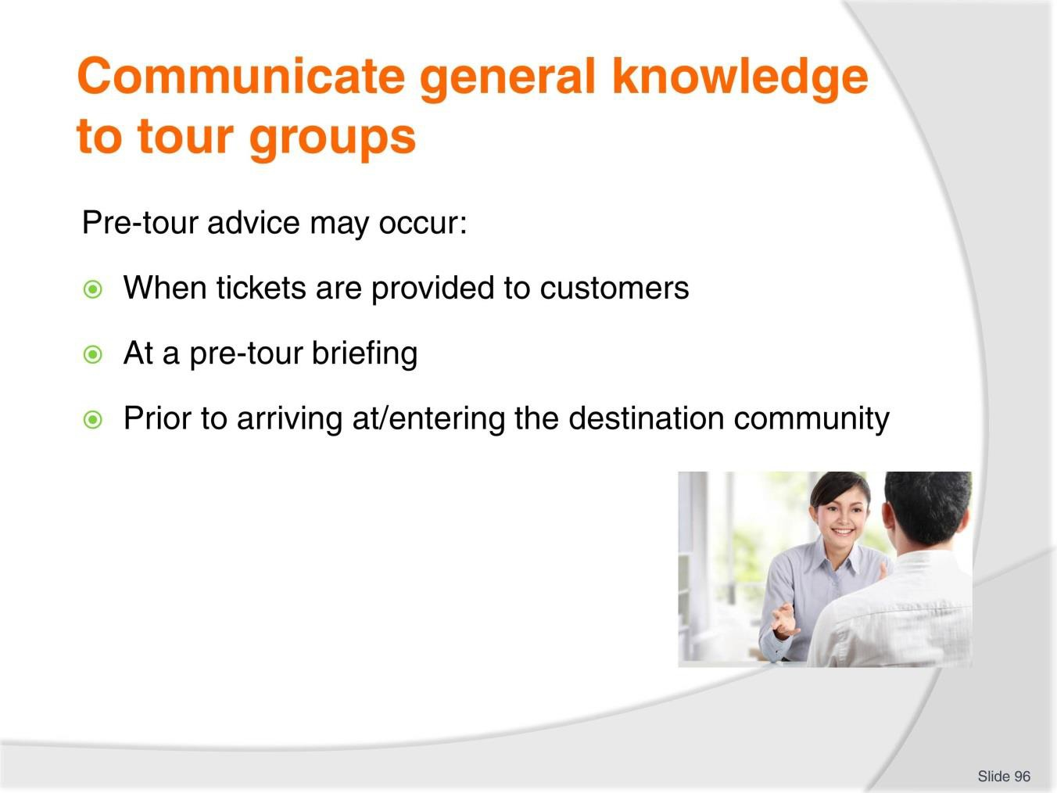
Slide No | Trainer Notes
96. | Trainer discusses provision of pre-tour advice stating this sharing of general knowledge may occur:  - When tickets are provided to purchasers – in hard copy form by handing out Information Sheets and Fact Sheets  - At a pre-tour briefing – in a variety of ways such as:  - Making a verbal presentation  - Screening a video/DVD  - Responding to questions  - Distributing and explaining Fact and Information Sheets  - Prior to arriving at or entering the destination community – such as:  - While travelling in the tour vehicle to the community  - While on the tour vehicle when it is parked at the entrance to the community  - While gathered together at a designated muster point adjacent to the entrance to the community

Slide
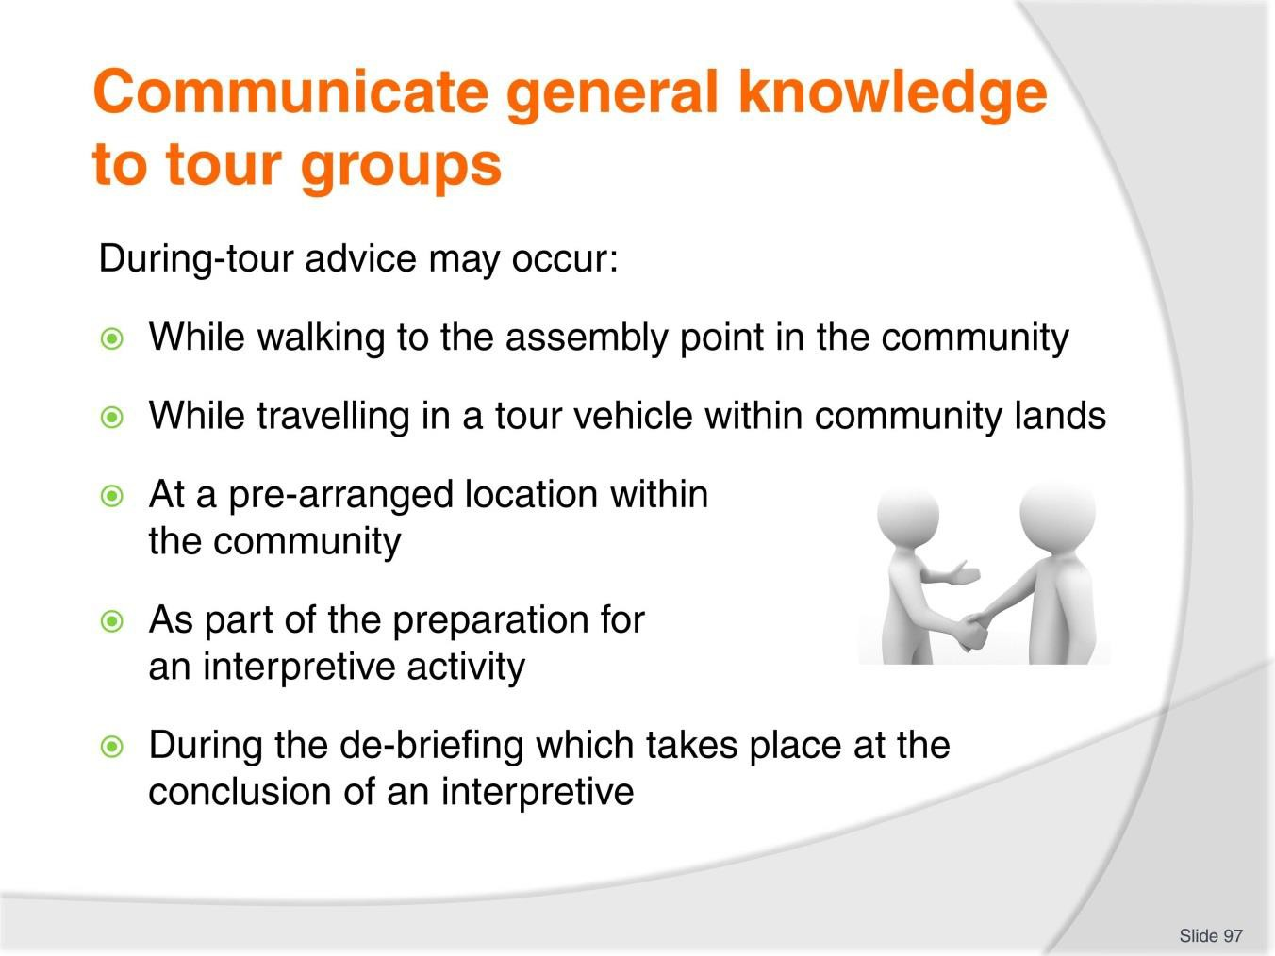
Slide No | Trainer Notes
97. | Trainer discusses during-tour advice noting this sharing of general knowledge may occur:  - While walking to the assembly point in the community  - While travelling in a tour vehicle within community lands  - At a pre-arranged location (a room/building) within the community – as part of a formal community-focussed briefing  - As part of the preparation for an interpretive activity – which requires certain general knowledge to be communicated in order to contextualise and provide necessary information to enable the activity to be conducted  - During the de-briefing which takes place at the conclusion of an interpretive activity  – as part of the process of helping tour group members learn from their experience and assisting them to consider and digest what they have discovered.

Slide
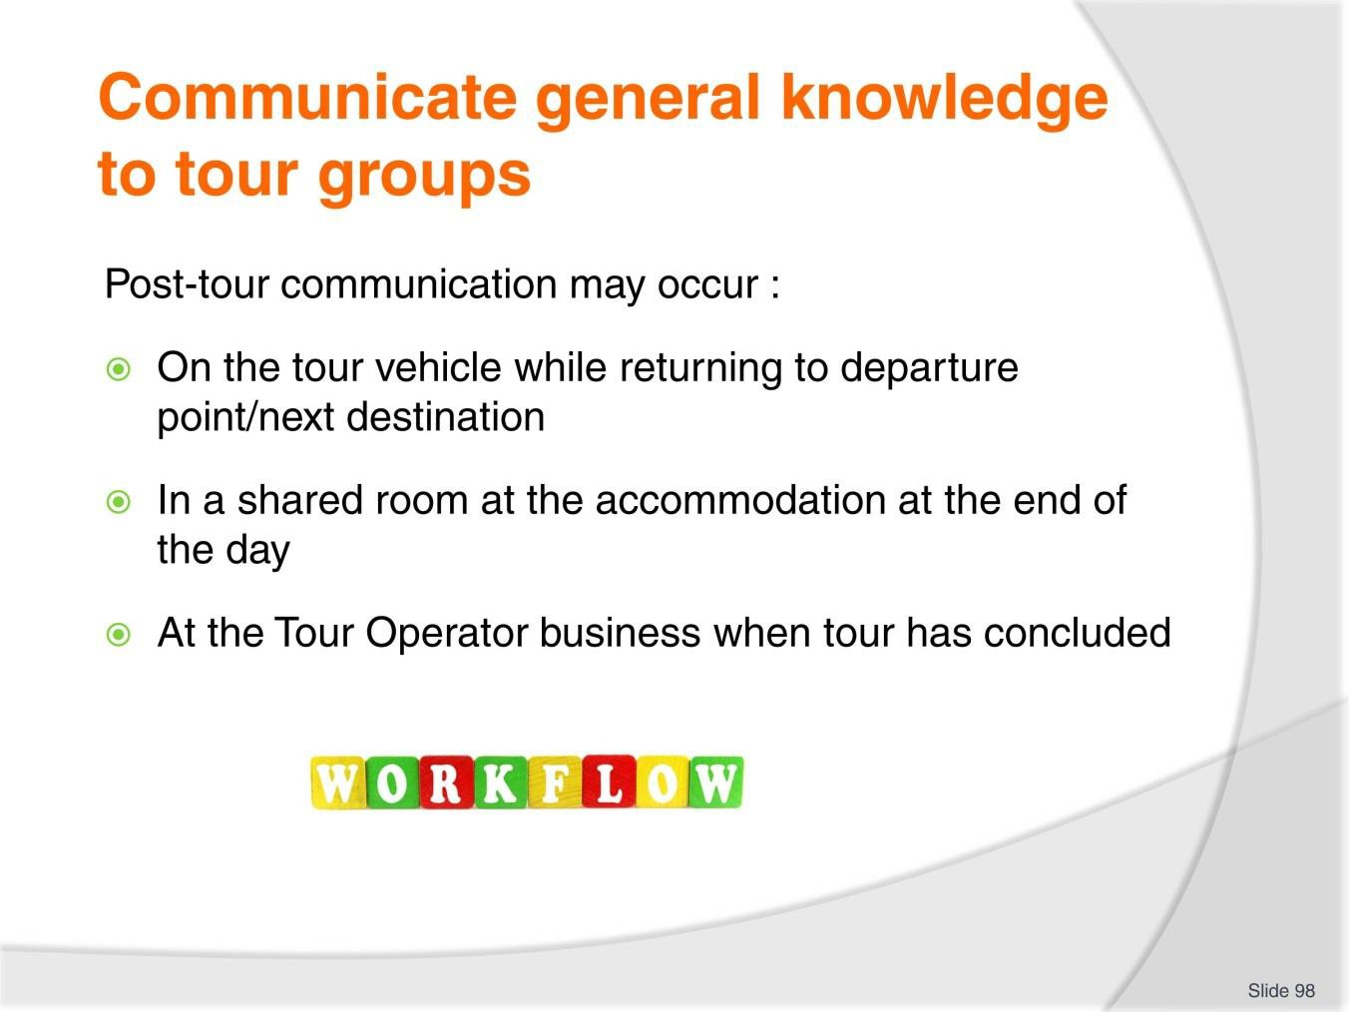
Slide No | Trainer Notes
98. | Trainer discusses post-tour communication noting this sharing of general knowledge may occur:  - On the tour vehicle as part of ‘general discussion’ as the tour group return to the departure point for the tour  - In a shared/common room at the accommodation venue at the end of the day – this occurs on a multi-day tour where the itinerary features a daily meeting/de-briefing session where Tour staff seek to:  - Provide an overview of the day’s activities  - Respond to questions  - Capture feedback about the tour  - At the Tour Operator offices when the tour has concluded – as part of the end-of- tour procedures which may also include:  - Distributing photographs from the tour – and other tour-related merchandise  - Thanking the group  - Obtaining feedback  - Farewelling customers.

Slide
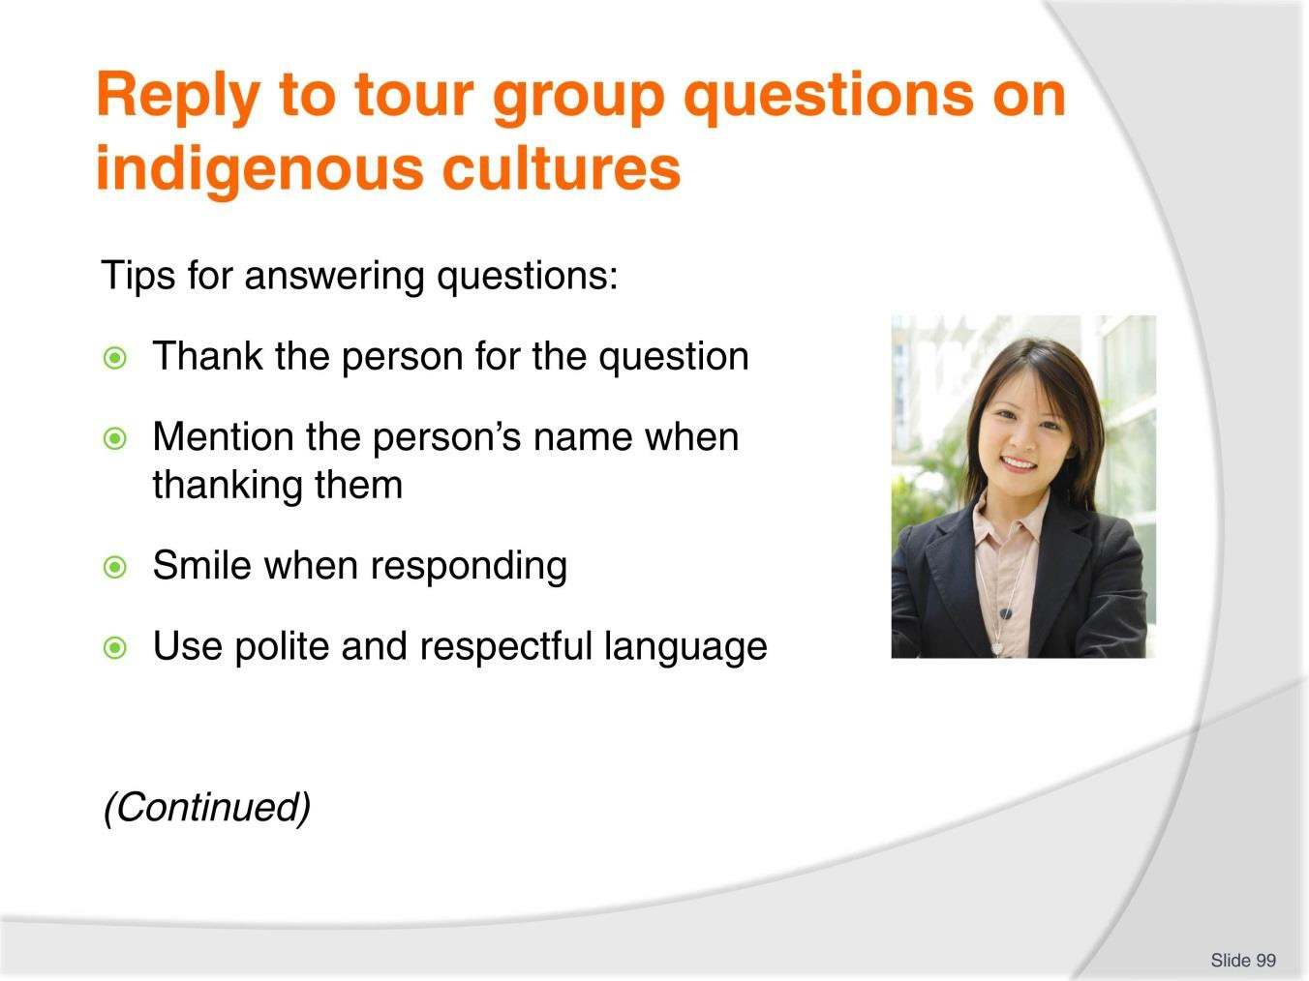
Slide No | Trainer Notes
99. | Trainer presents tips for answering questions asked as part of a tour include:  - Thank the person for the question – this encourages others to ask questions as it shows questions are actually welcomed  - Mention the person’s name when thanking them – many tours issue name tags which can be used to identify who individuals are:  - This personalises the answer and people love to hear the sound of their own name  - Smile when responding – if appropriate – this is another way of showing providing answers to questions is not an imposition  - Use polite and respectful language – when replying, including the use of humour, where appropriate.

Slide
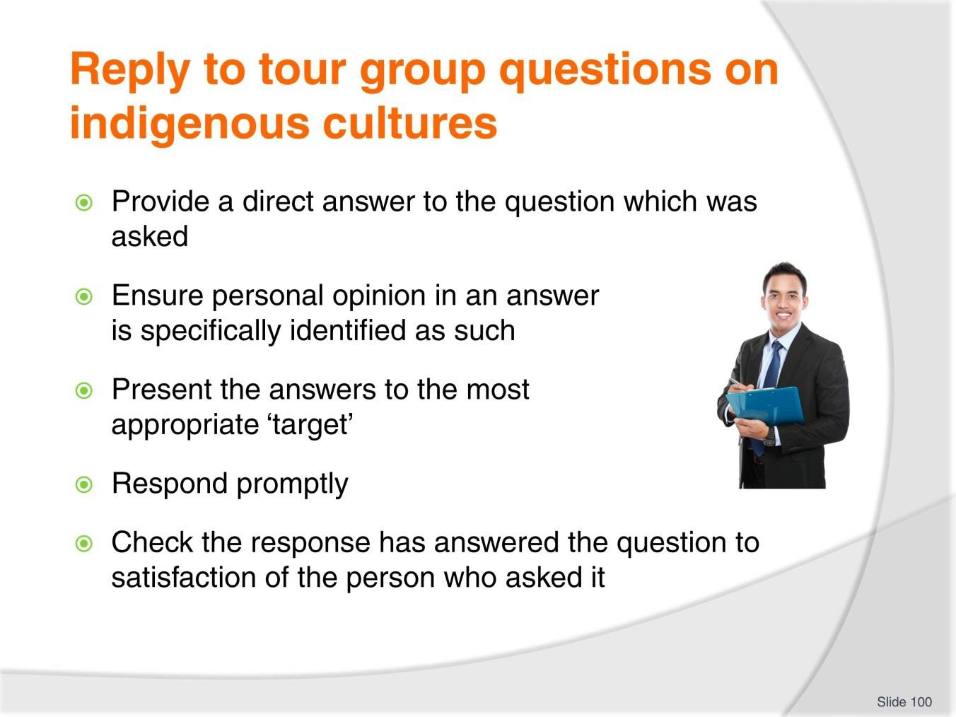
Slide No | Trainer Notes
100. | Trainer continues to present tips for answering questions:  - Provide a direct answer to the question which was asked – this means:  - Giving a full, detailed, comprehensive and honest answer as relevant to the question  - Not avoiding the question or re-directing or re-framing it  - Being prepared to say “I’m sorry but I don’t know the answer to that question.” See below for more on this.  - Ensure personal opinion in an answer is specifically identified as such – and not offered as fact  - Present the answers to the most appropriate ‘target’ – in some cases:  - The answer is best given just to the person who asked the question  - It is better to include the rest of the group in the response which is provided  - Respond promptly – taking care:  - Never to rush the response  - Not to appear curt  - To not give the impression there are better things to be done

- Check the response has answered the question to satisfaction of the person who asked it – this can involve:
  - Encouraging another question
  - Enquiring if clarification is needed
  - Asking if illustration of a point is required.

Slide
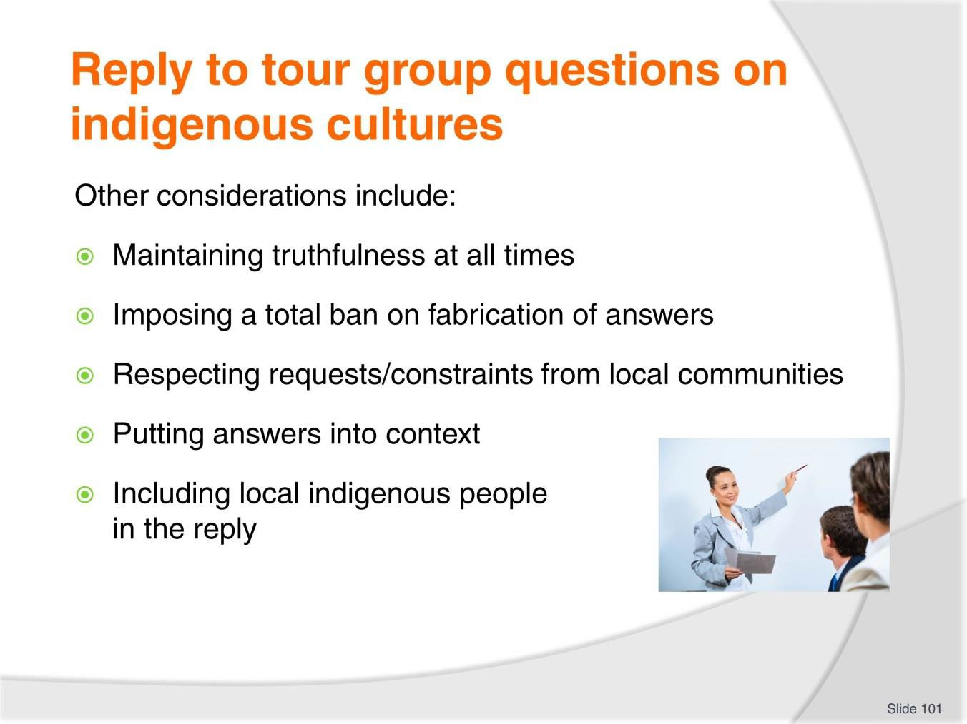
Slide No | Trainer Notes
101. | Trainer explains the following are all requirements when responding to tour group questions on indigenous cultures:  - Maintaining truthfulness at all times – in the content provided for all responses  - Imposing a total ban on fabrication of answers – if the answer to a question is not known: see below  - Respecting requests from communities – regarding:  - Information that cannot be shared with the pubic  - Details which are sensitive or confidential  - Putting answers into context – by (as appropriate):  - Providing background and history relevant to the issue  - Supplying detail to provide a framework for reference and/or comparison purposes  - Raising additional issues which are related and relevant to the question

- Including local indigenous people (local Tour Guides, interpreters, presenters, assistants) in the reply – in order to:
  - Provide a first-hand ‘unfiltered’ response from the local people
  - Show inclusivity and respect for the ability of the locals
  - Have them demonstrate an action as a physical response to the question.
Classroom Activity – Demonstration and Practical
Trainer demonstrates how to respond to answers from tour group members and provides opportunity for students to do the same.

Slide
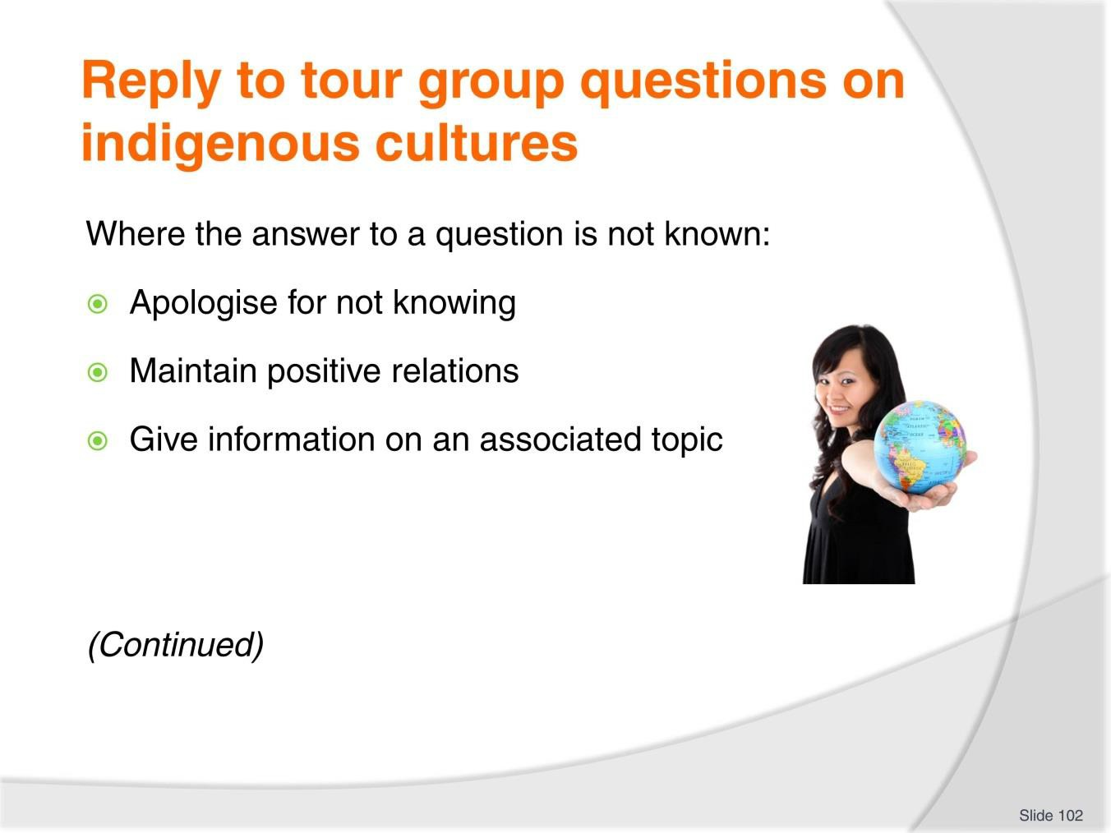
Slide No | Trainer Notes
102. | Trainer explains where no protocols exist the following are useful techniques:  - Apologise for not knowing – this is a standard ‘customer service’ response and needs to be done:  - The apology needs to be genuine and accompanied by appropriate supporting body language/facial expressions  - Maintain positive relations with the person/group – it is important:  - Not to show annoyance at not knowing the answer  - Not to be personally embarrassed about the lack of knowledge  - Not to give the person who asked the question the impression they should ask no more questions  - Give information on an associated topic – which:  - May give some generally broad detail in relation to the actual question asked  - At least shows a willingness to respond even though the real answer is not known  - Refer the question to the rest to someone else – this may be:  - A local Tour Guide or community representative  - To see if anyone else on the tour has an answer to the question.

Slide
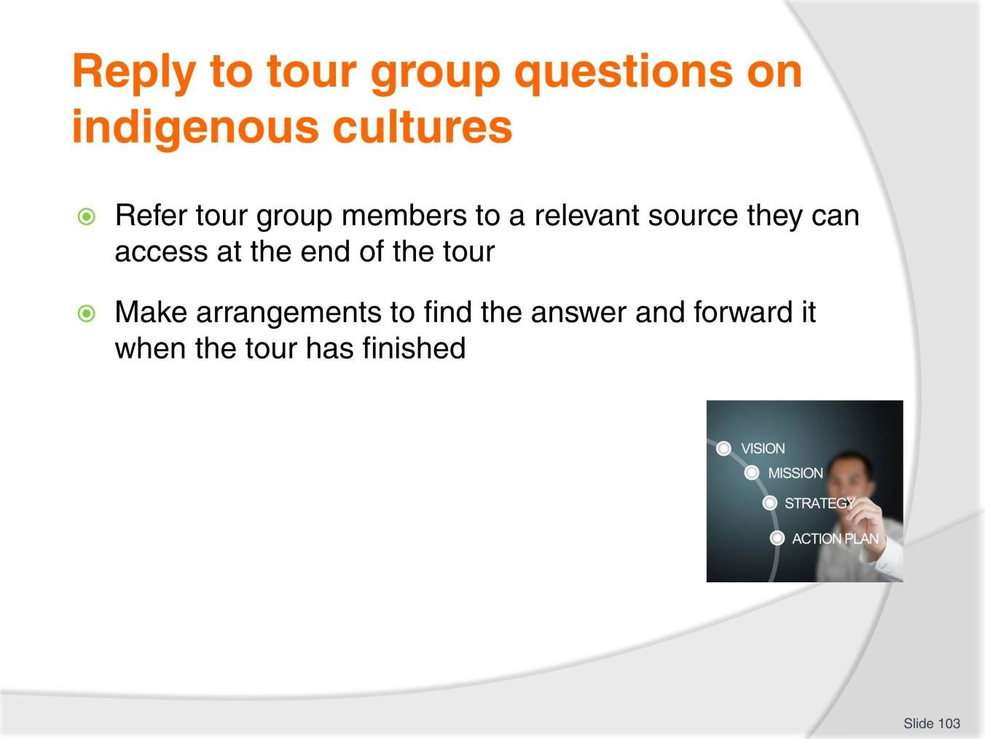
Slide No | Trainer Notes
103. | Trainer continues to present techniques for responding to questions where answer is not known:  - Refer customers to sources that may provide the relevant information at the conclusion of the tour – this may be:  - Brochures, posters, handouts which are available at the point of disembarkation  - A website  - A Visitor Information Centre  - A business, organisation or government agency/authority  - Make arrangements to research the question – at the conclusion of the tour and:  - Pass on the answer face-to-face at the point of disembarkation, if the person is willing to wait a few minutes  - Send a reply via email to the person if they are able to provide an address  - Give an SMS reply if they provide a number.  Classroom Activity – Demonstration and Practical  Trainer demonstrates how to respond to tour group members when answer to question is not known and provides opportunity for students to do the same.

Slide
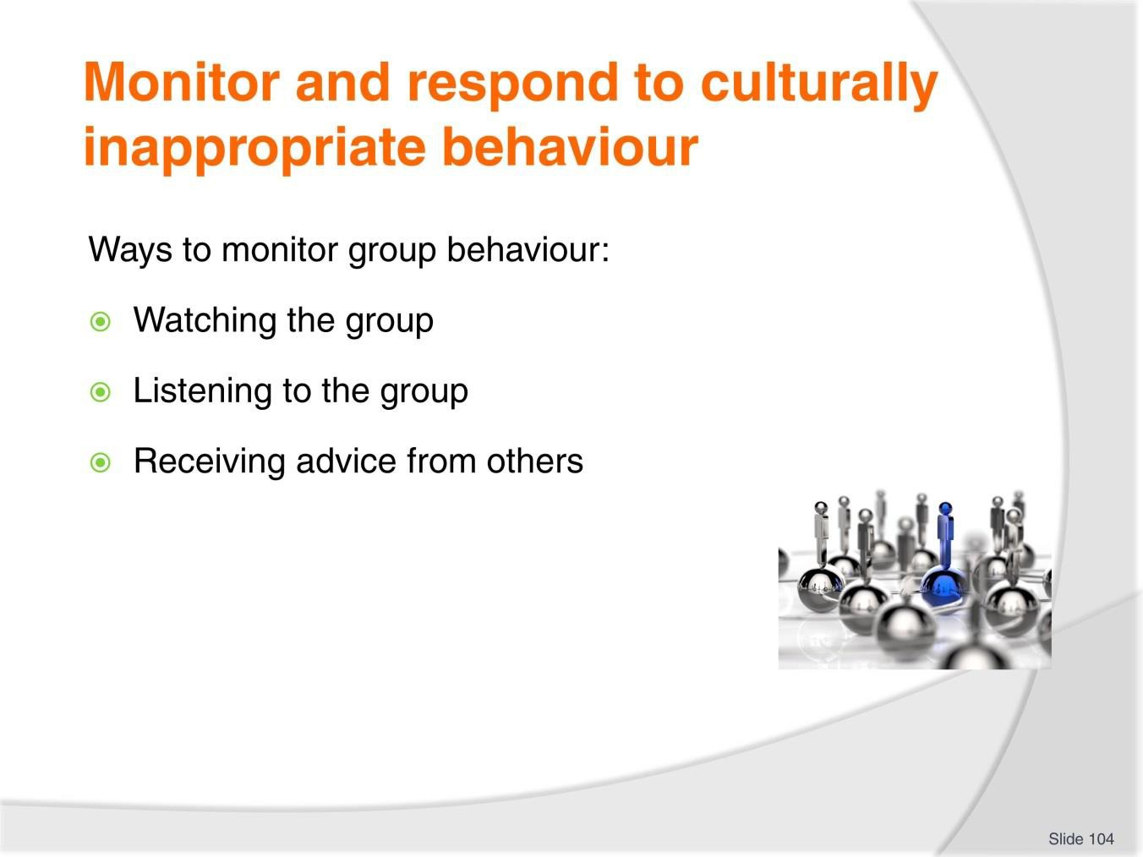
Slide No | Trainer Notes
104. | Trainer indicates monitoring the behaviour of tour group members when on-tour in indigenous communities will need to focus on:  - Watching the group – which means:  - Seeing what people are doing  - Noting where tour group members are going  - Checking body language/non-verbal communications signals  - Listening to the group – in terms of:  - What is said  - How things are said  - Tone and/or volume of voice used  - Receiving advice from others – in terms of:  - Input from Tour staff  - Advice from local representatives/members of the community  - Other tour group members.  Note: it is SOP for Tour Guides to make sure they actually observe (that is, they themselves hear or see) the inappropriate behaviour before they respond to it.

Slide
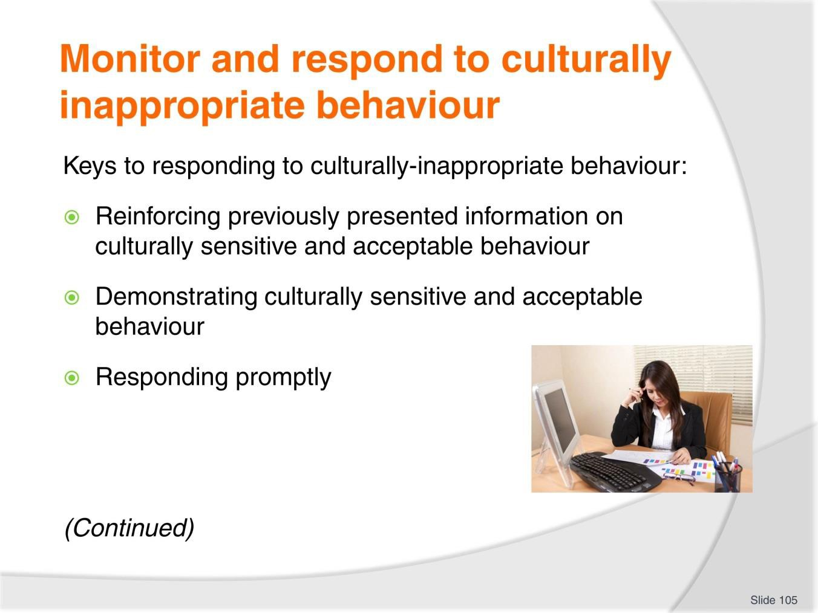
Slide No | Trainer Notes
105. | Trainer presents keys for Tour Guides when responding to culturally inappropriate behaviour:  - Reinforcing previously presented information on culturally sensitive and acceptable behaviour – as presented to the group during the briefing session/activity that preceded the tour  - Demonstrating culturally sensitive and acceptable behaviour – to help illustrate the point which needs to be made as part of the tour guiding process  - Responding promptly – issues must be addressed as soon as they are noticed because this:  - Demonstrates the issue is important and is being taken seriously  - Will send a message to all the tour group about what is unacceptable and inappropriate  - Helps to better control/eliminate unacceptable and inappropriate behaviour.

Slide
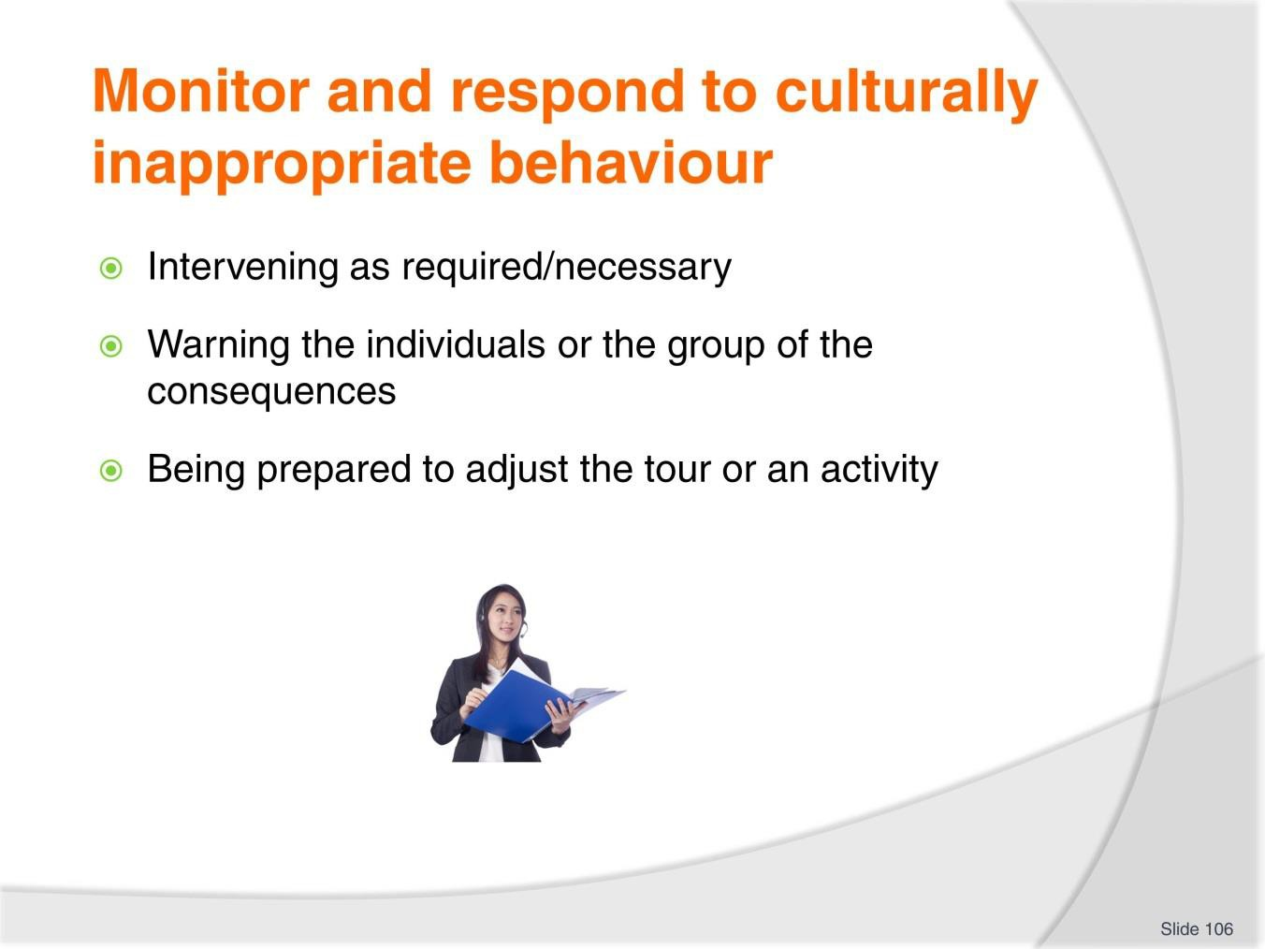
Slide No | Trainer Notes
106. | Trainer continues to present keys for Tour Guides when responding to culturally inappropriate behaviour:  - Intervening as required/necessary – to (for example)  - Asking tour group members to modify unacceptable behaviour  - Asking people to refrain from certain actions  - Demonstrating acceptable speech and/or actions  - Illustrating requirements through verbal explanations/descriptions  - Warning the individuals or the group (as appropriate) of the consequences – if they persist with their unacceptable/inappropriate behaviour (or language)  - Being prepared to adjust the tour or an activity – as required by the nature, extent or seriousness of the unacceptable/inappropriate behaviour (or language), which may mean:  - Modifying the content, location or duration of the tour or activity  - Changing the focus/nature of the tour  - Terminating an activity or visitation.  Classroom Activity – Demonstration and Practical  Trainer demonstrates how to respond to culturally-inappropriate behaviour from tour group members in an indigenous community and provides opportunity for students to do the same.

Slide
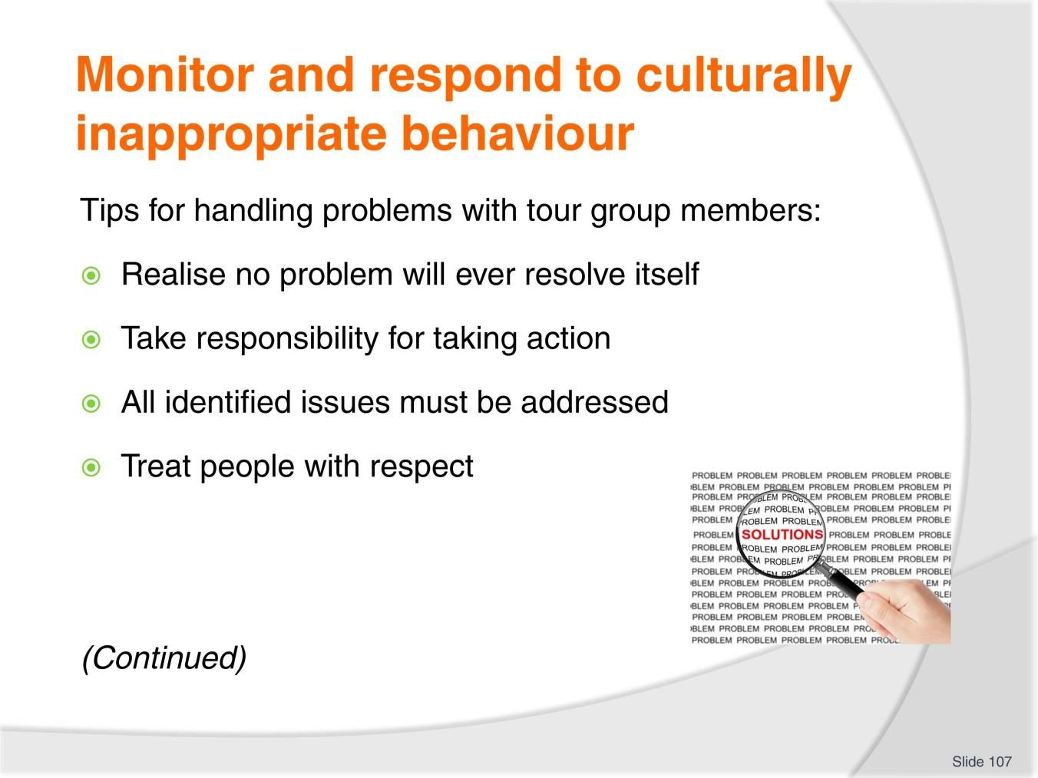
Slide No | Trainer Notes
107. | Trainer presents tips for handling problems with tour group members:  - Realise no problem will ever resolve itself – problems require action to fix/address them  - Take responsibility for taking action – it is part of the job to do so  - All identified issues must be addressed – never simply ignore a problem  - Treat people with respect – talk politely with them allow them their dignity.  Classroom Activity – Guest Speaker  Trainer arranges for experience Tour Guide to attend and:  - Provide advice on monitoring tour group behaviour in an indigenous community  - Explain how to respond to unacceptable tour group behaviour in an indigenous community  - Demonstrate how to intervene to address unacceptable tour group behaviour in an indigenous community.

Slide
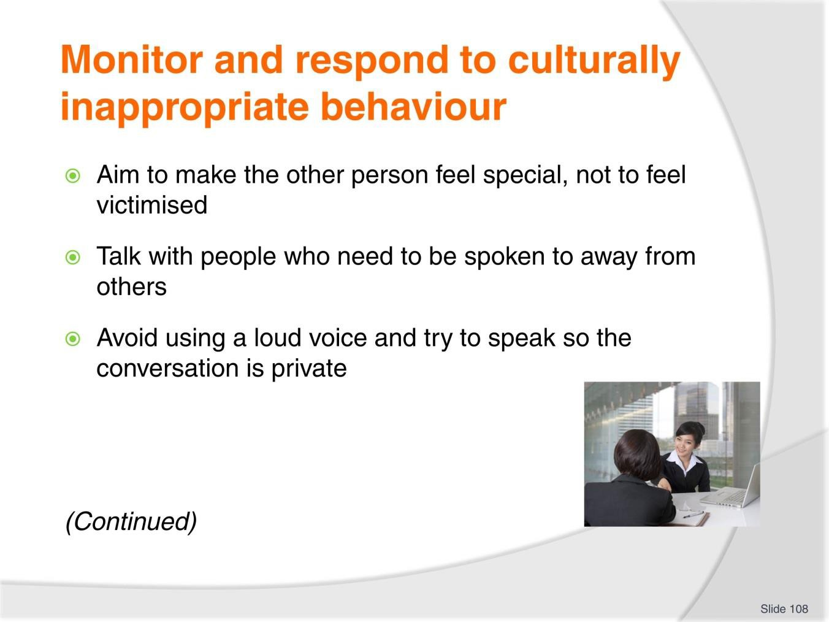
Slide No | Trainer Notes
108. | Trainer continues to present tips for handling problems with tour group members:  - Aim to make the other person feel special, not to feel victimised  - Talk with people who need to be spoken to away from others in order to respect their right not to be embarrassed or challenged in front of others:  - Try to stay calm – when a need to intervene and say something to a participant arises: ‘act’ but do not ‘over-react’  - Avoid using a loud voice and try to speak so the conversation is private – and so the participant/s do not feel as if they are being reprimanded in front of the rest of the group and being made to look silly or ‘small’.

Slide
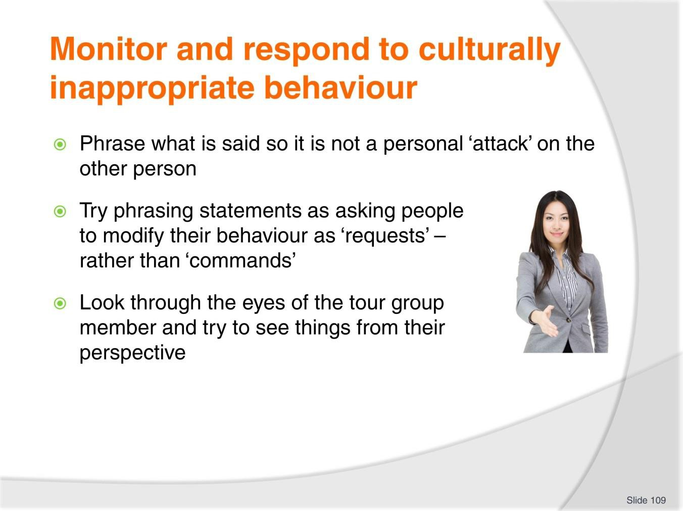
Slide No | Trainer Notes
109. | Trainer continues to present tips for handling problems with tour group members:  - Phrase what is said so it is not a personal ‘attack’ on the other person – for example, instead of saying “You must not do that”, re-phrase the statement to “We prefer such action does not take place while here/on tour/in this location”  - Try phrasing statements as asking people to modify their behaviour as ‘requests’ – rather than ‘commands’ to do things:  - Give reasons why the request is being made – there is big difference between ‘Stop doing that’ and “Could I please ask you not to do that because it offends people in this community?”  - Look through the eyes of the tour group member and try to see things from their perspective:  - For example, consider saying “I understand you would like to get closer to XYZ but we have been asked to stay at a distance because the community have said they feel threatened if visitors get too close”.  Classroom Activity – Demonstration and Practical  Trainer demonstrates how to handle problems with tour group members and provides opportunity for students to do the same.

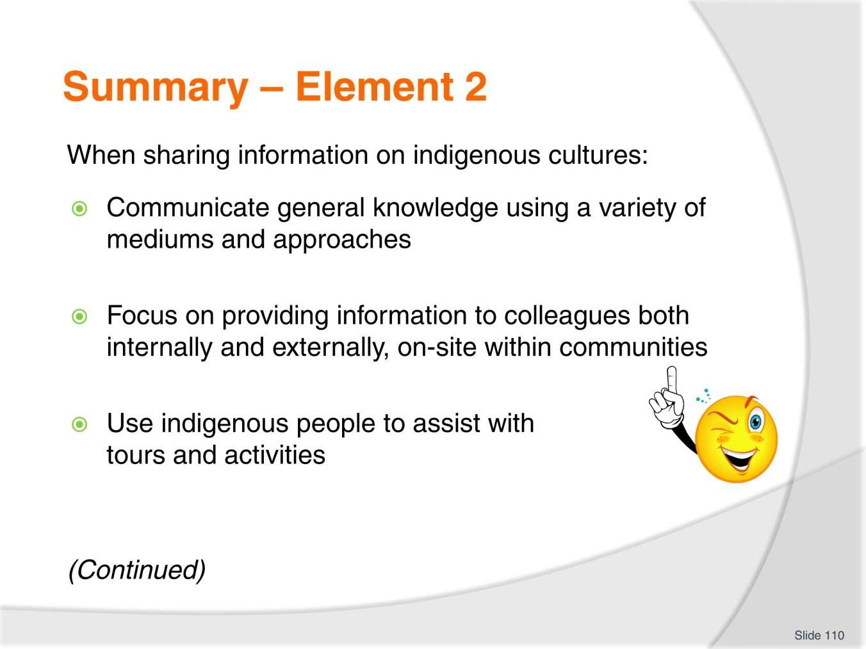
Slide
Slide No
Trainer Notes
110.
Trainer provides a recap of the Element asking questions to check trainee understanding and responding to questions from trainees, as required.

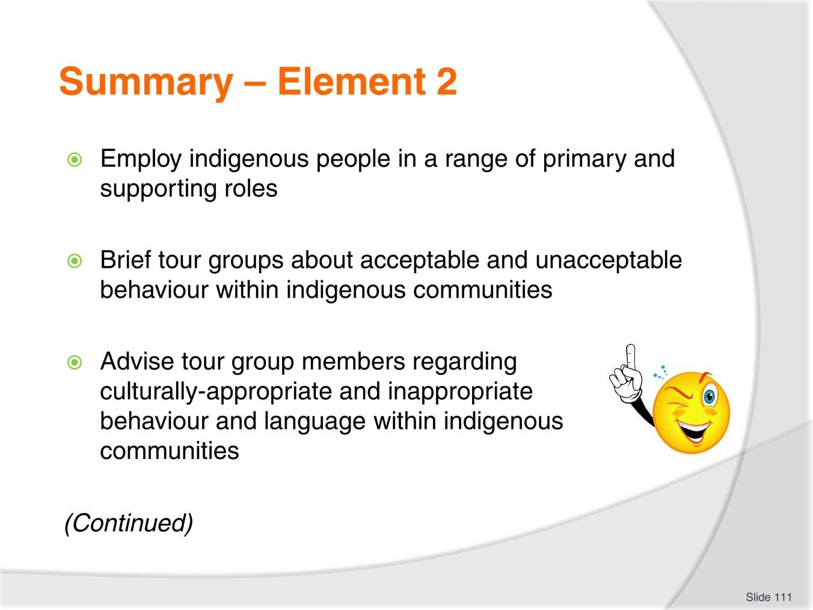
Slide
Slide No
Trainer Notes
111.
Trainer provides a recap of the Element asking questions to check trainee understanding and responding to questions from trainees, as required.

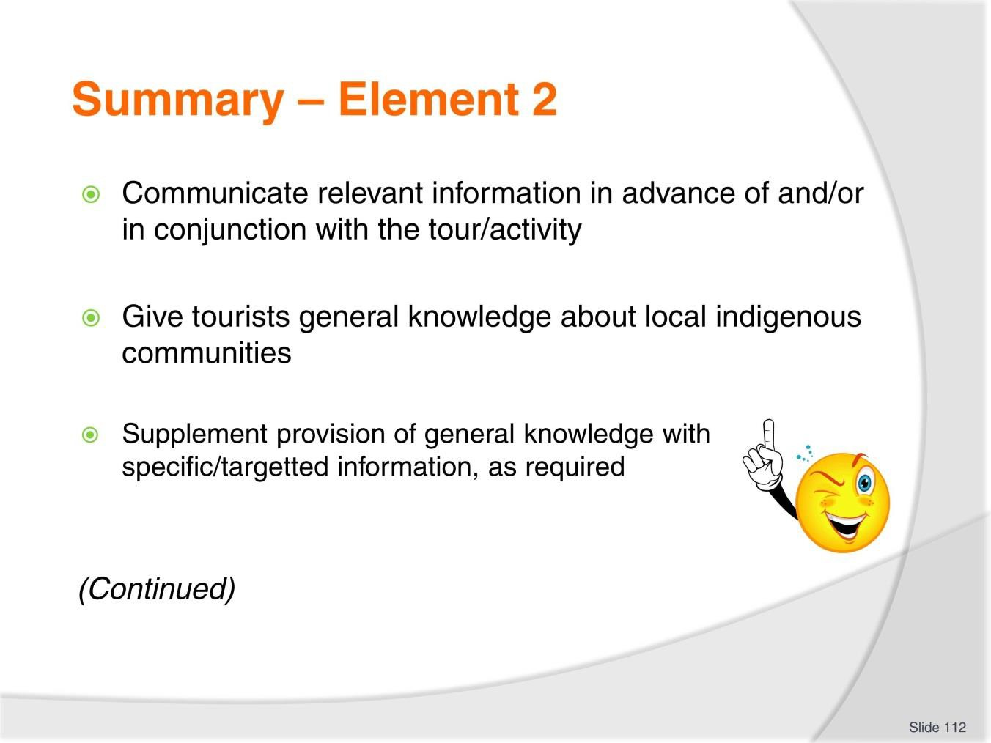
Slide
Slide No
Trainer Notes
112.
Trainer provides a recap of the Element asking questions to check trainee understanding and responding to questions from trainees, as required.

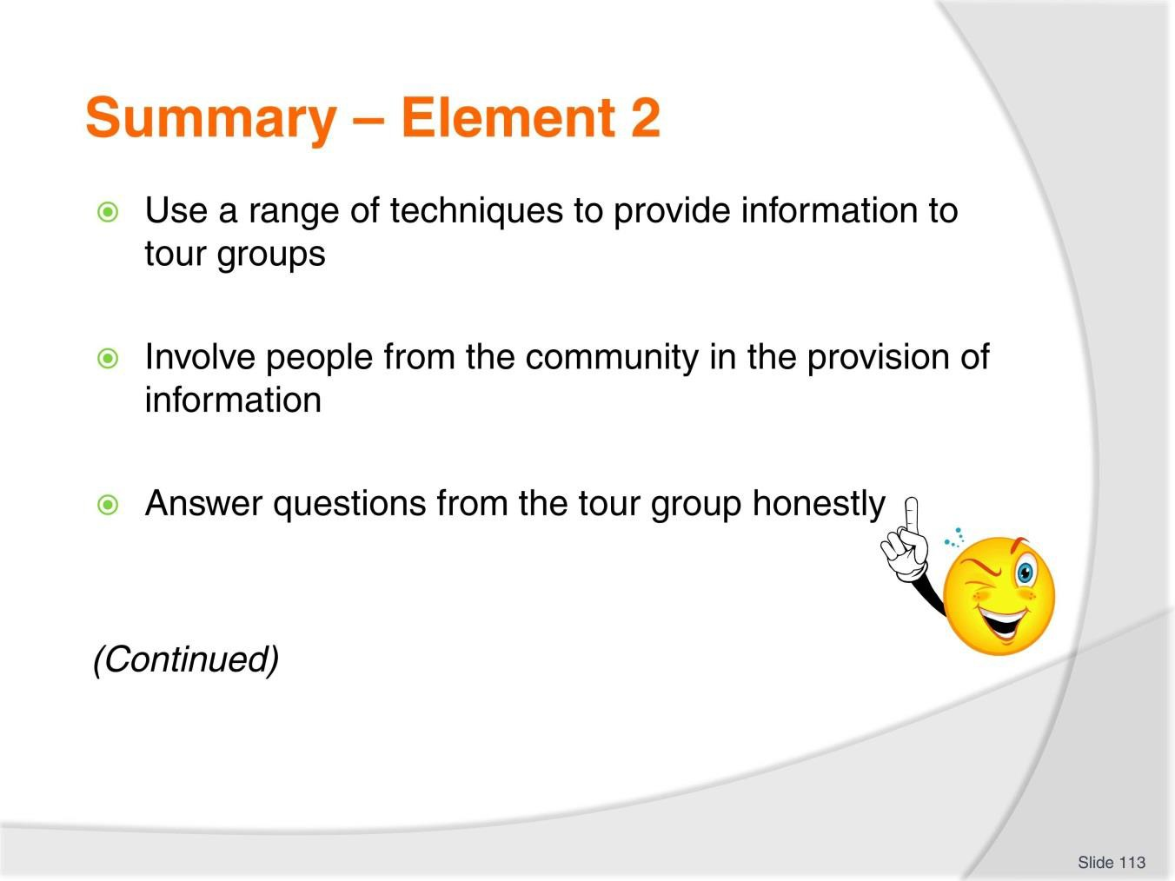
Slide
Slide No
Trainer Notes
113.
Trainer provides a recap of the Element asking questions to check trainee understanding and responding to questions from trainees, as required.

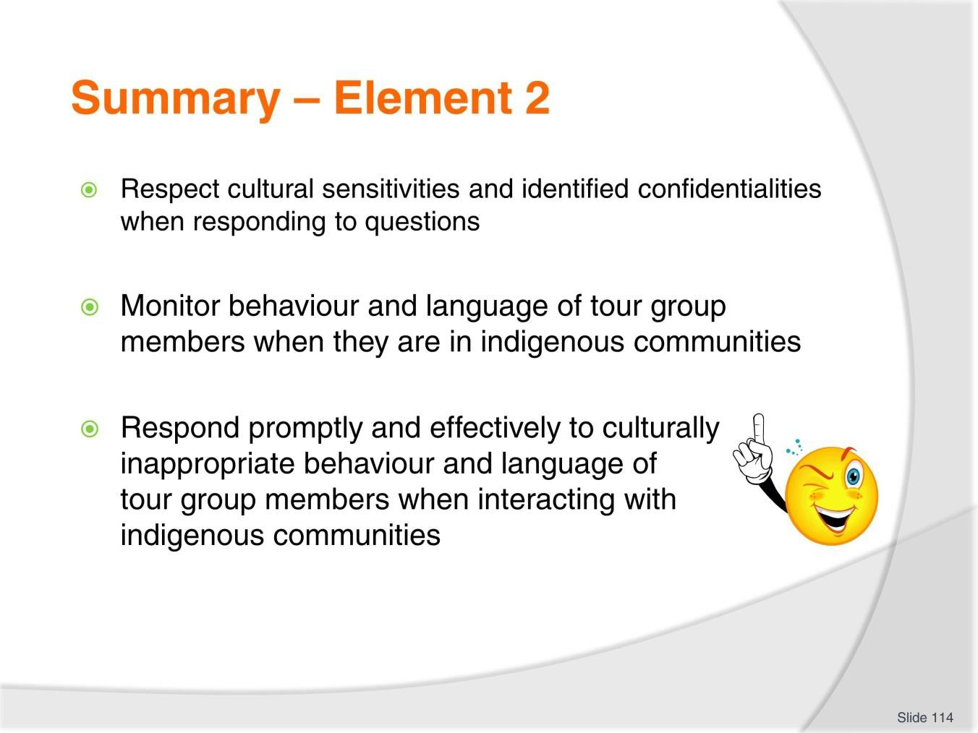
Slide
Slide No
Trainer Notes
114.
Trainer provides a recap of the Element asking questions to check trainee understanding and responding to questions from trainees, as required.

Slide
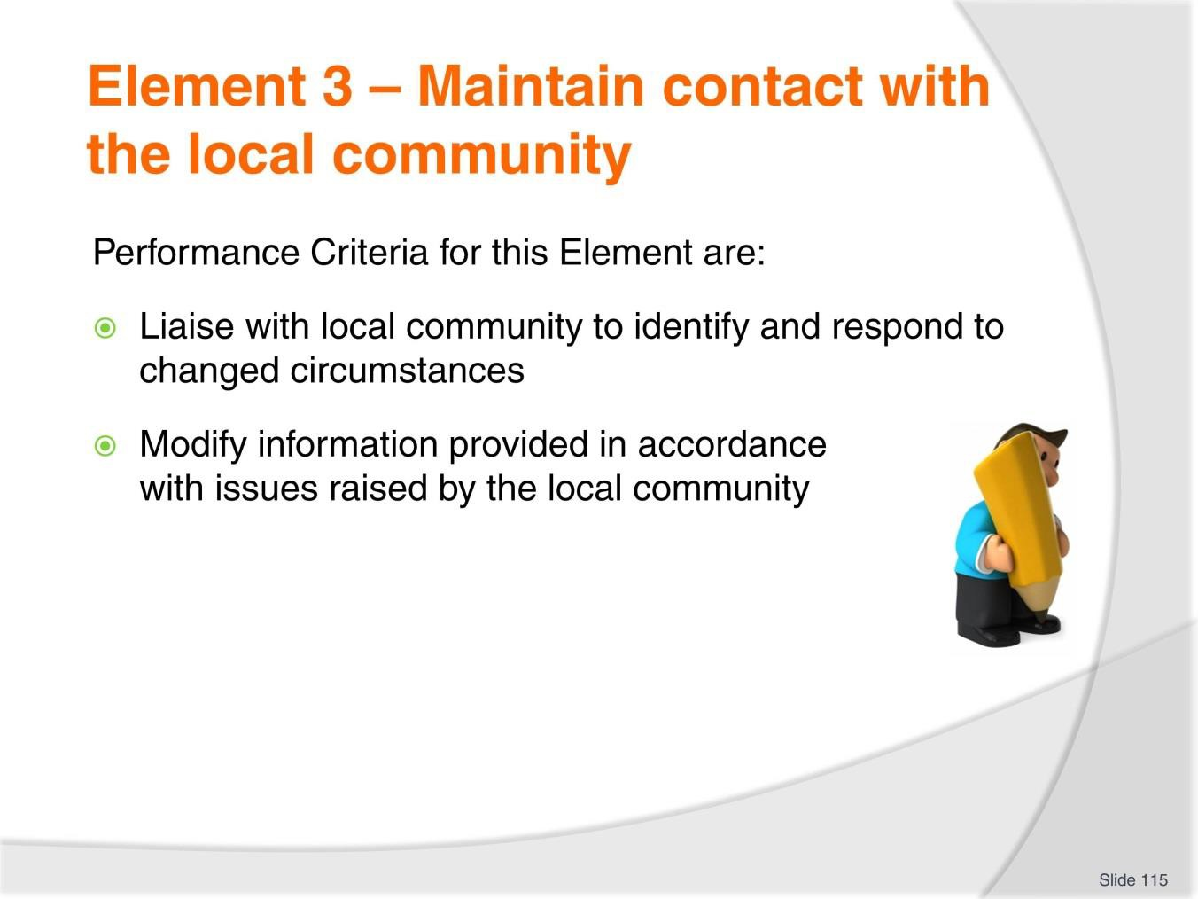
Slide No | Trainer Notes
115. | Trainer identifies for trainees the Performance Criteria for this Element, as listed on the slide.  Class Activity – General Discussion  Trainer leads a general class discussion by asking questions such as:  - Why is there a need to maintain contact with the local community?  - How might this contact occur?  - With what frequency?  - Who should participate in the communications?  - Where might the exchanges take place?

Slide
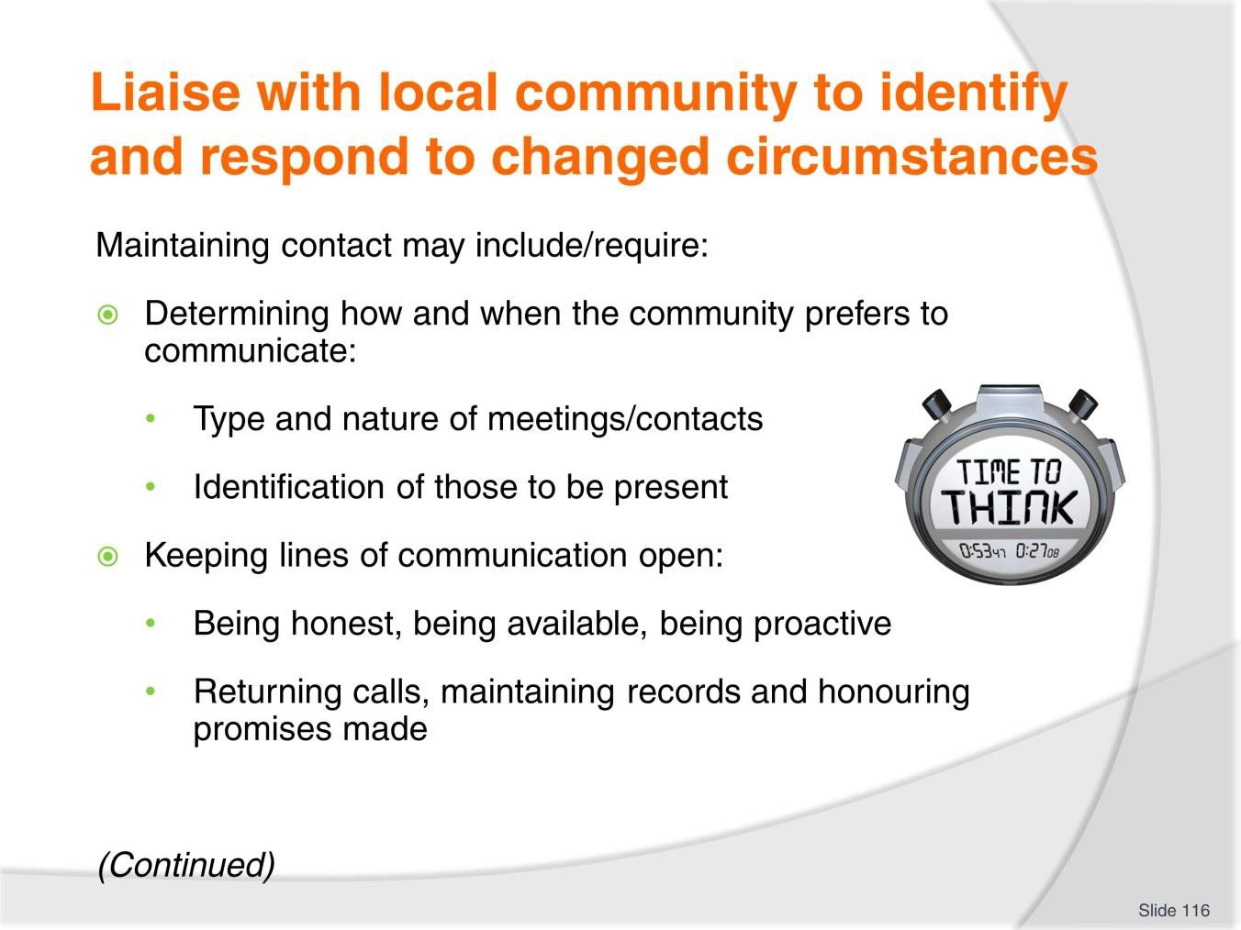
Slide No | Trainer Notes
116. | Trainer advises maintaining contact with local communities may include the following activities:  - Determining how and when the local community prefers to communicate – there may be a preference for:  - Face-to-face meetings or electronic/telephone contact  - Meetings in the local community or meetings at nominated other locations  - Short casual meetings or more formal/structured meetings  - Meetings with the community as a while or meetings with nominated representatives  - Frequent meetings or less-frequent but nonetheless scheduled meetings  - Keeping the lines of communication open – which can be optimised by:  - Talking honestly  - Being available when required  - Returning calls  - Being prepared to use a variety of different communication options  - Using different communication methods for individual stakeholders  - Being proactive in initiating contact

- Communicating in the way/manner preferred by the local community
- Being flexible in meetings times
- Maintaining and distributing hard copy information regarding information shared, decisions reached and arrangements which have been made
- Honouring promises that have been made – this is arguably the single biggest element in maintaining a positive relationship with a local community.

Slide
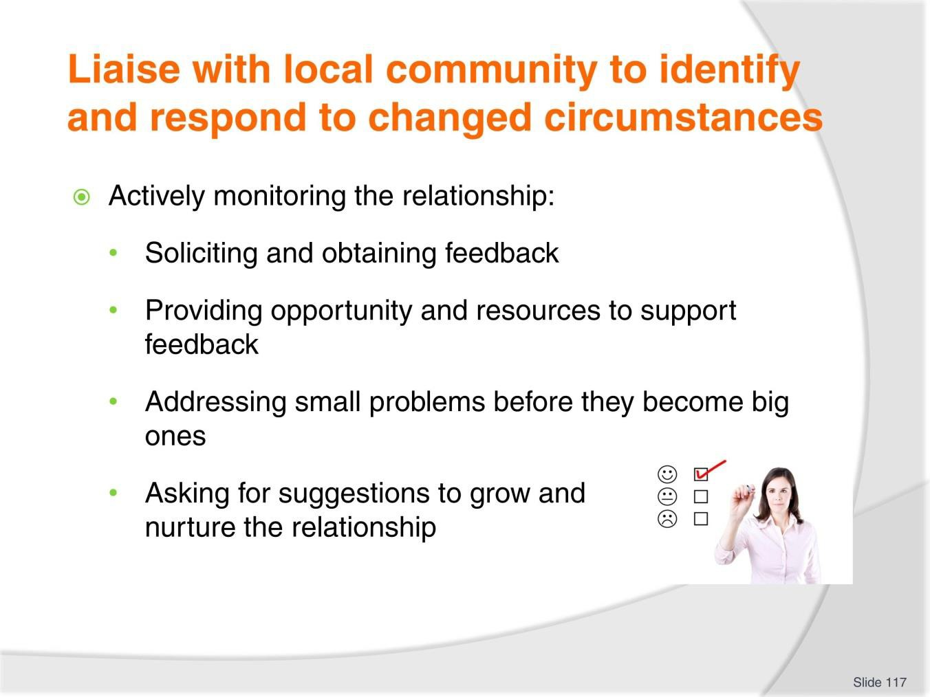
Slide No | Trainer Notes
117. | Trainer continues identifying activities inherent in maintaining contact with local communities:  - Actively monitoring the relationship – with a view to:  - Obtaining feedback/input from relevant stakeholders  - Creating opportunities for feedback from the community  - Supplying the means and methods for providing feedback  - Soliciting suggestions  - Factoring in feedback from tour groups  - Asking the community about the relationship and arrangements which have been made  - Identifying and addressing small problems before they become big ones  - Doing no harm – this must always be a primary priority in the relationship: no harm should come to the community, individuals in it, its reputations, its environment or anything to do with the people or their culture.

Slide
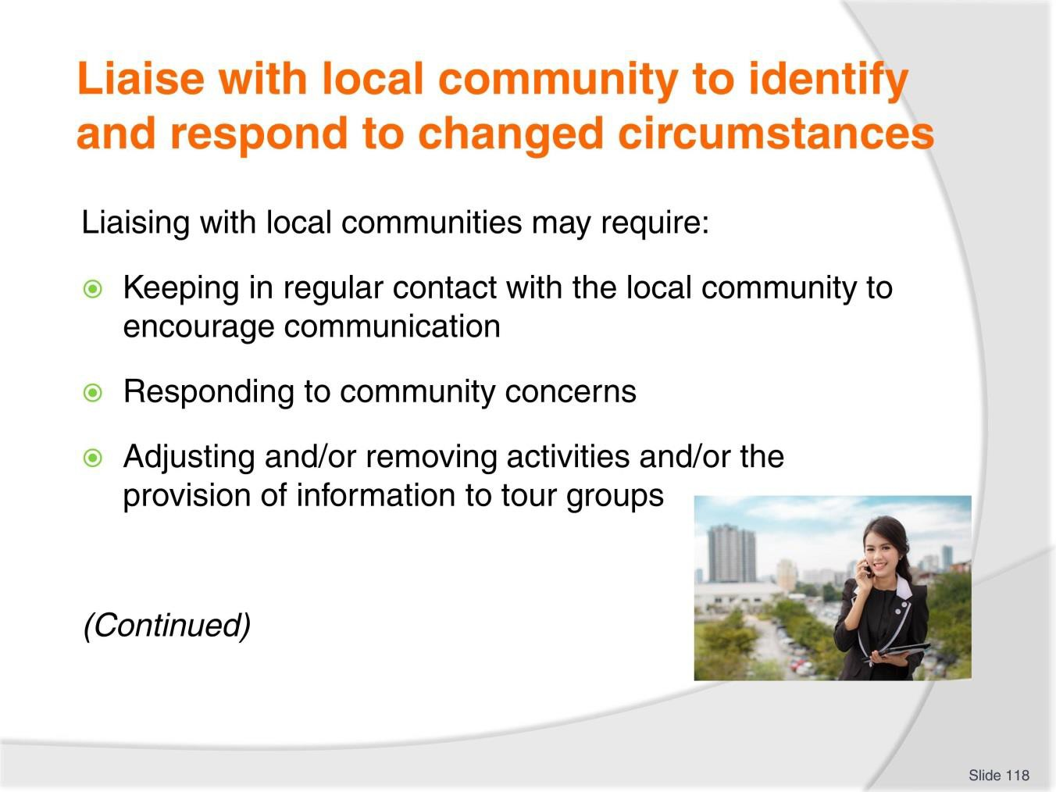
Slide No | Trainer Notes
118. | Trainer states liaising with local community may involve or require:  - Keeping in regular contact with the local community to encourage communication – meaning:  - Contact needs to occur even where there is ‘nothing special’ or something definite to be discussed  - A schedule of meetings/contacts might be useful in providing a basis for contact  - Making sure the local community has all contact details for the Tour Operator  - Designating one (or two) dedicated people within the organisation for the local community to use as their target contacts  - Responding to community concerns – by, as appropriate/necessary:  - Varying tours and activities to suit local community needs, wants and preferences  - Varying tours and activities as a result of local ceremonies, rites, rituals and festivals  - Varying tours and activities where any form of unacceptable impact on the community or the local environment has been observed

- Adjusting and/or removing activities and/or the provision of information to tour groups – as required:
  - On the basis of feedback from the local community
  - As the community provides additional information
  - Where the local community:
    - Authorises a change in the release of information to the public
    - Wants a change in the type/detail of information given to tourists.

Slide
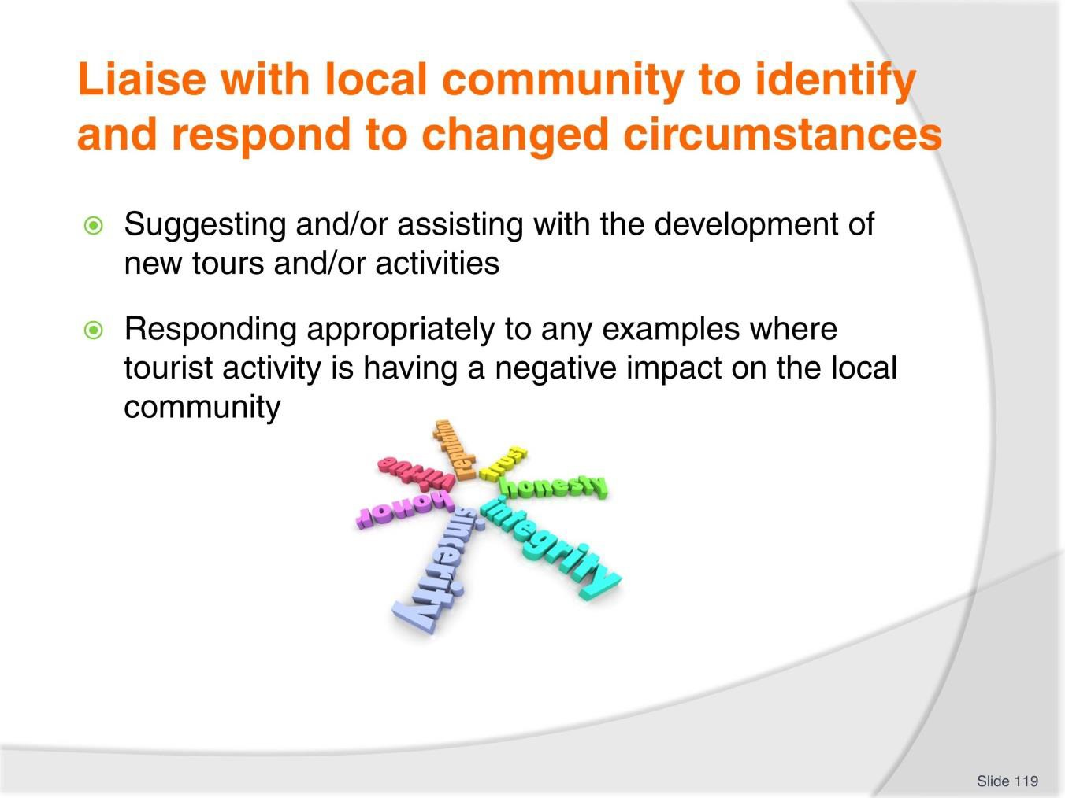
Slide No | Trainer Notes
119. | Trainer continues to state liaising with local community may involve or require:  - Suggesting and/or assisting with the development of new tours and/or activities – on the basis of:  - Mutually beneficial opportunities which may present themselves  - Ideas and proposals put forward by the local community are developed with the local community  - Responding appropriately to any examples where tourist activity is having a negative impact on the local community – this needs to embrace:  - Assisting the community take whatever ‘other action’ is necessary to address the issue/s – such as legal action, educational campaigns, engagement with authorities, security or protective action  - Willingness to cancel tours – and return payments/deposits to customers  - Ability to alter promotional material to reflect changed conditions/circumstances.  Classroom Activity – Guest Speaker  Trainer arranges for representative from local community to attend and:  - Discuss their requirements regarding maintaining contact with Tour Operators  - Explain how this occurs  - State why such a relationship is necessary  - Give examples of issues addressed.

Slide
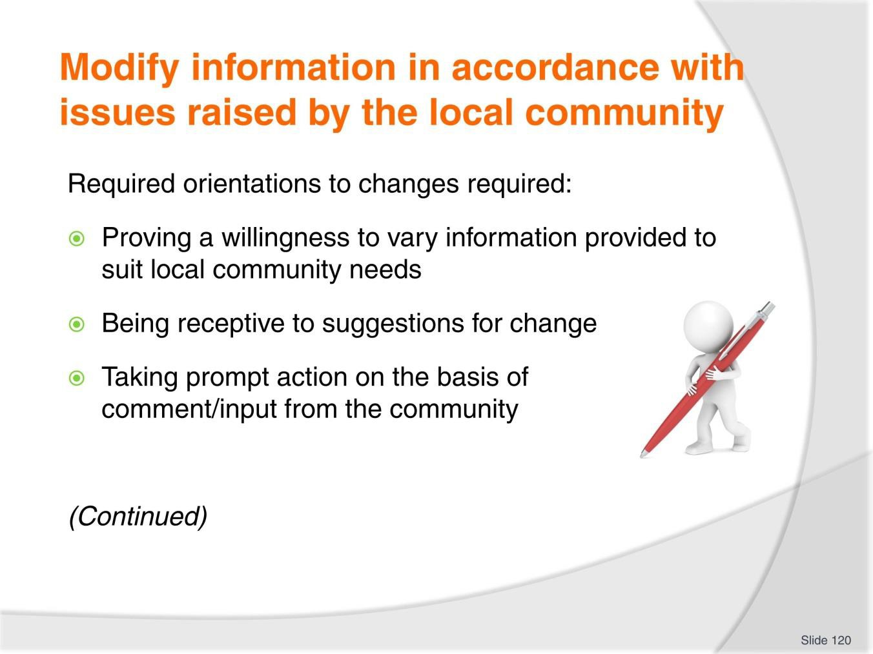
Slide No | Trainer Notes
120. | Trainer notes the Tour Operator must adopt the following orientations to the potential need to modify information provided to the public/tour group members:  - Proving a willingness to vary information provided to suit local community needs – via verbal and non-verbal language/cues  - Being receptive to suggestions for change – including suggestions to reduce or extend existing arrangements  - Taking prompt action on the basis of comment/input from the community – as opposed to delaying and deferring changes.

Slide
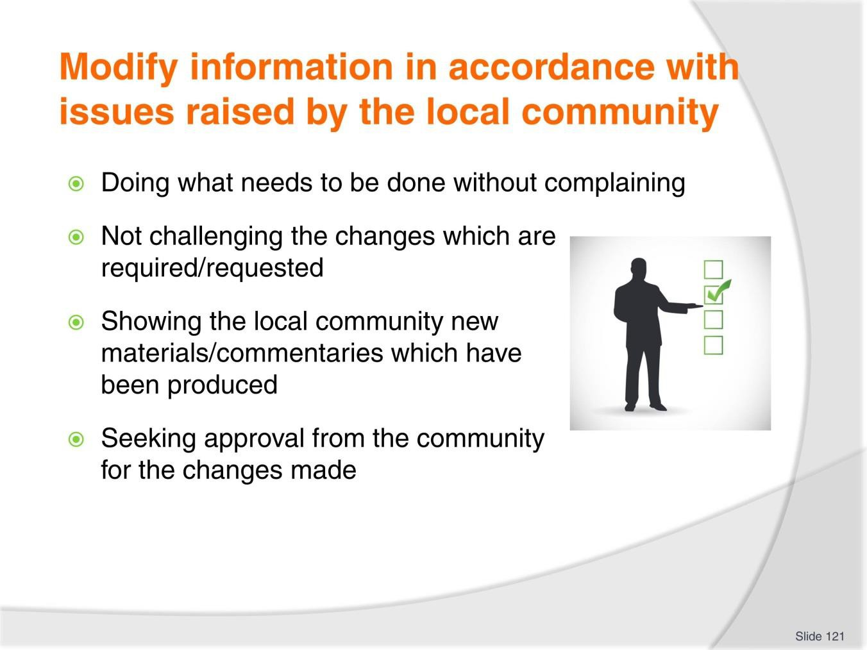
Slide No | Trainer Notes
121. | Trainer continues discussing orientation Tour Operators should have to information changes required by local communities:  - Doing what needs to be done without complaining – and without making the community feel as if their requests/requirements are an imposition  - Not challenging the changes which are required/requested – but accepting the changes which are identified as being necessary  - Showing the local community new materials/commentaries which have been produced – so they can see the positive response of the Tour Operator  - Seeking approval from the community – for the changes which are made before they are released/used.

Slide
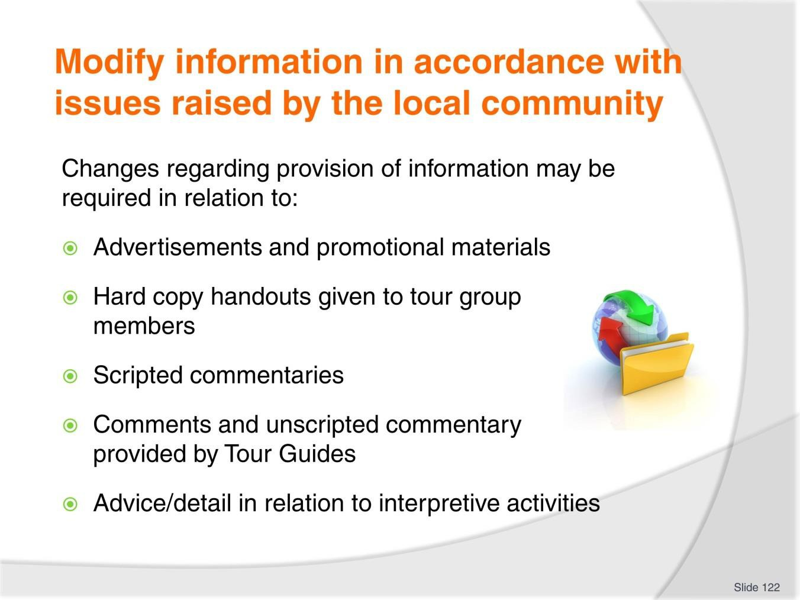
Slide No | Trainer Notes
122. | Trainer advises when changes need to be made they may be required to:  - Advertisements and promotions for tours and interpretive activities  - Material included in hard copy handouts supplied to tour group members  - Scripted commentaries prepared for tours and activities  - Comments/unscripted commentary provided by Tour Guides and tour staff  - Advice and detail used to explain, describe and/or demonstrate an interpretive activity.

Slide
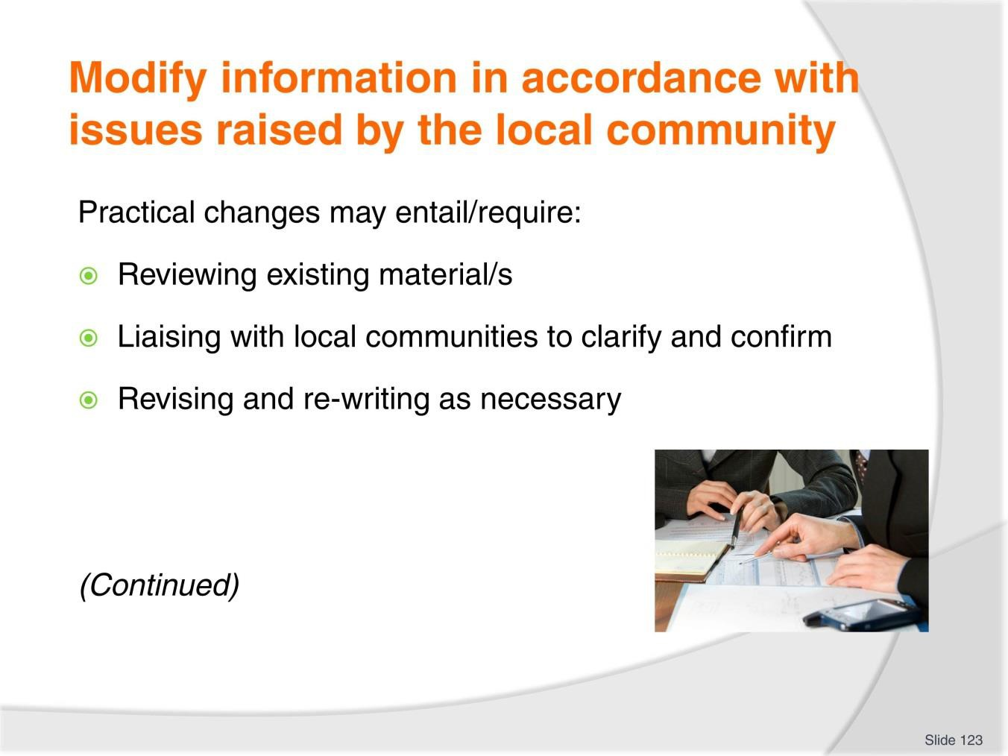
Slide No | Trainer Notes
123. | Trainer states the following are practical changes which may need to be made to information to be provided to tour group members.  - Reviewing existing materials – to determine:  - The exact items which need to be changed  - Nature and extent of changes needed  - Liaise with local communities – to:  - Clarify issues surrounding required changes  - Confirm required changes  - Seek help with making the required changes  - Gain approval for the changes which have been made  - Revising/re-writing items to reflect modifications required – in terms of:  - Advertisements  - Promotional brochures and posters  - Handouts provided as part of the tour and/or tour briefing sessions  - Sheets distributed as part of interpretive activities  - Scripted commentaries  - Agreements/contracts between Tour Operator and local communities.

Slide
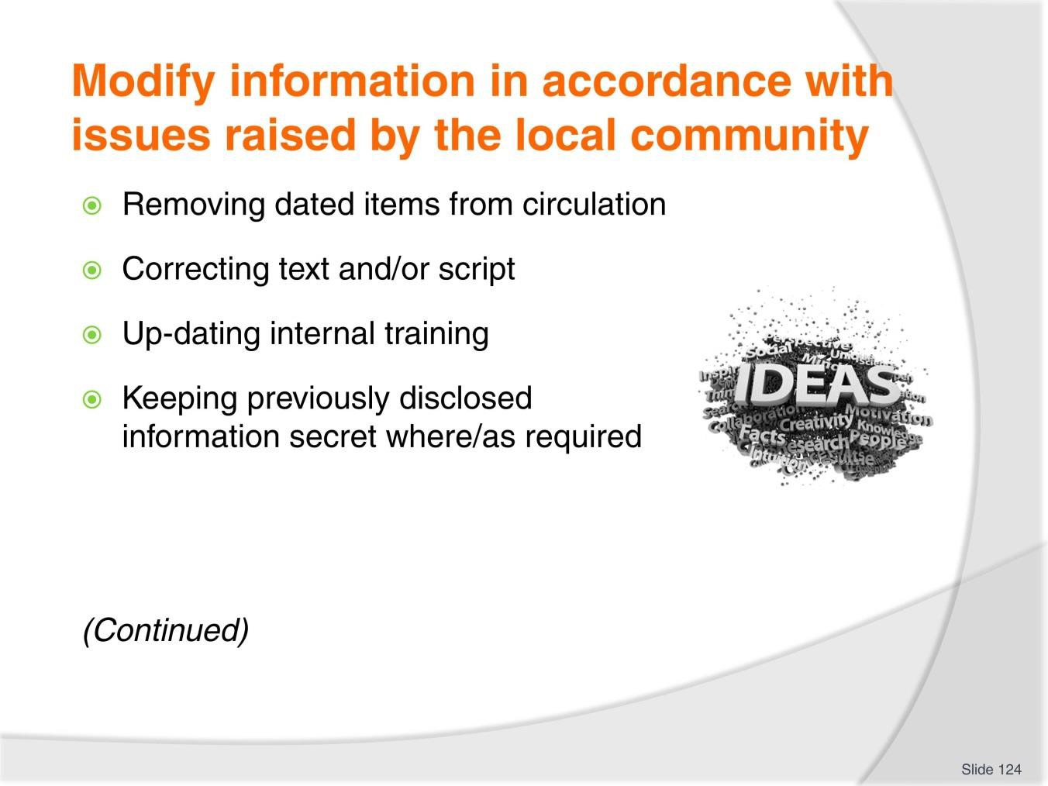
Slide No | Trainer Notes
124. | Trainer continues to identify activities involved in making required changes to information provided:  - Removing items from circulation – which may entail:  - Taking brochures and advertising materials from racks and locations in which they have been placed  - Taking material off the website  - Removing materials as required from pre-prepared kits/folders  - Updating version control protocols – to ensure the most current version is the one used in the future  - Correcting text and/or script – with references to issues such as:  - Mistakes  - Spelling  - Grammar  - Omissions  - Updating internal training – so that:  - Training (role plays, drills, practical sessions) uses current/up-dated materials  - Staff gain experience and competency with the new information

- Keeping previously disclosed information secret – in relation to:
  - Not taking tour group members into places/areas that are now restricted
  - Not making unscripted comments about information which is now prohibited.

Slide
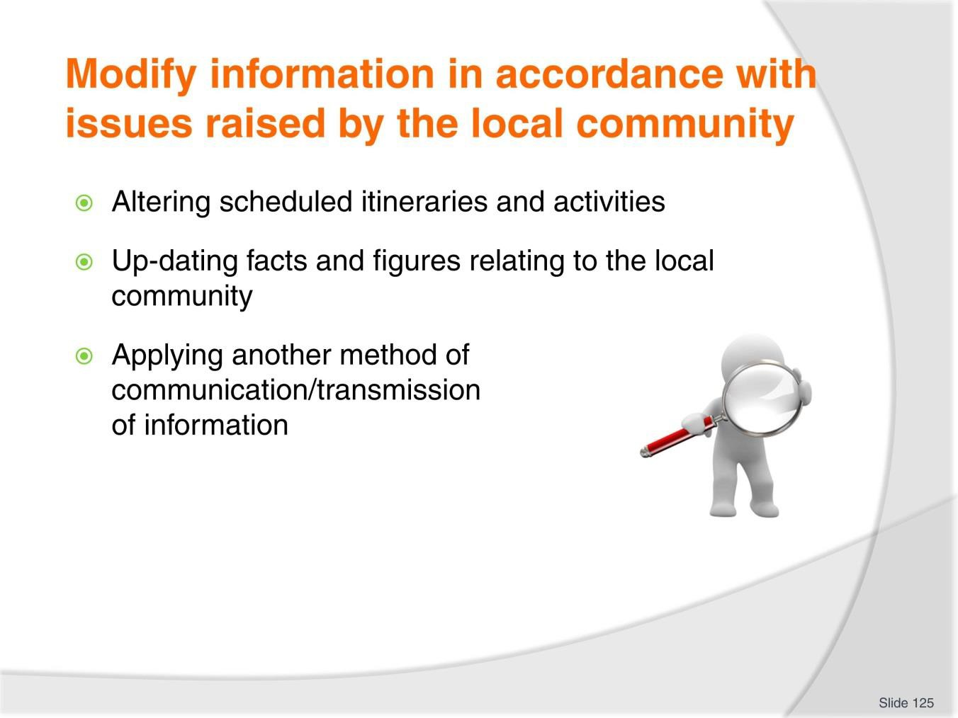
Slide No | Trainer Notes
125. | Trainer continues to identify activities involved in making required changes to information provided:  - Altering scheduled itineraries and activities – on the basis of:  - Feedback received from the local community  - Changed priorities of the community  - Concerns raised  - Up-dating facts and figures relating to the local community – regarding (for example):  - Population numbers  - Employment rates  - Crime  - Achievements  - Applying another method of communication/transmission of information – which may mean:  - Using a Tour Guide/presenter from the local community  - Speaking in a different language/local language

- Presenting the same information via (say):
  - Printed word instead of the spoken word
  - An activity as opposed to (just) information
  - Remote presentation rather than communication in the community.

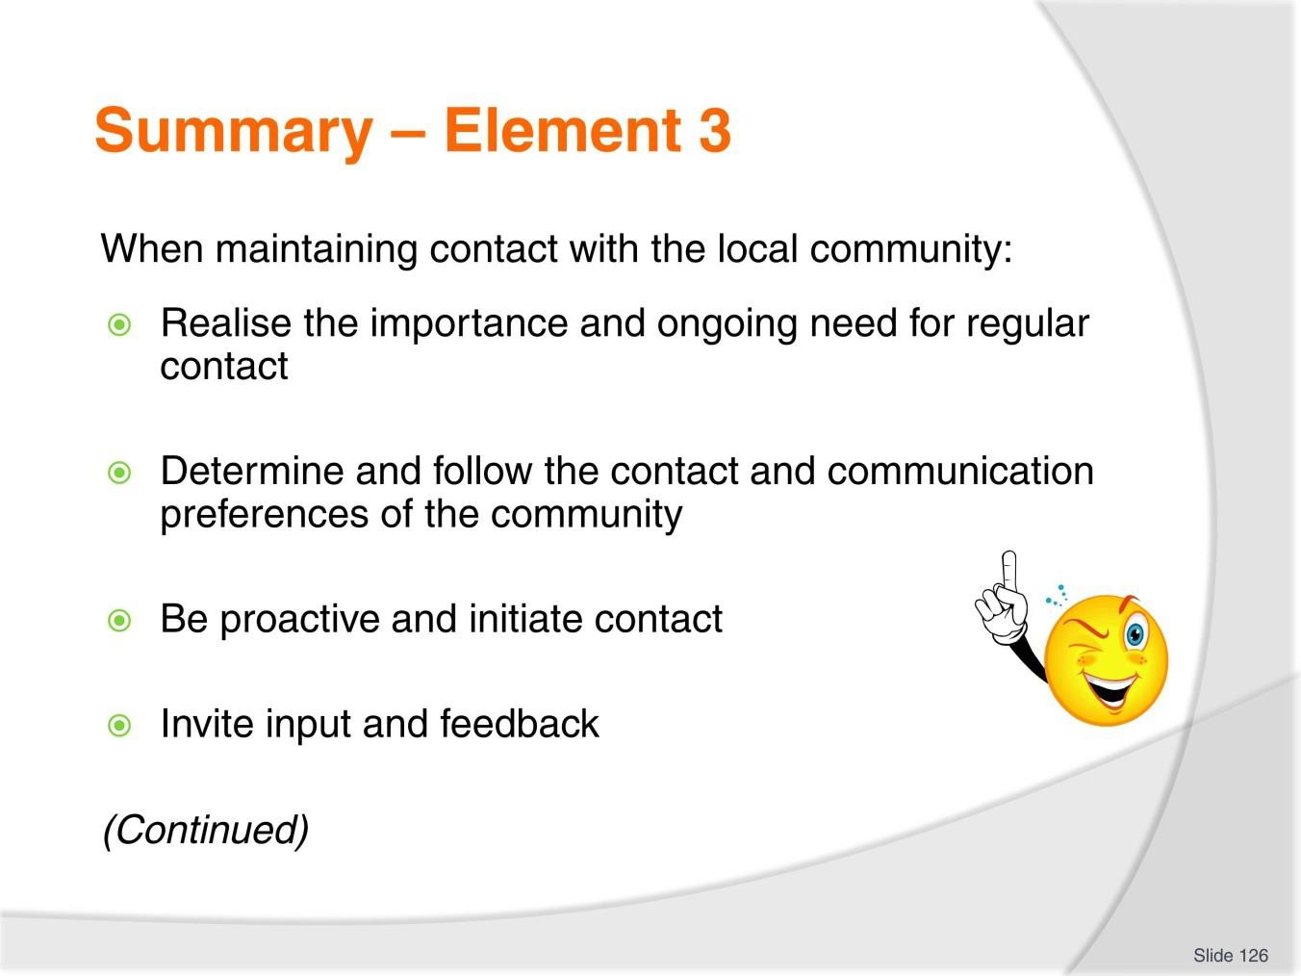
Slide
Slide No
Trainer Notes
126.
Trainer provides a recap of the Element asking questions to check trainee understanding and responding to questions from trainees, as required.

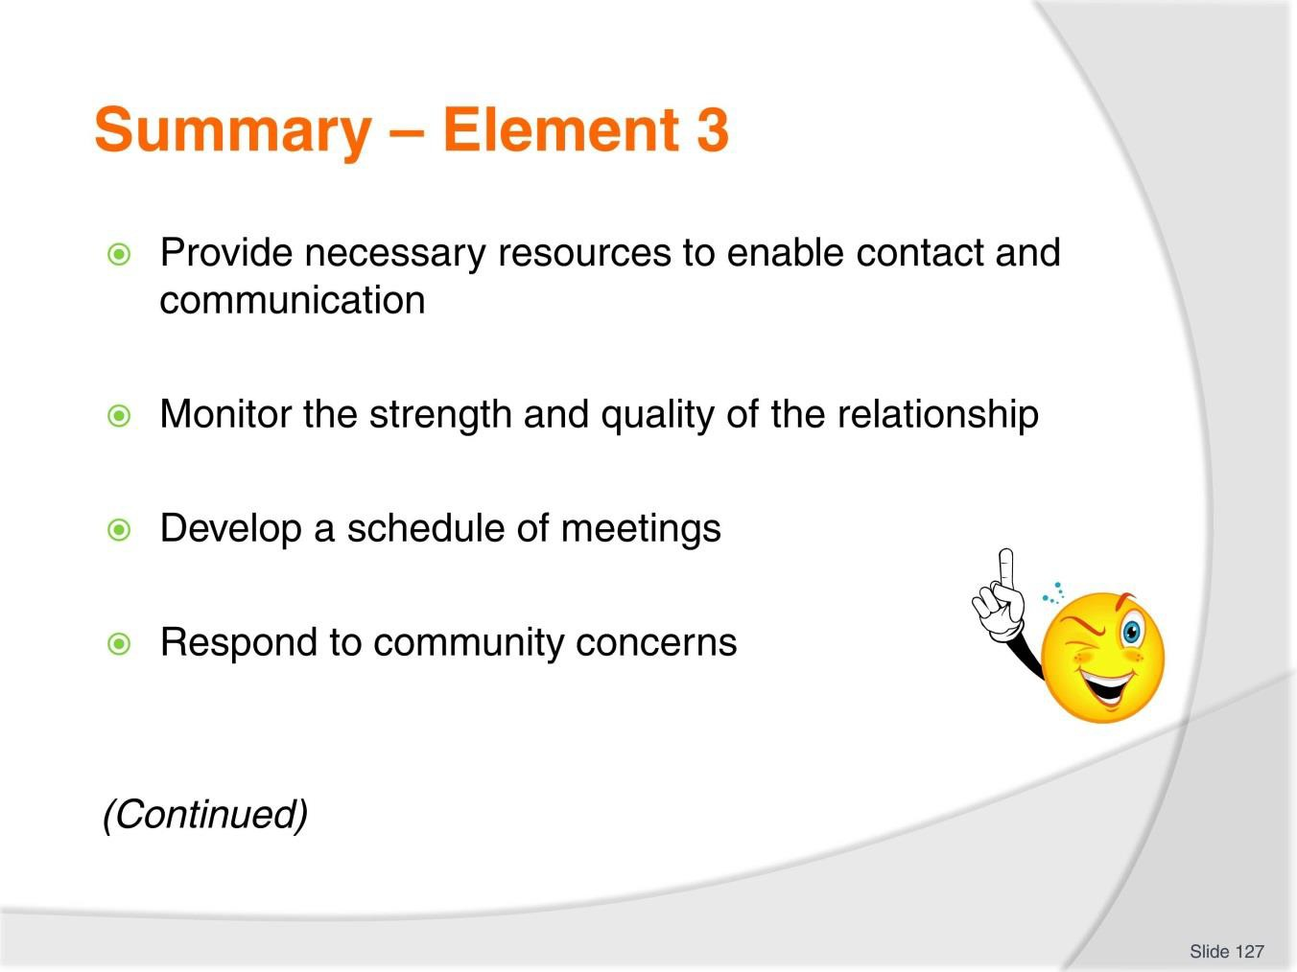
Slide
Slide No
Trainer Notes
127.
Trainer provides a recap of the Element asking questions to check trainee understanding and responding to questions from trainees, as required.

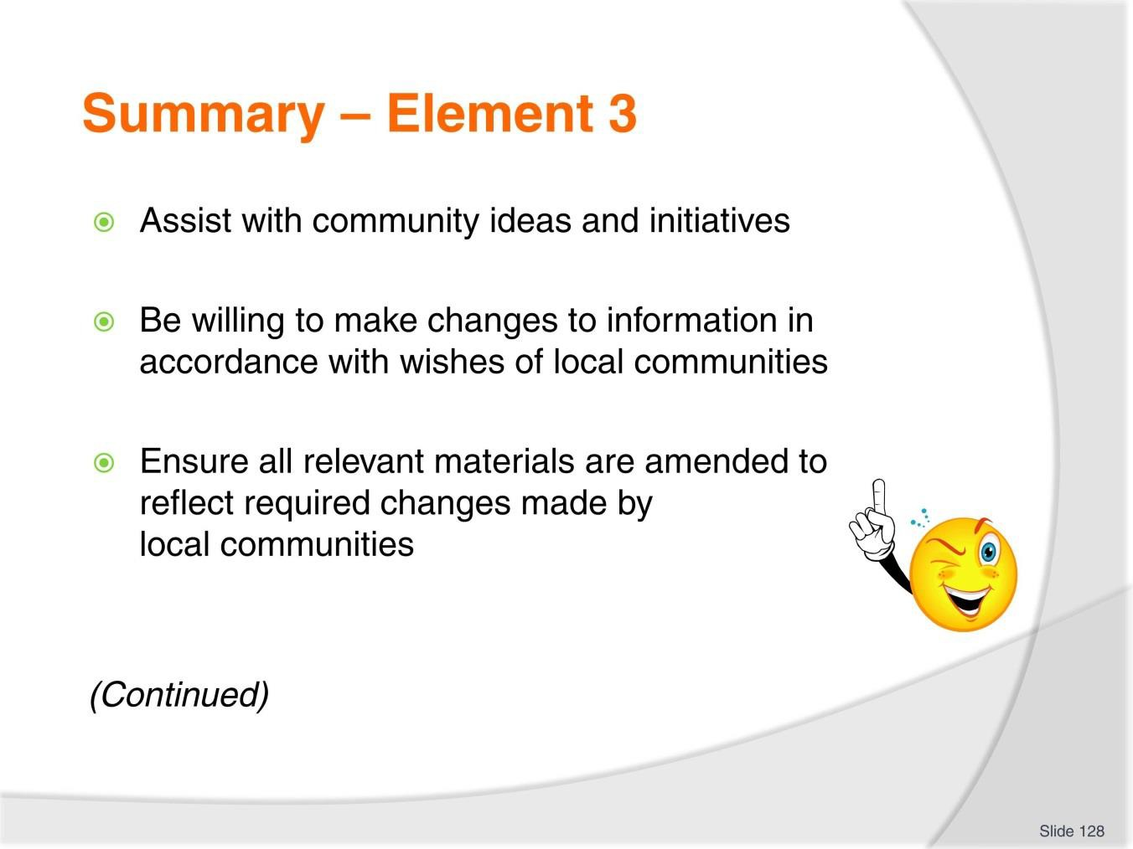
Slide
Slide No
Trainer Notes
128.
Trainer provides a recap of the Element asking questions to check trainee understanding and responding to questions from trainees, as required.

Slide
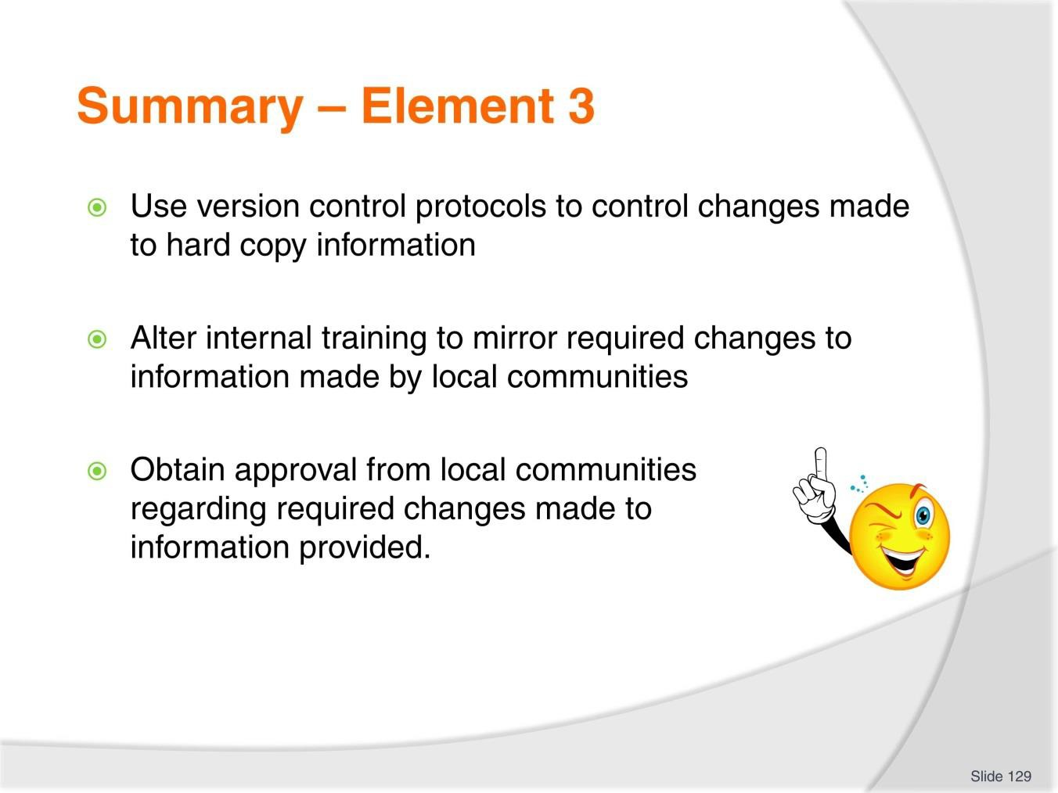
Slide No | Trainer Notes
129. | Trainer provides a recap of the Element asking questions to check trainee understanding and responding to questions from trainees, as required.  Trainer thanks trainees for their attention and encourages them to apply course content as required in their workplace activities.

Recommended training equipment
A wide range of reference/source material/s on different countries, communities and cultures – these items may include:
- Books and travel guides
- Travel and tourism magazines
- Travel and tourism articles from newspapers and magazines
- Advertising brochures, flyers and promotional materials from Tour Operators
- Recording of relevant TV and radio programmes and interviews
- Government reports and statistical information on target countries/communities
- Peak industry body reports regarding target countries/communities
- Handout material/fact sheets provided by institutions such as museums, galleries and cultural centres
- Atlases and maps.
Operational information produced by Tour Operators relating to tours they operate into target destinations – such as copies of their:
- Itineraries
- Fees and charges
- Tour schedules
- Terms and conditions
- Information sheets
- Fact sheets
- Scripted commentaries.
A range of materials which might be used by a staff member when sharing information with colleagues on an indigenous community – such as:
- Slides
- Overhead projection sheets/transparencies
- PowerPoint slides
- Handouts.
Equipment/technology to enable information sessions with colleagues to be conducted – which might include:
- Photocopier
- Overhead projector
- Data projector
- Laser pointer
- Playback devices for audio and video recordings.
Computers with internet connection for desk-top research – with printers.

Instructions for Trainers for using PowerPoint – Presenter View
Connect your laptop or computer to your projector equipment as per manufacturers’ instructions.
In PowerPoint, on the Slide Show menu, click Setup Show.
Under Multiple monitors, select the Show Presenter View check box.
In the Display slide show on list, click the monitor you want the slide show presentation to appear on.
Source: http://office.microsoft.com

Note:

In Presenter View:
You see your notes and have full control of the presentation Your trainees only see the slide projected on to the screen

More Information

You can obtain more information on how to use PowerPoint from the Microsoft Online Help Centre, available at: http://office.microsoft.com/training/training.aspx?AssetID=RC011298761033

Note Regarding Currency of URLs

Please note that where references have been made to URLs in these training resources trainers will need to verify that the resource or document referred to is still current on the internet. Trainers should endeavour, where possible, to source similar alternative examples of material where it is found that either the website or the document in question is no longer available online.

Appendix – ASEAN acronyms

AADCP | ASEAN – Australia Development Cooperation Program
ACCSTP | ASEAN Common Competency Standards for Tourism Professionals
AEC | ASEAN Economic Community
AMS | ASEAN Member States
ASEAN | Association of Southeast Asian Nations
ASEC | ASEAN Secretariat
ATM | ASEAN Tourism Ministers
ATPMC | ASEAN Tourism Professionals Monitoring Committee
ATPRS | ASEAN Tourism Professional Registration System
ATFTMD | ASEAN Task Force on Tourism Manpower Development
CATC | Common ASEAN Tourism Curriculum
MRA | Mutual Recognition Arrangement
MTCO | Mekong Tourism Coordinating office
NTO | National Tourism Organisation
NTPB | National Tourism Professional Board
RQFSRS | Regional Qualifications Framework and Skills Recognition System
TPCB | Tourism Professional Certification Board



